
UNDERSTANDING SCENARIO PLANNING IN THE PUBLIC SECTOR
THE CASE OF THE ABU DHABI GOVERNMENT

MARIAM SAIF AL MANSOORI
DOCTORATE OF BUSINESS ADMINISTRATION (DBA)

UNIVERSITY OF STRATHCLYDE BUSINESS SCHOOL
DEPARTMENT OF STRATEGY & ORGANISATION

September 2022

DECLARATION
This thesis is the result of the author’s original research. It has been composed by the author and has not been previously submitted for the examination, leading to the award of a degree.
The copyright of this thesis belongs to the author under the terms of the United Kingdom Copyright Acts as qualified by the University of Strathclyde Regulation 3.50. The acknowledgement must always be made of the use of any material contained in, or derived from, this thesis.

Signature : Mariam S. Al Mansoori
Date : 15.09.2022

ACKNOWLEDGEMENTS
First, I thank my Almighty ALLAH for granting me the opportunity to learn, strengthen my skills, broaden my knowledge, and carry out my study to completion.
I want to thank my supervisor Dr. Ronald Bradfield who opened the door for me to the University of Strathclyde and guided me well throughout this research.
My sincere thanks also to my primary supervisor Professor George Wright, for his efforts and mentorship, right from the time we had our first Skype meeting back in 2015.
I am grateful to both for sharing their immense knowledge, motivating me to carry out this work, and their patience during the entire study duration, which helped me stay on my feet and gave me the power and spirit to excel in academic writing. Conducting academic research dealing with a rather complex topic without their assistance and mentorship would have been tedious and difficult. They both are superlative mentors and have advised me during my doctorate journey beyond imagination.
I am grateful to my parents, siblings, friends, and colleagues who remember me in their prayers and wish me ultimate success. They are the pillars of my existence, and I consider myself nothing without them. They gave me the moral support, encouragement, and motivation to accomplish my personal goals.

TABLE OF CONTENTS
DECLARATION i
ACKNOWLEDGEMENTS ii
LIST OF FIGURES viii
LIST OF TABLES x
LIST OF ABBREVIATIONS xii
ABSTRACT xiii
1 INTRODUCTION 1
1.1 Research Background 1
1.2 Motivation of Study 3
1.3 Problem Statements 3
1.4 Research Objectives and Research Questions 4
1.5 Research Questions 5
1.6 Research Plan 5
1.7 Statement of Significance 6
1.8 Scope of the Study 7
1.9 Structure of the Thesis 7
2 RESEARCH CONTEXT: THE UNITED ARAB EMIRATES AND THE ABU DHABI GOVERNMENT 10
2.1 Introduction 10
2.2 United Arab Emirates (UAE) 10
2.3 The Abu Dhabi Government 13
2.4 Overview of Strategic Planning in the Abu Dhabi Government 15
2.5 Summary 27
3 SCENARIO PLANNING LITERATURE REVIEW 29
3.1 Introduction 29
3.2 The Concept of Scenario Planning 29
3.3 Brief History of Scenario Planning 29
3.4 The Growth of Scenario Planning 31
3.5 The Goals of Scenario Planning 32
3.6 Benefits and Weaknesses of Scenario Planning 33
3.7 The Scenario Planning Process 33
3.8 Enhancements to Scenario Planning 36
3.9 Applications of Scenario Planning in the Public Sector 37
3.10 Factors Impacting Scenario Planning Success 39
3.11 Government Foresight Maturity 43
3.12 Summary 45
4 RESEARCH METHODOLOGY, STUDY DESIGN, DATA COLLECTION, AND DATA ANALYSIS APPROACH 46
4.1 Introduction 46
4.2 Research Objectives 46
4.3 Identification of Research Paradigm 47
4.4 Social Construction of Scenario Planning in the Public Sector 47
4.5 Research Setting 48
4.6 Research Design: Three Phases of the Study 48
4.7 Research Method 51
4.8 Data Collection 52
4.9 Interview Process 53
4.10 Data Analysis 55
4.11 Research Rigor 63
4.12 Summary 66
5 PHASE 1: AN EXPLORATORY STUDY OF INTERVENTION 1 67
5.1 Introduction 67
5.2 Objective 67
5.3 Research Questions 67
5.4 Research Setting: Intervention 1 67
5.5 Research Method – In-depth Interviews 73
5.6 Profile of Participants 74
5.7 Data Collection – Interview Question Design 74
5.8 Interview Questions for the Core Team 75
5.9 Interview Questions for Government Employees and Consultants 76
5.10 Secondary Data: Scenario Planning Workshop Materials 76
5.11 Analysis 78
5.12 Phase 1 Findings 83
5.13 Phase 1 Findings Summary and Discussion 97
6 PHASE 2: ELICITATION OF EXPERT OPINION 99
6.1 Introduction 99
6.2 Objective of Phase 2 99
6.3 Participant Profiles 99
6.4 Data Collection Tool Design: Interview Questions 100
6.5 Analysis 102
6.6 Phase 2 Findings 107
6.7 Phase 2 Findings Summary and Discussion 117
7 PHASE 3: Foresight and Scenario Planning as an Innovative Approach 119
7.1 Introduction 119
7.2 Objective and Research Question 119
7.3 Participant Selection 119
7.4 Research Method – In-depth Interviews 121
7.5 Data Collection 122
7.6 Data Analysis 125
7.7 Phase 3A Findings 129
7.8 Phase 3B. The Introduction of Foresight and Scenario Planning as an innovation tool in the Abu Dhabi Award for ‘Excellence in Government Performance 139
7.9 Analysis - Phase 3B 139
7.10 Findings - Phase 3B 143
7.11 Phase 3 Findings Summary and Discussion 155
8 Chapter 8 Discussion and Conclusion 156
8.1 Introduction 156
8.2 A Summary of Phase 1 of the Study: Intervention 1 156
8.3 A Summary of Phase 2: An Elicitation of Expert Opinion 157
8.4 A Summary of Phase 3: Foresight and Scenario Planning as an Innovative Approach 158
8.5 A Comparative Analysis between Phase 1 and Phase 3B Findings 160
8.6 Reasons for Foresight and Scenario Planning 160
8.7 The Contributions of These Empirical Findings to the Wider Body of Knowledge 163
8.8 A Shift from a Rationalist School to a Processual School for Decision Making 165
8.9 A Shift of Mental Model from Making the Best Decision to an Exploration of Possible Outcomes 166
8.10 A Framework for a Foresight Ecosystem For the Abu Dhabi Government 167
9 FORESIGHT ECOSYSTEM FRAMEWORK FOR THE ABU DHABI GOVERNMENT 168
9.1 Introduction 168
9.2 Why Foresight, not Scenario? 168
9.3 Tool Design and Development 169
9.4 Main Objectives 170
9.5 Target Users and Proposed Use 170
9.6 Structure of Foresight Framework 170
9.7 Tool Testing and Feedback 183
10 REFLECTIONS, LIMITATIONS AND FUTURE RESEARCH 186
10.1 Introduction 186
10.2 Retiring the Gap in the Literature 186
10.3 Contribution of the Research 187
10.4 Managerial Implications 189
10.5 Reflections as a Researcher and Strategy Practitioner 190
10.6 Study Limitations 193
10.7 Suggestions for Future Research 195
10.8 Summary 195
REFERENCES 197
APPENDICES 206
Appendix 1: History of the General Secretariat of the Executive Council (GSEC) 206
Appendix 2: Interview Guides and Protocol 207
Appendix 3: Interview Consent Form 217
10.9 Appendix 4: 220
10.10 Research Phase 1: cohort detail – Intervention 1 220
10.11 Appendix 2: Expert’s Profile 221
Appendix 5: Comparison of Key Factors Across Scenarios 225
Appendix 6: Foresight Practices 227
Appendix 7: Cognitive mapping Explaining the Analysis Process 244
Appendix 8: Foresight Implementation Approaches 247
Appendix 9: Foresight Ecosystem For Government and Public Sector, Copyright registration Certificate. Source: Ministry of Economy 248
Appendix 10: Foresight Benchmark Summary 249

LIST OF FIGURES
Figure 1: Structure of thesis 8
Figure 2: Evolution of the planning system in the Abu Dhabi government. 15
Figure 3: The Abu Dhabi Vision. 18
Figure 4: The Framework of the Economic Vision 2030 for Abu Dhabi. 18
Figure 5: The Update on Policy Agenda. 19
Figure 6: The policy agenda framework.. 19
Figure 7: Illustration of the gap. 20
Figure 8: Abu Dhabi Government Planning and Performance Management Framework. 23
Figure 9: Abu Dhabi Government Excellence System and Its Foundations. 25
Figure 10: Main Process Steps (translated from Arabic to English). 26
Figure 11: Ghadan 21 One Year On. 27
Figure 12: The Purpose of Scenario Work.. 32
Figure 13: Scenario Planning Stages.. 33
Figure 14: Scenario Planning Stages. 34
Figure 15: Scenario Planning Stages. 34
Figure 16: A handwritten summary of an interview. 56
Figure 17: A page from an interview transcript showing line-by-line coding. 57
Figure 18: Interview excerpt sample. 58
Figure 19: Parent and child codes. 58
Figure 20: A cognitive map for visual representation of the links between concepts. 63
Figure 21: The planning stages of Intervention 1. 68
Figure 22: Modules for Intervention 1 proposed by GBN/Monitor. 69
Figure 23: Module 1 capacity building training series. 70
Figure 24: Human Capital 2030: Abu Dhabi as a pilot scenario planning project. 73
Figure 25: Overview of Phase 1 findings. 85
Figure 26: Key Theme 1—Leadership Commitment, Sponsorship, and Stakeholder Engagement 86
Figure 27: “The Future of Geopolitics: Perceptions and Realities” presented by Peter Schwartz October 2019. 87
Figure 28: Organisation Chart of Abu Dhabi Government for the Chain of Command and Decision-Making Hierarchy. 88
Figure 29: Key Theme 2—Instil Scenario Planning Culture within the Government. 91
Figure 30: Key Theme 3—Capacity and Competencies Development for Scenario Planning. 92
Figure 31: Key Theme 4—Scenario Planning Potentials. 95
Figure 32: Scenario planning process based on expert opinion. 104
Figure 33: Factors influencing scenario planning implementation, Phase 2. 111
Figure 34: Part of the Summary of Foresight Practice for the Department of Health—Phase 3B 143
Figure 35: Visual representation of foresight and scenario planning practice at the Department of Health—Phase 3B 144
Figure 36: An overview of foresight practice—Phase 3 148
Figure 37: Foresight process for the Abu Dhabi Statistics Authority. 149
Figure 38: Establishment of Foresight Units—Phase 3B 151
Figure 39: Foresight Ecosystem Framework for the Abu Dhabi Government (FEFFAG) 173
Figure 40: Sample of adoption of foresight practices in the federal government. 176
Figure 41: Foresight Unit proposal for Abu Dhabi Executive Office (ADEO) 177
Figure 42: Required capabilities and activities for scenario planning. 178
Figure 43: Global Business Network (GBN) scenario planning process. 180
Figure 45: Global Business Network (GBN) Scenario Planning Process 180
Figure 45: Public sector foresight process. 181

LIST OF TABLES
Table 1: Summary of scenario planning interventions in the Abu Dhabi government from 2009 onward. 2
Table 2: The three main pillars of the Abu Dhabi government transformation. 16
Table 3: Summary of the design of Phase 1 research. 48
Table 4: Summary of the design of Phase 2 research. 49
Table 5: Foresight and scenario planning as an innovation approach, Phase 3. 50
Table 6: An example of a code and the coded text/ excerpts from transcripts. 59
Table 7: Stage 2, merging codes. 59
Table 8: List of parent and child codes from data analysis, step 2. 60
Table 9: Step 4: Clusters of emerging themes. 61
Table 10: Reviewing emerging themes and re-clustering, and labelling of themes. 62
Table 11: Training schedule for “Developing and Using Scenarios,” Jan 9–13, 2011. 70
Table 12: Intervention 1: Scope of Module B—Establishing strategic planning team and operations manual. 72
Table 13: List of Phase 1 participants. 74
Table 14: Interview questions for the core team. 75
Table 15: Interview questions for government employees and consultants. 76
Table 16: Module 1, Capability Building, secondary data summary. 77
Table 17: Module 2, Institutional Design, secondary data summary. 77
Table 18: Module 2 Scenario Analysis, secondary data summary 78
Table 19: List of clusters of codes and emerging themes for Phase 1. 80
Table 20: Clusters of codes for Key Theme 1: Leadership Belief and Commitment. 81
Table 21: Clusters of codes for Key Theme 2: Scenario Culture. 82
Table 22: Clusters of codes for Key Theme 3: Capacity and Competency for Scenario Planning. 83
Table 23: Clusters of codes for Key Theme 4: Potentials of Scenario Planning. 83
Table 24: List of Phase 2 participants. 100
Table 25: List of Phase 2 interview questions. 102
Table 26: Scenarios as stories about the future. 103
Table 27: Scenarios challenge pre-conceived ideas and dominant assumptions about the future. 103
Table 28: A comparative analysis of public versus public sector scenario planning—Phase 2. 105
Table 29: Clusters of codes and emerging themes on factors influencing scenario planning—Phase 2. 107
Table 30: Comparative analysis of public and private sector scenario planning. 109
Table 31: Phase 3A participants. 121
Table 32: Phase 3B entities. 122
Table 33: Phase 3A interview questions. 124
Table 34: Phase 3B interview questions. 126
Table 35: Clusters of codes for Phase 3A. 130
Table 36: Clusters of codes for Phase 3A: Reasons for scenario planning. 142
Table 37: Reasons for foresight and scenario planning: A comparison between Phase 1 and Phase 3B. 163
Table 38: Foresight and scenario planning: A comparison between Phase 1 and Phase 3B. 164

LIST OF ABBREVIATIONS
Abbreviation | Description
AD | Abu Dhabi: Capital of the United Arab Emirates
ADEO | Abu Dhabi Executive Office
ADEK | Abu Dhabi Education and Knowledge Department
ADFSA | Abu Dhabi Agriculture and Food Safety Authority
ADGE | Abu Dhabi government entity
AD Award | Abu Dhabi Award for Excellence in Government Performance
DOH | Department of Health
Emiratisation | An initiative by the government of the United Arab Emirates to employ its citizens in a meaningful and efficient manner in the public and private sectors
GBN | Global Business Network
GSEC | General Secretariat of the Executive Council
KF | Khalifa Fund
Masdar | Masdar City is a planned city project in Abu Dhabi, in the United Arab Emirates. Its core is being built by Masdar, a subsidiary of Mubadala Development Company, with the majority of seed capital provided by the government of Abu Dhabi
PESTEL | A framework or tool used by marketers to analyse and monitor the macro-environmental (external marketing environment) factors that have an impact on an organisation, company, or industry
Public sector | Public sector includes those employed in the federal government, government departments, municipality employees, public bodies, and federal and public institutions
Public entity | An organisation or body providing services to the public on behalf of the government or another public entity
SCAD | Statistics Centre Abu Dhabi
SWOT | A strategic planning and strategic management technique used to help a person or organisation identify strengths, weaknesses, opportunities, and threats related to business competition or project planning
SP | Scenario planning
SPPM | Strategic Planning and Performance Management
TCD | Department of Culture and Tourism
UAE | United Arab Emirates

ABSTRACT
This research is an in-depth study of the implementation of foresight and scenario planning as an innovative approach to enhancing strategy and policy development in the Abu Dhabi government.
The over-arching aim of this study is to identify the factors influencing scenario planning implementation and practice within the Abu Dhabi government to develop a guide for public managers. The research is designed as a three-phase study. This includes Phase 1, an assessment of an initiative for scenario planning implementation as an early intervention within the Abu Dhabi government, known as Intervention 1. This is followed by Phase 2, elicitation of expert opinion on their views of the factors influencing effective implementation of scenario planning and scenario planning practice. Finally, Phase 3 is a follow-up study to examine the role of foresight and scenario planning as innovative approaches in enhancing public sector operations. The findings of the study will inform the development of a framework for a Foresight Ecosystem for the Abu Dhabi government.
Phase 1 findings showed that there was tremendous support and commitment from the Executive Office in their efforts to enhance and develop the public sector. Intervention 1 was successful in the sense that the initiative has created a good foundation for an open mindset to the adoption of new and innovative management approaches. Intervention 1 put forward the need for the creation of networking, skills development and awareness-raising events around foresight, systems thinking, and integrated policy development. This reflects the more significant aspiration of developing a foresight culture within the government of Abu Dhabi.
The nationwide introduction to scenario planning has urged public managers to get out of their comfort zone and to embrace new practices such as using scenario planning as a process for strategy development. Intervention 1 (Phase 1 of this study) demonstrates the willingness of the senior management at the executive level of the government to test and challenge basic or dominant assumptions of the decision making and policy development process. Intervention 1 was evidence of the shift from a rationalist school of thought where strategising for the future lies with an elite few to a processual school of thought, in which entities install and create processes to make the organisation more adaptive and capable of learning from its mistakes (Argyris, 1977, van der Heijden, 1997). Intervention 1 also demonstrates the shift from a functional, hierarchical organisation that tends to “engage in centralised and bureaucratic planning to a network organisation with more divergence in goals that tends to approach planning with an emphasis on learning and space for dialogues for converging goals and purposes” (Galer and Van der Heijden 1992).
Participants appreciated foresight and scenario analysis, as government entities struggle to keep up with and ahead of the disruptions caused by rapid changes, facing questions such as “how must the role of the department change in order to remain relevant?” While foresight practice was found to be embedded across functions within some of the departments or entities, they realised that foresight and scenario planning requires intense involvement of senior executives, as well as extensive time and financial resources, and they struggled with the lack of expertise and capabilities for application of methodologies.
The findings surface the desire for an operational guide or framework for foresight practice. The final output of this research is a framework for a Foresight Ecosystem for the Abu Dhabi government. The framework serves to describe the key elements of the foresight ecosystem for the Abu Dhabi government and public sector entities. It will inform the design and implementation of scenario planning as a coherent and integrated practice that emphasises engaging with key stakeholders’ perspectives, linking strategy planning and policy development, clarifying and embracing its role as a planning tool rather than a single-use tool, and provide system flexibility to reflect internal and external demands. It will also provide an opportunity for other governments and public sectors to learn from the experiences of Abu Dhabi, which could reduce both the time required to climb the learning curve and the cost of improvement and be a reference tool for public sector foresight efforts.
This research empirically documented the experiences from two major milestones of the Abu Dhabi government (i) a nationwide introduction to and first implementation of scenario planning and (ii) the subsequent expansion of the quest for expertise in considering and planning for the future to include foresight as part of the innovative approaches to public sector management. This empirical study extends the literature on foresight and scenario planning by including knowledge constructed from the Middle East.

INTRODUCTION

Research Background
The environment of public sector organisations changes constantly. Change profoundly impacts public and non-profit organisations, and they must determine how to handle change. Moreover, it is also important to understand how top management adapts to the changing environment because this will reflect its ability to cope successfully with unpredictable and unknown external and internal events. With the help of strategic planning, governments, communities, and public organisations have dealt with change and promptly adapted to it. In addition, strategic planning is intended to strengthen an organisation’s capacity to adapt to change and to enhance the ability of an organisation’s members to think, act, and learn strategically (Bryson, 2004, p. 15).
Strategic planning has been an important concern for many governments. For example, the UAE government introduced strategic planning towards the end of 2006 as part of the government’s significant restructuring efforts. Furthermore, the government of Abu Dhabi introduced a new approach within government entities to adopt a Strategic Planning and Performance Management Framework in 2007. This was aimed to unify all the government entities under one umbrella and build a high-performing management team to help achieve the government’s vision of making Abu Dhabi a better place to live, work, and visit.
To initiate this approach, the Abu Dhabi government entities (ADGEs) worked closely with the General Secretariat of the Executive Council (GSEC) to identify overall goals and prioritise a secure community and an open, sustainable economy with a global vision. As a result, various government entities adopted different strategic planning approaches.
Different strategic planning tools have been introduced throughout this journey of adopting strategic planning, such as executive systems, simulations, balanced scorecards, performance management systems, and scenario planning. The Abu Dhabi government believes in the concept of scenario planning and what it can offer. Therefore, the Abu Dhabi government has experimented with scenario planning in different entities since 2011. As part of a trial, scenario planning was incorporated into the government's strategic planning processes. Although scenario planning has long been established as a useful planning tool in western society. The Abu Dhabi government did not see much success in 2011 with the first intervention. Previous studies also described problems associated with scenario planning implementation and underlying reasons for its failure in different organisations (Hodgkinson and Wright, 2002, Bradfield et al., 2005, Wright et al., 2008). Two questions arose in the context of scenario planning implementation: (i) Can Abu Dhabi learn from problems associated with scenario planning implementation? And (ii) What is contextually different with Abu Dhabi compared to other countries' scenario planning implementation?
Scenario planning was introduced twice in the Abu Dhabi government processes, first as a strategic planning and policy formulation tool, and second as an innovation tool under the Abu Dhabi Award for Excellence in Government Performance (Table 1).
 | Intervention 1 | Intervention 2
Intervention Name: | The Introduction of Scenario Planning in Abu Dhabi government public entities. | The Introduction of Foresight and Scenario Planning as an Innovation Tool in the Abu Dhabi Award for ‘Excellence in Government Performance.’
Time Frame: | 2009–2011 | 2016–Present
Aim: | To create awareness and dialogue, with the ambition of embedding Scenario Planning within the strategic planning and policy formulation process in the public sector. | To use Future Foresight as an innovation tool to enhance public sector operations.
Table 1: Summary of scenario planning interventions in the Abu Dhabi government from 2009 onward.
Due to the lack of supporting infrastructure (human, data, systems) for strategic planning and scenario planning, most Abu Dhabi government organisations found it more convenient and efficient to hire consultancy firms to help develop their strategic planning documents. Institutional heads do not have autonomy in decision-making positions and/or share the responsibilities for setting their institution’s objectives. Furthermore, they were oblivious to the contents of the strategic planning documents and had no hands-on experience with strategic planning practice. In addition, they could not relate strategies or organisational goals to stakeholders. As a result, the strategic and scenario planning produced only a corporate document.
This study took on the task of examining, documenting, identifying, and communicating good scenario planning practice emphasising day-to-day practical application within the context of Abu Dhabi public bodies. The research attempted to find the answer to the following questions: What challenges did Abu Dhabi public administrators face with implementation of scenario planning? Did the public administrators find scenario planning a helpful exercise? Did the public administrators understand the importance of scenario planning within the government? What was the perceived level of effectiveness of existing scenario planning practice? Would public managers require a guide to support and facilitate scenario planning?

Motivation of Study
This study originated from a singular opportunity to contribute empirical evidence to understand factors that influence the implementation of scenario planning in the public sector of Abu Dhabi, UAE. As a practitioner, the author of this study (the researcher) was involved in several strategic planning formulations and updates thereof in Abu Dhabi, including their introduction, adoption, and evaluation.
The researcher worked in various roles in scenario planning and performance management within the government, including holding the position of Strategy Director of one of the strongest financial centres in the world. More than a decade of personal experience in strategic planning gave the researcher the prospect of witnessing and contributing to developing strategies in various governmental organisations. One of the researcher’s greatest challenges has been to ensure that the strategic planning team was aware of the vocabulary needed to articulate their wishes concerning strategic planning and had the capabilities required to enhance the robustness and relevance of strategic planning processes in Abu Dhabi. Therefore, the researcher aims to provide empirical evidence by using prior experience in strategic planning to understand factors that influence the implementation of scenario planning in the public sector of Abu Dhabi, UAE.

Problem Statements
- The environment in which Abu Dhabi public organisations operate has become increasingly uncertain. Some of the significant forces of change include shifts in population demographics (millennials being the largest proportion of the population); a diverse population that includes migrants and expatriates; a shift in people’s expectations arising from higher standards of living and consumer spending trends; political changes; and macroeconomic weaknesses.
- The government initiatives to enhance strategic planning practices put public administrators under pressure to quickly rethink how organisations can act to strengthen and improve public sector operations. These initiatives created a different set of managerial challenges that have not previously been encountered.
- Public administrators were challenged to expand their viewpoints and actions when introducing scenario planning. They were caught off guard, as they did not have the knowledge, the right capabilities, and/or the language and vocabulary to discuss scenario planning. For example, they used world foresight to refer to the scenario planning process.
- Based on the limited success of Intervention 1, it is crucial to better understand cultural and/or institutional barriers encountered earlier in adopting scenario planning within the Abu Dhabi government.
- There is a lack of empirical research and published materials relating to scenario planning within the Middle East region; existing literature skewed very much toward the western world.
- The findings of this research provide insights into matters requiring attention for any engagement in scenario planning intervention in public sector organisations. These findings reveal the influence of organisational characteristics, culture, and leadership (Atiyyah, 1993; Tahir and Ertek, 2018) on implementation and practice.
- Most previous research in scenario planning implementation has been conducted in Europe, Asia, and the United States (Flynn, 1995). More research is needed to explore scenario planning implementation in Middle Eastern countries and regions, such as the UAE.

Research Objectives and Research Questions
This study aims to bridge the research gap by examining factors impacting scenario planning implementation in general and for the Abu Dhabi government in particular. Providing updated documentation of current practices is timely and can contribute to knowledge in this field. Moreover, the over-arching aim of this study is to conduct in-depth research to explore the factors influencing scenario planning implementation and practice within the Abu Dhabi government to develop a guide for public managers.
The objectives of this research are as follows:
- Objective 1: To gain an in-depth understanding of the implementation of scenario planning as an early intervention within the Abu Dhabi government.
- Objective 2: To elicit expert opinion on the factors influencing the effective implementation of scenario planning.
- Objective 3: This consists of two phases.
- Phase 3A: To examine the evolution of the Abu Dhabi government and its efforts to develop a more structured approach to planning and policymaking to gauge its readiness for scenario planning; and
- Phase 3B: To gain an understanding of the role of foresight and scenario planning as innovative approaches in enhancing operations in public sector organisations from the perspective of government entities.
The initial scope of the research was to develop an in-depth understanding of the efforts of the Abu Dhabi government to implement scenario planning for the first time in the public sector between 2009–2011. This original scope of research was Phase 1. The research was expanded to elicit expert opinions on the factors influencing the successes and failures of scenario planning implementation as guiding elements much needed by the Abu Dhabi government; this formed Phase 2. Phase 3 was added to gain insight into how public administrators perceive the role of scenario planning as an innovative approach to enhancing public sector operations.

Research Questions
Based on the objectives, the research questions for this study are as follows:
Research Question 1: What factors influence scenario planning implementation?
Research Question 2: What are some of the issues and challenges facing public administrators in their first experience with scenario planning implementation within the Abu Dhabi government?
Research Question 3: Do public administrators need a framework for scenario planning?”
Research Question 4: From the expert’s point of view, what are some of the factors contributing to the success and failure of scenario planning in general?
Research Question 5: How do public administrators perceive the role of scenario planning as an innovative approach to enhancing public sector operations?

Research Plan
The initial focus of the research was to gain an in-depth understanding of the first implementation of scenario planning in the Abu Dhabi government and answer the following questions. What were some of the issues that emerged from the implementation? What were some of the challenges faced by public administrators in an undertaking that was entirely new to them?
The inquiry paradigm for this study is social constructionism. The research aims to understand the phenomenon under study by seeking explanations as to what, why, and how things happen the way they do. This study employed an in-depth interview approach guided by using semi-structured questions. An in-depth interview is naturalistic as it seeks to study the everyday life of different groups of people and communities in their natural settings. It is also known as the interpretive approach. It differs from quantitative research because of its diversity, covering a wide range of epistemological positions and theoretical frameworks containing many distinct research methods. This led researchers to ask different questions than quantitative researchers (Miller and Crabtree, 2004).
The research is an exploratory study, designed as a sequential three-phase study, with each phase designed to address a specific research objective. The outline of each phase is as follows:
Research Objective 1: Phase 1: An Exploratory Study into Intervention 1
This phase focused on examining the issues and challenges facing public administrators as they navigate the introduction of scenario planning as part of the strategic planning process. This phase gathered the information needed for a broader understanding of the introduction of scenario planning for the first time between 2009 and 2011 (referred to as “Intervention 1”). This phase was carried out using a series of face-to-face interviews with nine key personnel across the government who were directly involved in the implementation of scenario planning.
Research Objective 2: Phase 2: Elicitation of Expert Opinion
This phase focused on identifying some of the critical factors of good practice for implementing scenario planning as a reference point or guide for the Abu Dhabi government. A series of interviews with six experts was conducted between 2018–2019.
Research Objective 3: Phase 3: Foresight and Scenario Planning as an Innovative Approach
This phase consisted of two parts: 3A and 3B. Between the implantation of intervention 1(research Phase 1 in 2011 and the beginning of intervention 2 (Research Phase 3 in 2021, there were substantial changes within the Abu Dhabi government. For example, with a change in leadership, the use of foresight was introduced in the federal government and adopted by the Abu Dhabi government as part of the government excellence program. In 2018, the government re-introduced scenario planning as an innovation initiative known as Future Foresight. Two phases were designed to follow through with this study's primary objectives: (i) Phase 3A and (ii) Phase 3B. Phase 3A was designed to develop a guide and a scenario planning framework and to examine the maturity of the government in their efforts to implement foresight and scenario planning. Phase 3B was a series of in-depth interviews with representatives of 12 public organisations to identify factors influencing successful implementation, conducted in 2021.

Statement of Significance
The research is expected to lead to a significant contribution to knowledge in the following areas: First, and most significantly, it will impact scholars, practitioners, and public administrators. Although much has been written about scenario planning and foresight in general, writers and practitioners have paid scant attention to factors impacting scenario planning or foresight implementation within public sector organisations. This research will deepen the understanding of the factors that need to be taken into consideration before engaging in a scenario planning intervention in public sector organisations, by exploring previously unexplored research areas, such as the influence of organisational characteristics, culture, and leadership.
Second, it will impact Middle eastern public sector organisations’ scenario planning practices. Most of the research in the area of public administration has been conducted in the context of Europe, Asia, the United States, and other western countries. Documentation for Arab countries is limited, and it is completely absent for the UAE. The research context is relatively new since the UAE only gained independence in the early 1970s, and scenario planning as a discipline was only introduced in 2006 (details are provided later in the thesis). Therefore, this study is believed to be the first of its kind to focus on the UAE and Abu Dhabi and it may open the door for future studies exploring current scenarios in other Middle Eastern countries and regions.
Third, it will aid in improving public sector operations in Abu Dhabi, which is a major objective of the Abu Dhabi government regulatory bodies. For example, the government has introduced several initiatives to enhance the effectiveness of the public sector, including the establishment of the Abu Dhabi Award Program as a regulatory and policy body. The findings of this study will be important to regulatory bodies and government policymakers since the research will assess the process used for the introduction of predictive tools and their effectiveness within the Abu Dhabi public sector. It is expected that the findings will be a basis for future developments. Also, the research will propose a foresight ecosystem framework for comprehensive inclusion of scenario planning and foresight practice within the government that could readily be applied by regulatory bodies of any government organisation.
Fourth, findings of the research involving the identification of barriers and obstacles that are associated with the introduction of scenario planning in public sectors will assist organisations’ decision-makers and management teams. These findings will be crucial for decision-makers within public sector organisations to make quick and timely decisions to overcome the barriers and obstacles restricting the planning process and to take necessary corrective actions. Findings resulting from the above objectives may also serve as a starting point for future research on public sector scenario planning.

Scope of the Study
Firstly, the study focuses only on public sector entities and organisations in Abu Dhabi, excluding private and for-profit organisations. Secondly, the study examines the factors influencing the implementation of scenario planning in the public sector. Other aspects, such as the evolution of the scenario planning process over time, are not covered since such analysis requires a longitudinal study that is outside the scope of this research. Geographically, the study focuses entirely on public sector organisations in Abu Dhabi, providing a cursory look into the Arab world.

Structure of the Thesis
Figure 1 shows the structure of the thesis. This introductory chapter highlights the gaps in the literature on public sector performance measurement and states the research problem and research objectives. This section proceeds to explain the structure of this thesis, guiding what the reader should expect to see and in what order.

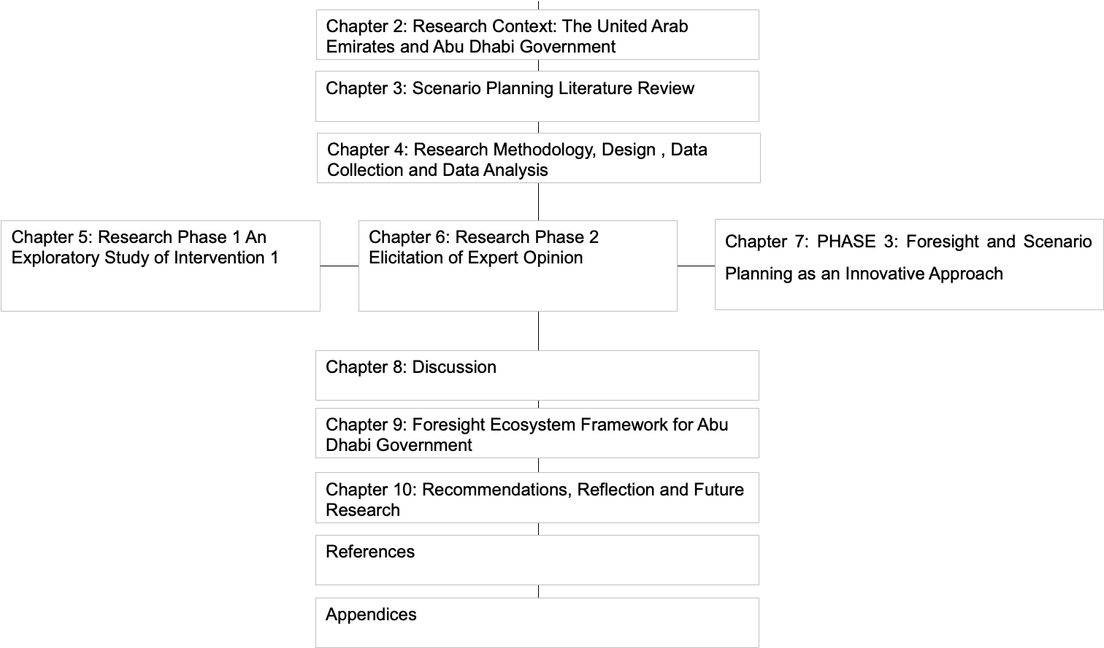
Figure 1: Structure of thesis
Chapters 2 and 3 establish the theoretical context of the research and provide background for the following chapters that address the research issues. Chapter 2 provides general background on the UAE, and on Abu Dhabi in particular. This chapter aims to give the reader an overview of how strategic planning is formatted in the Abu Dhabi government and the challenges faced, in understanding the rationale behind the introduction of scenario planning in the Abu Dhabi government.
Chapter 3 provides a review of the scenario planning literature and includes a brief background and history of scenario planning as a concept, goals, benefits, process, stages, and applications, with some examples of well-known organisations that implemented scenario planning, such as Royal Dutch Shell (RDS) and British Airways. This is followed by scenario planning in the public sector, benefits, challenges, and success factors. The last parts of those two chapters inform the proposition for scenario planning as a tool to enhance strategic planning in public organisations in the Emirate of Abu Dhabi.
Chapter 4 describes the research methodology applied in this study, the methods for data collection and analysis, and the research rigour.
Chapters 5, 6, and 7 are the core of this study, and they describe the three phases of the research. Each chapter presents a phase of the study, describing the participants, data collection methods, data analysis, and findings. The aim of presenting the research this way is to allow the reader to understand the process of introducing scenario planning, and to see how each phase built on the findings of the previous phase.
Chapter 8 pulls together the findings from all three phases, establishing how the findings from each phase of the study meet each research objective, and drawing conclusions.
Chapter 9 presents recommendations for developing a scenario planning framework for the Abu Dhabi government, based on the findings of this research, as well as the limitations of this research and proposed future research.
The last chapter, Chapter 10, explains the practical and theoretical contributions of and managerial implications drawn from the research findings. The limitations of this thesis are explained. Finally, avenues for further research are suggested.

RESEARCH CONTEXT: THE UNITED ARAB EMIRATES AND THE ABU DHABI GOVERNMENT

Introduction
This chapter expands on the previous chapter by providing context for how strategic planning and policy formulation were performed in the Abu Dhabi public sector and what triggered the need to introduce scenario planning in Abu Dhabi public institutions.
This chapter explores the public sector in the United Arab Emirates (UAE) and Abu Dhabi regarding strategic and performance management planning and the impact of policymaking and leadership styles within the government. This chapter also touches on the socioeconomic organisation of the UAE, summarising its natural resource localisation, population dynamics, geographic distribution, and governance mechanisms. The other key area underpinning the review is the strategic planning and performance management systems in Abu Dhabi and their applicability in pursuing the country’s long-term vision.

United Arab Emirates (UAE)

Overview
The UAE is a Middle Eastern country founded in 1971 that borders the Persian Gulf and the Gulf of Oman. It was formed as a federation after the consolidation of seven countries (sheikhdoms): (i) Abu Dhabi, (ii) Ajman, (iii) Dubai, (iv) Fujairah, (v) Ras al-Khaymah, (vi) Sharjah, and (vii) Umm Al Quwain (Shahrour, 2020). The UAE delegates specific authority and responsibilities to the UAE federal government and member emirates in its federal system. While the president is the head of state, the prime minister is the head of the government (Shahrour, 2020).
The UAE is strategically located between Saudi Arabia and Oman. Abu Dhabi is by far the largest of the Emirates, covering approximately 87 percent of the total land area, and it therefore occupies an important socioeconomic position in the UAE. Emiratis and members of several other ethnic groups make up the UAE population. Shahrour (2020) estimates the UAE population to be 9.5 million, with a 1.2% growth rate. The economy of the UAE depends primarily on the oil industry. However, after the banking and finance crisis of 2008, the country embarked on an ambitious economic and political reformation agenda, culminating in visible growth in investments, infrastructure, and education (Foley, 1999; Shahrour, 2020).
The UAE has an open market economy in which a free price system regulates product prices. According to Reuters (2021), the UAE economy is expected to grow by 2.1% in 2021 and 4.2% in 2022. As supported by the economic recovery in the second quarter of 2021, these figures and projections are indicators of expected economic recovery. For instance, the oil sector, which is indisputably the most important sector of the UAE economy, benefited from the growth and recovery of the travel and tourism sectors in the second quarter of 2021 (Reuters, 2021).
Despite a somewhat shaky political and economic outlook, a good business environment makes the UAE a potential destination for local and international investors (Foley, 1999; Shahrour, 2020). Furthermore, it is noteworthy that the UAE’s economic climate has several strengths, mainly because the country is a regional trading hub with a highly diversified economy. In addition, the UAE enjoys considerable political stability compared to its neighbours (Foley, 1999). Finally, its other strengths are vast financial assets and new or emerging investment and market opportunities.

United Arab Emirates Political System
On 2nd December 1971, the establishment of the UAE, including seven emirates with Abu Dhabi as its capital, was officially announced. The constitution is the supreme legislation from which the state derives its federal and local powers

United Arab Emirates Culture
The culture of the UAE is not only rich but also observably diverse and representative of the Arabic values, traditions, and heritage of the citizens. According to Herb (2009), a review or understanding of UAE culture must consider or capture its landscape and environment and their influences on people’s lifestyles. UAE culture is broadly categorised under Arab and Islamic heritage, food, art, social life, sports and recreation, and coexistence (Herb 2009). The other noteworthy aspects of UAE culture are language, etiquette, and business practices.
Its associated glamour and extravagance notwithstanding, the UAE has an ingrained culture that arises from its domestic settings and extends to the international arena. Although not an exhaustive report on the size and diversity of UAE culture, the present information helps to highlight and promote an understanding of critical aspects of the culture, namely language, religion, customers, etiquette, and business culture or practices. As Herb (2009) observes, the success of living, working, or conducting business in the UAE hinges mainly on the extent to which an individual or an organisation is culturally aware and tolerant.
Whereas traditional patriarchal tendencies characterise UAE culture, progressive forces have endorsed and promoted gender equality and equal rights, freedoms, and legal status for both genders. There is also equal access to resources, jobs, claims to inheritance, and education. For example, according to Bianco and Stansfield (2018), these freedoms are more prevalent in the UAE than in other Middle Eastern countries. Because of the progressive forces, UAE women are increasingly playing central and more significant roles in the workforce. For instance, more women are participating in business, the military, education, administration, and government. Concerning socialisation, UAE culture encourages interaction with and nurturing of children and calls for respect of and obedience to elders and people in positions of authority.

Leadership Style
In an experimental study on the leadership approaches and styles in the UAE's human resource practices and strategy, Sowmya et al. (2018) explored the various decision-making styles used by leaders in UAE organisations. The authors examined the correlation between variables, such as organisational levels and types, positions, age, experience, educational background, and leadership styles. The authors reported that leaders' characteristics influenced and distinguished their leadership styles and approaches (Sowmya et al., 2018).
Sowmya et al. (2018) also reported the role and influence of the constitution- and policy-based leadership in the UAE's public sector. The easily discernible characteristics were age, commitment levels, educational levels, communication abilities, and effectiveness. Furthermore, Smith (2021) argued that leadership styles in the public sector are quite different from those in the private sector. The author stated that this might be due to the impact of the UAE constitution and government policies. Unlike some current literature, Smith (2021) also highlighted that the UAE's public sector is more efficient than the private sector, mainly because of the leadership styles and standards used in the public sector.
In line with the country’s culture, leadership in the UAE is primarily paternalistic and directive, with people in leadership and decision-making positions making and giving clear directives to their juniors. In an organisational setting, the absence of clear instructions, guidelines, policies, or vision from leaders often creates confusion, culminating in operational and management challenges (Shahrour, 2020). Moreover, the culture and leadership styles dictate that subordinates follow their leaders’ instructions without questioning their merit or appropriateness.
As Sowmya et al. (2018) highlight, the main weakness of the leadership style in the UAE is that it discourages initiative, creativity, and innovation by subordinates. That is, subordinates must wait and follow instructions from their leaders because being innovative may be mistaken for disobedience or disrespect. Cognisant of this weakness, leaders in the UAE ensure that they give their subordinates clear, precise, and comprehensive directives. This practice helps reduce or eliminate chances and cases of misunderstanding.
In a study on leadership in the maintenance sector of the UAE, Naeem and Azam (2017) established that executive leadership in the UAE is somewhat autocratic. As with domineering styles elsewhere, this approach has failed to achieve organisational goals in the UAE maintenance sector. In particular, staff motivation levels are relatively low, and many employees are dissatisfied with their work and workplace. In some cases, organisations achieve targets but lack the all-important corporate citizen’s feeling required for motivation, productivity, and job satisfaction. In addition, Naeem and Azam (2017) reported that different leadership styles permeate mid-level management in the UAE. For instance, the team leadership style evident among mid-level managers has translated into feelings of happiness and satisfaction among employees of the UAE maintenance industry.

Impact of UAE culture and leadership style on organisations’ success
In a study of leadership style in the UAE’s maintenance industry, Naeem and Azam (2017) opine that the impact of culture and leadership on organisational success manifests through the reaction of subordinates to culture and leadership styles. In the UAE, for instance, top-level managers' autocratic tendencies discourage employees because employees lack the authority or opportunity to participate in decision-making. When an organisation prevents expression of divergent opinions and strategies such as brainstorming, it is likely to be restricted in its solutions to problems or challenges. Thus, their operations or projects are more likely to fail than those of organisations or cultures that promote sharing ideas. Likewise, Sowmya et al. (2018) reported that promoting stakeholder participation and integrating divergent views positively correlate with shared responsibilities for tasks and projects and their outcomes.
Overall, the autocratic approach taken by the UAE’s top and low-level leaders hinders growth by increasing work backlog, giving organisations or agencies a poor reputation, and causing loss of business. In addition, employees become unhappy and spread negative word-of-mouth messages about their employers. Consequently, the outcomes of these practices or trends can induce loss of sales and revenue and create disgruntled customers.
According to Sowmya et al. (2018), the practice of secluding subordinates from decision-making creates disconnections across the organisational structure, especially regarding implementation of change and development of vision and goals. The autocratic approach taken by the top and low-level leaders in the UAE further affects success by preventing leaders from understanding or recognising on-the-ground realities as experienced by subordinates. Subsequently, leaders fail to plan for, support and allocate resources to achieving organisational goals. According to Naeem and Azam (2017), the remedy is transformational leadership, which will likely result in empowered, satisfied, and happy employees, a good organisational reputation, and secured business. Finally, an organisation will most likely obtain good financial results, keep customers happy, and attract new customers.

The Abu Dhabi Government

Overview
As in the UAE, Abu Dhabi’s government is absolutist with operations and laws founded mainly on Islamic law. While a sheikh heads the state, a crown prince wields equally immense power and influence in the emirate and serves as the head of the executive council. The executive, which governs the Abu Dhabi emirate, functions through departments or ministries (Al-Muhairi, 1996, Morton, 2016). These departments deal with specific issues such as education, urban planning, supervision, and regulation. In addition, the departments, government agencies offer vital services to the public.
Abu Dhabi is the capital of the UAE and the largest of the seven emirates. Abu Dhabi occupies 67,240 km², approximately 86% of the country’s landmass (AbuDhabi.ae, 2021). Abu Dhabi is divided into three central regions:
- City of Abu Dhabi
- Eastern Region, which lies around the oasis of Al Ain
- Western Region (Al Gharbia), which includes Liwa, Dalma, Sir Bani Yas, and Das Island
It is worth noting that prominent businesspersons, politicians, and individuals from ruling families and elite groups govern most departments, ministries, and agencies (Al-Muhairi, 1996). The Abu Dhabi government also employs the services of autonomous agencies, such as the Abu Dhabi Police, the Abu Dhabi Tourism Authority, and the Abu Dhabi Environmental Agency. Moreover, the Abu Dhabi government has municipalities, such as the Abu Dhabi capital district, western region, and eastern region, which operate under the ministry of municipal affairs. Through these agencies, Abu Dhabi has developed a unified approach to delivery of services such as defined healthcare, education, employment, financing, social welfare, and retirement benefits to citizens and visitors (Morton, 2016).

Abu Dhabi Executive Council
The Abu Dhabi Executive Council is the local executive authority of the Emirate of Abu Dhabi (council. Ae, 2021). The Executive Council assists the Ruler in fulfilling his duties and exercising his powers through regular meetings to determine the general policies of the Emirate, establishes development plans and oversees their implementation, approves draft laws and decisions before submitting them to the Ruler, oversees workflow in departments and local authorities, and ensures coordination among entities for the general welfare of the country (Appendix 1: History of the General Secretariat of the Executive Council).

General Secretariat of the Executive Council (GSEC)
The GSEC is an administrative body entrusted to propose public policies and strategies to be decided by the Emirate of Abu Dhabi Executive Council. It provides a multitude of support services to the Council, from drafting and scheduling resolutions to preparing minutes and issuing and following up on the execution of solutions. The General Secretariat studies topics on the orders of the Executive Council and follows up on the implementation of directives.

Overview of Strategic Planning in the Abu Dhabi Government
The roots of management-based strategy planning in Abu Dhabi’s public sector lie in a 2006 request from the Executive Council General Secretariat to develop an agenda to promote sustainable growth and development and to modernise the public sector. GSEC (now ADEO), the administrative body that proposes Abu Dhabi’s public policies and strategies for cabinet discussion and decision, commissioned twelve experts from different sectors to formulate the policy proposal. This panel interviewed the leadership and solicited their suggestions to document the UAE’s aspirations and identify the best way forward. Figure 2 shows the journey of public policy planning and management over the last 12 years.
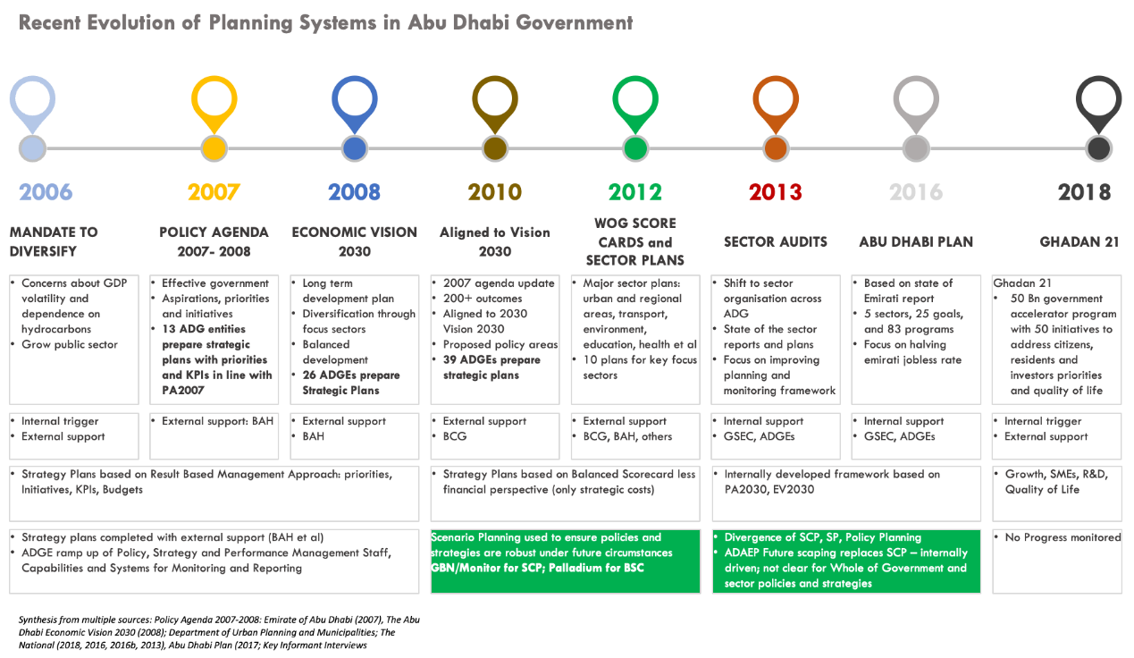
Within this process, several innovations and adaptations took place, which led to different iterations for planning, monitoring, and evaluating public policies and strategies in Abu Dhabi. The stages outlined in Figure 2 formed the blueprint for how the government sought to conduct its work and deliver various services.

Figure 2: Evolution of the planning system in the Abu Dhabi government.

Mandate to Diversify (2006)
The journey to diversify Abu Dhabi started in 2006 because the leadership was concerned about GDP volatility and dependence on hydrocarbons. Therefore, the leadership aimed to grow the public sector. The GSEC initiated a new way of formulating the strategic plans of the Abu Dhabi government, using a results-based management approach. Due to the lack of capacity within public sector entities at that time, the leadership allowed entities to use external support (consultancy or expert house). GSEC hired one consultancy company that helped develop policy, strategy, and performance management staff, capabilities, and systems for monitoring and reporting. The Abu Dhabi government transformation started in 2005 and had three main pillars, as shown in Table 2.
Government Restructuring | Focused Strategic Planning | Capability
Minimised duplication of services  Outsourced non-core services  Focused on increasing  efficiency and reducing the cost of service  Increased use of technology  Increased Emiratisation | Published first ever Abu Dhabi Government Policy Agenda 2007–2008 in addition to several important sector development plans such as the Economic Vision 2030 and Plan Abu Dhabi 2030, an urban structure framework plan, amongst others  Created strategic planning, performance management, and internal audit functions in Abu Dhabi government entities  Launched first ever cross-government strategic planning and performance management  Alignment to a sector management approach to policy development and coordination | Established Centre of Excellence to develop Abu Dhabi Government leaders  Launched Abu Dhabi Excellence Awards to cultivate performance excellence
Table 2: The three main pillars of the Abu Dhabi government transformation.

Policy Agenda 2007–2008 (2007)
The Policy Agenda serves as the primary source of information for the government’s aspirations, programmes, and policy directions. It articulates the vision of Abu Dhabi's government at a given time. Moreover, the Policy Agenda describes the key policy areas that government entities will be working on or are currently implementing to achieve this vision. As shown in Figure 2, Abu Dhabi government priorities and circumstances change over time. Thus, the policy will take advantage of significant developments and proactively pursue them, positively influencing them in the long term.

Economic Vision 2030 (2008)
The Abu Dhabi Economic Vision 2030 is led by GSEC, the Abu Dhabi Council for Economic Development (ADCED), Department of Planning and Economy. In 2006, His Highness Sheikh Mohamed bin Zayed Al Nahyan, Crown Prince of Abu Dhabi and Chairman of the Executive Council, mandated the General Secretariat of the Executive Council, the Abu Dhabi Council for Economic Development, and the Department of Planning and Economy to develop a long-term economic vision for the Emirate (see Figure 3). This mandate was given to manifest the vision of Sheikh Khalifa bin Zayed Al Nahyan, President of the UAE, Ruler of Abu Dhabi, for the ongoing economic success of Abu Dhabi. The expectation involved the creation of a long-term roadmap for economic progress for the Emirate through establishing a common framework aligning all policies and plans and fully engaging the private sector in their implementation. The initiative builds upon the foundations set by the Abu Dhabi Policy Agenda 2007/2008 and was produced by a task force comprising stakeholders from both the public and private sectors.
The task force received extensive expert support from internationally renowned institutions and was mandated with two essential tasks:
- To conduct an exhaustive assessment of the critical enablers for economic growth.
- To create a comprehensive long-term economic vision with explicit targets to guide the evolution of the Abu Dhabi economy by 2030.
The year 2030 represents a significant milestone for the Emirate of Abu Dhabi. Based on the principles laid out in the government’s Policy Agenda published in August 2007, the Abu Dhabi Economic Vision 2030 is a roadmap for the Emirate’s economic progress. Baseline growth assumptions indicate that Abu Dhabi could achieve tangible levels of economic diversification by that time.
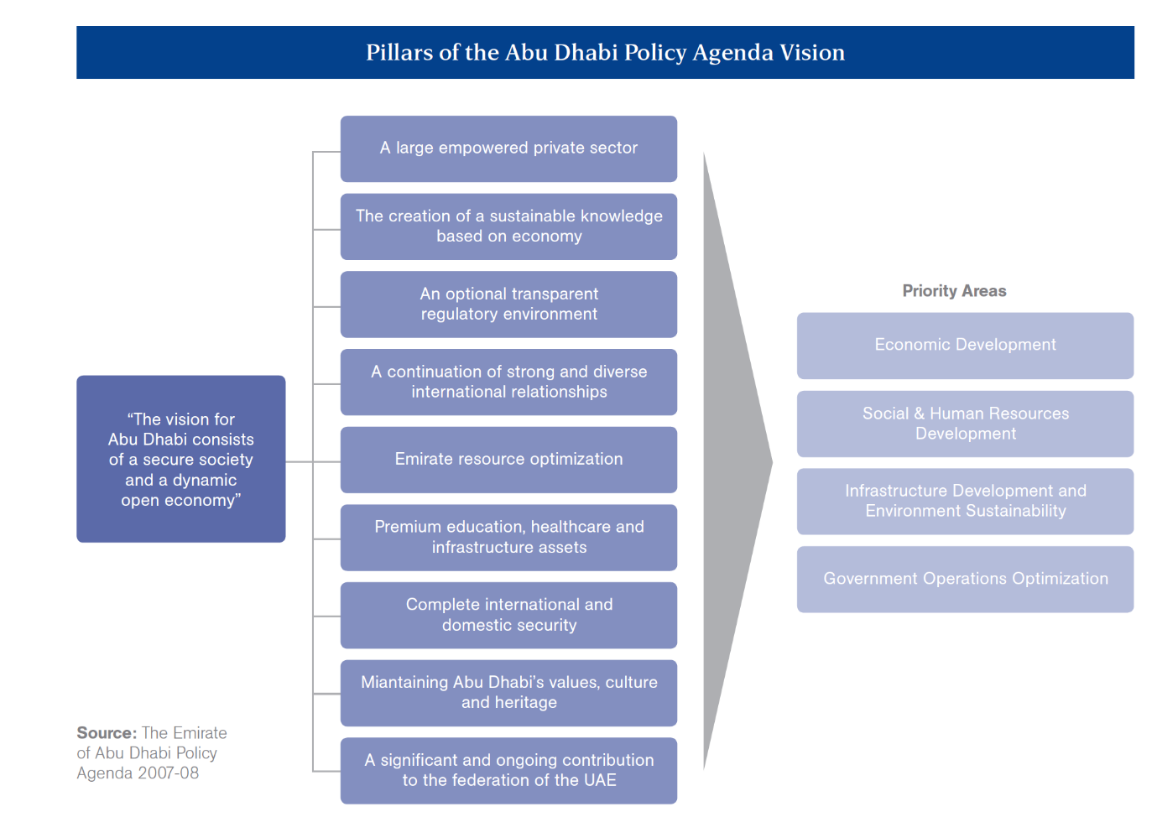
Figure 3: The Abu Dhabi Vision. Source: The Emirate of Abu Dhabi Policy Agenda 2007–2008.
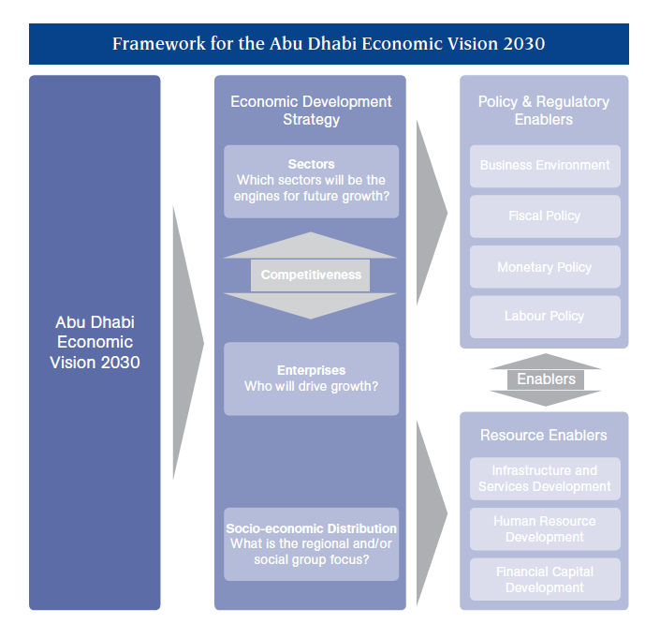
Figure 4: The Framework of the Economic Vision 2030 for Abu Dhabi. Source: Abu Dhabi Economic Vision 2030 Team Analysis.

Policy Agenda 2030
The Abu Dhabi Policy Agenda 2030, “Mapping the Road Ahead,” details the future strategic aspirations and plans of the Emirate in all significant sectors of life. It presents the long-term unified view of the Abu Dhabi Strategy. Moreover, it is a significant update of the previous version, 2007–2008, adding clarity to the priorities of Abu Dhabi and defining a long-term vision, as shown in Figure 5.
Figure 5: The Update on Policy Agenda. Source: ADGSEC PDP Presentation to EC. V15.17Oct.
To achieve its mission, the Executive Council coordinates the design and implementation of policy across all portfolios and evaluates proposals against the government’s vision for Abu Dhabi. The Policy Agenda represents the primary source of information regarding the government’s aspirations and programmes, cutting across all areas of government activity, including economic development, social development, environmental sustainability, infrastructure, and government excellence. The directions set in the agenda are then variously turned into policies and actions through sector plans, entity strategic plans, and the standard policy and operational decisions of the entities, as shown in Figure 6.
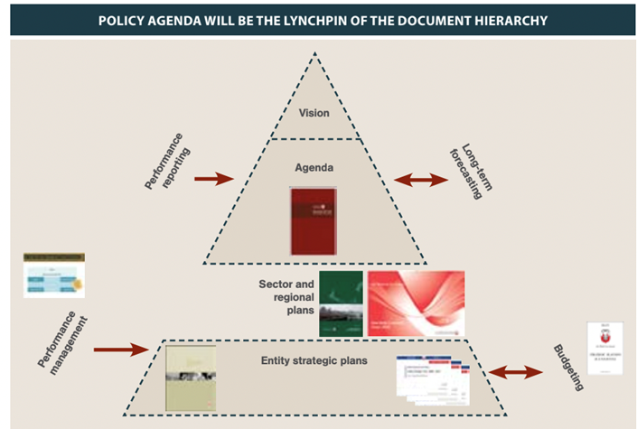
Figure 6: The policy agenda framework. Source: Mapping the Road Ahead.

Scenario Planning: Test Policy Robustness
In 2008, GSEC observed some gaps in the performance of Abu Dhabi public entities. As a corrective action, the Strategy and Performance Management division/GSEC tested and implemented various tools, including scenario planning developed by Global Business Network (GBN) and the Balanced Scorecard approach developed by Palladium, to ensure that policies and strategies are robust under future circumstances.

Figure 7: Illustration of the gap. Source: Abu Dhabi Performance Delivery Plan - June 2010.
In 2008/2009, the GSEC team developed The Policy Agenda 2008, which was built under a long-term scope. The policy agenda contained actions and policies grouped under dimensions, reflecting different focus areas, as well as several goals and outcomes.
By January 2009, the policy was due for updating, and the policy team at GSEC started thinking about updating the long-term policy agenda. After introductions and running a couple of performance management cycles, it was time to look for a tool to assist in policy and strategy formulation. This was aimed to improve performance, as the GSEC SPPM team was working on the performance management framework, in terms of reporting, contracting, and tools. The team realised that they needed more insights for the coming period. The GSEC commission and sector leaders in certain areas launched various activities such as running data simulations systems. However, they realised it lacked the maturity required to hand it over to the sector leaders. They realised it needed to be updated on a centralised basis, specifically by using scenario planning (Figure 7).

Whole of Government (WOG) Scorecard and Sector Plans (2012)
When Abu Dhabi’s policy planning team started to evaluate the first five years of implementation of Vision 2030, which was launched in 2007, they faced a massive task. The overall policy objectives were still relevant, and it was clear that progress had been made in achieving them in some areas, despite the upheavals of the global financial crisis. Moreover, implementing this vision was the responsibility of more than 70 government entities. However, each entity had its own strategic plan to translate the Vision into actionable projects.
To enhance strategic planning, the government aimed to design a more straightforward yet comprehensive and collaborative approach to achieve the 2030 vision. The GSEC produced its baseline report in March 2013, summarising progress and defining the gaps in each of the main areas of government activity (GSEC, 2012). That insight provided the impetus for development of the Abu Dhabi Plan, due to be launched in 2016.

Status of the Emirates (2012)
The Abu Dhabi government planning and performance management framework supports the Executive Council’s policy and decision-making capacity. It does so via development and/or analysis of government plans and performance data in support of informed decision-making and accountability.
The planning and performance management framework comprises four main elements, as shown in Figure 8. This framework ensures that government planning is premised on a thorough understanding of the current situation in all its functions across the entire Emirate (State of the Emirate) so that it can make informed decisions about its five-year priorities (Government Priorities). Moreover, it also ensures that these national priorities are developed in conjunction with and communicated to all entities, so they can align their budgets/plans (Entity Budgets/Plans). Finally, the framework includes performance reporting as a tool for monitoring the progress of entity projects/programs and services against the selected national priorities.
This integration of planning and performance management not only enables all government stakeholders to move forward in one clear direction but also enables them to do so more efficiently through the optimisation of government spending and coordination of policy.

Sector Focus (2013)
The government priorities report describes the top national priorities for the next five years. The Executive Council develops it through a consultative process between GSEC and the Abu Dhabi government entities, and it is meant to be updated every five years.
The priorities stem from long-term government ambitions previously identified in the Policy Agenda 2030 and Economic Vision 2030. They are intended to provide a roadmap that will guide entity plans/budgets to ensure that all government stakeholders are aligned with the overall government direction.
The government priorities are structured around the nine themes identified in the State of the Emirate report. The priorities are also selected from the improvement areas identified in the State of the Emirate report based on the impact of these improvement areas on the development of the Emirate and the quality of life of its citizens. Furthermore, each priority is linked to an indicator with set base and target values as well as a project and/or service that will enable achievement of the priority. Finally, an indicator is allocated to each project and/or service.

Abu Dhabi Plan (2016)
Insights gathered from performance results and observations of government operations drove development of the Abu Dhabi Plan, due to be launched in 2016. It took almost three years, over 200 workshops and meetings with government entities, and several rounds of substantial feedback from the leadership of the Executive Council and the government entities to produce the new plan. However, that effort resulted in a framework for implementation that embodies three principles: (i) Alignment, (ii) Collaboration, and (iii) Responsibility. These three principles enable the government of Abu Dhabi to reach a new level of government effectiveness whilst maintaining its continuous progress towards an established and clarified vision.
The Abu Dhabi Plan has not fundamentally changed the direction of planning and development in Abu Dhabi, but it has transformed the approach to execution. For every objective and policy, the planners have thought through how best to implement, measure, and report on it, and clarified who is responsible for achieving what by a certain time and who will monitor progress and ensure completion. Furthermore, the coordinating entities played a crucial role in the process, maintaining momentum through the five years with detailed monitoring and reporting. The coordinators hold quarterly meetings with all the participating entities involved in its program to discuss progress in specific projects and handle problems encountered. The primary goal was to solve most issues in this forum and ensure that accountability is exercised at the entity level.
Having agreed on a shortlist, GSEC set ambitious and communicated targets for 2020, broken down into annual instalments to track whether progress is being made. As part of this plan, once a year, GSEC planned to check and report on a set of key performance indicators (KPIs) designed to measure progress in achieving the broader objectives. These outcome oriented KPIs (around 200) have been developed in cooperation with the entities. Figure 8 illustrates the Abu Dhabi government planning and performance management framework.
Figure 8: Abu Dhabi Government Planning and Performance Management Framework. Source: Abu Dhabi Performance Delivery Plan - June 2010- Source: Mapping the Road Ahead.

Government Excellence
Over the last two decades, excellence models have increasingly been adopted to increase competitiveness and reduce costs by helping to incorporate and assess total quality management (TQM) principles and practices within organisations (Kim et al., 2010, Al‐Marri et al., 2007). The European Quality Award of the European Foundation for Quality Management (EFQM) and the Malcolm Baldrige National Quality Award are proven excellence models for quality awards and self-assessment, and are used around the globe (Samuelsson and Nilsson, 2002). Moreover, these models use the process of self-assessment at different organisational levels to evaluate organisations against the TQM-based model criteria (Samuelsson and Nilsson, 2002).
There has been significant research and application of business excellence models and the associated use of self-assessment in Western countries, as detailed in the literature review by Kim et al. (2010). However, in-depth implementation of business excellence in Middle Eastern countries has not yet been studied adequately, as indicated by the comparative study of quality implementation in Middle Eastern countries by Najeh and Kara-Zaitri (2007). In the Middle East, application of business excellence and self-assessment is not well developed and has not been implemented beyond corporate-level applications (Al‐Marri et al., 2007; Najeh and Kara-Zaitri, 2007; Jones and Seraphim, 2008).
A key theme in research relating to the effectiveness of business excellence and self-assessment is the rigor of the implementation process at all organisational levels. Ideally, employees from all groups and levels should be involved. The effectiveness of this implementation is often expressed in terms of key success factors that are determined by cultural and contextual settings within a country or an organisation (Salaheldin, 2009; Najeh and Kara-Zaitri, 2007). The present study is based on the Middle Eastern public sector organisations dealing with implementing the Dubai Government Excellence Programme (DGEP). Furthermore, the DGEP is the Dubai version of the European excellence model and is based on the same nine primary criteria with minor differences in sub-categories.
The Abu Dhabi government aspires to achieve the highest standards of excellence, including the highest quality and efficiency of government services and human capital (government employees), while maximising use of technology in the public sector, maintaining optimal government transparency, and providing access to information about the financial management strategies adopted.
The government has recently instituted the Abu Dhabi Award for Excellence in Government Performance, in which all government entities are entitled to participate. The award is based on entity submissions detailing all key enablers and entity-based results and requires proof that the entity promotes innovation and learning.
- The Abu Dhabi Award for Excellence in Government Performance
The Abu Dhabi Office of Excellence Program (ADEP) coordinated the efforts of two departments that support excellence in government and government services. The award was launched in 2006 to recognise and promote excellent performance and positive competition in the country. It was intended to contribute to the active sustainability of the government's management system and cement the vision of the Abu Dhabi government.
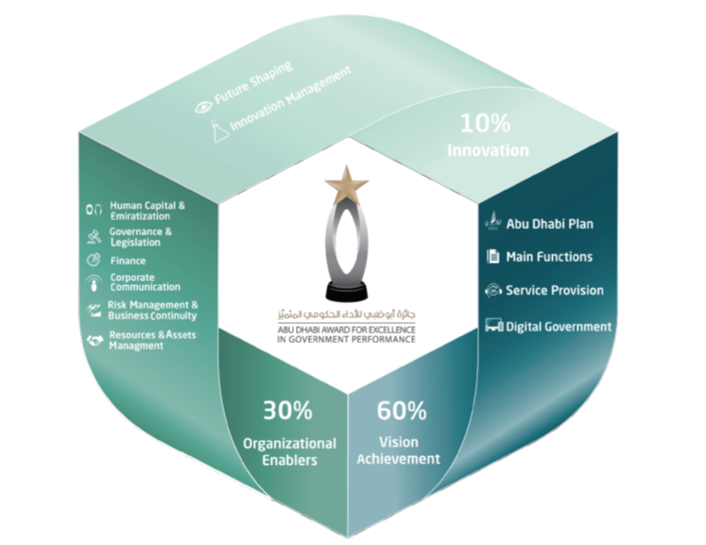
Figure 9: Abu Dhabi Government Excellence System and Its Foundations. Source: Abu Dhabi Excellence Award in Government Performance Guideline, 2016, Fifth Cycle
The Abu Dhabi government's system of excellence is based on a successful experiment that the UAE government previously implemented. The design is based on assisting government agencies in achieving leadership positions through knowledge of programs, initiatives, and strategies to be adopted and implemented. Moreover, the design has been sub-categorised into three main categories: (i) Vision Achievement, (ii) Innovation, and (iii) Organisational Enablers, as shown in Figure 9.
- The objective of launching the Abu Dhabi Government Excellence System
The main objective of implementing the Abu Dhabi Government System of Excellence is to meet the government's prerequisites for implementing the results-focused Abu Dhabi Plan. Another aim is to link it to performance indicators of government bodies to achieve the highest level of leadership and transform it into a digital, pioneering, and innovative government. The results will serve as models for implementing government best practices through the following performance evaluation tools: efficiency, effectiveness, and learning and development using modern concepts, such as innovation, future education, and integration into government work.
- Pillars of the Abu Dhabi Government Excellence System
Figure 9 illustrates the pillars of the Abu Dhabi Government System of Excellence, divided into three main pillars representing the foundation. Building on this foundation, government agencies provide leadership by effectively carrying out their core functions, striving to achieve government goals holistically through optimal use of resources and continuous learning and development. The present study will emphasise only the innovation pillar.
- Innovation criteria
The innovation pillar consists of two main criteria: (i) future modelling, and (ii) innovation management. These criteria also focus on how innovative solutions and leading-edge initiatives are managed in the services provided and programs implemented, ultimately ensuring the achievement of strategic objectives and overall customer satisfaction. Moreover, future shaping focuses on how the entity has developed future thinking skills through increased intellectual capital and continuous modernisation efforts toward global leadership. In addition, entities must address global and future changes with agility, responsiveness, and preparedness by using various tools that help shape the future, analysing expected and unanticipated future trends, possibilities, and outcomes through creative working methods to advance the entity's results beyond its current abilities. Additionally, the criteria emphasise an entity's efforts to understand future changes and seize opportunities while maintaining strategic and field flexibility that will impact its operations, services, and policies. One of the tools is the scenario planning process, as shown in Figure 10.

Figure 10: Main Process Steps (translated from Arabic to English). Source: Scenario Planning Toolkit 2016, Ministry of Cabinet Affairs and Future.
Ghadan 21 (2018)
The AED 50 billion three-year programme envisioned and launched by HH Sheikh Mohamed bin Zayed Al Nahyan, Crown Prince of Abu Dhabi, Deputy Supreme Commander of the UAE Armed Forces and Chairman of the Abu Dhabi Executive Council, in 2019 focuses on developing the economy, knowledge base, and community. The Ghadan 21 is delivered by the Executive Committee, led by its Chairman, HH Sheikh Khalid bin Mohamed bin Zayed Al Nahyan and has launched more than 50 initiatives in its first year (see Figure 11), with an array of new plans anticipated to be rolled out in 2020 and 2021. In response to global economic challenges in 2020, the Abu Dhabi Executive Council launched an economic stimulus package, fast-tracking the implementation of key Ghadan 21 initiatives. Under the package, 16 initiatives have been announced to improve the ease of doing business and reduce the cost of living in the Emirate.

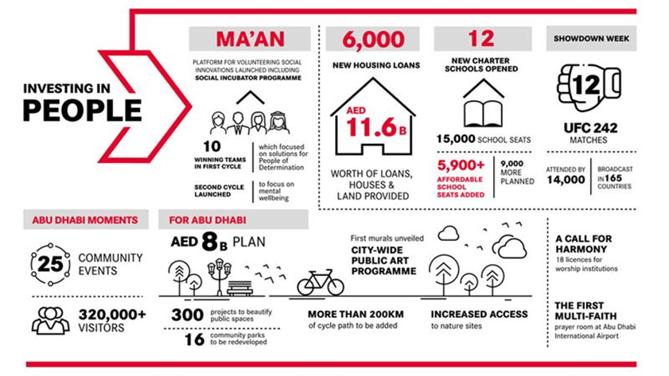
Figure 11: Ghadan 21 One Year On. Source: Ghadan, 2021.
This stimulus package contains 16 wide-ranging initiatives for businesses and individuals across Abu Dhabi. The Stimulus Package falls under Ghadan 21, Abu Dhabi’s three-year government accelerator program launched in 2019, which aims to drive the Emirate’s development through investments in business, innovation, and people.

Summary
The analysis of the basic socioeconomic organisation, population dynamics, cultural aspects, and governance of the UAE and Abu Dhabi presented in this chapter shows how several innovations and adaptations took place, which led to different iterations for planning, monitoring, and evaluating public policies and strategies in Abu Dhabi. Later chapters will show the impacts of these innovations on implementation of scenario planning. This chapter also covers planning models; characteristics of public sector organisations; problems encountered with planning in the public sector; SP in the Middle Eastern context; SP and organisational elements; as well as planning formality. Finally, this chapter concludes by highlighting the recent initiatives for fostering the socioeconomic development of the UAE by 2030.

SCENARIO PLANNING LITERATURE REVIEW

Introduction
Scenario planning is designed to help organisations to anticipate likely trends or external forces in their sphere of operation and then develop a range of strategies that will enable them to respond flexibly and effectively to the various ways in which the identified trends and forces may impact upon their ‘industry’ (Ringland, 1998). Unlike many of the traditional approaches to strategic planning, scenario planning takes a straightforward approach to managing ambiguity and uncertainty (Van der Heijden, 1996).

The Concept of Scenario Planning
The word “scenario” has been used in various fields, especially in the theatre, where it was used to describe the outline of a play or a movie. The Oxford Advanced Learner’s Dictionary states that the term “scenario” can indicate a) a written outline of a film or play, etc., with details of different acts and plots; and b) an imagined order of future events.
Schoemaker (1991, p. 549) defines a scenario as “a script-like characterization of a possible future presented in considerable detail, with special emphasis on causal connections, internal consistency, and concreteness.” A good scenario will include dynamics and a path from a current state to a future state. Scenarios have been defined by Schwartz (1996) in “The Art of the Long View” as “tools for ordering one’s perceptions about the alternative future environment in which one’s decisions might be played out” (Chermack et al., 2007, p. 380). In short, scenarios are internally coherent pictures of possible futures, and their use includes exploring trends, alternatives, and implications of choices, as well as evaluation of cause-and-effect sequences.

Brief History of Scenario Planning
Scenario techniques are firmly rooted in the military, with the first documented use in the 19th century as written by von Clausewitz and von Moltke, two Prussian military strategists who have been credited with being the first to develop the principles of strategic planning (von Reibnitz, 1988). Following the World War, in 1946, the RAND Corporation (an acronym for Research and Development) evolved out of a joint project between the US Airforce and the Douglas Aircraft Company that explored developing prediction and forecasting systems for military and industrial goals to predict the enemy’s strategy and to prepare alternative combat strategies (Gidley, 2017). Modern-day scenario planning arose from this in the 1960s, led by Kahn’s escalation ladder that describes stages of possibilities in war and peacetime circumstances. Kahn, the authority on Civil Defence and strategic planning at the RAND Corporation, then began developing scenarios for the Air Defence System Missile Command, a large-scale early warning system known as the “father” of modern-day scenario planning (Bradfield et al., 2005).
Meanwhile, the U.S. Department of Defence (DoD) used scenario planning to develop war games to understand conflicts better. They also used scenario planning in decisions for developing new weapons systems after World War II. The DoD needed a way to obtain consensus from experts and build simulation models to evaluate the future using different alternatives (Bradfield et al., 2005). The process developed at the DoD later became known as the Delphi technique and led to approaches in systems analysis that were developed at the RAND Corporation.
Much of the work Khan performed while at the RAND Corporation was never made public because of national security concerns. He eventually left RAND to form the Hudson Institute, where he “transposed scenarios from the theatre to government and corporate planning” (Millett, 2003). With Anthony Wiener, Kahn wrote the book, “The Year 2000: A Framework for Speculation on the Next Thirty-Three Years,” Kahn et al., 1967)
which introduced the definition of scenarios and how they could be used (Bradfield et al., 2005). Scenario planning emerged as an effort to structure the inquiry into the future, to help researchers stay in the future longer, to structure future exploration, and to improve planning (Spaniol, 2017).
Royal Dutch Shell (RDS) and General Electric (GE) were early pioneers of scenario planning in the United States and Europe. In 1965, Royal Dutch Shell introduced a complicated computerised financial forecasting system called the Unified Planning Machinery (UPM). However, they soon realised that UPM lacked accuracy and shut it down. Newland and a colleague, Henk Alkema, began to develop scenarios around the long-term outlook for oil which they presented to the senior management with limited success. Davidson then brought in Pierre Wack, the Head of Planning for Shell Française, to make a second attempt at scenarios. In 1973, a year after Wack’s team had presented their scenarios, an ‘energy crisis’ arose as OPEC countries placed an embargo on their oil exports, resulting in an increase of around 400% in the global price of a barrel of crude oil, and causing turmoil in the oil industry (Millett, 2003). One of the scenarios developed by Wack had foreseen this event, and shortly after that, scenario planning was extended throughout the company replacing UPM. Shell has been using scenario development for over 50 years; its approach has evolved over the years and has spread to other corporations globally (Wilkinson and Kupers, 2013).
Other early adopters of the scenario concept were the Stanford Research Institute (SRI) and SEMA Metra Consulting Group (Mietzner and Reger, 2005, Chermack et al., 2001). Both began promoting long-term future planning concepts in the mid-1960s (Chermack et al., 2001). Many variations of what is known as the ‘Intuitive Logics’ (or the ‘Shell model’ of scenario planning) have been published, each with several steps, varying from four (Slaughter, 2000) to twelve or more (Vanston et all, 1977). There have also been efforts to develop more straightforward and less resource-intensive models focusing on scenario planning as a learning process, as demonstrated in the work of Van der Heijden et al. (2002).
In 1957, Gaston Berger, a French philosopher, established the Centre International de Prospective (International Centre for Foresight) in Paris. He developed a scenario approach to long-term planning, which he named prospective thinking or La Prospective. In La Prospective were Pierre Masse, the Commissaire General au Plan (High Commissioner for the Plan), and Bertrand de Jouvenel, a well-known French journalist and economist who joined the Prospective centre in 1966. The objective of the Prospective centre was to develop a scenario methodology for creating positive images of the future, which could serve as a guiding vision and basis for action for policy makers and the nation (Huber, 1978).

The Growth of Scenario Planning
Although scenario development has mostly been employed in the private sector and the military (Wilkinson and Ramírez 2010; Wilkinson and Kupers 2013), a wide range of organisations are using scenarios, including civil defence management (for crisis simulation); scientific communities and policymakers (to understand the playout of drivers such as climate change, demographics, food security, fuel and energy demands, etc.); public policy makers (to involve multiple agencies and stakeholders in policy decisions); professional futurist institutes (to spread ideas and promote futures research methodologies); and educational institutes (to enable the research and development of future studies theories and methods).
Studies of European companies by Malaska et al. (1984), Malaska (1985), and Meristö (1989) indicate that scenario planning was not widely used in Europe until after the first oil crisis in 1973, following which the number of SP adopters almost doubled. There was a further surge in adoption between 1976 and 1978. This led Malaska et al. (1984) to conclude that adopting scenario planning was closely linked to the high unpredictability surrounding the 1970s corporate environment.
It is estimated that in the early 1980s, half of US Fortune 1000 industrial firms, US Fortune 300 non-industrial firms, and Fortune Foreign 500 industrial firms were using scenarios in their planning process. Both Malaska et al. (1984) and Klein and Linneman (1981) suggest that there is a correlation between the adoption of scenario planning and "environmental discontinuities and instability."
The growth in popularity of scenario techniques between the early 1980s and today has not been documented in the literature. However, Martelli et al., (2001) has suggested that use of scenarios fluctuates. Although it has increased in the past 30 years, this increase is less than predicted. Several underlying reasons have been suggested, including that scenario practitioners have only partially succeeded in finding the right balance between over-use of technology on the one hand and recurrence on the surface on the other (Bradfield et al., 2005). However, Varum and Melo (2010, p. 3) state that based on their bibliometric analysis, scenario planning has gradually gained ground in international academic publications, and “in more recent years, scenario planning has enjoyed a clear revival, apparent in the boom in published research on the matter.” This literature review has indicated an explosion of scenario publications regarding the COVID-19 pandemic from a wide range of institutions, including the CDC (Centers for Disease Control and Prevention), United Nations, World Energy Council, and the Scientific Pandemic Influenza Group on Modelling, along with consultancies such as McKinsey and Deloitte, and even academic institutions, such as the Institute for Management Development (IMD).

The Goals of Scenario Planning
Scenario planning aims to make sense of a confusing circumstance, develop a strategy in anticipation of a situation, or build organisational learning (Bradfield et al., 2005). Mietzner and Reger (2005, p. 220) argue that “scenarios should provide strategists with various possible futures and not forecast the future” and that the value of a scenario is “being able to take complex elements and weave them into a story which is coherent, systematic, comprehensive and plausible.” To this end, Wack states that the purpose of scenarios is “to gather and transform information of strategic significance into fresh perceptions” (1985a, p.140). Harries (2003) meanwhile states that scenario planning involves envisioning “alternative future realities by combining qualitative and quantitative methodologies, as well as objective and subjective methods.” The process aims to identify drivers of change and key uncertainties and to utilise this information (Schoemaker, 1991).
Volkery and Ribeiro (2009, p. 1199) noted that scenario planning aims to “identify a range of new threats and opportunities that arise across a set of plausible alternative scenarios, describe a range of possible consequences for candidate policies, help discover policy options demonstrably robust to long-term uncertainties, and surface some of the blind spots of an organisation’s policy, or strategy.” But scenarios may not be helpful when the organisation cannot absorb them, when there is no political backing, or when relevant policymaking features have not been accounted for.
According to Van der Heijden et al. (2002), the decisive factor between success and failure in scenario work is the degree to which a scenario project is ‘purposeful.’ The purpose of scenario work can be categorised along two dimensions. Along one axis, the work can serve specific one-off content needs or be an ongoing general process aimed at longer-term survival capability. Along the second axis, the work can be undertaken either to open an organisational mind for exploration or to achieve closure on specific decisions and actions. Combining these dimensions, Van der Heijden (2004) developed a two-dimensional matrix, as shown in Figure 12, that identifies four primary areas of purpose in scenario work: making sense of a puzzling situation; developing strategy; anticipation; and adaptive organisational learning.
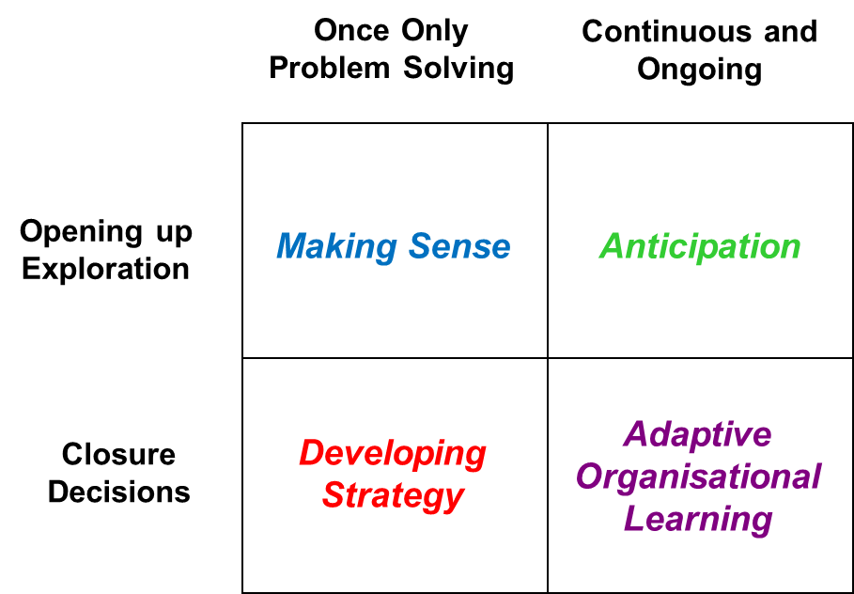
Figure 12: The Purpose of Scenario Work. Source: Van der Heijden, 2004.
Although no empirical evidence is offered to support this ‘purpose of scenario work,’ the flexibility of the intuitive logic methodology lends itself to a wide range of scenario purposes, as evidenced by the literature, which demonstrates the application of the methodology for fulfilling all four of the ‘purposes’ mentioned above.

Benefits and Weaknesses of Scenario Planning
The benefits of scenario planning include being prepared for multiple futures or outcomes, mitigating challenging beliefs, recognising environmental signals, improving communication, and improving coordination and decision-making (Mietzner and Reger, 2005). Other benefits include changed thinking, informed narratives about the future, and enhanced individual and organisational learning (Haeffner et al., 2012, p. 524). The authors note another benefit: a “strong link between the scenario planning method and stakeholder satisfaction.” Scientific credibility, consistency, stakeholder engagement, and goal focus are listed as benefits by Rickards et al. (2014). Additional benefits of scenario planning include the potential for increased profit and return on capital, framing of public debates, learning, and strategic communication (Phelps, 2006). The weaknesses of scenario planning, as noted by Mietzner and Reger (2005), include the time involved in a scenario development exercise; the need for continuous support from senior management; the need for the appropriate combination of participants forming the scenario team; the need for an experienced facilitator to lead the process; the need for data collection from multiple sources; and the bias inherent in focusing on “black and white scenarios.”

The Scenario Planning Process
As with strategic planning, there are many different approaches (and variations thereof) to scenario planning. However, certain elements are common across approaches.
There are multiple characterisations of the process of scenario planning. Chermack et al. (2001) have argued that there are three practical approaches to scenario planning: primarily qualitative, primarily quantitative, or a combination of the two. The intuitive logic method uses a team from within the organisation and another team of external experts to challenge the team with the scenarios, all having the same probability. The La Prospective and probabilistic methods, i.e., quantitative methods use outside experts to lead the process because the mathematics and modelling tools are complex, and scenarios can have different probabilities (Bradfield et al., 2005).
In contrast, Schoemaker (1991) proposed that developing two scenarios is a promising way to proceed, where one scenario is composed of the most negative possibilities while the alternate scenario is composed of the most positive possibilities. From these two primary scenarios, additional scenarios can be developed, revised, assessed, and examined for consistency. The scenarios can then be incorporated into a quantitative model and used to explore the effects of ranges of uncertainty.
Scenario methodologies can be based on the intuitive logic model developed by Shell and SRI International, the trend-impact analysis used by the Futures Group, and the cross-impact analysis used by the RAND Corporation (Cairns et al., 2004). Many variations of the process have been described in the literature. According to Mietzner and Reger (2005), the four primary stages in building scenarios are: defining the scope of the scenario exercise, constructing a database, building scenarios, and choosing strategic options. The process illustrated in Figure 13 below starts with identifying the decisions to be made, challenging mental maps, gathering information, identifying fundamental forces and drivers, and identifying key uncertainties. Von Reibnitz (1988) defined an eight-step process that creates scenarios that fall between two extremes (Mietzner and Reger, 2005).

Figure 13: Von Reibnitz Scenario Planning Stages. Source: Drawn from Mietzner and Reger, 2005.
Amer et al. (2013, p. 32) warned that “only a limited number of scenarios can be developed in detail; otherwise, the process dissipates.” The suggested number is between two and four, where scenarios are plausible, different, consistent, useful, and challenging to the conventional knowledge base (Mietzner and Reger, 2005).

Figure 14: Scenario Planning Stages. Source: Godet and Roubelat, 1996.
According to the above figure 14, scenario planning forces decision-makers to consider uncertainty through collecting information, identifying critical problems, and careful planning against anticipated issues. Uncertainty is part of scenarios and must be regarded as another element within them.
Bradfield et al. (2016) note that scenario planning is more craft than science and has been criticised for lacking a solid conceptual foundation. In this regard, it is believed that the nature of scenario planning comes mainly from intuition. Still, the entire scenario planning process is logically supported by the plausibility and consistency of the final descriptions of possible events. In this context, the Intuitive Logics model is considered the standard approach to scenario planning. According to these authors, the scenario planning process follows eight stages, as shown in Figure 15.

Figure 15: Scenario Planning Stages. Source: Godet and Roubelat, 1996.
While there are numerous descriptions of the scenario planning process in the literature, as already described in this chapter, the process identified by Schoemaker (1995) captures all the essential elements. A similar process is described by Bradfield et al. (2005). In his research, the scenario planning Schoemaker’s process consists of defining the scope, identifying major stakeholders, identifying fundamental trends, identifying key uncertainties, constructing initial scenario themes, checking for consistency and plausibility, developing learning scenarios, identifying research needs, developing quantitative models, and evolving towards decision scenarios (Figure 15 depicts the process).

Enhancements to Scenario Planning
While the intuitive logic approach to scenario planning is often mentioned in the literature, several authors have suggested improvements. Wang and Lan (2007) combine scenario analysis with technological substitution methods to improve forecasting. Technological forecasting “attempts to predict technological changes, especially the future characteristics of useful machines, procedures, or techniques” Wang and Lan (2007). The technical substitution model gradually replaces obsolete technologies with newer ones and uses data-based forecasts with quantifiable parameters. The authors analyse the changes in high-speed internet access as an example of combining scenario analysis with technological substitution, capitalising on the strength of scenario analysis to incorporate uncertainty, and leveraging technical substitution to provide quantitative forecasts (Wang and Lan 2007).
Wright and Goodwin (2009) pointed out the possible causes of low predictability, which include inappropriate framing (the way a problem is viewed), cognitive and motivational biases (use of heuristics), and wrong attributions of causality (attempting to explain random events). The authors suggested that methods to improve scenario planning include: non-restricted predictions by the data in the reference class, challenging mental models, avoidance of cognitive bias when estimating probabilities, considering possibilities, avoiding placement of too much confidence in one scenario, exploiting certainties, distinctions of the known from the unknown, and identification of uncertainties with the largest potential impact. Finally, the authors proposed a backward-logic approach to encourage participants to focus on extreme results.
While scenario planning typically focuses on analysing potential events, history may also be necessary. Bradfield et al. (2016, p. 1) argued that history needs more emphasis in scenario planning and believe the intuitive logic approach would benefit if history were a part of the causality of future change, with the understanding that “things can happen that have not happened before.” The three main objectives of scenario planning include enhancing understanding, challenging conventional thinking, and improving decision-making. There is also the possibility of information overload, given the huge quantities of information available today and the human brain’s limited capacity to assimilate data. How people interpret the past helps us understand different perspectives on the future. Steps in the intuitive logic method focus on the driving forces, including predetermined elements. Still, a second iteration should consider history using research related to the company, economy, or the system’s focus.

Applications of Scenario Planning in the Public Sector
As mentioned above, scenario planning was employed by the Allies in the latter stages of World War II in their attempts to predict what approaches the Axis commanders might employ in battlefield situations. In the 1940s and 50s, Herman Kahn led the development of scenario planning within a military-oriented think tank called the RAND Corporation. He used scenarios to challenge people to ‘think the unthinkable’ concerning nuclear war (Kleiner, 1996). In the 1960s, Kahn left the RAND Corporation to join the Hudson Institute, where he began work on the development of several possible scenarios for the Year 2000. The Institute set out (in conjunction with the American Academy of Arts & Sciences) to explore “alternative futures,” and in October 1965, the Academy created the Commission on the Year 2000 (composed of 30 individuals) to stimulate research into the future. The result was “The Year 2000,” a collation of scenarios that attempted to picture what the world would look like at the end of the millennium (Kahn and Wiener, 1967).
This section discusses literature specific to scenario planning in the public sector. The impact on decision-making, the effect of a wider range of interested parties, the lack of comprehensive approaches, and the challenges and success factors are discussed in the following sections.

The Maryland Scenario Project
Many authors argue that special concerns must be considered when attempting scenario planning in the public sector. Government is likely “to be judged and penalised especially harshly for both poor and delayed action.” Applying scenario planning in the public sector can increase collaboration, participation, and coordination and may improve decision-making and policy development (Rickards et al., 2014, p. 643).
In the Maryland Scenarios Project (MSP), 850 stakeholders in Maryland met to look at population growth and jobs up to 2030. Future growth was the driving force, and four scenarios were developed and compared “with projected outcomes of other local or regional policies to assess how different futures will have differential impacts on and across the region” (Wright et al., 2008, p. 221). Participants used blocks to visualise new jobs and households for density estimation. In the priority funding areas, scenarios (smart growth scenario), investment policies, and growth controls were applied to a land use model. Different outcomes were revealed for the distribution of households under each scenario. Lessons from the exercise included finding common trends across scenarios, preparing for alternative issues, and outputs that could be helpful for other organisations or fields (land use can impact watershed planning). The key finding was that scenario planning is helpful for tackling large-scale regional problems (Chakraborty, 2010).

The Singapore Case
The Singapore government has a strategic foresight enterprise based on the idea that “the future is inextricably linked to present action” (Kuah, 2013, p. 104). In 1979 the Minister for Foreign Affairs gave a speech called “Singapore into the 21st Century,” which demonstrated the leadership’s vision for the future in Singapore. Like the United States, Singapore initially used scenario planning in the Ministry of Defence, where activities were focused on security. In 2012, Our Singapore Conversation was launched to get people to talk about what they envisioned for the future in Singapore. The author called this a positivist “exercise in strategic foresight” and hoped to discover truth by using scientific methods and rational analysis. It was considered successful in shaping the vision in Singapore.
Since then, Singapore has continued to develop and employ scenarios through The Centre for Strategic Futures (CSF), which has developed foresight tools to deal with new and sudden discontinuous trends.

Global Business Network
Differences between scenario planning in public versus private sector projects were examined by the Global Business Network (GBN) to determine whether the two sectors require different approaches (Ogilvy and Smith, 2004). GBN conducted several public interest projects in the 1990s in Michigan (Autoworld), Oklahoma (Oklahoma Academy), Chicago (unplanned development), and South Florida (unplanned growth). The authors found that in the public sector representatives from all constituents must be involved in the process for the scenarios to be accepted. Multiple perspectives must be considered, and the process may take longer than in the private sector (Ogilvy and Smith, 2004). Bloom (1986) stated that a program’s greatest supporters are the developers themselves. With the participation of all interested parties, the process is more likely to reach a consensus in the context of decision-making and implementation. The benefits of expertise, political influence, authority, and funding are more likely to be available. However, operational planning and budgeting also need to be incorporated, along with the time frame (Bloom 1986).

Scenarios and the State of Victoria, Australia
In Victoria, Australia, scenario planning was used in the Scenarios for Climate Adaptation project, which investigated how the state of Victoria could adapt to global climate transformations. Victoria was well-versed in scenario planning, and during the initial workshops, 33 prior scenario planning projects were identified (Rickards et al., 2014). When evaluating the scenario exercise, participants thought the process integrated knowledge, raised awareness, and helped to develop a shared understanding of risks. However, challenges included a lack of resources, poor relationship between outcomes and decision-making, difficulty integrating multiple sources of knowledge, insufficient data, concerns about the outputs, and lack of high-level support. Developing mutual trust and understanding was found to be time-consuming. The authors speculated that the authorities could be averse to situation-making plan strategies as they could be perceived as giving up control (Rickards et al., 2014).

Factors Impacting Scenario Planning Success
Scenario planning for public policymaking can be executed in an ad-hoc manner and sometimes in an isolated manner (Volkery and Ribeiro, 2009). Scenario planning “helps policy-makers make better sense of changes in their external environment, spotting early warning signals and refining perceptions of existing or emerging problems and corresponding problem-solving strategies” (Volkery and Ribeiro, 2009, p. 1199). It can also help manage conflicts, find common ground, and trigger cultural change. The policy cycle includes phases of policy issue identification, policy issue framing, policy measure development, policy measure implementation, and policy measure assessment of effectiveness or termination (Volkery and Ribeiro, 2009).
It is apparent from the literature that five main factors may impact upon successful implementation of scenario planning:

Intensity of Research Approach
Schwartz (1996) emphasises the importance of pursuing skills and gathering information with the intent to gather not just the facts needed for specific scenarios but also any data that will challenge your assumptions and understandings built on experience. Thus, the unusual and unexpected become as crucial as the predictable, and uncertainties and surprises will often form the basis of valuable scenarios. Schwartz (1996), Van der Heijden et al. (2002), Van der Heijden (1996) and Ringland (1998) all stated the value of the research phase of a scenario planning process. Leadership, stakeholders, and key decision-makers are unlikely to take scenarios seriously unless they can be convinced that the scenarios have been built upon a well-thought-out, credible research process.
Godet (2001) says that if the process of scenario planning is to be credible and valued, then the research phase should include a complete and comprehensive diagnosis of the organisation’s environment, a structural analysis of the key questions and critical variables to be considered, and a detailed analysis of the external issues relevant to the firm’s current and future business environment. According to Schwartz (1996), the research should be practiced both narrowly (i.e., to pursue facts needed for a specific scenario) and broadly (i.e., to educate yourself to pose substantial questions). In addition, paying attention to the fringes of your industry or sphere of operation is essential, as these are the sources of innovation (Schoemaker, 1995).

Leadership Support During the Scenario Planning Process
Schwartz and Ogilvy (1998) argue that “one of the strongest contributions to a good scenario process is the direct and continuous involvement of key decision-makers.” It is not enough for leadership to play an active role in the introduction of the scenario. Because the process has a lasting impact on an organisation, leadership should be continuously involved across various stages, including while introducing, performing, and following up on the scenario process.
As per Van der Heijden (1996), “the ultimate proof that scenario planning has arrived” is when corporate leadership accepts formal strategic communication and/or the inclusion of scenario planning in informal decision-making processes. Likewise, Venable et al. (1993) say that scenario analysis can serve as a common thread for strategic planning if the (scenario planning) process is adopted by senior management and approved by the department head. De Geus (1988) points out that since the only relevant training in a company is that provided by those who have the right to act (managers), it is clear that “any process designed to improve the way managers think, learn, and reason” should be observed. On strategy development (Georganzas and Akar, 1995) requires the continued support and approval of these managers to have a lasting impact on the organisation.
According to De Geus (1997), if the scenario planning effort continues to benefit the organisation, top management must continue to approve the various planning processes associated with the scenario. One of the main reasons Shell succeeded in the 1970s was the planning rules that Shell's board of directors issued. Thus, the annual capital and operating budget are set in the context of the scenario environment (De Geus, 1997).

Stakeholders' and Executives' Involvement in the Scenario Planning Process
Schoemaker (1998) has recommended that the first step in any scenario process should be to secure the political support and involvement of senior executives. Without them, there can be no significant change in strategy at the end of the process. Similarly, Wilson (1998) argues that only by actively involving decision-makers in development of the scenarios is an organisation likely to have its executives accept ownership of the final scenarios, and only under these conditions are they likely to use them to make operational decisions effectively. Weinstein et al. (2003) has commented that the process of examining the feasibility of current or potential organisational goals, resources, and practices against various possible futures is readily available to almost all executives, and that the process is made more valid for such participants by their engagement in linking external elements, in the form of alternative scenarios, to their current views of the critical success elements for their organisation’s future.
Executive ‘buy-in’ to the process is generally achieved by ensuring that the scenarios are based upon a credible body of research (see Section 3.10.i); that the scenarios address issues of immediate concern and relevance to the executives; and that the scenarios achieve a good balance between being plausible yet challenging of current assumptions and beliefs.
Van der Heijden (1996) argues that scenarios that do not align with decision makers’ current and ongoing concerns are ineffective since they will probably be rejected as irrelevant to operational reality. He also argues that plausibility is a key precondition for success but that “just feeding back to managers the views they already share” is not useful, and that fresh perspectives of critical issues should be added. Again, if a scenario is not sufficiently disconcerting and challenging, it is undoubtedly not worthwhile. The same is true if it is not plausible to people with experience in that domain or line of business. (Galt et al., 1997). “Scenarios that make a difference must connect with core managerial concerns and yield new perceptions about strategic opportunities for the business today and tomorrow” (Day and Schoemaker, 2004).
Finally, the best way to ensure executive ownership of the process is to involve them in (or at least consult them about) creating the original scenarios. “It is not enough that scenarios are logically sound, internally consistent, and therefore persuasive intellectually. They need to be believable, visceral, and exciting emotions. To achieve this result, a management team should be actively involved, together with experienced scenario writers, in creating scenarios they will own” (Marsh, 1998).

Type and Size of Organisation
Public sector agencies can be classified into three broad functional types: policy, regulatory, and service. Broadly these types can be defined as follows:
- Policy: advising the Commonwealth government on formulating public policy, e.g., developing a policy framework for National Occupational Health and Safety.
- Regulatory: overseeing the implementation and/or enforcement of Commonwealth legislation, e.g., inspecting organisations to ensure that the guidelines set out in the National Occupational Health and Safety Framework are followed.
- Service: providing government services to public and/or private sector organisations, e.g., providing training and/or support services to organisations that wish to improve their management of occupational health and safety practices.
Many agencies are a combination of two or more of these types. What research has been done on public sector scenario planning has not suggested any link between the type of agency and the effectiveness (or otherwise) of scenario planning. However, writers such as Bryson and Roering (1988), and Berry and Wechsler (1995) discussed the difficulty of implementing strategic planning processes of any type in the public sector. Since it is their policy and regulatory functions that tend to set public sector agencies apart from private sector organisations, it was important for the researcher to see if there was any apparent link between the success of scenario planning (or lack of it) and agency type.
Organisation size is not discussed in the existing literature as a factor that will help or hinder scenario planning. However, writers such as Kaufman (1992) argued that the type or scope of the methodology employed in strategic planning should vary according to the organisation's size. Research on scenario planning in the public sector has mostly been done with large-scale organisations such as the British National Health Service, Scottish Enterprise, and the U.S. National Education Association, implying that this is a process more suited to large and/or wide-reaching agencies. However, scenario planning has been reported as having benefits for smaller, distinct public sector agencies such as Austrade (Ringland, 1988) and Geoscience Australia (Williamson and Wright, 2002), so again, it was engaging to investigate any apparent link between agency size and usefulness of scenario planning.

Style of Scenarios
Style of scenarios refers to the number of scenarios developed and the timeframe in which they were set. Schoemaker (1991) suggests that two to four scenarios are usually sufficient to bracket the range of future outcomes and to provide alternative images to the current prevailing view(s) in the organisation. Similarly, Ringland (1998) comments that many scenario planners consider four a good number, but two may be sufficient. Beck et al. (1982) commented that the experience of Shell was “the fewer, the better” and that their aim was often to try and distil the range of possible futures into two broad archetypes. Van der Heijden (1996) argues that at least two scenarios are needed to reflect uncertainty, but that more than four have proven organisationally impractical. Schwartz (1996) argues against “ending up with three scenarios” because of the risk that the scenario planners or the executives for whom the scenarios have been developed will be tempted to identify one of the three as the ‘middle’ or ‘most likely’ scenario and then treat it in the same manner as a single-point forecast, thereby losing all the advantages of multiple-scenario methodology. By the same token, one of the risks of developing only two scenarios can be a somewhat limited outcome of “best case” and “worst case” views (van der Heijden, 1996). This point highlights that the number of scenarios is important, as too many can confuse management.

Open Mindset and Willingness to Change
To study success and failure, Wright et al. (2008) performed a case study of a successful scenario intervention and then compared that study to an unsuccessful scenario intervention from a prior study. When organisations make decisions using the status quo as the model, they are eventually pressured to change, especially when the environment changes or becomes less profitable. Mental models of managers that are locked in the status quo, or strategic inertia, can cause them to pursue ineffective actions, keep them from sensing problems, and may contribute to a delay in implementing strategy changes. Failure to detect signals from the market can lead to strategic drift or misalignment with the external environment. However, strategic drift is not necessarily inappropriate when the environment is stable; it can allow managers to focus on critical issues and avoid expensive blunders that come with making ill-considered step-wise changes to a well-aligned strategy (Wright et al., 2008). However, scenario planning can overcome strategic inertia or drift in a fast-changing environment by focusing on the organisation's alignment with a range of possible futures.
According to the OECD (2019), several success factors contribute to superior foresight. Participation and actual involvement of decision-makers are necessary “at all the levels in various parts of the participatory process” (OECD, 2019, p. 10). Forming a group consisting of experts, external stakeholders, and citizens with a viable media strategy will translate the results of the exercise to the public. In contrast, Bradfield et al. (2005, p. 806) pointed out that the decisive factor contributing to the success of scenarios lies in the purpose pursued by the exercise. Indeed, the authors stated the following: “The purpose of scenario work can be categorised along two dimensions: (1) the work can either serve specific one-off content needs or an on-going general process aimed at longer-term survival capability; (2) the work can be undertaken either to open up an organisational mind for exploration or to achieve closure on specific decisions and actions” (Bradfield et al., 2005).
The significance of developing scenarios may often be misunderstood by uninvolved stakeholders/decision-makers, as illustrated by O’Brien and Meadow (2013). They highlighted that applying the scenarios in real-life settings is as important as exploring scenario development. The authors reported that in most cases, the execution is deficient or non-existent because of the lack of consistent strategies and efforts, even though efforts were devoted to carefully preparing the scenario planning strategies (O’Brien and Meadow, 2013). According to these authors, it seems that the development of scenarios is not adequately linked to “the post-development phase of the scenario process and in particular on the use of scenarios within the context of strategy development” (O’Brien and Meadow 2013, p. 644). In short, it seems that scenarios fail because they lack consideration of the factors influencing the execution phase (O’Brien and Meadow, 2013). In the same context, the European Environment Agency (EEA) (Zhongming et al., 2009) presented a technical report in which the scarcity of studies exploring the problems/issues of scenarios implementation was highlighted since “little documented information is available on the value of using scenarios to support policy-making in the public sector” (Zhongming et al., 2009, p. 6).
The research data on the implementation of scenario planning in the public sector is relatively sparse and mainly about the nation- or sector-wide processes such as the Mont Fleur scenarios in South Africa or the Hemingford scenarios in Britain. There is a need for detailed comparative work in and between agencies of this type and size so that those responsible for business and strategic planning can have some confidence that if they proceed in a certain way, the various benefits of scenario planning will be realised.

Government Foresight Maturity
Foresight is the capacity to predict future events and to take appropriate measures considering that information. Foresight views the future as an evolving reality that cannot be predicted. Future events are impossible to predict with certainty because the evidence is always insufficient. The goal is to broaden and reinterpret the range of conceivable changes that must be considered rather than accurately anticipate the future. Strategic foresight alone cannot make a plan. Instead, strategic foresight tries to expose and confront potentially fatal assumptions.
Moreover, expectations are built into present policies and plans, and important issues could have gone unnoticed during the development of a strategy. Every time there is a significant amount of uncertainty surrounding future changes, foresight is necessary. To uncover and explore practical ideas for the future, foresight employs a variety of approaches, including monitoring any future changes, analysing megatrends, and creating numerous eventualities.
Organisations have utilised foresight to assist decision-makers with long-term planning of education, training for developing skills, and anticipation (Aichouni et al., 2021).

Public Open Foresight
The global problem of sustainability affects people beyond corporate and national boundaries. Collaboration between parties and development of long-term initiatives are required to address the complexity of the sustainability problem. Many authors have suggested improving decision-making strategies for a sustainable future (Schmidthuber and Wiener, 2018). Politicians, economists, and scientists have spent years identifying global problems affecting the world on all levels. The financial crisis and its associated issues bring imbalanced public expenditure to light. The least a government can do is hire an external consultant who employs good decision-making strategies; this will enhance the efficacy of decisions, open the government boundary, and fortify the relationship with the public. This makes the general populace active as co-producers and lets them collaborate with the government (Schmidthuber and Wiener, 2018). Schmidthuber and Wiener (2018) emphasised creating a methodology of open public foresight that will provide recommendations for further study based on the theoretical considerations of earlier research on open foresight in the corporate setting. Open foresight deeply involves the public in creating plans for the future and responses to upcoming challenges. Foresight addresses the long-term future. Citizen sourcing solicits assistance in problem-solving from an unspecified group of individuals.

Competence Model
Competence is necessary for both current and future planning. The futures industry started posing concerns about personal, organisational, societal, and governmental foresight over thirty years ago. After a decade of restructuring, some businesses wondered if they were prepared to compete in the future. If so, they would need to concentrate on primary competency. Futurists wondered if they were developing leadership ability for foresight on the public and private levels in this rush of competency thinking (Hines et al. 2017).
Hines et al. (2017) also say that everybody agrees that a competence model is an analysis based on the skills required to perform in a particular capacity within a career, profession, or industry. Using this method to explain the abilities, information, and qualities that "fit" the job may be very effective and persuasive. Futurists are also working on finding adjacent subjects to investigate potential areas for collaboration. Doing so creates an ecosystem because several disciplines are engaged in future exploration, each filling a distinct niche. These also can occasionally overlap.

Foresight Maturity Model
Terry Grim’s (2009) Foresight Maturity Model (FMM) also gives a method for developing foresight activities. The FMM has gained popularity and widespread application in foresight planning. This model provides good leadership, can help to identify problems at a broader level and find better solutions, examine the extent of future possibilities, and develop a plan according to the skills and people required. It evaluates quantitative data to set standards and targets and provides a tested system for controlling risk. The model is also referred to as the development model.

Summary
This chapter reviewed the current literature and identified a gap in the knowledge base that needs further elaboration. The fundamental questions that require further investigation include the extent to which scenario planning may serve as an effective tool for the areas under the Abu Dhabi government’s jurisdiction, the barriers to implementation, the influence of leadership, and their core competencies. The following chapter describes the research methods used in this thesis and presents the conceptual framework for this study.

RESEARCH METHODOLOGY, STUDY DESIGN, DATA COLLECTION, AND DATA ANALYSIS APPROACH

Introduction
The review of the literature presented in Chapter 3 found that there is a lack of empirical studies on the practice, implementation, and use of scenario planning in the Middle East in general and the UAE public sector in particular. This study documents the issues and challenges facing the Abu Dhabi government in their two attempts to introduce and implement scenario planning as part of the strategy development process.
The research objectives are reiterated here to guide the discussion of the research design. This chapter begins with a discussion of the research paradigm that underpins the study's overall design. Each research phase is discussed in detail, covering research strategy, design and methods, data collection tool design, sample selection, and data analysis strategy. The chapter concludes with discussion of research validity, reliability, and ethics.

Research Objectives
The over-arching aim of this study is to conduct an in-depth study to explore the factors influencing scenario planning implementation and practice within the Abu Dhabi government in order to develop a guide for public managers. The research is exploratory, designed as a sequential three-phase study, with each phase designed to address a specific research objective.
The objectives of this research are as follows:
- Objective 1: To gain an in-depth understanding of the implementation of scenario planning as an early intervention within the Abu Dhabi government.
- Objective 2: To elicit expert opinion on the factors influencing the effective implementation of scenario planning.
- Objective 3: This consists of two phases.
- Phase 3A: To examine the evolution of the Abu Dhabi government and their efforts to develop a more structured approach to planning and policymaking and to gauge their readiness for scenario planning; and
- Phase 3B: To gain an understanding of the role of foresight and scenario planning as innovative approaches in enhancing the operations in public sector organisations from the perspective of government entities.

Identification of Research Paradigm
This section discusses the inquiry paradigm that underpins the decisions and strategies that shaped the design of this study, “as the researcher’s actions are underpinned by a basic set of beliefs (known as paradigms) that define their worldview” (Goodson and Phillimore, 2004, p. 38).
The researcher believes that the knowledge used in scenario planning implementation is strongly influenced by the culture and socio-economic milieu that it was drawn from, and that there is no single perspective or one-size-fits-all answer to the problems faced in different contexts.
This study examines what did and did not work in implementing scenario planning within the public sector in Abu Dhabi. This knowledge is held by those who were active in implementation of scenario planning. This study aims to examine that information and use that knowledge to develop and enhance scenario planning capabilities within the government. Hence, this study subscribes to the social constructivist paradigm of research.

Social Construction of Scenario Planning in the Public Sector
The study was designed to document the lived experiences of the scenario planning participants and the meaning they accorded to them. A questionnaire survey using exhaustive lists of known factors (derived from the literature) or an analysis of published corporate documents such as strategic plans or annual reports is highly unlikely to provide much insight into what makes scenario planning effective and what successful implementation means within the Abu Dhabi government. Such tacit knowledge is woven in the stories of struggles and challenges and embedded in the practice of experienced scenario planners. For this reason, the study is designed to be exploratory, capturing information on what works and what does not for scenario planning.
The knowledge of scenario planning in the public sector is more than just how a tool is implemented or a process is followed; it is also the knowledge that is based on socio-cultural constructions. The conception of knowledge focuses on interpreting and negotiating the meaning of the social world, “the social construction of reality” (Berger and Luckman, 1996). This study aims to identify the key factors that influence the implementation of scenario planning within the context of (part of) the public sector in general and the Abu Dhabi government in particular, i.e., the ‘whats’ and ‘whys’ of adoption of scenario planning. These key factors were examined and interpreted in context as this phenomenon is believed to be strongly influenced by the public sector's culture, politics, and value systems (Easterby-Smith, et al. 2002, p28).
This ontological premise requires using different methodologies to those of a positivist, instead leaning toward phenomenology, postmodernism, and social constructionism. Social constructionism does not suggest a separation but rather an interactive and cooperative relationship between the researcher and the researched. The focus is not on the quantity of information gathered but rather on its quality and richness. The social constructionism epistemology strives to understand naturally occurring phenomena in their naturally occurring states (Lincoln and Guba, 1985); and “to inspect not only how the people within that specific place construct the world, but how different groups of people differently construct the world, and more especially, how they each differentially construct the world in different settings” (Hollinshead 2004, p. 72). Social constructionism relies on a holistic-inductive approach where the phenomenon is investigated as a whole, and theoretical propositions are generated from the empirical field (Decrop 2004, p. 157).
Therefore, the researchers' aim is not just to gather facts or measure how often certain patterns occur but to appreciate and interpret the different constructions and meanings people place on their experiences. This basic belief shapes the design of this research.

Research Setting
The context of the study is the Abu Dhabi government. Interviews were conducted with officials and/or executives directly involved in implementing scenario planning (Phase 1) and foresight activities (Phase 3B). Expert opinions were elicited to form an outline as the foundational framework for developing the Foresight Ecosystem for the Abu Dhabi government (FEFADG).

Research Design: Three Phases of the Study
The research is an exploratory sequential three-phase study, with each phase designed to address a specific research objective. The research design outline of each phase is presented briefly here and comprehensively discussed in the chapters dedicated to each phase. Each phase of the study extends and expands the knowledge gathered in the previous phase.

Research Objective 1 = Phase 1: Exploratory Study of Intervention 1
This phase focused on examining the issues and challenges facing public administrators as they navigate the introduction of scenario planning as part of the strategic planning process. This phase gathered the information for a broader understanding of the very first introduction of scenario planning between 2009 and 2011, referred to as “Intervention 1,” as part of the strategy development process within the Abu Dhabi government. This phase was carried out using a series of face-to-face interviews with nine key personnel who were directly involved in implementing scenario planning within the government, as shown in Table 3.

Phase 1 | Introduction of scenario planning in the Abu Dhabi Government (Intervention 1)
Description and objectives | This phase focused on examining the issues and challenges facing public administrators as they navigate the introduction of scenario planning as part of the strategic planning process.
Time frame | End of 2009–2011
Data collection method | In-depth interviews using semi-structured questions
Participants and their roles within the Abu Dhabi government  Total: 9 | - Government employees (3)  - Strategy Planning Director  - Strategy Planning and Performance Management Director  - Performance Management Director  - GSEC Employees (4)  - Policy Formulation Advisor  - Director Government Performance Management  - Executive Director Policy and Strategy Formulation Division  - Manager in Public Policy Department  - Consultants (GBN) (2)  - Project Manager  - Facilitator
Interview period | 2017–2018
Table 3: Summary of the design of Phase 1 research.

Research Objective 2 = Phase 2: Elicitation of Expert Opinion
This phase focused on identifying some of the key factors of good practice for implementing scenario planning as a reference point or guide for the Abu Dhabi government. A series of interviews with six experts was conducted over 7 months, between June 2018 and January 2019. These experts were renowned for their scenario planning knowledge and experience working with premier organisations, as shown in Table 4.
Phase 2 | Elicitation of Expert Opinion
Description and objectives | This phase focused on identifying some of the key factors of good practice for implementing scenario planning as a reference point or guide for the Abu Dhabi government
Time frame | June 2018 to January 2019
Data collection method | In-depth interviews using semi-structured questions
Phase 2: Interview participants  Total: 5 | - Centre of Strategic Foresight – Singapore  - Thinking Future  - Shell UK  - Director of Trilateral Research  - The Monitor Group / Global Business Network (GBN)
Interview period | 2018–2019
Table 4: Summary of the design of Phase 2 research.

Research Objective 3 = Phase 3: Foresight and Scenario Planning as an Innovative Approach
This phase consisted of two parts: 3A and 3B. Between the completion of Phase 1 (intervention 1) in 2011 and the beginning of Phase 3 (Intervention 2) in 2021, the Abu Dhabi government underwent significant changes; for example, there was a change in leadership as each organisation has its own internal strategic planning team. In 2018, the government re-introduced scenario planning as an innovation initiative known as Future Foresight. To achieve the primary objective of this study, to develop a guide and a scenario planning framework, during Phase 3A a series of in-depth interviews with the public administrators representing six public organisations was conducted. The interviews were designed to examine the maturity of the government in its efforts to implement foresight and scenario planning. Phase 3B was a series of in-depth interviews with another six administrators of public organisations designed to examine the role of scenario planning as an innovative approach to public sector management.
Phase 1 | Foresight and Scenario Planning as an Innovative Approach
Description and objectives | Phase 3A was designed to examine the maturity of the government in its efforts to introduce foresight and scenario planning. | Phase 3B involved in-depth interviews with representatives of six public organisations to understand the role of foresight and scenario planning as innovative approaches in enhancing the operations in public sector organisations from the perspective of government entities.
Time frame for the scenario planning exercise | Part 3A: August 2020–present | Part 3B: August 2020–present
Data collection method | In-depth interviews using semi-structured questions
Phase 3 Interview Participants  Total: 12 | Phase 3A  - Social Sector project management expert  - Government Strategic Planning and Organisation Development  - Real Estate, Financial Institution Performance, and Project Management  - Education Affairs, Sports Council, and Executive affairs investment - Governmental Arm  - Public Finance  - Economic Public Police | Phase 3B  - Abu Dhabi Agriculture and Food Safety Authority  - Abu Dhabi Education and Knowledge Department  - Department of Culture and Tourism  - Department of Health  - Khalifa Fund  - Statistics Centre Abu Dhabi
Interview period | 2021 | 2021
Table 5: Foresight and scenario planning as an innovation approach, Phase 3.

Research Method

In-depth Interviews
Data for the three phases of this study were collected using interviews. In-depth interviews were deemed an appropriate technique for conducting a systematic inquiry into scenario planning within the Abu Dhabi government. This approach allows a researcher to gather data on subjects who cannot be observed or situations that cannot be witnessed first-hand (Holstein and Gubrium, 2002).
The interviews for this research were exploratory and were conducted using semi-structured questions. The questions were designed to capture participants’ thoughts and experiences during the introductory phase of scenario planning. This format allowed the researcher to guide interviews whilst ensuring that the interviewees described their views and experience freely and extensively, without any inhibitions. Questions in this type of interview require a good deal of thought, and the responses need to be explored and clarified (Easterby-Smith et al., 2002).
The study was designed to draw out and document the participants’ lived experience of scenario planning and the meaning they accorded to it. Structured interviews or analyses of published corporate documents are unlikely to reveal the types of insights that could be gleaned from participants during interviews. These interviews aimed particularly to understand individuals’ experience as it was influenced by their sociocultural context.

Data Collection

Tool Design
Interview questions were designed specifically for each phase to gather the information relevant to the objectives of the respective phases. The design of the sets of questions is presented in the following chapters (Phase 1 in Chapter 5; Phase 2 in Chapter 6; and Phase 3 in Chapter 7), each dedicated to discussing the data collection tool and design, data analysis, and findings of the respective phases.
Tailored interview manuals were prepared in English, and the language used was kept as simple as possible to avoid ambiguity. This approach was in keeping with the recommendation of Frazer and Lawley (2000), whereby the questions should be framed so that the respondents can read and understand the words used in the instrument, which will help ensure that they respond to all the questions completely.

Conduct of Interviews
Initial contact was made with each prospective participant to determine if they were interested in sharing their experience and opinions regarding their involvement in Intervention 1. Once they agreed to participate in the study, an invitation to the interview, a copy of the Interview Guide and Protocol (Appendix 2), and a copy of the Consent Form (Appendix 3) were sent by email. In the same email, the participants were asked for their preferred date/time and location for the interview to be conducted.
The Interview Protocol is a document that introduces the research along with its objectives and expected outcomes, explains participant involvement, and details the interview process.
The Interview Protocol contains the following information:
- A brief introduction to the research and the purpose of the interview. Interviewees were also prompted to think about the phases
- A discussion of confidentiality issues. This was a main priority of the protocol. Participants were assured of anonymity and informed about the restrictions to data access. Permission was requested for tape-recording of the conversation and for using interview materials to illustrate findings in a DBA dissertation and other published materials.
- The interviewer's profile with contact information such as mailing address, email, telephone numbers, and the Department website address.
- The Consent Form is a document requiring each participant to read and consent that the interview will be recorded, and a transcript will be produced. (Appendix 3: Interview Consent Form)
- With the participant's consent, each interview was voice recorded to be transcribed for analysis purposes. A copy of the transcript was sent to the respective participant for verification purposes.

Pilot Interview
After the instrument was designed, it was tested using several procedures. Pilot interviews were conducted with three participants, one from each of the three participant categories. These mock interviews allowed the researcher to practice the interview process to ensure good interview management and to verify the internal validity of the interview questions. Feedback can provide information about how well participants understand the interview questions and whether their understanding is close to what the researcher intends or expects (Hurst et al., 2015; Patton, 2015; Blair and Presser, 1992). Following slight changes to the initial questions, the question set was finalised.
There are a series of ethical obligations that relate to the actions or competencies of the researcher. Once the sample had been determined, a letter was drafted to all potential participants. This set out details of the study and included confidentiality provisions and a request for their participation in a recorded interview. A written consent form (Appendix 3) was attached to the letter, to be completed before the interview. The invitation was accompanied by an email cover letter written by the senior manager to support the study. After a few days, a follow-up phone call was made to each participant to provide further details or explanation of the research and what would be required from the participant and to set an appointment for the interview. Interview subjects were informed that they were under no compulsion to participate initially or to remain in the research activity if they chose to withdraw. Subjects were provided with a copy of the informed consent to participate before the interview. All potential participants gave their consent.

Interview Process

Setting up an Ideal Interview Environment
The environment in which interviews are conducted can impact responses. Therefore, observations on the interview environment should be reported to ensure the replicability of data (Jackson, 1995). Each interview was conducted in a formal environment, at the interviewee’s place of choice, to allow a level of familiarity and comfort to the proceedings, as advised by Sarantakos (1998).
Once the researcher and participant were seated, a few minutes of light discussion took place since the participant and the researcher were acquainted with each other in all cases. The interviewer acknowledged the participant for agreeing to participate in the interview and then requested uninterrupted availability for the next two hours. This was followed by a quick check with the participant to determine if they were happy/comfortable proceeding with the interview. No participants expressed the desire to exempt themselves from the interview. The participant reviewed the consent form (Appendix 3) and signed it. The digital voice recorder was then placed on the table after a check if the participants had any concerns with the interview being recorded. No participants expressed concern about the interview being recorded.
In conducting the interviews, particular attention was paid to the interviewee’s comfort and appropriate rapport was established with interviewees, per De Vaus (2002), as the ability to develop trust and rapport with interviewees facilitates valid data collection (Ryen, 2003). At all times, the interviewee was monitored for signs of discomfort in keeping with the advice of Bergson et al. (2003, p. 315), who warned that “their comfort should be of higher priority than obtaining juicy data.” Particular attention was paid to ensuring interviewees' comfort with an electronic voice recorder since Lount and Hargie (1997) noted some reluctance of participants to record their interviews due to concerns relating to anonymity and confidentiality.

Interview Length
The average duration scheduled for each interview was approximately 85 minutes. Given the specified duration, questions were prioritised to ensure that critical questions were asked within the allocated time.

Interview Transcription
All interviews were transcribed verbatim, and the transcripts were retained for records. Before transcription, each interview was evaluated “to ensure the overall quality of the interview, and the assessment of ulterior motives, possible distortions, and surprises” (Miller and Crabtree, 2004, pp. 199-200). No attempt was made at this stage to identify themes or theory to limit the amount of data that could potentially be transcribed; instead, the researcher’s approach was to capture all the data, even though it was time-consuming, allowing creation of a database for use in this study, as well as for potential research in the future. Transcription commenced as soon as possible after each interview. Some ideas about possible themes were noted as temporary memos at this stage for exploration in later interviews (Glaser, 1998).
A professional secretarial service transcribed the initial set of interviews due to time constraints. The error rate in both transcription methods was high, and two rounds of corrections were made for all interviews by listening to the tapes again. The first was the main correction run, while the second was to check that all the corrections were incorporated. The rather rare instances where a recorded comment could not be deciphered were noted. All corrections were performed by the researcher, who personally conducted all the interviews and was therefore familiar with the context of the conversation and the general direction and topic of discussion.

Data Analysis

Thematic Analysis
Data from all three phases of this study were analysed using thematic analysis, which involved a data-driven inductive approach.
Data reduction (Miles and Huberman 1994, p. 12) entailed an iterative coding process of recognising an ‘occurrence’ (or a critical moment) and encoding it in preparation for the process of interpretation (Boyatzis 1998, p. 5).
The data analysis process for this study followed a step-by-step procedure informed by Boyatzis’ Thematic Analysis (1998, p33) and by Strauss and Corbin’s (1998) open and axial coding.

Coding
The richness of qualitative data can provide a barrier to its analysis, as it requires care and the application of appropriate and proven methodologies. Miles and Huberman (1994: p. 10-11) suggested that there are three individual phases of qualitative data analysis: i) data reduction, ii) data display, and iii) conclusion drawing and verification.
Data reduction consists of transforming transcriptions into a focused, simplified form, with the data then being organised and compressed in the data display phase. They also noted that the most common form of display for qualitative data is extended text. When data is in the form of extended text, it facilitates data verification and allows the researcher to draw appropriate conclusions.
Expanding on this approach, Marshall and Rossman (1999: 152) outlined a six-step qualitative data analysis model which consists of (i) organising the data, (ii) generating categories, themes, and patterns, (iii) coding the data, (iv) testing emergent understandings, (v) searching for alternate explanations, and (vi) writing the report.
Transcripts were imported into the qualitative data analysis software NVivo v.11 (QSR International Pty Ltd., 2015) as the primary tool for categorising, organising, and tracking raw data. Thematic data analysis was conducted based on Braun and Clarke's (2014) approach, which consists of five main steps: (i) reading and becoming familiar with the data, (ii) coding, (iii) searching for themes, (iv) reviewing, and (v) naming themes.

Strategies for Interview Data Analysis
The data collected from the interviews were mainly qualitative, focusing on the ‘code and retrieve’ approach for structuring qualitative data. All interviews were recorded, transcribed, and then coded. Conclusions were drawn from the themes emerging from the coded data, and a framework to guide scenario planning was built around those conclusions.

Manual Coding
- Summarising from interview transcripts
This data analysis stage started by reading through the interview transcripts and summarising the notes from the conversation (see Figure 16). The researcher followed an inductive approach and kept the research questions in mind. As this process progressed, it was felt to be ineffective as a lot of information seemed to be lost during the process. Data reduction was determined to be a poor strategy for analysing qualitative data.
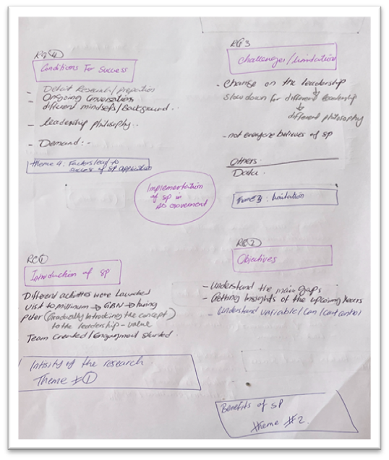
Figure 16: A handwritten summary of an interview.
- Making sense of the data
The researcher read through interview transcripts, highlighting phrases connected to the research questions, and assigned codes to relevant phrases/ideas. Sometimes participants’ own words were used as codes. This phase helped to understand the data in general and formed a good base to update the codes in the coming rounds.
- Line-by-line coding
The line-by-line coding began with combing through the data line by line. In this round, the codes assigned to phrases from (step ii) were reanalysed, renamed as required, and merged when they were similar, finding patterns and possible connections between codes, as well as creating parent-child codes (see Figure 17).
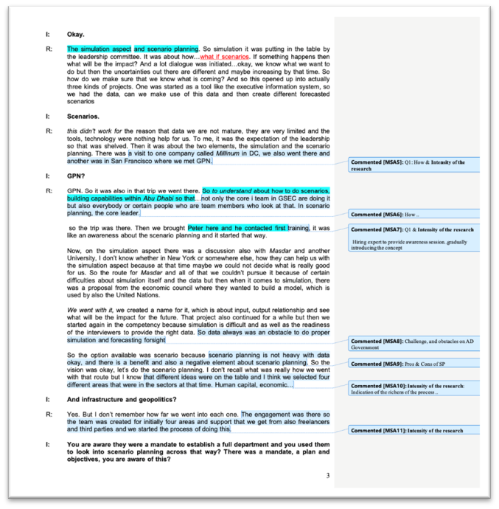
Figure 17: A page from an interview transcript showing line-by-line coding.

Data Analysis – Step by Step

Step 1: Reading: All nine transcripts were read thoroughly to familiarise the researcher with the data.
Step 2: Data coding
Stage 1: Coding: Figure 18 shows an excerpt from one of the interviews with the Core Team. The yellow highlights are text sections related to the parent code of strategies/reasons for scenario planning.
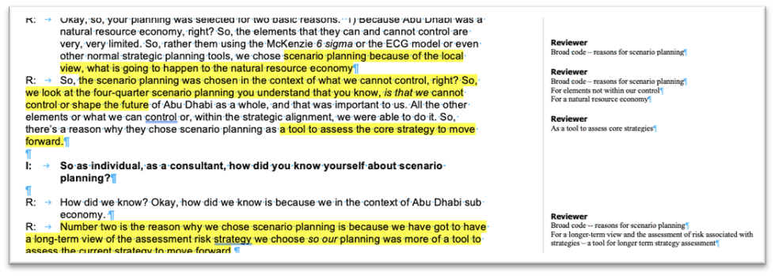
Figure 18: Interview excerpt sample.
This coding process was performed for all transcripts. Once the coding process was completed, a list of parent and child nodes was produced (Figure 19).
Parent code: P1 – reasons for scenario planning
Child code:
P1C1 – necessary for elements not within our control
P1C2 – useful for a natural resource economy, i.e., Abu Dhabi
P1C3 – as a tool to assess core strategies to move forward (with planning for the country)
P1C4 – for a longer-term view
P1C5 – as a tool for risk assessment associated with longer-term strategies
Figure 19: Parent and child codes.
Each transcript was read line-by-line and broad coding was assigned as parent code to statements or paragraphs; the details for each broad code were assigned child codes (see Table 6).
Code: Ongoing leadership support
Coded text from transcripts
in the beginning, we introduced the concept to the leadership; we showed them how governments, countries, and organisations are using scenario planning as a tool to come up with flexible, agile strategy plans that can take them to the next level – (Core 2)
“The biggest factor contributing to the success of a project is a sponsor who believes in the value of scenario work and commits to using outcomes in the organisation in a very visible way. I believe adopting scenario processes cannot be mandated across a sector because it is not a process that can be undertaken after reading a book - people need to be trained to use it effectively, and not every public sector organisation will have the resources to do this. If a leader doesn’t have a good grasp of Scenario Planning and the value of scenarios, it wasn’t possible to bring their managers along on the scenario's journey, so projects will fail. For me, then, people are the key success factor in any project” – (Exp2)
He (Strategy Executive Director) noticed a gap in the planning and looking at risks and the resilience of the health sector, ... so, he thought, why not start a program in the Department of Health for foresight and future studies? – (Core 1)
Table 6: An example of a code and the coded text/ excerpts from transcripts.
Stage 2: Merging codes: The codes from all transcripts were read and re-read. Similar codes were merged. Using the same excerpt from Figure 20, three child codes were merged, see Table 8.
Parent code: P1 – reasons for scenario planning
Child code:
P1C1 – necessary for elements not within our control – external forces of change
P1C2 – useful for a natural resource economy, i.e., Abu Dhabi
P1C3 – as a tool to assess core strategies for policy planning and development
P1C4 – for a longer-term view
P1C5 – as a tool for risk assessment associated with longer-term strategies
P1C4 and P1C5 were merged into one child code
The new P1C4 – as a tool to assess core longer-term strategies and their associated risks, as reflected in Table 8 below
Table 7: Stage 2, merging codes.
A label was given to each finalised code, as shown in Table 8, which presents the list of parent and child codes from the interview transcripts.
Parent code 1: Reasons for Scenario Planning
P1C1 – As a tool to manage uncertainties and external forces of change
P1C2 – Useful planning tool for a natural resource economy with a lot of external forces of change
P1C3 – As a tool to assess core strategies for policy planning and development
P1C4 – As a tool to assess core longer-term strategies and their associated risks
P1C5 – As a tool to identify local opportunities and become a centre of excellence independent of foreign influence
Parent code 2: Approach for SP introduction
P2C1 – Involving a variety of stakeholders
P2C2 – Initial training sessions
P2C3 – Initial research, piloting, and testing
P2C4 – Public administrators implementing the new knowledge in their context
Parent code 3: Factors that led to the shelving of scenario trials
P3C1 – Lack of involvement, sponsorship, and support from leadership
P3C2 – Lack of leadership's belief and support in scenario planning
P3C3 – Decrease in engagement and interest over time
P3C4 – Lack of resources
P3C5 – Lack of demand for scenario planning
P3C6 – Changes in the structure of leadership
P3C7 – Scenario planning not presented in an attractive, appealing way
P3C8 – Lack of competence in scenario planning
P3C9 – Not enough research and planning in the initial stages
Parent code 4: Factors that impact the adoption of SP in the public sector
P4C1 – Sponsorship and Leadership: Core team's decision to look for alternatives
P4C2 – Open-minded leadership that understands the uncertainties the country is faced with
P4C3 – It needs to be localised and consider environmental factors
P4C4 – Research, planning, and piloting
P4C5 – Awareness and interest from both the micro and macro level stakeholders
P4C6 – Understand how to appeal to key stakeholders
P4C7 – Project monitoring – Setting goals and assessment for achievements
P4C8 – Reporting directly to senior decision-makers
P4C9 – Leadership Involvement
P4C10 – Flexibility in terms of trying out new tools
Table 8: List of parent and child codes from data analysis, step 2.
Step 3: Searching for themes: This step involved reviewing codes and identifying emerging clusters of similar codes. A short description was then given to each cluster, making it a theme. Part of the list of clusters of codes for Phase 1 is shown in Table 9, as an example.

Clusters of Codes | Emerging Themes
P2C3 – Initial research for information required for scenario planning, e.g., trends and emerging issues analysis, piloting, and testing | Initial stages of research for data required to work on scenario planning and pilot testing exercise
P3C2 – Lack of leadership's belief and support in scenario planning | A continuation of leadership belief, support, sponsorship, and involvement despite a change of government structure or a change of leadership
P3C6 – Changes in the structure of leadership
P3C1 – Lack of involvement, sponsorship, and support from leadership
P3C8 – Scenario planning not presented in an attractive, appealing way | A lack of appreciation for scenario planning was due to a lack of engagement and interest, and that interest decreased over time, which then led to a lack of demand for scenario planning as part of the strategy development process
P3C3 – Decrease in engagement and interest over time
P3C5 – Lack of demand for scenario planning
P3C4 – Lack of resources | With a lack of interest, belief, and support from the leadership, there was a lack of resources dedicated to scenario planning implementation activities resulting in a lack of competence required for the initial stage of research and planning
P3C9 – Lack of competence in scenario planning
P3C10 – Not enough research and planning in the initial stages
P4C9 – Leadership involvement | Leadership involvement, sponsorship, ownership – open to trying out new tools and thinking about alternatives with an acute awareness of the uncertainties surrounding the country and its economy
P4C1 – Sponsorship and Leadership: Core team's decision to look for alternatives
P4C2 – Open-minded leadership with an awareness of the uncertainties surrounding the country and its economy
P4C5 – Awareness and interest from both the micro and macro level stakeholders
P4C10 – Flexibility in terms of trying out new tools
Table 9: Step 4: Clusters of emerging themes.
Step 4: Reviewing themes: During this step, codes and clusters were reviewed, similar clusters were merged, and some descriptions were fine-tuned to be more precise and succinct, as illustrated in Table 10.
Step 5: Naming themes: Each theme was given a descriptive label. See Table 10 below.
For instance, the theme label ‘Leadership’ includes the clusters of Leadership involvement, Sponsorship, and Ownership, which include codes such as “are open to trying out new tools and thinking about alternatives with an acute awareness of the uncertainties surrounding the country and its economy” and “A continuation of leadership belief, support, sponsorship, and involvement despite a change of government structure or a change of leadership.”
The theme label ‘Stakeholder Engagement’ encompasses issues regarding “– identifying all stakeholder groups likely to be affected by the scenario planning initiative, creating awareness of the new intervention, and soliciting their input to gain commitment and success” and ‘Organisational Culture’ revolved around the values and norms held in government entities and how they influence the adoption of new initiatives such as scenario planning.
Clusters of Codes | Label: Leadership  Emerging Theme:  Leadership belief in, support, and sponsorship for scenario planning as a strategy development tool
- P4C9 – Leadership involvement | Leadership involvement, sponsorship, ownership – open to trying out new tools and thinking about alternatives with an acute awareness of the uncertainties surrounding the country and its economy
- P4C1 – Sponsorship and Leadership: Core team's decision to look for alternatives
- P4C2 – Open-minded leadership with an awareness of the uncertainties surrounding the country and its economy
- P4C5 – Awareness and interest from both the micro and macro level stakeholders
- P4C10 – Flexibility in terms of trying out new tools
- P3C2 – Lack of leadership's belief and support in scenario planning | A continuation of leadership belief, support, sponsorship, and involvement despite a change of government structure or a change of leadership
- P3C6 – Changes in the structure of leadership
- P3C1 – Lack of involvement, sponsorship, and support from leadership
Table 10: Reviewing emerging themes and re-clustering and labelling of themes.

Cognitive Maps for Data Structuring
Cognitive maps (Eden and Sims 1979) are used to visual express and explore relationships between different variables in the data, to explore the causal and other relationships expressed in the data, and to highlight actions and their consequences. A cognitive map is made up concepts, and in this case, the concepts are codes. Each concept is presented using short phrases that express an idea about an issue and linked to other concepts by short phrases such as ‘may lead to’ or ‘enables’ or ‘informs.’ Figure 20 shows a visual representation of the links between concepts. Cognitive maps were used to structure the data collected from the three series of interviews.
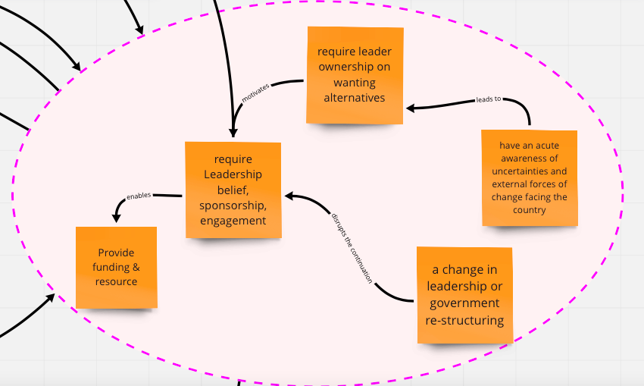
Figure 20: A cognitive map for visual representation of the links between concepts.

Secondary Data: Scenario Planning Workshop Materials
In addition to primary data from the interviews, secondary data was collected to better understand the implementation process at different stages of the intervention. This is explained in each phase of the following sections.

Research Rigor
Reliability and validity are used to evaluate the ‘goodness’ of the measures. As mentioned by Cunningham et al. (2006), “A measure may be consistent (reliable) but not accurate (valid), and alternatively, a measure may be accurate but not consistent.” Therefore, reliability and validity are used to evaluate the ‘goodness’ of the measures. Moreover, reliability is used to determine the stability and consistency of measurement (Sekaran, 2003). On the other hand, validity examines whether the right concept is measured. To ensure the quality of the findings and conclusions of this thesis, both reliability and validity were assessed.
Qualitative researchers have different perspectives about using various criteria for quality assessment. For example, Lincoln and Guba (1985) mentioned that the validity of the findings of qualitative research can be measured using concepts such as trustworthiness, credibility, dependability, and confirmability. In contrast, Miles and Huberman (1994) suggested using the ‘four Rs,’ based on Katz (1983): (i) representativeness, (ii) reactivity, (iii) reliability, and (iv) replicability to judge qualitative research.

Reliability
The reliability of a measure indicates the extent to which it is without bias and hence ensures consistency across the variable items in the instrument. Reliability indicates the stability and consistency with which the instrument measures the concept and the ‘goodness’ of the measure. Moreover, as mentioned by (Easterby-Smith, et al. 2002, p. 135), “Reliability is a matter of stability so here, the researcher should consider the consistency of the research findings as the challenge of reliability occurs during interviewing, transcribing, and analysing” (Kvale, 1996, p. 235). The methods applied to the interview, transcription, and analysis processes are intended to increase reliability.
In this study, reliability was improved by providing documentation that other researchers could use to conduct similar qualitative research in the future or in a different context. Consistent procedures were used for collecting, analysing, and drawing conclusions from data. A list of interview prompts was developed to ensure interviews were conducted consistently, regardless of the respondent, the place, or the conditions under which the interview was carried out.

Validity
Reliability alone is insufficient to consider an instrument adequate (Churchill, 1979), and validity is also required. According to Zikmund et al., (2003, p. 331), validity means “the ability of a scale to measure what is intended to be measured.” Neuman (1994) points out that the better the fit between the conceptual and operational definitions, the greater the measurement validity.
Qualitative researchers, including Lincoln and Guba (1985), Miles and Huberman (1994), and Kvale (1996), among others, discussed the importance of re-conceptualising generalisability, reliability, and validity in terms of appropriateness and relevance to interview research. A rationalist’s assumptions about these concepts would disqualify qualitative research findings with common responses, such as (extracted from Kvale, 1996, p. 230): “The results are unreliable, leading interview questions produce them;” “The interview findings cannot be generalised (in positivist versions where social science aimed to produce laws of human behaviour that could be generalised universally), there are too few interview subjects;” or “The results are not valid, they are only based on subjective interpretations.”
The researcher asked respondents to verify and enhance the study's reliability and validity. Transcripts of interviews were forwarded to interview participants for validation. Follow-up verification provided an opportunity for participants to verify and validate the transcript, in addition to providing an opportunity to expound on their initial responses or experiences. No participants expressed concern with the contents of the transcripts, and therefore no changes were made to the transcripts. Following validation of transcripts, data analysis was performed. The original electronic recordings were deleted following data analysis. Subjects were advised to contact the researcher if they had any issues with the transcript content. Subjects were offered a digital audio copy of the interview (upon request). No subjects availed themselves of this offer.

Researcher Bias
Research bias refers to subjectivity on the part of the researcher in selecting data that fit existing theories or preconceptions (Miles and Huberman 1994, p. 264). However, Maxwell (2005, p. 108) emphasises that “qualitative research is not primarily concerned with eliminating variance between researchers in the values and expectations they bring to the study, but with understanding how a particular researcher’s values and expectations influence the conduct and conclusions of the study and avoiding negative consequences.”
The sampling method and interview procedures were designed to control bias. Under no circumstance did the researcher select interviewees by preference; each interviewee was selected based on work affiliation and/or experience. The interviews were conducted using a specific set of interview questions designed for each specific phase of the study.
Data collected from the first few interviews may not be as comprehensive those from later interviews, as the researcher was learning from doing, improving the way the questions were asked and when certain questions were presented to the interviewees. Some interviewees are naturally ‘more informative’ as they may be more articulate and/or reflective of their experience and actions and enjoy talking about events and processes. The interviews were designed to accumulate ideas from individual participants, rather than having them validate each other’s responses and feedback. Each interviewee contributed to creating a better understanding of the phenomenon under study.
Interviewing skills also play an important role in coaxing interviewees to elaborate on their experience and knowing when to probe into certain points made by interviewees. Interviewing is a skill; one gets better with experience. The researcher compensated for the relative lack of skill in earlier interviews by following up with emails or telephone calls when gaps in information were noted.

Reactivity
Reactivity refers to the researcher's influence on the setting or individual studies. In this study, this would generally arise during interviews. Semi-structured interview questions were used to guide the conversation rather than leading the interviewees in their responses. In some cases, when the time allocated for the interview ran out, the researcher had to decide which questions should be prioritised and which questions should be dropped (subjective judgement). At the end of each interview, the researcher made a point of asking for permission to follow up through emails or telephone should further information be required, or clarification were needed. However, this did not "influence what the interviewees say or affect the validity of the inferences the researcher draws from the interview” (Maxwell, 2006, p. 109).

Summary
This chapter presents the methodology for this study. It provides a clear argument for why social constructionism best explains the design of the study, and that the knowledge for foresight and scenario planning implementation and practice is strongly influenced by the culture and socio-economic context within which it operates. What worked and what did not work for implementation of foresight and scenario planning within the Abu Dhabi government can only be learned from those who performed the implementation.
The objectives of the study were designed to be conducted in three phases, with each phase extending and expanding the previous phase. Each objective was mapped onto each phase of the study, indicating the focus, data collection method, participant selection, number of interviews to be conducted, and the timing of those interviews.
The chapter explains the rationale behind the choice to conduct a series of in-depth interviews for each phase of the study, how and why the data collection tool was designed, how the interviews were conducted, and how the data collected from the interviews were managed and processed. These topics are further expanded in the chapter dedicated to each phase of the study, to demonstrate the flow of how ideas and findings emerged from the analysis.
As data for all the three phases were mainly collected from interviews, the data analysis strategies were similar for all three phases, except for some differences concerning the types of data display used in each phase, and how cognitive maps were used to structure some data from each series of interviews for each phase. The data analysis process is described and discussed in greater detail, with examples, in the chapter devoted to each phase.
Research rigor was discussed as it relates to research reliability, validity, researcher bias, and reactivity, with special attention to the steps taken during the conduct of research to ensure reliability and validity.
This research methodology chapter leads to the discussion of the design, conduct and findings of each of the three phases of the study in the following three chapters.

PHASE 1: AN EXPLORATORY STUDY OF INTERVENTION 1

Introduction
The first phase of the study involved an in-depth analysis of a formal introduction of scenario planning in the Abu Dhabi government that began in December 2010, which is referred to as “Intervention 1”. The chapter begins with iterating the research objective and research questions for Phase 1 as a reference point for making sense of the analysis and findings. This is followed by a detailed introduction of the research setting for Phase 1 by presenting the proceedings of Intervention 1 as designed and led by the consultants commissioned for the project.
The chapter continues with brief discussion of the research methods employed (a more comprehensive discussion was presented in Chapter 4), followed by the analysis and findings of Phase 1.

Objective

Objective 1: To gain an in-depth understanding of the implementation of scenario planning as an early intervention within the Abu Dhabi government (reiterated here to navigate analysis of interview data).

Research Questions
- What factors influence scenario planning implementation?
- What are some of the issues and challenges facing public administrators in their first experience with scenario planning implementation within the Abu Dhabi government?
- Do public administrators need a framework or guide for scenario planning?

Research Setting: Intervention 1
Phase 1 of this study was an exploration to gain an in-depth understanding of the introduction of scenario planning for strategy and policy within the Abu Dhabi government, and from that exploration, to draw out some of the issues and challenges faced by public administrators while learning about and trying to implement scenario planning for the very first time.
This section provides comprehensive documentation of the process for every stage of Intervention 1 from the conception of the idea, commissioning of consultants, development of an operations manual for the public sector in Abu Dhabi, to the final stage of piloting scenario development for the Human Resource Sector in the UAE.
The process of introducing scenario planning in the Abu Dhabi government occurred via progressive stages. As illustrated in Figure 21, rigorous research and many activities were performed before finalising the adoption of scenario planning as a tool for formulating strategies and developing policies. This initiative is known as Intervention 1.
The Core Team set an ambitious vision for Intervention 1: “To support robust decision making by infusing a culture of scenarios thinking in strategy and policy planning across the Abu Dhabi government” (GSEC, 2011). Achieving this vision would require the scenarios team to go beyond discrete scenario projects. The process of embedding scenario planning in the Abu Dhabi government was anchored in the articulation capabilities of personnel in leadership positions, which GSEC regulated to balance the context (i.e., Abu Dhabi Governance) and best practices of scenario planning worldwide. Although the goal was to have all of the above in place, GSEC recognised that a phased approach to attaining a fully functioning institutionalisation of scenario planning in governance was required. In addition to developing the ability to create scenarios and lead scenario planning projects, priority must be given to embedding a robust scenario planning culture within the government.

Figure 21: The planning stages of Intervention 1.

Intervention 1: Project Scope
Monitor/GBN was commissioned as the consultant for Intervention 1 following endorsement by the leadership, strategy, and policy formulation teams. The Monitor Group was engaged to create awareness of and dialogue around the ambition of embedding SP within the strategic planning and policy formulation process in the public sector, as indicated by the project sponsor. The project led by Monitor GBN had three components: capability building, institutional design, and scenario analysis, and it was set to be completed within 9–11 months. Meetings between the Project Sponsor (GSEC) and GBN/Monitor confirmed the three primary modules of scenario planning, as shown in Figure 22 below.
The scope of Intervention 1 – GBN was to deliver three training programs for Abu Dhabi government employees on the introduction to and use of scenario planning for policy development in the Emirate. The team also advised on the creation of a central scenario planning unit, as well as the completion of an Operating Manual to run scenario projects. Finally, a case study of scenario creation was completed for demonstration purposes, which focussed on “The Future of Human Capital” in Abu Dhabi.
The first module began in December 2009 and involved a series of training workshops on scenario planning which were provided to officials from more than 30 different government entities. The second module also began in December 2010. It involved an institutional design study in helping the Abu Dhabi government plan and set up a unit responsible for future scenario exercises. The third module was commissioned as a pilot and proof of concept to explore “the future of human capital in Abu Dhabi”. It began in January 2011 and was intended to demonstrate what scenarios are, and how they might be helpful in Abu Dhabi.

Figure 22: Modules for Intervention 1 proposed by GBN/Monitor.
Module A: Capability Building (Training)
The objective of capability building focused on scenario planning concepts and methodology. This training was attended by the public administrators from 30 different departments of the government. They were selected to lead scenario planning-based projects in Abu Dhabi. The module consisted of three different training sessions, each session targeting different groups with different objectives (Figure 23).

Figure 23: Module 1 capacity building training series. Source: Developing & Using Scenarios - Scenario Training Seminar -Abu Dhabi. Jan 9 -13, 2011.
Developing and Using Scenarios (January 9–13, 2011): The first training session was a five-day course focused on developing and using scenarios. The session introduced theories and concepts on scenarios and generated awareness of good practices. The content and schedule for the training are presented in Table 11 below. This training was attended by a cohort of 40–50 public administrators who held positions involving strategic planning, performance management, organisational development, and quality management.
Developing and Using Scenarios Program Schedule
Day 1 | Day 2 | Day 3 | Day 4 | Day 5
Welcome and Course Overview | Developing a Focal Question | Creating a Scenario Framework | Building Alternative Narratives | Scenario Reports
What are Scenarios? | Driving Forces and Blind Spots | Importance of Scenario Narratives | Signs, Implications, and Options | Reframing the Focal Question
Introduction to the Case Study | Identifying Critical Uncertainties | Exploring the Expected Future | Communicating Memorably | Final Questions and Feedback
Table 11: Training schedule for “Developing and Using Scenarios,” Jan 9–13, 2011. Source: Developing & Using Scenarios - Scenario Training Seminar -Abu Dhabi. Jan 9 -13, 2011.

Leading Scenario Projects session (January 23–25, 2011). The aim was to understand scenario-based analysis and how scenario-based analysis projects are led. This included leading scenario planning conversations, producing high-quality results, and scenario and policy options.
Scenario to Strategy (February 13–14, 2011). A cohort of 51 senior personnel attended this two-day seminar session. Before the training session, all participants received resource material, which consisted of reading material entitled “What is Strategy?” by Porter (1985, 1996) and “The Gulf Cooperation Council Countries and the World; Scenarios to 2025,” published by the World Economic Forum.

Module B: Institutional Design. Organisational Design Blueprint and Operation Manual
The Core Team-- GSEC identified a need to develop scenario planning capabilities across the Abu Dhabi government to encourage the thought process about future uncertainties and enable more robust strategic planning and policymaking.
Module B of the intervention focuses on Institutional Design and comprises two parts: 1) Scenario Planning operating manual, and 2) Designing an organisational blueprint. It was proposed that the government should establish a central Scenario Planning Team (SPT) within GSEC, along with an operating manual. The Strategic Planning and Performance Management SPPM team agreed on a set of high-level design principles and addressed positioning across key design dimensions. See Table 12.
Scenario Planning Operating Manual: It was proposed that the government develop a manual, mainly to document the process of conducting scenario projects. The manual was to include details of several significant activities required for institutionalising scenario planning within the government and was intended to guide capacity development efforts for government officials. The consultants created an initial manual, suggesting that it could be further developed over time. The initial manual provided the content required for a fresh scenario planning team to begin creating new scenarios and applying them across different aspects under the jurisdiction of the government of Abu Dhabi.
Before Module B began, some research involving the senior leadership team was conducted:
- Reviewing the GSEC structure, Abu Dhabi Vision 2030, and the 2030 Policy Agenda that aims to understand the structural organisation of the GSEC as well as the strategic intent of the Abu Dhabi government.
- Conducting interviews with Directors of other GSEC Units that aim to contextualise the scenarios project and understand activities and expectations from scenarios.
- Interviews were conducted with Directors from various GSEC Departments to better understand the context in which the Scenarios Planning Team (SPT) would potentially operate.
MODULE B | GSEC SPT Design Blueprint:  Establishing Strategic Planning Teams and An Operations Manual for Scenario Planning
Objectives
The primary purpose of this manual is to document the process of conducting scenario projects for the government of Abu Dhabi. Its secondary objectives are to provide a brief introduction to scenario planning for individuals new to the topic, to highlight several key uses of scenarios in the government context, and to provide additional detail on several key activities that the government will need to deliver to successfully institutionalise scenario planning in Abu Dhabi.
Operations Manual Contents
- Why are Strategic Planning Teams (SPT) needed? Institutionalising capability.
- What executive sponsorship does an SPT need?
- What should an SPT do/not do?
- Objectives, mandate, focus: How should an SPT be configured to succeed?
- Processes: functions and activities.
- Structure: reporting, governance, roles.
- Enablers: information, networks, KPIs.
- Who should an SPT engage, and how? External linkages and providers of inputs.
- What is scenario planning (SP)?
- What is an SP project, and why do it? Macro vs. focused scenarios and uses.
- How do you run an SP project effectively? Preparation and design.
- Co-creation workshops and a seven-step process.
- Refining, writing, and packaging scenarios.
- When do you do what? (SP project planning).
- How do you use scenario planning outputs?
- Scenarios to change the mindset.
- Scenarios to formulate policy and strategy.
- Scenarios to stress-test policy and strategy.
- How do you engage key stakeholders?
- What tools and templates do you need?
- Set of templates with explanations.
- Stakeholders and users of outputs.
- What initiatives should an SPT undertake and when?
- Short-term, medium-term, and long-term.

Table 12: Intervention 1: Scope of Module B—Establishing strategic planning team and operations manual. Source: Scenario Planning Operating Manual- Abu Dhabi- March 2011

Module C: Proof-of-Concept Pilot Study
The proof-of-concept pilot study was initiated to engage Abu Dhabi’s leadership and demonstrate the value of scenario planning. This pilot project was intended to demonstrate what scenarios are and how they might be helpful to the Abu Dhabi government. The GSEC/Core team selected Human Capital 2030 for Abu Dhabi as a focal question for scenario development.
Responsibility for the area of Human Capital was spread across several different government sectors, and assignment of responsibility contained many uncertainties. The report presents the four possible scenarios for the Emirate of Abu Dhabi, focusing on the future of human capital in Abu Dhabi in 2030, as shown in Figure 24.
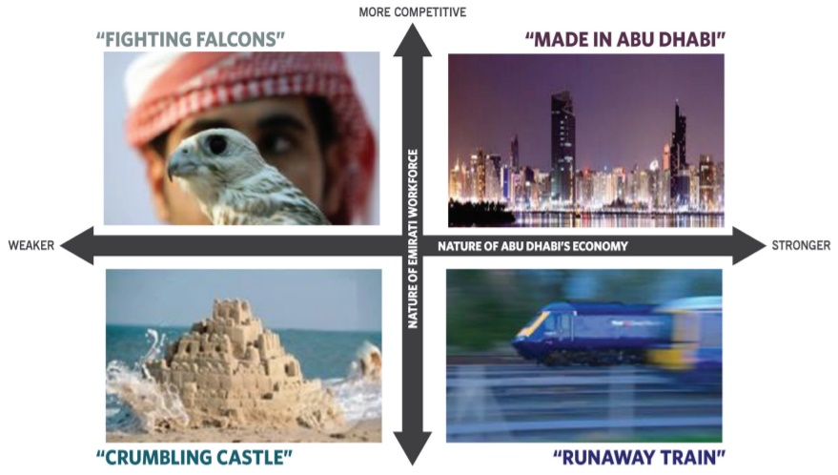
Figure 24:. Human Capital Scenarios. Source: Human Capital 2030: Abu Dhabi as a pilot scenario planning project
GSEC presented a report as a pilot version intended to demonstrate the value of scenarios to aid decision-makers across Abu Dhabi’s government. The report provided narratives of four different, yet plausible scenarios for human capital in Abu Dhabi in 2030. Figure 24 shows metaphors for each of the four scenarios framed by two critical uncertainties, namely (i) the nature of the Emirati workforce, and (ii) the nature of Abu Dhabi’s economy. It explored the economic and social challenges newer generations of Emirati may face, and how they might adapt to produce different outcomes over the next 20 years. (See Appendix 4: Comparison of Key Factors Across Scenarios). Although the objective of Module C was achieved in creating a set of scenarios as a pilot project, these scenarios were neither implemented nor used for wind-tunnelling the proposed strategies or plans.

Research Method – In-depth Interviews
This study was guided by the epistemological assumptions of social constructionism, as described in Chapter 4. This exploration was in-depth and aimed at teasing out participants’ experiences; in doing so, the study identified issues and challenges facing public administrators in their first experience with scenario planning implementation within the Abu Dhabi government.
For Phase 1, a series of in-depth semi-structured interviews were conducted with nine individuals representing different organisations.

Profile of Participants
The participants of this phase (presented in Table 13) who were directly involved in Intervention 1. (Appendix 5: Participants Codes)
Category | Role (coding labels in parenthesis)
Project Core Team (4)  GSEC | Executive Director Policy and Strategy Formulation Division (Project Sponsor)
Project Core Team (4)  GSEC | Director of Government Performance Management (Project Director)
Project Core Team (4)  GSEC | Manager in Public Policy Department (Project Manager, Core 3)
Project Core Team (4)  GSEC | Policy Formulation Advisor (Non-executive role)
Government Employees (3) | Strategy Planning Director
Government Employees (3) | Strategy Planning and Performance Management Director
Government Employees (3) | Performance Management Director
Consultants (GBN) (2) | Project Manager
Consultants (GBN) (2) | Facilitator
Table 13: List of Phase 1 participants.
Project Core Team: The core team that made up this group consisted of the Abu Dhabi Executive.
Council Employees: These participants played an active role in convincing the leadership of the importance of scenario planning–based interventions. These individuals were employed in decision-making positions and oversaw the implementation of scenario planning–based interventions.
Government Employees: Three employees worked in the field of strategy development and planning for the Abu Dhabi government or were involved in policy making and performance management. They were chosen because they were heavily involved in the exercise and witnessed the implementation of the system either by attending the training sessions or assisting in formulating the pilot study, which is covered in detail in the findings chapter.
Consultants: This study group consisted of two external scenario planning consultants and project managers from GBN/Monitor, who were hired to run scenario planning sessions for government entities. These individuals were leading trainers and facilitators or project managers.

Data Collection – Interview Question Design
Phase 1 interviews were designed to:
- Examine the reasons for scenario planning implementation.
- Uncover the factors influencing the implementation of scenario planning in Intervention 1, and identify key elements and degree of adoption within the public sector, and
- Examine whether public administrators should have had a framework to guide scenario planning implementation and practice.

Interview Questions for the Core Team
Category: Core Team
Introduction:
- How did you hear/know about scenario planning?
- What made you decide that scenario planning is the right fit for Abu Dhabi government?
- What was your role?
Aims of the process:
- How did scenario planning improve the strategic planning of the Abu Dhabi government?
- How is scenario planning being used: is it more geared towards indirect or direct forms of decision support?
- What was the level of executive involvement in the scenario planning process?
- How did decision-makers and stakeholders support the delivery of the project?
Monitoring and follow-up:
- How do you measure the success of the full intervention?
- What factors impacted implementation?
- If you could re-do or re-introduce the concept, what would you do differently?
- Which impacts can be observed?
- In your opinion, how do variables such as organisational culture or management style in Abu Dhabi affect the success or failure of a scenario planning intervention?
- Being the sponsor of the intervention, what lesson can be drawn from the previous intervention?
Table 14: Interview questions for the core team.

Interview Questions for Government Employees and Consultants
Category: Government Employees/Consultants
Personal Information
- As one of the participants in the Scenario Planning Sessions that were run by GSEC in 2011, can you talk about your experience, such as how you were nominated to attend the sessions; did you find useful tools that you might consider using in your organisation?
- Tell me about your experience in the field of Scenario Planning?
Understanding factors that impact SP intervention
If you have participated in any type of Scenario Planning intervention, considering all the SP projects that you have been involved with, what
- Considering all the SP projects that you have been involved with, what were the conditions that led to an unsuccessful outcome?
- To what degree do you think the focal SP project has been a success?
- What were the reasons for the (degree of) success?
- To what degree do you think the focal SP project has been a failure?
- What were the reasons for the (degree of) failure?
Private vs. Public Sector
- Are scenario interventions in the public sector different from those in the private sector?
- Do the conditions for success differ between the public and private sectors?
- To what extent do you think SP is a useful tool for strategic thinking by the government?
Table 15: Interview questions for government employees and consultants.

Secondary Data: Scenario Planning Workshop Materials
In addition to primary data from the interviews, secondary data was collected to better understand the implementation process at different stages of the intervention.

Phase 1 Supplementary Documents
The main documents for Intervention 1 consisted of three modules, which were primarily developed by the consultant and were shared by the Project Manager (Core 3). These documents were used to expand the discussions of emerging themes in the findings section of this chapter, including discussion of the reasons for scenario planning, which elements were essential, the potential of scenario planning, and the lessons learned from the Intervention. The detailed content of each module is as follows:
Module 1 Capability Building:
A series of training sessions to produce a cohort of trained practitioners to lead SP projects in Abu Dhabi
Three scenario training module workshops aimed to develop scenario planning capabilities in the Abu Dhabi Government Public Sector.
Objective: This module laid the foundation of SP and its significance, which in the context of the AD government primarily included achieving governmental excellence in infrastructural or socio-economic development while simultaneously maintaining environmental sustainability.
Documents
- Developing and using Scenarios, January 9–13, 2011
- Leading Scenario Projects, January 23–25, 2011
- Scenarios to Strategy, February 13–14, 2011

Table 16: Module 1, Capability Building, secondary data summary.
Module 2 Institutional Design
An organisational design blueprint and operation manual to help integrate SP into GSEC’s overall strategy and policy planning process
This manual provides detailed guidance on how to run effective SP. It demonstrated how to use scenarios to generate and test policy options and helped institutionalise SP over time. The manual was primarily aimed at scenario practitioners and analysts for creating potential scenarios or reviewing or formulating policies and strategies in context-specific scenarios.
Objective: This module was developed to provide the stakeholders with appropriate tools and templates to successfully reach SP outputs and develop an ongoing culture open to scenario planning in governance or independent institutions.
Document:
Scenario Planning Operating Manual, March 2011
Table 17: Module 2, Institutional Design, secondary data summary.
Module 3 Scenario Analysis
A proof-of-concept pilot study to engage Abu Dhabi’s leadership and demonstrate the value of scenario planning
This report provides a detailed picture of four different, yet plausible, future scenarios for human capital in Abu Dhabi. It explores how the rising generation of Emiratis may interact with the economic and social challenges they face, producing very different outcomes for the next 20 years.
Objective: This document is a compilation of exclusive interviews of policy experts and senior decision-makers serving the Abu Dhabi Government analysing various issues with the overall objective of laying the foundation of realistic strategies for future scenarios in Abu Dhabi.
This is a pilot version intended to demonstrate the value of scenarios to aid decision-makers across Abu Dhabi’s government.
Document:
Abu Dhabi 2030: Scenarios for the Emirate of Abu Dhabi, focusing on the future of human capital in Abu Dhabi 2030.
Table 18: Module 3 Scenario Analysis, secondary data summary

Analysis
This section presents the list of codes and clusters of themes emerging from the analysis.

Clusters of Codes
The list of clusters of codes and associated emerging themes for Phase 1.
Clusters of Codes | Emerging Themes
P1C1 – As a tool to manage uncertainties and external forces of change | Scenario planning is a useful planning tool for a natural resource economy when the country is faced with uncertainties and external forces of change
P1C2 – Useful planning tool for a natural resource economy with a lot of external forces of change
P1C5 – As a tool to identify local opportunities and become a centre of excellence independent of foreign influence
P1C3 – As a tool to assess core strategies for policy planning and development | Scenario planning as an assessment framework for core strategies and their associated risk – for policy planning and development
P1C4 – As a tool to assess core longer-term strategies and their associated risks
P2C1 – Involving a variety of stakeholders | Stakeholder involvement in the implementation
P2C2 – Initial training sessions | Public administrators are trained for scenario planning
P2C4 – Public administrators implementing the new knowledge in their context | Public administrators are trained for scenario planning
P2C3 – Initial research for information required for scenario planning, e.g., trends and emerging issues analysis, piloting, and testing | Initial stages of research for data required to work on scenario planning and pilot testing exercise
P3C2 – Lack of leadership's belief in and support of scenario planning | A continuation of leadership belief, support, sponsorship, and involvement despite a change of government structure or a change of leadership
P3C6 – Changes in the structure of leadership
P3C1 – Lack of involvement, sponsorship, and support from leadership
P3C8 – Scenario planning not presented in an attractive, appealing way to stakeholders or decision-makers | A lack of appreciation for scenario planning was due to a lack of engagement and interest, and that interest decreased over time, which then led to a lack of demand for scenario planning as part of the strategy development process.
P3C3 – Decrease in engagement and interest over time
P3C5 – Lack of demand for scenario planning
P3C4 – Lack of resources | With a lack of interest, belief, and support from the leadership, there was a lack of resources dedicated to scenario planning implementation activities resulting in a lack of competence required for the initial stage of research and planning.
P3C9 – Lack of competence in scenario planning
P3C10 – Not enough research and planning in the initial stages
P4C9 – Leadership involvement | Leadership involvement, sponsorship, ownership – open to trying out new tools and thinking about alternatives with an acute awareness of the uncertainties surrounding the country and its economy
P4C1 – Sponsorship and Leadership: Core team's decision to look for alternatives
P4C2 – Open-minded leadership with an awareness of the uncertainties surrounding the country and its economy
P4C5 – Awareness and interest from both the micro and macro level stakeholders
P4C10 – Flexibility in terms of trying out new tools
P4C7 – Project monitoring – Setting goals and assessment for achievements | Project monitoring and reporting
P4C8 – Reporting directly to senior decision-makers | Project monitoring and reporting
P4C3 – It needs to be localised and consider environmental factors | In making the intervention more appealing to more groups of stakeholders, scenario planning needs to be contextualised, and initial research and planning were essential
P4C11 – Research, planning, and piloting
P4C6 – Understand how to appeal to key stakeholders
P5C1 – Establishing a unit responsible for planning to move the country forward; this Unit must report to the Sec Gen for accountability | Leadership accountability for budget and spending towards the next steps for the country
P5C2 – Reporting and accountability for budget and spending
P5C3 – Public reporting of results for stakeholder engagement and buy-in | Stakeholder engagement and buy-in for more effective implementation
Table 19: List of clusters of codes and emerging themes for Phase 1.

Emerging Themes Analysis
The list of codes and emerging themes was reviewed, and similar clusters were merged and given a label with a succinct description.
Key Theme 1: Leadership
Emerging Theme: Leadership belief in, support and sponsorship of, and stakeholder engagement for scenario planning as a strategy development tool, as shown in Table 20.
Clusters of Codes | Label: Leadership  Emerging Theme:  Leadership belief in, support and sponsorship, and stakeholder engagement for scenario planning as a strategy development tool
P4C9 – Leadership involvement | Leadership involvement, sponsorship, ownership – open to trying out new tools and thinking about alternatives with an acute awareness of the uncertainties surrounding the country and its economy
P4C1 – Sponsorship and Leadership: Core team's decision to look for alternatives
P4C2 – Open-minded leadership with an awareness of the uncertainties surrounding the country and its economy
P4C5 – Awareness and interest from both the micro and macro level stakeholders
P4C10 – Flexibility in terms of trying out new tools
P3C2 – Lack of leadership's belief and support in scenario planning | A continuation of leadership belief, support, sponsorship, and involvement despite a change of government structure or a change of leadership
P3C6 – Changes in the structure of leadership
P3C1 – Lack of involvement, sponsorship, and support from leadership
P5C1 – Establishing a unit responsible for planning to move the country forward – this Unit must report to the Sec Gen for accountability | Leadership accountability for budget and spending towards the next steps for the country
P5C2 – Reporting & Accountability for budget and spending
P5C3 – Public reporting of results for stakeholder engagement and buy-in | Stakeholder engagement and buy-in for more effective implementation
P2C1 – Involving a variety of stakeholders
P4C6 – Understand how to appeal to key stakeholders
Table 20: Clusters of codes for Key Theme 1: Leadership Belief and Commitment.
Key Theme 2: Scenario Culture
Emerging Theme: Instil scenario culture within the government and across all levels for continuity.
Clusters of Codes | Label: Scenario Culture  Emerging Theme: Instil scenario culture within the government and across all levels for continuity
P5C1 – Establishing a unit responsible for planning to move the country forward – this Unit must report to the Sec Gen for accountability | Establishing accountability for budget and spending towards the next steps for the country through project reporting and monitoring
P5C2 – Reporting and accountability for budget and spending
P4C7 – Project evaluation and monitoring: Setting goals and assessment for achievements
P4C8 – Reporting directly to senior decision-makers
P5C3 – Public reporting of results for stakeholder engagement and buy-in | Stakeholder engagement and buy-in for more effective implementation
P2C1 – Involving a variety of stakeholders
P4C6 – Understand how to appeal to key stakeholders
P3C5 – Lack of demand for scenario planning | Increasing appreciation for scenario planning leads to an increase in demand as a planning tool
P4C5 – Awareness and interest from both the micro and macro level stakeholders
Table 21: Clusters of codes for Key Theme 2: Scenario Culture.
Key Theme 3: Capacity and Competency for Scenario Planning
Emerging Theme: Capacity and Competency for Scenario Planning.
Clusters of Codes | Label: Capacity and Competency for Scenario Planning  Emerging theme: A need for a unit responsible for scenario planning and strategy development with the right talent and expertise
P5C1 – Establishing a unit responsible for planning to move the country forward; this Unit must report to the Sec Gen for accountability | Establishing a Unit responsible for scenario planning and strategy development, staffed with the right talent and expertise for scenario planning
P4C3 – It needs to be localised and consider environmental factors
P4C11 – Research, planning, and piloting
P3C4 – Lack of resources allocated for planning
P3C9 – Lack of competence in scenario planning
P2C3 – Initial research for information required for scenario planning, e.g., trends and emerging issues analysis, piloting, and testing
P6C3 – Train public administrators with skills and knowledge for scenario planning
P7C4 – A team with diverse backgrounds and work experience
P5C3 – Public reporting of results for stakeholder engagement and buy-in | Competence and ability required for contextual research in making scenario planning more relevant and appealing to stakeholders
P4C6 – Understand how to appeal to key stakeholders
P3C5 – Lack of demand for scenario planning | Increasing appreciation for scenario planning leads to an increase in demand as a planning tool
P4C5 – Awareness and interest from both the micro and macro level stakeholders for buy-in
Table 22: Clusters of codes for Key Theme 3: Capacity and Competency for Scenario Planning.
Key Theme 4: Awareness and Appreciation of the Value and Potential of Scenario Planning
Emerging Theme: An awareness and appreciation of the value and potential of scenario planning – a realisation of the need for skills and expertise to use them
Clusters of Codes | Label: Value and Potential of Scenario Planning  Emerging Theme: An awareness and appreciation of the value and potential of scenario planning – a realisation of the need for skills and expertise to use them
P1C1 – As a tool to manage uncertainties and external forces of change | Scenario planning is a useful planning tool for a natural resource economy when the country is faced with uncertainties and external forces of change  Scenario planning as an assessment framework for core strategies and their associated risk, for policy planning and development  Scenario planning as a tool to identify local opportunities and become a centre of excellence independent of foreign influence
P1C2 – Useful planning tool for a natural resource economy with a lot of external forces of change
P1C5 – As a tool to identify local opportunities and become a centre of excellence independent of foreign influence
P1C3 – As a tool to assess core strategies for policy planning and development
P1C4 – As a tool to assess core longer-term strategies and their associated risks
Table 23: Clusters of codes for Key Theme 4: Potentials of Scenario Planning.

Phase 1 Findings
The coding and thematic analysis revealed four key themes emerging from the clusters of codes (refer to Figure 25).
The four key themes include
- Leadership commitment, sponsorship, stakeholder engagement, and buy-in for scenario planning as a strategy and policy development tool,
- The need to instil scenario culture within the government across all public organisations,
- Capacity and competencies for scenario planning, and
- An awareness of and appreciation of the value and potential of scenario planning.
Cognitive maps (Eden and Sims 1979) are used to structure codes/themes, and visually express and explore the relationships between themes. The maps are representations of data reduction, and data are displayed in concluding the findings of the three phases of qualitative data analysis as recommended by Miles and Huberman (1994)).
Following the conventions of cognitive mapping (Eden and Sims 1979), the concepts at the bottom enable / support / facilitate / motivate the concepts at the top right up to the achievement of the over-arching objectives.

An Overview of Phase 1 Findings
Starting from the bottom of the map, referring to Figure 25, Key Theme 4: An awareness and appreciation for the value and potential of scenario planning forms the foundation for Intervention 1. Having an awareness and appreciation for the value and potential of scenario planning motivates Key Theme 1: leadership commitment, sponsorship, and stakeholder engagement and buy-in. Key Theme 4 also motivates Key Theme 3: capacity and competencies development for scenario planning. Key Theme 1: leadership commitment and sponsorship enable/facilitate the allocation of funding and resources for scenario planning initiatives, including capacity development (Key Theme 3). This capacity development is essential to create a team skilled in implementing scenario planning for strategic planning and evaluating and monitoring project reporting performance. The regular project reporting practice helps raise interest and awareness across all levels of stakeholders (part of scenario culture, Key Theme 2) and keeps the senior leadership informed about policy performance which reflects the potential of scenario planning to maintain interest and belief in scenario planning for strategy development (Key Theme 1).
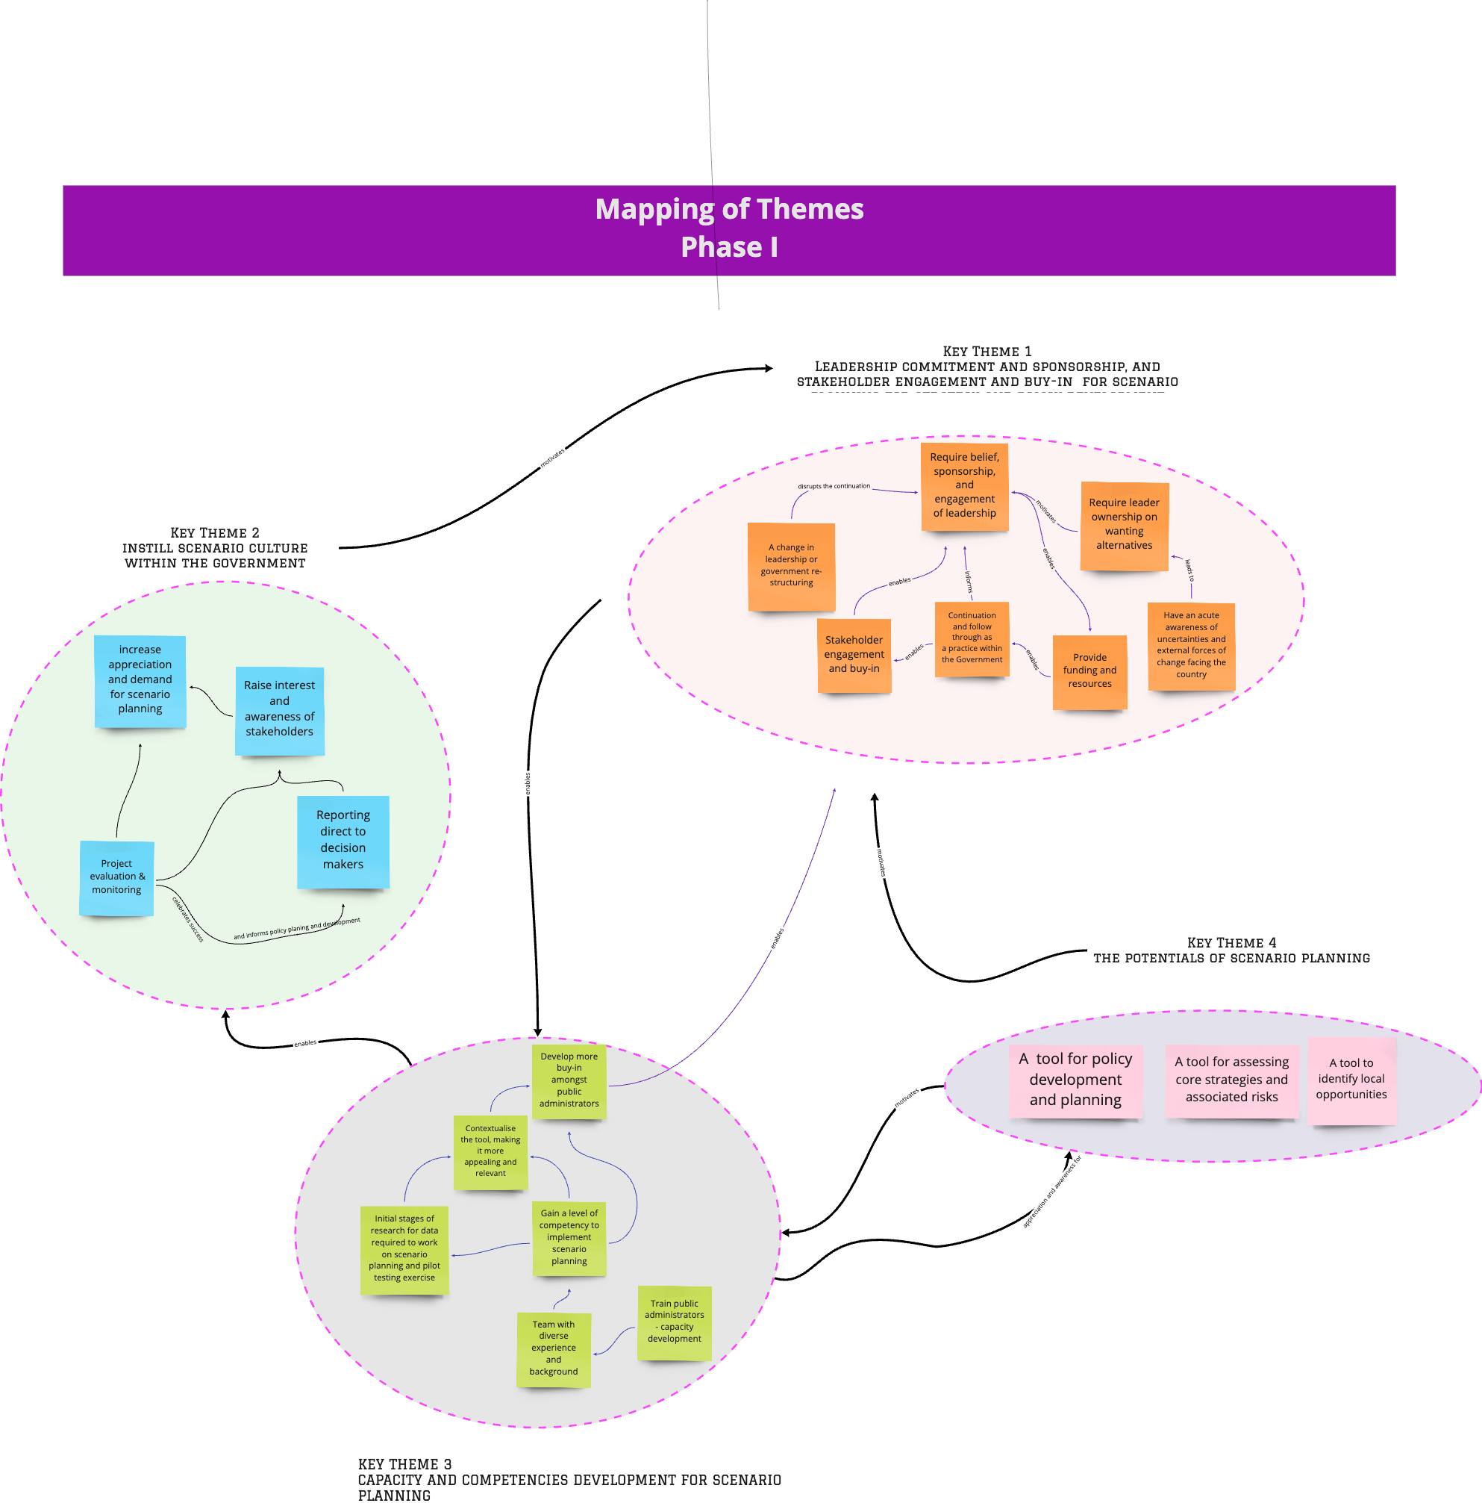
Figure 25: Overview of Phase 1 findings.
Key Theme 1: Leadership commitment and sponsorship, and stakeholder engagement and buy-in for scenario planning as a tool for strategy and policy planning and development
Figure 26 presents the cognitive map of the clusters of codes for Key Theme 1 and the relationships between clusters. This map helps describe the main elements that were essential for leadership belief, sponsorship, and engagement to happen. For example, leaders who are acutely aware of the impacts and implications of uncertainties and external forces of change affect the country. With this awareness, strategically, they would want to see/create alternatives and possibilities in navigating those uncertainties and forces of change. This leadership would then have a commitment to and belief in driving the scenario planning initiative forward. This commitment and belief are essential to ensure allocation of funding and resources for scenario planning and are crucial for continuation and follow-through in making scenario planning a government practice. Budget and resource allocation demonstrate commitment and would naturally encourage engagement and buy-in from the stakeholders at various levels. A change in leadership or government restructuring disrupts the commitment to continued support and engagement.
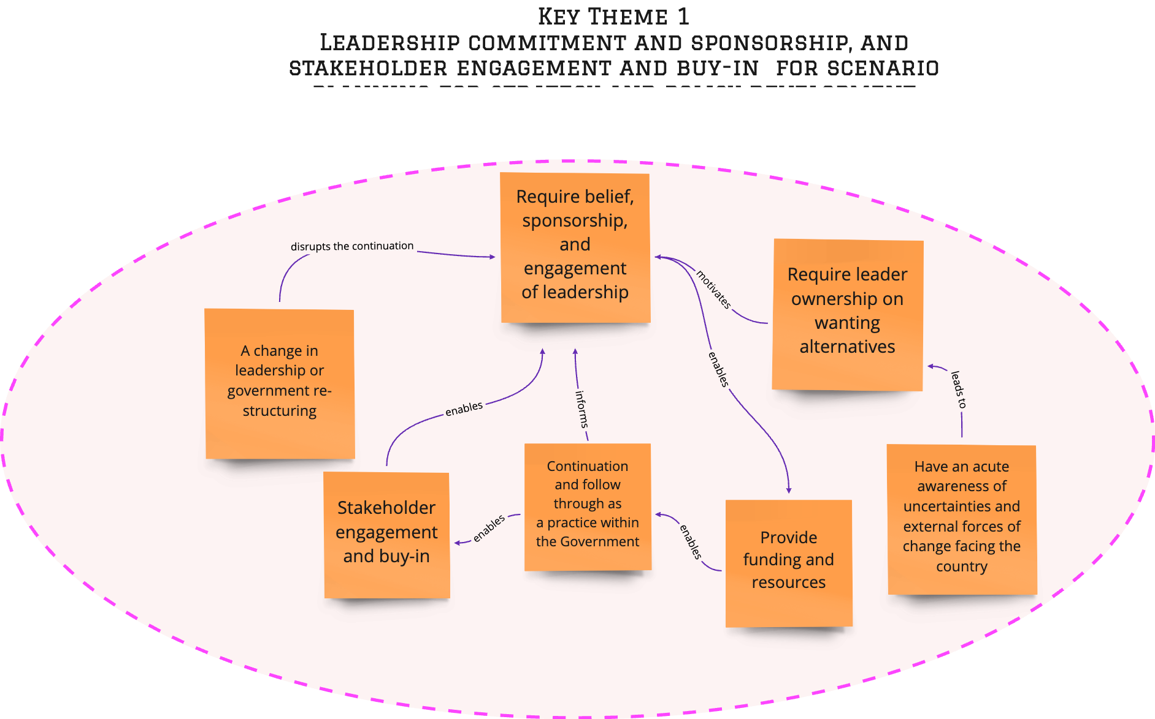
Figure 26: Key Theme 1—Leadership Commitment, Sponsorship, and Stakeholder Engagement
- Leadership Awareness and Endorsement for Buy-In
Leadership awareness and internal endorsement for buy-in: The visit to GBN in their U.S. headquarters helped the GSEC team recognise the potential of scenario planning
Leadership initiated a scenario planning introductory endeavour amongst personnel holding crucial leadership positions in the government by inviting Peter Schwartz to visit the UAE. Schwartz co-founded Global Business Network (GBN, subsequently bought by the Monitor Group), specialising in scenario planning.
“Working with Monitor, we came up with a Plan that consisted of awareness sessions about SP, benefits, and how to use it, and we trained a lot of people into sessions… In the beginning, we introduced the concept to the leadership, we showed them how governments, countries, and organisations are using scenario planning as a tool to come up with flexible, agile strategy plans that can take them to the next level” – (Core 1).
Peter Schwartz presented the latest trends, entitled “Global Trends and the Implications for the UAE/Abu Dhabi”. In this document, Schwartz talked about scenario planning as a discipline in general, the steps to developing scenarios, and its application in different fields, including geo-economics, demographics, geo-politics, and the environment. Schwartz’s presentation provided an understanding of scenarios and scenario content, as well as the thought processes involved in scenario planning, as shown in Figure 27.
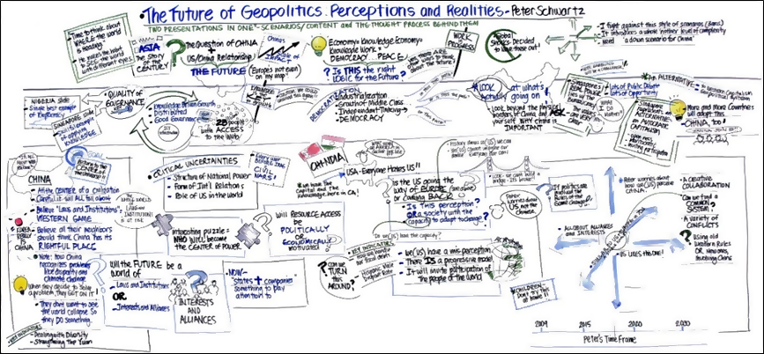
Figure 27: “The Future of Geopolitics: Perceptions and Realities” presented by Peter Schwartz October 2019.Source: Scenario Planning Presentation Abu Dhabi Nov 23.
Understanding the structure of the Abu Dhabi government's decision-making during Intervention 1 is necessary to understand the influence the executive/leadership has on the process. The organisational chart of the government of Abu Dhabi is presented in Figure 28.
The Assistant Secretary-General has the power to delegate autonomy to the Strategic Planning Project (SPP) team to be innovative in their approaches as mentioned by the Project Sponsor:
“During that time, we had strong support from the leadership. During that time, I believe we were blessed with leadership. We are not talking about only SP, and we are talking about a bigger framework that falls within the policy formulation where scenario planning was introduced along with other tools.” – (Core 1).
In addition, the chosen approach provided the SPP team with the opportunity to introduce the tool, which proved to be a good decision, as this ensured that they had the endorsement of the tool before full engagement with GBN from the executives/leadership. As explained by the Project Sponsor, the leadership was seen to be supportive and open to the process, and was even thought to be a blessing:
“In the beginning, we introduce the concept to the leadership and showed them how governments, countries, and organisations are using scenario planning as a tool to come up with flexible, agile strategy plans that can take them to the next level. Also, how they can use SP to reduce future risks, and the benefits of using SP in reducing risk, budget control, and response time against uncertainties. During that time, I believe we were blessed with the leadership so during that time we had strong support from the leadership.” – (Core 1)
“So, there was a leadership that believed in strategy, performance and scenario planning and all of that and as an element for engagement or interaction and setting the direction.” – (Core 2)
“Yes, they were very supportive we presented the case study at that time to the Secretary-General who was there.” – (Core 4)
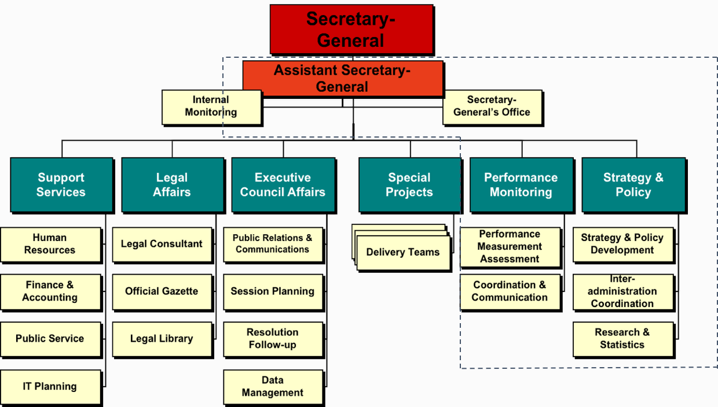
Figure 28: Organisation Chart of Abu Dhabi Government for the Chain of Command and Decision-Making Hierarchy. Source: ADGSEC Strategic Plan 2009–2013, developed October 2008.

- An acute awareness of the uncertainties and external forces of change would have an impact on the country and foster an appreciation for the value of scenario planning
An appreciation for scenario planning as a tool to anticipate uncertainties in planning for the future; a tool to help people visualise alternative, possible futures
“We said if we were not able to include SP within the level of public entities, we ensure that it is embedded in the laws of sectors such as economy sector; and that’s why we used the pilot in Human Capital as it was the hot topic back in 2008 to 2009 and we needed to ensure that education outcomes were linked to the workforce requirements and other uncertainties that made us choose Human Capital as a pilot study. But first, we wanted the entities to test it, and we piloted on Human Capital Strategy, and we came up with four scenarios, and one of them was applicable after 10 years.” – (Core 1)
“And I think it’s not that one is seeing the value; second is about can we do things without scenario planning? Yeah, scenario planning will give you this. It’s really to give you an insight, to understand the different uncertainties that could be foreseen into the future. But does it have a big impact on how we operate and what we deliver? Not necessarily. Okay, so here there is an element of doubt from the scenario planning.” – (Core 1)
“We have to understand the issues of the scenario planning. It is a narrative, so it is a viewpoint of a certain group of people. It doesn’t have to be the correct tool, so everybody will see it from a different angle, and this is one element of it because it’s about the story, it’s about what the future will look like. I can paint the future differently than how you paint it.” – (Core 2)
- A commitment to see things through
“Commitment to see things through, commitment to better governance—eliminating ‘waste’ in decision making on strategy and budgets, holding people and organisations accountable (which will be difficult given the preference to not embarrass) and not shifting problematic people from entity to entity. Build clarity about vision and strategy and the objectives over time and show people how they fit into/support the journey. Understand national and organisational culture and assess and track people’s perceptions and adapt scenario and strategy approaches to planning frameworks. Encourage public reporting of scenarios, policy, and strategy, including truthful discussions of good and bad news promptly. Encourage inclusion and participation to increase ownership and commitment.” – (Core 4)
“Secure sponsorship at a more senior level than Sec Gen/entity leadership. Cross-entity (EC or subcommittee may be more appropriate). A stronger commitment to a robust planning framework with more effective governance is necessary to ensure a greater probability of success over the medium term. Also, to prevent the situation of starting and abandoning different tools and techniques without full intervention” – (Core 4)
- Allocation of budget and resources
“Project owners tend to stop their projects if they don’t get the budget they have requested for, therefore the action plans that were submitted were not realistic and they have mentioned under zero budget that they will put their projects on hold. Having said that, I believe that to have a successful scenario planning other elements and enablers need to be taken into consideration and developed such as innovation, sustainability, etc.” – (GE2)
- Leadership change caused a discontinuity
Leadership support at the beginning of Intervention 1 was obvious and high, and the team was able to roll out activities as planned. In the later stages of the Intervention, a change in leadership curtailed this crucial support. That change resulted in a change in governmental priorities, which led to a lifeline cut from the Intervention.
Leadership changes represent a particularly salient event that disrupts team plans and may trigger active cognitive processing that breaks a team's existing habits and cognitive biases.
“I think if we are talking about scenarios, we have to have the speed of leadership change in Abu Dhabi government as a fixed scenario that never changes. And this is the biggest challenge to continuous change.” – (Core 1)
Changes occur at all levels and impact operations. Unfortunately, a reset button can often be pressed just before completion while working on projects and initiatives. As new leadership takes over, initiatives may have to be restarted, sometimes before a complete evaluation of previous efforts, propagating frustration amongst employees.
“This is one of the common things in the AD government. Unfortunately, you may be working on something (project, initiative) and you go all the way and before the completion, we hit the reset button. When new leadership comes, even before they evaluate previous efforts they just come and hit the rest button and start all over again. And this is one of the things we have to deal with.” – (Core 1)
“The proposal was there but whether it was supposed to be done as part of policy addition, as a tool within the policy was unknown. Because of leadership changes, it slowed down for different leaders, who may have different philosophies about doing things. Okay?” – (Core 2)
Along with changes in the leadership came changes in priorities
“The main elements for any change, priorities altered. I don’t blame anyone. Some decision-makers see having tools as a priority to be able to evaluate “what if” decisions and what are the consequences that come with them. Or if we proceed with a certain decision, will I be able to shift or change easily if something comes up?” – (Core 3)
Key Theme 2: Instil Scenario Planning Culture within the Government
Figure 29 is a visual representation of the clusters of codes and the relationships between the elements that were associated with the aspiration of instilling scenario culture within the government across all public entities. Evaluating, monitoring, and reporting on the performance of each scenario planning project informs policy planning and development, and celebrates success, which in turn raises awareness of and generates an appreciation for scenario planning as a strategy development approach; this would then lead to more demand for scenario planning in practice, and over time this practice becomes a management culture.
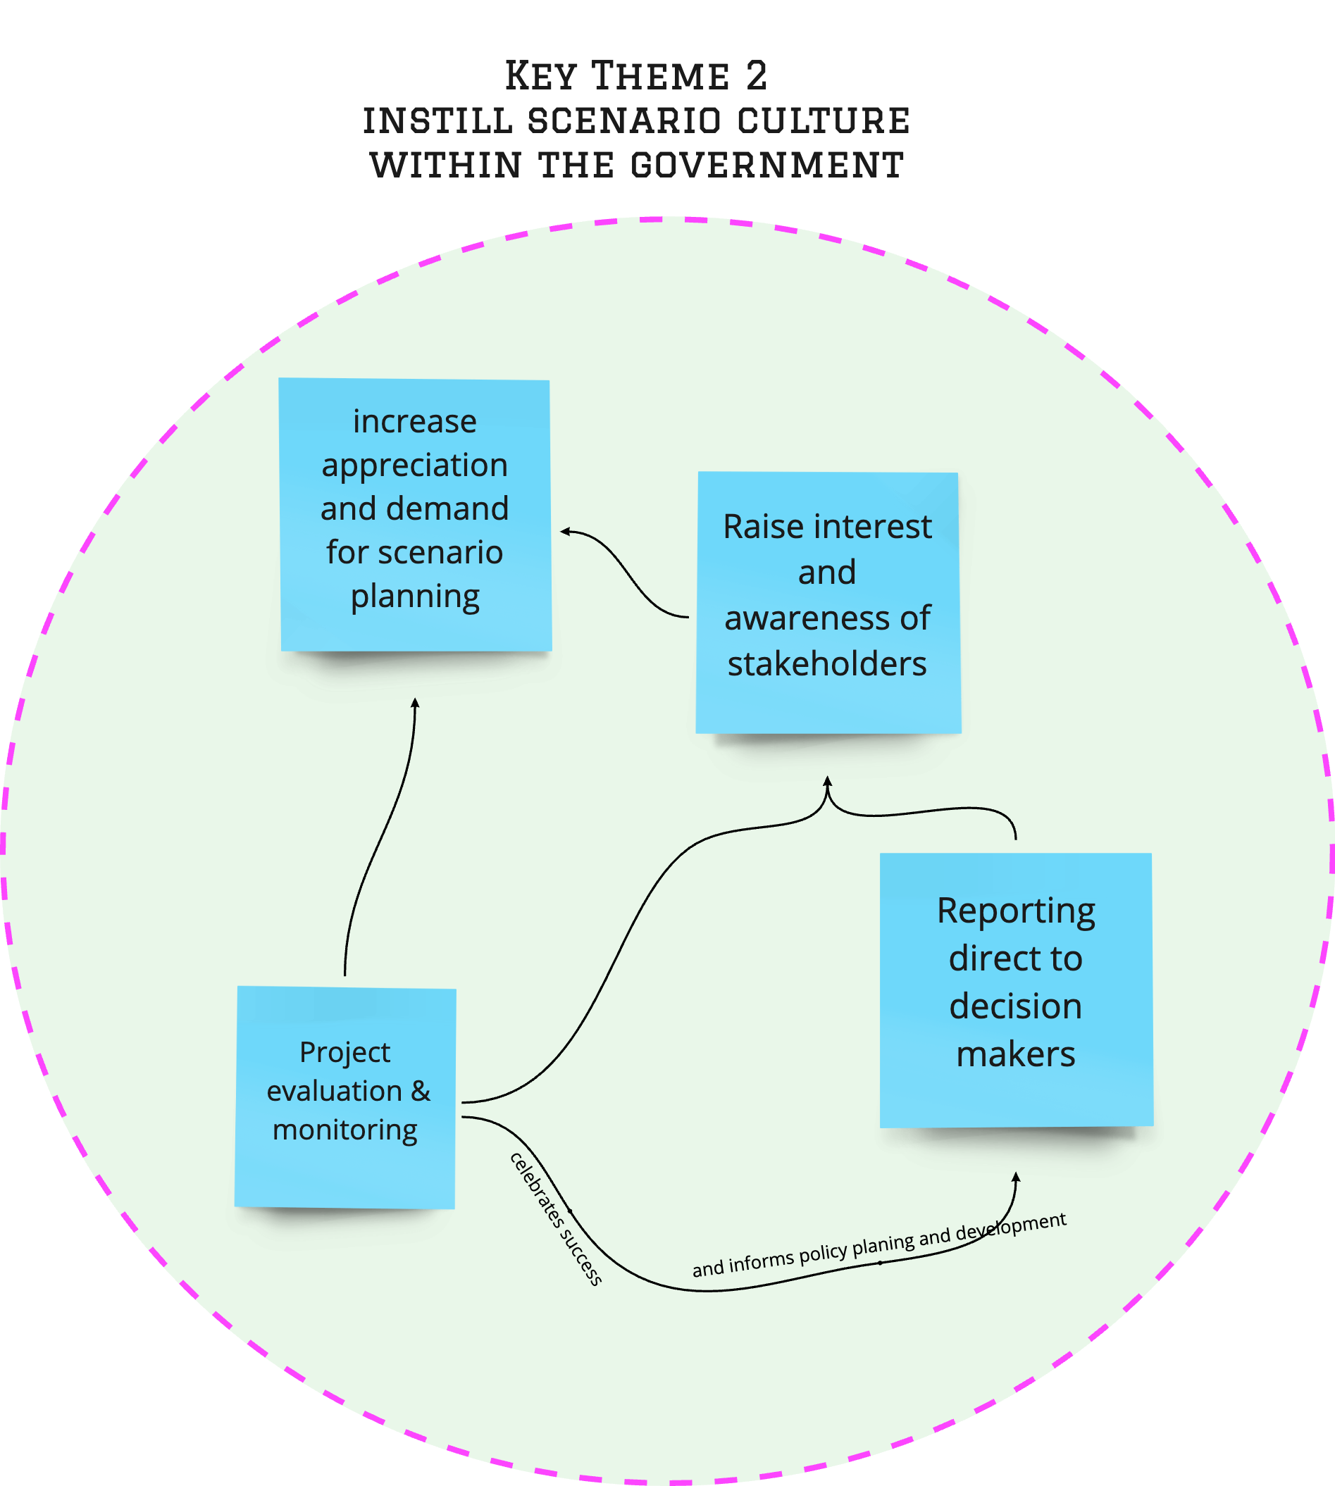
Figure 29: Key Theme 2—Instil Scenario Planning Culture within the Government.
- Project Evaluation and Monitoring
Foresight or scenario planning is not one job at one time, and there are a lot of activities that need to take place even after production of the outcomes. Organisations cannot generally act on the generated results, particularly when it comes to translating foresight outcomes into strategy. Scenario planning or even foresight come with alternative futures, a set of alternative policies, and pushes for short, non-traditional feedback loops. Many bureaucratic structures that exist within the organisation do not allow for the kind of adaptability and flexibility required for the implementation of action plans derived from foresight (e.g., budget cycles, work plans with strictly sequenced deliverables, long-term evaluation strategies, etc.). Therefore, regular feedback and follow-up on the outcomes are necessary to ensure successful interventions.
- “Lack of accountability: You might have the best-crafted scenario planning but if ownership and accountability are not established then it is bound to fail.
- Lack of consequence management: If the intended plans are not executed what is the mutually agreed rewards or penalties should be established upfront
- Considering the strategy exercise as an offsite pleasure trip and just as a tick in the box.
- Not so well thought out so that needs frequent chopping and changing. The underlying assumptions are faulty.
- Organisations getting caught up with operational and tactical issues and abandoning the longer-term actions and agenda. They consider SP as more of a “flavour of the season” nice to have rather than as a key to strategy execution.
- Organisations not referring to the alternate scenarios and executing their backup plan.” – (GE3)
“The failure is increased in the implementation phase rather than the planning phase.
- The lack of discipline to monitor and adapt leads to failure in implementation
- Some residual risk lies in the process and governance of implementation
- Lack of management commitment to change plans halfway through
- Lack of acceptance to kill or terminate ineffective projects
- Lack of alignment between budgeting processes, planning and implementation” – (GE2)
Key Theme 3: Capacity and Competencies Development
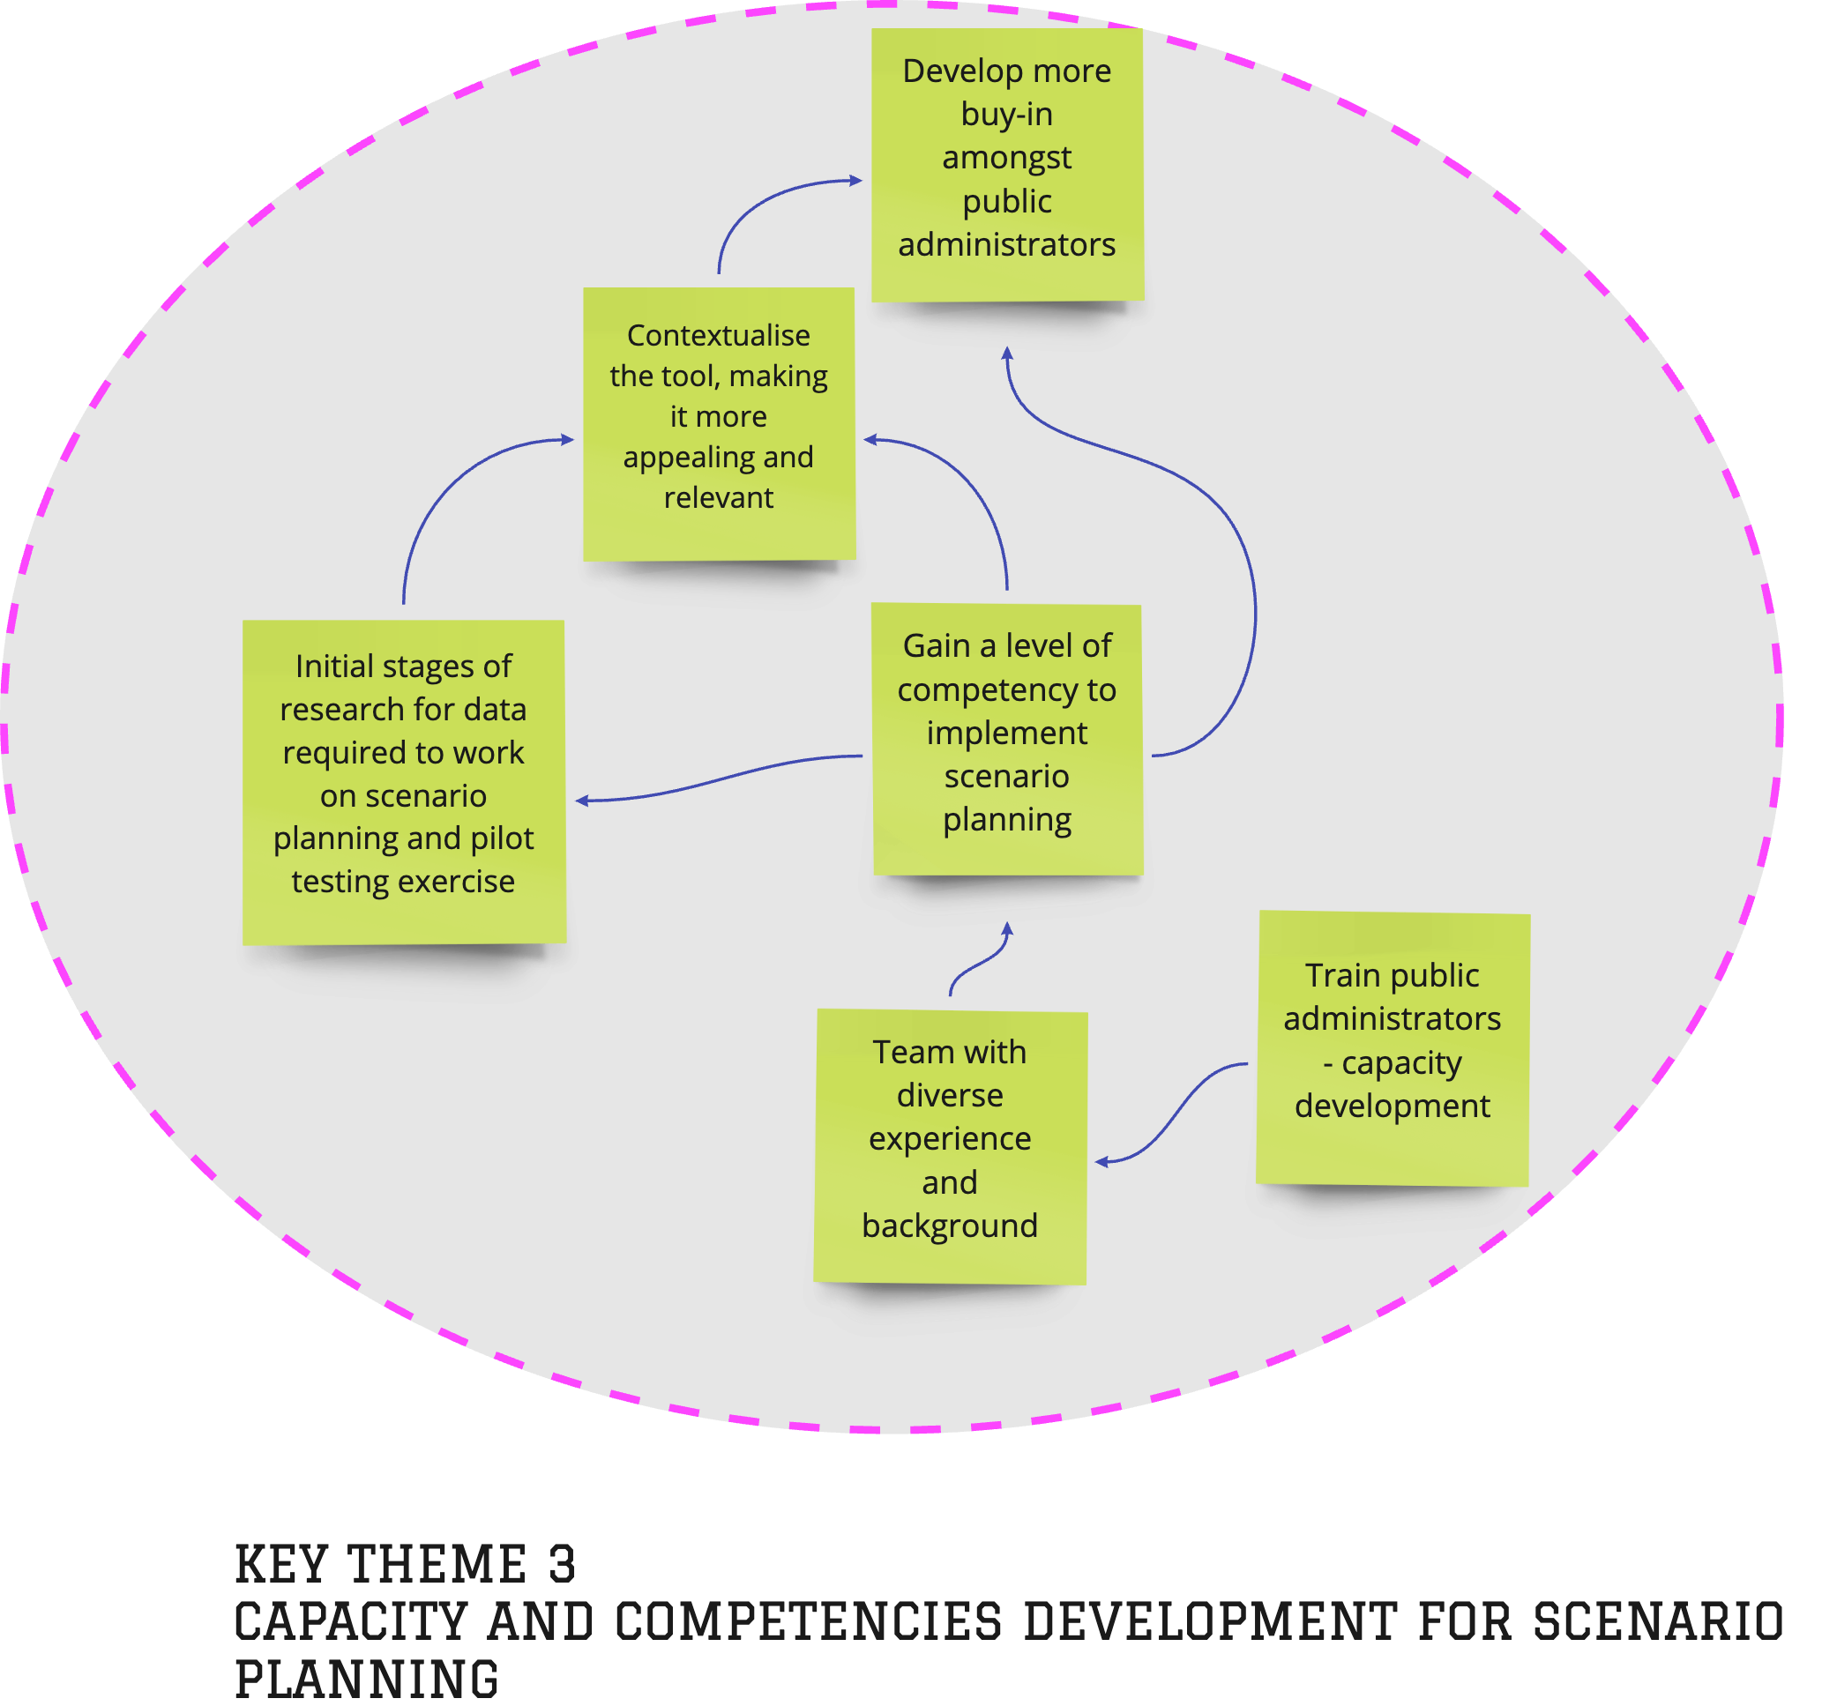
Figure 30: Key Theme 3—Capacity and Competencies Development for Scenario Planning.
- Scenario Planning Implementation requires skills, knowledge, and experience built over time
“Implementation of scenario planning takes skills and experience – something that could only be built/developed over time. One participant recalled the initiation of the staff training, “We identified leads within the public sectors who were trained in SP…Capacity building was part of the whole SP project from the beginning, and it does not come overnight, it takes time.” – (Core 1)
“So, can you train a cohort of 40 to 50 key individuals across the Abu Dhabi government well and its divisions, and it all went to divisions? So, they become scenario planning literate. They can then help us design and build an organisation that they would sit at the centre under the executive council that will champion a scenario planning for Abu Dhabi and the broader UAE” – (Participant 6, Project Manager)
“Everybody got trained. Everybody participated in trying to look at what the potential scenarios could be, and what would happen under those scenarios. So, you ended up with this document, The Future of Human Capital. I think that was shared with the people who were there.” – (Core 3)
“Adequate human resource for effective project management is a critical parameter. The expertise and leadership of a project manager, an analyst, and an expert coach would be pertinent for an initial time of three months for a standard scenario planning project to be initiated to reach a reasonably productive state.” – (Consultant 1)
“Based as a senior partner, we have an ABC on responsibility for the relationship and projects, for example, the workshop on human capital, I lead that workshop. I didn’t drift to get involved in some of the training sections. So, XYZ led and that with another colleague of ours that led the two of them to lead the training session number 3 that were kind of cool modules that people worked through.” – (Consultant 2)
“There was a lot of documentation, a lot of best practices shared. A lot of materials were transferred and some great programs including Don who is fantastic in training and so on. He came over and helped the achievement with a development program and capability building programs” – (Consultant 2)
“Then we had a project team of consultants in the ground who happened to put together some of the research. Some organisations design and implement, but I have a soul, but in terms of the actual kind of workshop that’s the thing I directly led.” – (Core 2)
- Skill-sets for scenario planning
The skills and experiences of those carrying out the scenario exercise and those who played an active role in the selection or negotiation of the scenario methodology contributed heavily to the success of the scenario planning project. The hiring of GBN also contributed to the success, since GBN was already known for assisting organisations in adapting and growing effectively and responsibly in the face of mounting uncertainty. GBN was the leader in the application of scenario planning and played an integral part in its evolution. GBN integrated this expertise with experiential learning; insights from a diverse network of experts and visionaries; and other strategic tools, which actively benefitted the intervention.
- Customised approach
The approach for implementation must be contextualised and designed to fit the needs of the government. In this case, the participants came up with a specifically tailored design proposal for the Executive Council of Abu Dhabi.
“We came up with an articulated and very clear specific tailored design for the executive council for Abu Dhabi. In terms of the type of organisation that needs to have a sensor recognising a key part of that will be the network of people that you will have across the various departments. A couple of departments cannot be officially part of a central ‘group’. It will be part of a broader network that can perpetuate, propagate scenario thinking and lead initiate projects in various invested divisions, in different departments. Then we had a very successful highlight program which focused mainly on the future of Abu Dhabi talent.” – (Consultant 2)
- Key members with diverse backgrounds and experience within the government
It seems that the Abu Dhabi government found the right formula for success with respect to the participants that were involved in the initial implementation. The team consisted of individuals with the right interests and experience to contribute to the success of the project, and often included experts from outside the organisation who brought in their unbiased and fresh perspectives. The participants included the GSEC core team, as well as government/public employees associated with various entities.
The core team itself was comprised of educated individuals with diverse backgrounds (Public Police, Strategy, Performance, etc.) who complemented each other. The team included individuals with a relatively strong knowledge of the public sector in Abu Dhabi, who understood the challenges and the gaps in governance. A clear understanding of the roles among the core team was also noted:
“I was the lead in the project, my team and I as a sector were in charge of initiating scenario planning – we have had prior experience working in the public services and have worked on policy formulation.” – (Core 1)
“Sit and talk with GSEC (Core Team) So, whatever is needed to get it approved and get it done. And to support that GBN team and my team, we had GBN and then the policy and strategy team and we worked together, but they were the drivers.” – (Core 3)
Key Theme 4: Scenario Planning Potential s
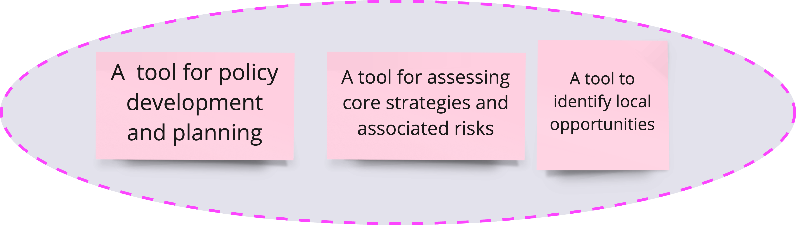
Figure 31: Key Theme 4—Scenario Planning Potentials.
As with any government, Abu Dhabi faced numerous uncertainties and was challenged to review and re-assess existing strategic plans. The interviews provided the reasons for adopting a scenario planning-based intervention tool. These reasons were essentially the potentials of scenario planning, which include the following:
- An approach to dealing with uncertainties and driving forces of change
“We have a lot of uncertainties; and variables around us, such as budget concerns, oil prices, and even the education outcomes, so we wanted something to help us to look forward” – (Core 1)
“The question then at that point became, are these the right goals? Are these the right outcomes? How do you prioritise them? What if there is a different set-up or a different environment? If the environment changes, then what happens? Would these still be the right outcome policy goals?” – (Core 3)
- The need for horizon scanning for driving forces of change
“Because Abu Dhabi was a natural resource economy, right? the elements that they can and cannot control are very limited, we chose scenario planning because of the local view, of what is going to happen to the natural resource economy. So, the scenario planning was chosen in the context of what we cannot control, right? As a tool to assess the core strategy to move forward.” – (Core 4)
“Then while doing policy agenda, strategy and performance, then we realised okay what are the main gaps for the system and also the things that need to be covered or worked on by Abu Dhabi government…So it was getting insights what is needed for the coming period…” – (Core 2)
- Using scenarios for wind-tunnel strategies and options
“While looking into different solutions and options to close the gap, Abu Dhabi government leadership suggested performing simulations using “what-if” scenarios, which initiated a substantial amount of dialogue between the leadership and the SPPM team. The result was the introduction of three new projects. We brought expertise from different places, and we did a peer review. The aim at that time is to test the available tools and come up with manual or handbook that can guide anyone when it comes to policy formulation.” – (Core 1)
The United Nations had successfully adopted the simulation technique. Hence the Abu Dhabi government wished to adopt the technique.
“There was a proposal from the economic council where they wanted to build a model, which is used by also the United Nations. We went with it, and we created a name for it, which is about input, and output relationships, and see what the impact will be for the future. That project also continued for a while but then we started again in the competency because simulation is difficult and as well as the readiness of the interviewers to provide the right data.” – (Core 2)
“The team struggled with some difficulties associated with the technology used, as well as the data needed to build the model which required collaborative efforts with the economic council in Abu Dhabi. The project continued for some time, but it was difficult to capture future foresight, leading to one team not pursuing simulation.” – (Core 2)
There were also problems associated with the existing platform and consistency of the input data, which inspired the team to keep searching for another tool to meet their needs.
“The team agreed on the need for tools that ensured that policy choices made today, would be resilient to unforeseen circumstances in the future. This gave rise to the option to pursue the development of scenario planning and socio-economic simulation capabilities across ADG.” – (Core 4)
A suggestion was implemented to visit some of the leading organisation to evaluate the systems currently in use and their suitability in the context of the Abu Dhabi government and public sectors. As explained by the GSEC project sponsor, “We benchmark other countries' experience and how they utilise SP within their planning activities. So, we decided that SP will become one of the processes in the policy formulation within AD government and should be part of the process before submitting it to AD leadership.” – (Core 1)
The intention to adopt scenario planning in the AD government from the beginning was to create awareness and dialogue with the ambitions for embedment of SP within strategic planning and policy formulation process in the public sector. Therefore, the team participated in a visit to a company named Millennium, based in Washington DC, USA, and subsequently to GBN, which was based in San Francisco, USA (Core 2). As explained by the GSEC Project Sponsor:
“I was handling the policy and strategy formulation in government, so my priority was to come up with the pool of tools that helped me to develop and form policies or develop and review strategies.” – (Core 1)
Scenario Planning for Policy Formulation: “We decided that SP will become one of the processes in the policy formulation within AD government and should be part of the process before submitting it to AD leadership.” – (Core 1)

Phase 1 Findings Summary and Discussion
The findings from Phase 1 of this study empirically documented the factors influencing the implementation of scenario planning in the Abu Dhabi government. This study was a tremendous opportunity to gain deep insights into what worked and what did not for public sector scenario planning in the Middle East region. The knowledge gained from this study informs the development of a framework for the foresight ecosystem for the Abu Dhabi government.
The four key themes that emerged from the interviews conducted with ten senior government officials based on their experience gained from Intervention 1 include:
- Leadership commitment and sponsorship, and stakeholder engagement and buy-in for scenario planning are important for strategy and policy development
- Scenario culture needs to be instilled within the government across all public organisations
- Capacity and competencies development is important for scenario planning, and
- An appreciation for scenario planning needs to be developed.
Leadership commitment and sponsorship are crucial for the rolling-out of a governmental project of this scale. For Intervention 1, the Abu Dhabi government was 100% behind the initiative, providing the much-needed resources and funding for implementation. The Government Support Executive Council of Abu Dhabi successfully led the creation of a series of networking, skills development, and awareness-raising events around scenario planning, but the initiative has yet to achieve significant, sustained integration of systems thinking with policy development. This did not come as a surprise, as Intervention 1 was new, and many public administrators lacked the required skills or knowledge.
The roll-out of Intervention 1 relied heavily on the support of external consultants and experts. There are benefits of engaging consulting experts at an early stage of implementation. The consultant’s presence provides confidence in getting engagement and buy-in at different levels within the government. The consultant-led implementation/ intervention allowed public managers to recognise the skills and knowledge required for each step of the way and, in a way, emphasised the need for capacity development for foresight and planning within the government.
The Intervention has successfully sparked interest and created a significant level of awareness regarding scenario planning as part of the strategy development process. This perhaps has provided a foundation for foresight and scenario planning efforts within the government. The leadership was looking for something the entities could use to manage uncertainties and the rapidly changing socio-economic environment in their effort to remain relevant (Cummings and Worley, 2001). They aim for decisions and policies to be evidence-based. They want strategies developed from robust and vigorous analyses; hence scenario planning was introduced. The efforts to inculcate future thinking and scenarios culture take time. Scenario planning as an intervention to spark change, as in this Intervention 1, can potentially affect the lives of public managers (Georgantzas and Acar, 1995, Van der Merwe, 1994) across the entire government, affecting the type and process of work being done. How did those effects impact the decision-making capabilities of public managers? How did they feel about using scenarios for planning and strategy development? These questions were explored in Phase 3 of this study.
Many public administrators felt that they needed the skills and competencies required for scenario planning and welcomed the operations manual and a guide/framework for implementation.
The next chapter presents Phase 2 analysis and findings focusing on expert opinions and viewpoints on good practices for scenario planning.

PHASE 2: ELICITATION OF EXPERT OPINION

Introduction
Chapter 5 presents Phase 1 of the study, providing an understanding of the nationwide initiative of integration of scenario planning for policy and strategy development (known as Intervention 1) and based on the opinions gathered from public administrators, pulling together a list of factors influencing scenario planning implementation. Following that, this chapter presents Phase 2 of the study, which focuses on drawing from expert knowledge about scenario planning (i.e., approach and methodology), the factors influencing implementation, the differences between the public and private sectors, and what implementation success means. This phase aims to expand the knowledge on the factors influencing scenario planning implementation by consulting the experts.
The data for this phase were collected from a series of interviews with six experts conducted from June 2018 to January 2019.
The chapter begins with reiterating the objective of Phase 2, participant profiles, data collection tool design, the set of interview questions, data analysis process, and findings.

Objective of Phase 2
The objective of Phase 2 is to elicit expert opinions on the factors influencing the effective implementation of scenario planning.
Research Question 4:
From the expert’s point of view, what are some of the factors contributing to the success and failure of scenario planning in general?

Participant Profiles
Six scenario planning experts were selected to participate in the second phase of this study. These experts worked with premier organisations that are also known for their practice and implementation of scenario planning.
Affiliation of Expert | Position in Organisation and Track Record with Scenario Planning
Centre of Strategic Foresight – Singapore | Deputy Head, Centre for Strategic Futures & Senior Assistant Director (Strategic Planning & Futures) Strategy Group, Prime Minister’s Office
Thinking Future | Founder Foresight Futures. Foresight advisor/researcher. PhD on new conversations about university futures. Seeking the new in the present.
Shell UK | Chief Political Analyst, Global Business Environment team at Shell International in London. He is an active scenarios practitioner, focusing on using scenarios in future thinking, with over 20 years of experience in leading and advising on country scenario projects.
Trilateral Research | The director leads Trilateral’s Innovation & Research service in overseeing the progress and implementation of TRI’s research projects and in developing proposals for new projects in diverse areas of interest to TRI, such as cybersecurity, artificial intelligence, data protection, ethics, the environment, inequalities and democracy, and socio-economic impact assessment.
The Monitor Group / Global Business Network (GBN) | Over 20 years of experience in scenario planning, he worked with the Monitor Group that eventually purchased GBN early in his career. Worked with Peter Schwartz and consulted with government, non-governmental organisations (NGOs), banks, the World Economic Forum, and Finance Singapore.
The Monitor Group / Global Business Network (GBN) | Works with GBN and Morgan Stanley focusing on internal support to Morgan Stanley while applying the same techniques to clients worldwide (EXP6). Early in his career, he was in the software technology business and got involved with strategic planning for understanding the impact of the internet on financial services and markets.
Table 24: List of Phase 2 participants.

Data Collection Tool Design: Interview Questions
The list of questions was designed to elicit expert opinions based on their experience working on scenario planning. The interviews intended to encourage a conversation about scenario planning on what they have learned from their years of practice, how the practice has evolved, their experience with things that worked and didn’t work well, some recommended methodologies, what to avoid, and their recommendations on how implementation can be improved or enhanced to provide a better experience for decision makers/users.
A series of six interviews were conducted. All interviews were voice recorded for reference and transcribed for reference and analysis purposes. In general, an interview lasted for 90–120 minutes. The list of interview questions is presented in Table 25:
Elicitation of Expert Opinion
Interview Questions
Personal Information
- Please tell me about your background in Scenario Planning. When did you begin working in this field?
- At which kinds of organisations have you undertaken scenario planning?
- What kinds of projects have your undertaken? What was your role in these projects? Could you kindly offer me several examples of the kind of work you did?
Definition/Concept
- In your opinion, what is Scenario Planning?
- In your opinion, are there any aspects routinely labelled as Scenario Planning that you believe are not? Which ones? Why do you think they should be excluded?
- How has the practice of Scenario Planning evolved in the last 10 years?
Application of SP
- In the projects you were engaged with, what were the main objective/s of scenario planning?
- Does the objective vary from government, private, and NGOs?
- Are there projects you know or have participated in where Scenario Planning was applied, although it did not seem a suitable tool to you? What made Scenario Planning unsuitable in these cases?
Methodology
- What steps, if any, do you generally follow when undertaking scenario planning? Please explain why you undertake each of these steps.
- Have you typically followed the same set of steps for all types of projects, in all countries?
If not, what factors influence the design of the scenario planning process?
Enhancement of Scenario Planning
- Do you usually combine scenario planning with other foresight methods, or do you do it as a standalone method?
- (If yes, above), which other foresight methods do you combine with scenario planning, and what value do they add to the process, or how do they augment scenario planning?
- Do you utilise these combination(s) in all cases or specific types of cases, and if so, which ones and why?
Stakeholders and participants
- Who usually initiates the process, top management, or department management, and what difference does it make in your opinion?
- Which kinds of stakeholders have typically been involved in the Scenario Planning projects you have undertaken? Which kinds of stakeholders do you feel should have been involved but were typically not involved? Why have these kinds of stakeholders been typically left out?
- Typically, is your involvement in a Scenario Planning project collaborative with the client organisation or a consultation arrangement? Which arrangement works best in your opinion? Is it best for all kinds of projects or just some?
- How do you involve time-poor senior members and decision-makers?
- How does the sampling of participants affect the success of a Scenario Planning intervention?
Scenario Planning in the Public Sector
- How is scenario planning in the public sector different from private sector scenario planning?
- How do you meet the challenge of politics and organisational complexity in public sector scenario planning projects?
- How do you go about ensuring scenario planning is linked to policymaking in the public sector?
- How do factors such as leadership, participant competencies, and organisational culture and structure impact the degree of adoption of the tool in the public sector? Which other factors are likely to affect the success of a scenario planning project?
Challenges
- Are there any limitations to using Scenario Planning techniques? If so, which ones?
- Which types of expertise and skills were necessary? (Types of capabilities, facilitators, participants' qualifications)
Measurement
- How did you go about assessing the success or failure of scenario planning projects?
Table 25: List of Phase 2 interview questions.

Analysis
The data from Phase 2 were limited to the interviews conducted with the six experts. Hence, rather than using an extensive coding and thematic analytical process, the data were examined by eye and summarised for the data reduction process; appropriate approaches to data display were used for each set of analyses. For example, tables were used to display the part of the analysis regarding defining scenario planning; cognitive mapping was used to structure and make sense of the methodology for scenario planning; a table was used to display the comparative analysis between public and private sector scenario planning; and finally, summaries for clusters of codes and the emerging themes on factors influencing implementation were created.
The information gathered from each expert builds, expands, and informs the scenario planning phenomenon rather than validating one another. The analysis section comprises four sections: defining scenario planning, methodology and implementation process, public and private sector scenario planning, and factors influencing scenario planning implementation.

Defining Scenario Planning
When the experts were asked to explain what scenario planning is, they were essentially describing how the approach can be used and why it can be a useful/helpful approach in thinking about the future. The themes emerging from the data are displayed in Table 26 and Table 27 below.

Scenarios: recognising there are different possibilities; a technique for developing stories about the future; is a structured and information-rich process designed to help people move beyond today’s constraining cognitive assumptions about the future
“The scenarios element is about recognising that there are different possibilities when we look into the future. So, what are those different possibilities of the future that we are looking at? To understand that you must understand the present, where we are today, and we've talked about that, different understandings of the present. From different understandings of the present, we look at different possibilities in the future. Now, that’s the word scenarios, stories about the future. The next one is planning. Why? Why do we do that? Because we need to plan for the future and a big company does it through developing strategy.” – (EXP3)
“Scenario planning is a technique for developing stories about the future that are relevant to the decisions that leaders need to make today.” – (EXP5)
“Is a structured and information-rich process designed to help people move beyond today's constraining cognitive assumptions about the future to be able to identify multiple possible futures for themselves or their organisation?” – (EXP2)
Table 26: Scenarios as stories about the future.
Scenarios: challenge pre-conceived ideas and dominant assumptions about the future; sensitise and create an awareness and appreciation for forces of change and the unpredictability and volatility of the future
“Scenario planning can also be seen as a change management tool: specifically, a way to sensitise the participants in the process to indicators of change and the unpredictability and volatility of the future.” – (EXP1)
“It’s a way of challenging your pre-conceived ideas about how the future will unfold and can enable you. You’re therefore left with the ability to bet on a strategy rather than bet on a single future or single outcome.” – (EXP6)
Table 27: Scenarios challenge pre-conceived ideas and dominant assumptions about the future.

Methodology and Implementation
In the responses to questions about methodology, the experts described the sequence of activities at different points of the implementation process. A cognitive map was used for this analysis to visualise the sequencing and the links between components. The inputs from each expert were written succinctly in shortened phrases as concepts for mapping purposes. Figure 32 below shows the flow of the scenario planning process as described by the experts.
Some approaches to scenario planning might differ due to differing focal questions or the client's preference and competencies, but the principles underlying the use and implementation of scenario planning are the same.
“Every approach is different because the question being asked is a different one, but the principles underlying how we do it are the same. The actual process may be different because it is a different topic, but the principles are the same.” – (EXP3)
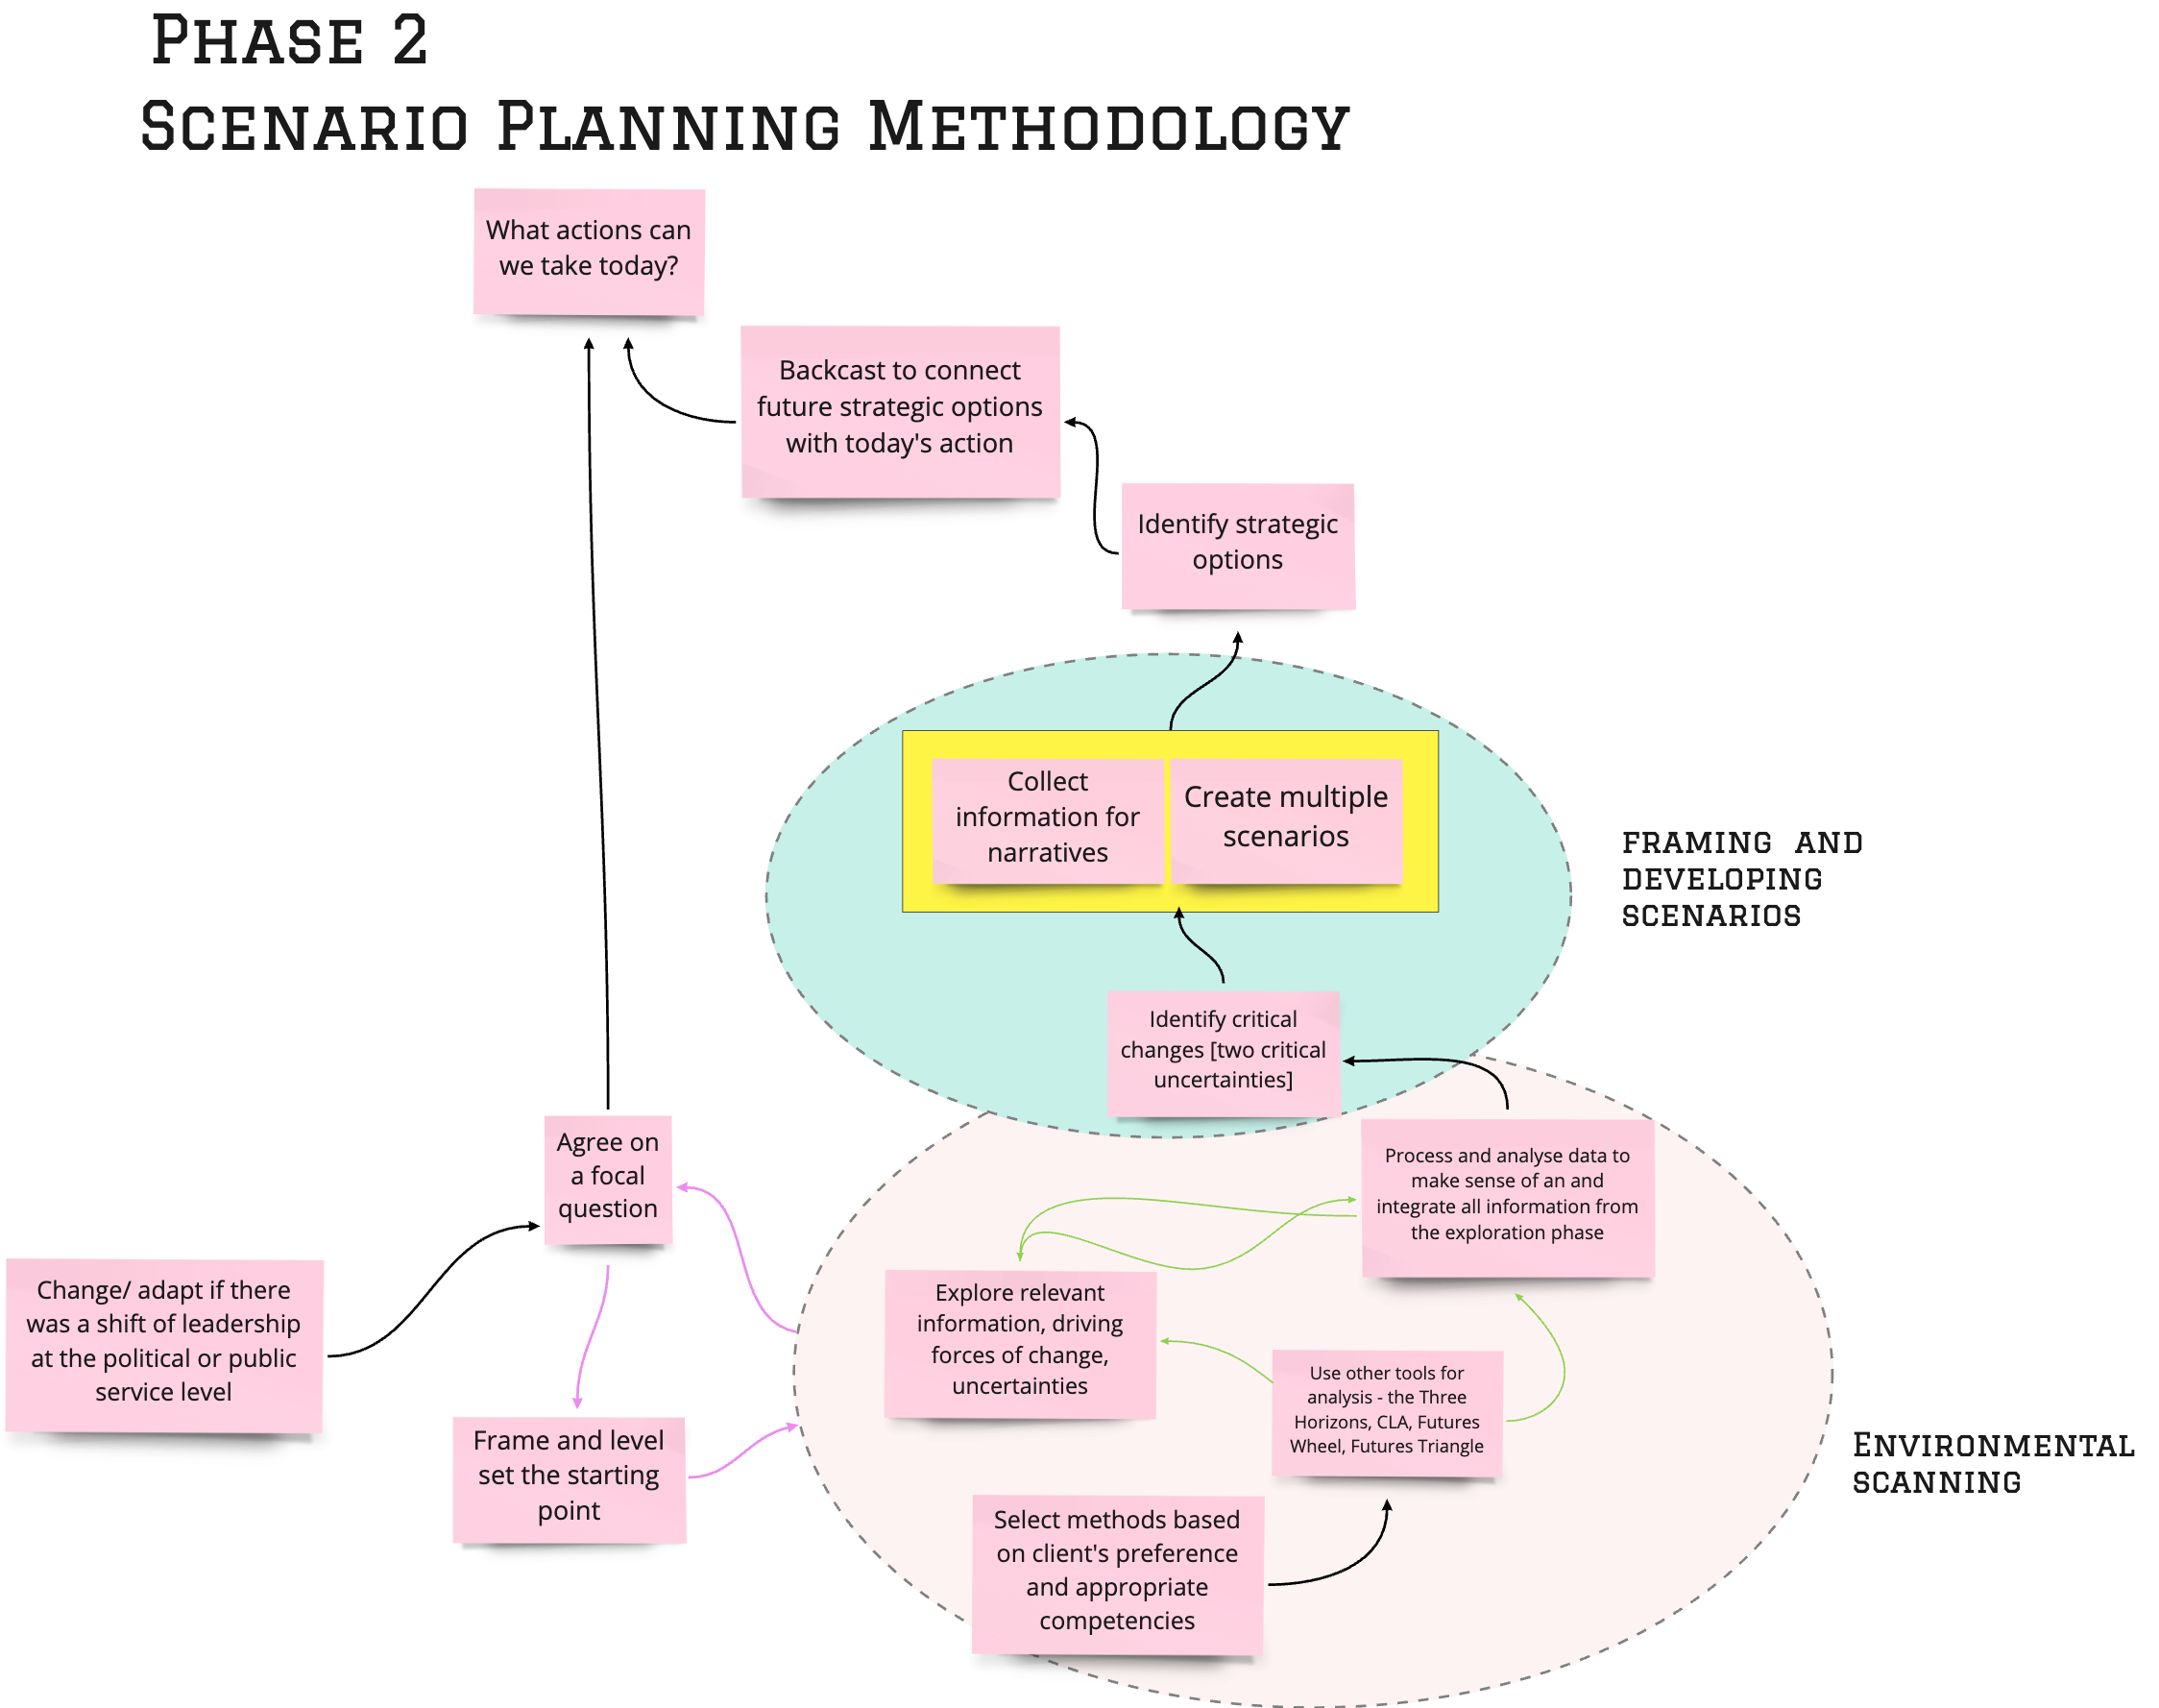
Figure 32: Scenario planning process based on expert opinion.

Public and Private Sector Scenario Planning
The only significant difference between public and private sector scenario planning lies in the goals, objectives, and capacity to think long term Table 28 presents the summary of the emerging theme and the associated transcripts for public versus private sector scenario planning.

A comparative analysis of public and private sector scenario planning
Goals and Objectives for Scenario Planning and the capacity for thinking longer term
“I think the one thing I would say about working for government and private organisations, typically they’re facing less commercial and market pressure, but they do sometimes have a greater capacity to think long term.” – (EXP6)
“The objective does vary. Government usually wants a clear outcome so that the process and its cost can be justified. There's a lot more reporting for government clients. Non-government clients want outcomes that they can use immediately as input into strategy development, and my experience has been they are surprised when they begin to understand that the value of changing thinking about the future and how we anticipate it today is as important as the tangible outcomes.”– (EXP2)
Table 28: A comparative analysis of public versus public sector scenario planning—Phase 2.

Factors Influencing Scenario Planning Implementation
The data for scenario planning implementation was coded and thematically analysed (Table 29). Five key themes emerged from the analysis.
These themes were then structured using a cognitive map to understand the links and relationships between themes in making sense of the factors influencing scenario planning as described by the experts, see Figure 33 in the Findings section below.
Clusters of Codes | Emerging Themes
Simple, engaging presentation and clear relevance to the given context and audience and enable them to link it to their specific context, i.e., match the sector and type of organisation | 1) Decision and policy makers need to see how scenarios are relevant—how they can use the stories/narratives for decisions in a specific context
“Use scenarios to show how things that could go wrong”, “that created a kind of (...) earthquake for them (...) because they never considered all of these impacts on privacy, data protection, all of the ethical issues.”
A realisation that the future’s going to be very different from the present and the past, (...) people see more value in doing scenarios
“Leaders grasp the value of scenarios and the ability to bring their managers along on the scenarios journey, then projects will fail”. | 2) Leaders have an acute awareness of the impacts and implications of environmental factors; understand the context within which the government operates; and appreciate the value of scenario planning for strategy development and decision making—essential to lead/ sponsor scenario planning exercise/project
A clear understanding of the values and potentials of scenario planning
Understanding the context and environmental factors
There needs to be a problem that requires a solution
An open mind to connect the past, present, and future | 3) Mindsets of leaders—open to new ideas, different points of view and perspectives, awareness of time required, of the limitations of different planning tools; a need for double loop learning rather than placing blame and punitive actions.
An open mind to being willing to discuss and accept different points of view, as well as understanding your limitations
Open to using/trying different tools for planning and supporting the decision-making process
Willingness to devote time and wait for long-term results
A recognition for double loop learning, i.e., when something didn’t go as planned, ask why, what did we miss, what did we learn from the process/experience
Being realistic with the time required for the team to learn and get a grasp of the idea of using scenario planning
Raising awareness among a variety of stakeholders | 4) Getting engagement and buy-in to the project through education and participation in workshops; commission expert knowledge and skills in facilitating workshops and engaging the right groups of stakeholders for workshops
Teamwork and discussions, and sharing responsibility
Resistance due to experience with a failed project
Key decision makers' participation in workshops
Educating decision-makers and stakeholders about some megatrends or big shifts in the socio-economical- technological-political milieu
Commissioning experts to facilitate workshops and discussions
Monitoring, supporting, and upgrading the process | 5) Review and refine scenarios and narratives with a wide range and diverse audience—an opportunity to educate people about scenarios and how we can use them
Networking and knowledge exchange
Important to involve “a lot of people” and “a diverse group of partners” to review iterations of narratives for scenarios
Transparency and educating the public
Table 29: Clusters of codes and emerging themes on factors influencing scenario planning—Phase 2.

Phase 2 Findings
The findings for Phase 2 are presented in five parts.
- Defining scenario planning
- Methodology and implementation
- Public and private sector Scenario Planning
- Factors influencing Scenario Planning Implementation
- What does successful implementation look like?

Defining Scenario Planning
Scenarios allow for the recognition that there are different possibilities. They are a technique for developing stories about the future. Scenario planning is a structured and information-rich process designed to help people move beyond today’s constraining cognitive assumptions about the future. Scenarios challenge pre-conceived ideas and dominant assumptions about the future; help sensitise and create an awareness and appreciation for forces of change and the unpredictability and volatility of the future.

Methodology and Implementation Process
- Begins with a focal question
The implementation process begins with a focus on a central issue; the senior management team and decision makers start with a consensus about the focal question for the scenario development process (e.g., Human Capital for Abu Dhabi 2030). This helps frame and set the environmental scanning analysis's starting point and scope. Sometimes the findings from the environmental scanning inform and further refine the project's starting point, scope, and focal question. This is an iterative cycle.
- Environmental scanning
The environmental scanning analysis is a diagnostic exploration phase of researching and analysing the driving forces of change to identify critical uncertainties. Using frameworks such as the Three Horizons, Futures Wheel, and Causal Layer Analysis helps structure and draw out patterns of impacts and implications of the fundamental driving forces of change facing the Abu Dhabi government.
“There is a kind of diagnostic exploration phase that happens in all projects really to help to frame, and level set the starting point. There then needs to be some way of digesting, integrating all the information, the driving force and uncertainties and whittling it down to a more manageable set, which you can then use to start to construct the narratives.” – (EXP6)
“The steps I usually follow are: Agreeing on the 'focal question' that needs to be answered; environmental scan; analysis and interpretation of change identified in the scan; identifying critical changes likely to have the most impact on the organisation's future in the context of the focal question; creation of multiple scenarios; identifying strategic options for the organisation in the future; back casting to connect the future strategic options with action today. These steps are fundamental to the scenario development process and are designed in a way that enables people to think more openly and deeply about the future.” – (EXP2)
“Scenario planning necessarily involves other methods as part of the process. For me, the creation of the scenarios themselves doesn't happen in isolation and thinking needs to be contextualised. For example, for analysis and interpretation of the environmental scan, I might use The Three Horizons, Causal Layered Analysis, Futures Wheel, and Futures Triangle. The process for constructing the scenarios is the four-quadrant approach. The choice depends on how 'futures ready' the client is. Simple methods are usually better for people who haven't used scenarios before.” – (EXP2)
- Identification of critical uncertainties and framing scenarios
Once the environmental scanning analysis stage has been completed, the analysis draws out the two critical uncertainties, which form the two dimensions that frame the development of the four possible scenarios (based on the 2X2 matrix method).
- Scenario narratives
Narratives were created for each of the four scenarios. Once the framing has begun, it might come to light that there were aspects of the phenomenon that require more research. Hence the process cycles back to environmental scanning. This is an iterative cycle.
The scenario planning process is generally standardised, and although the approaches or frameworks might be different, the principles remain the same: what is and why scenario planning.
“The core process is described as seven steps or eight steps, but you’ve seen those steps and it starts with developing the focal question and it ends with exploiting the location. So, the core steps – yes; the customisation happens just below the core steps.” – (EXP5)
“The core work that we do is always called scenario planning. The process itself has evolved. When we started, we borrowed the process from Shell. We’ve adapted it along the way, more organically to suit the needs of the team at the time, as well as the government of the day. Because every time we do a scenarios exercise, the leadership will have shifted a little bit, but if not at the political level, then just maybe at the public service level. Thus, we will adjust to make the content work in that context. But we call it scenario planning all the time.” – (EXP1).
- Back casting and wind tunnel strategies
Using the set of scenarios, decision makers can then develop strategic options based on each narrative; or use the scenarios to wind-tunnel some of the proposed core strategies before they are rolled out. Scenario planning ultimately provides a space to consider the decisions and actions that can be taken today with a longer-term view in addressing future issues.

Public and Private Sector Scenario Planning
On how scenario planning differs between the private and public sectors, the responses formed a set of criteria for comparisons as presented in Table 30.
The findings reveal that scenario planning is similar for both public and private sectors except for a glaring difference: the goals, objectives, and accountability.
The public sector must account for the taxpayers' money spent on every initiative and project and has a statutory requirement to publish reports on achievements accounting for the costs, impacts, and outcomes. In comparison, the private sector requires urgent input for strategy development for agility in responding to the competitive environment and market pressure.
The public sector has a greater capacity for longer-term thinking, while the private sector tends to move too quickly; strategizing with a shorter-term view could be damaging in the longer term. The private sector needs to learn to appreciate the value of long-term thinking and be better at anticipating and preparing for the future.
Criteria | Private | Public
Goal/Objective | Need to respond to commercial and market pressure | Have greater capacity for longer-term thinking
Goal/Objective | Need urgent input for strategy development; learn to appreciate the value of thinking about and anticipating the future. A focus on translating strategies into outcomes | Accountability and public reporting for costs and impacts, and outcomes
Table 30: Comparative analysis of public and private sector scenario planning.
“I think the one thing I would say about working for government and private organisations is because, typically, they’re facing less commercial and market pressure, but they do sometimes have a greater capacity to think long term.” – (EXP6)
“The objective does vary. Government usually wants a clear outcome so that the process and its cost can be justified. There's a lot more reporting for government clients. Non-government clients want outcomes that they can use immediately as input into strategy development, and my experience has been they are surprised when they begin to understand that the value of changing thinking about the future and how we anticipate it today is as important as the tangible outcomes.” – (EXP2)

Factors Influencing Scenario Planning Implementation
The findings for this section consist of five components that are influential for scenario planning, namely:
- Leaders must have an acute awareness of the impacts and implications of environmental factors, understand the context within which the government operates, and appreciate the value of scenario planning for strategy development and decision making.
- Mindsets of leaders
- Review and refine scenarios and narratives with a wide range and diverse audience as an opportunity to educate people about scenarios
- Understand the relevance of scenarios
- Getting engagement and buy-in to the project through education and participation in workshops
Using the cognitive mapping convention (Eden and Sims 1979), the concept at the bottom informs/enables/influences the concepts at the top. The importance of a concept is denoted by the number of arrows in and out of the concepts, demonstrating the activities that require that concept.
The map on the below figure reveals that two concepts are ‘busy,’ with four arrows connecting them to the others. These two concepts are (i) the mindset of leaders and (ii) decision-makers need to see how scenarios are relevant and how they can use the stories /narratives for decisions on identifying strategies and developing action plans. The concept right at the top of the map, getting engagement and buy-in to the project through education and participation in workshops, is the core factor influencing scenario planning implementation. There might be leaders with the right mindset who are committed and support the project 100%, the team might be educated about scenarios, and decision and policy makers might see the relevance of scenarios, but without buy-in, scenarios and narratives will not be acted upon.
The following sections discuss each component in detail. The discussion begins with the bottom concept on the map.
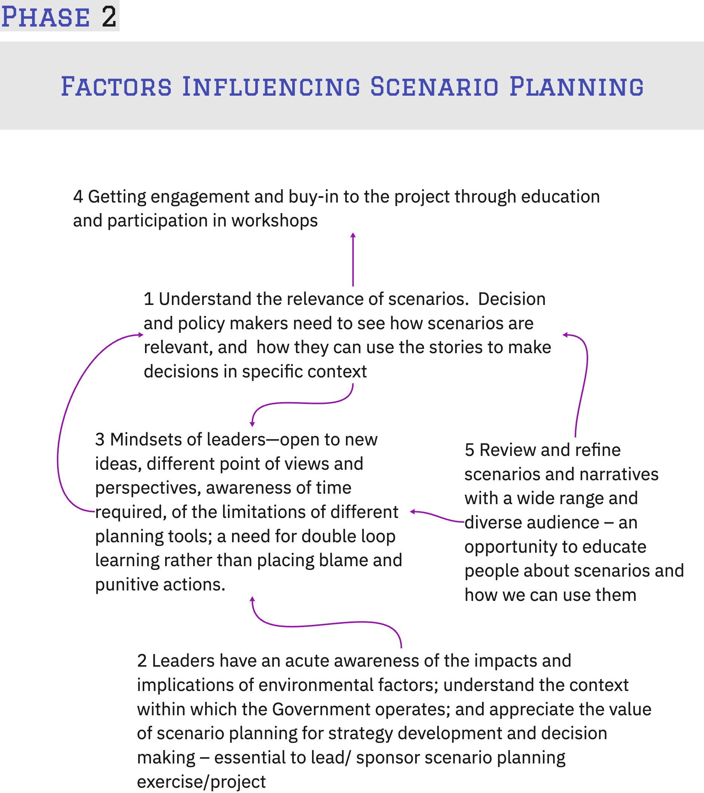
Figure 33: Factors influencing scenario planning implementation, Phase 2.
- Leaders who have an acute awareness of the impacts and implications of environmental factors and appreciate the value of scenario planning
“The biggest factor contributing to the success of a project is a sponsor who believes in the value of scenario work and commits to using outcomes in the organisation in a very visible way.” (EXP2) “Context is all-important, framing is all important, sponsorship is all important and if these things aren’t in place, then often you’re better not doing a project at that moment in time and employing a different tool or a different approach and coming back at a later date to reassess if it is helpful to an organisation.” – (EXP6)
- Mindsets of leaders, open, willing to change and learn
Leaders ought to be open to new ideas, willing to hear different and opposing views and perspectives, question existing assumptions, and willing to learn from what went wrong and why things did not work as planned. “The implementation process ought to be action research where decisions are made, sometimes as an experiment and exploration. If and when things did not work as planned, find out why things did not work and take action to change the way we work or the process we use.” – (EXP6)
“For scenario planning to work, the leadership should be very enlightened and should be able to accept that they may not have all the answers. If the leaders misunderstand scenario planning, they will have difficulty if they bring along the managers who can lead to the failure of projects.” – (EXP6)
“The biggest limitation is cognitive, the ability of people to open up their thinking to the possibilities of the future rather than accepting “what is” today as the only answer to challenges. Being able to accept that assumption they have never questioned what is possible in the future is a challenge for many and can cause some discomfort.” – (EXP2)
“And very often we get pushed back because it’s hard for people who are operating entirely in the present, to connect the implications of a possible future to their current work. And it’s very natural resistance.” – (EXP1)
“You can’t do double loop learning when you’ve just completed a project, and you need space to reflect and watch your thinking evolve and then you come back, and you ask the question all over again as to how successful was the project? What did we learn, what did we miss, what did we catch? And critically – and this is the double loop question – why did we miss what we missed? Why did we have the blind spot that we had? Single loop learning: what were our blind spots? Double loop learning: why do those blind spots exist?” – (EXP5)
- Understand the relevance of scenarios:
Decision and policy makers see how scenarios are relevant and how they can use the stories or narratives for decisions in a specific context,
A tendency to apply scenario planning to projects for which they are not well-suited means that scenario planning efforts can also be met with resistance.
“The biggest limitation is cognitive, the ability of people to open up their thinking to the possibilities of the future rather than accepting “what is” today as the only answer to challenges. Being able to accept that assumptions they have never questioned about what is possible in the future is a challenge for many and can cause some discomfort.” – (EXP2)
“And very often we get pushed back because it’s hard for people who are operating entirely in the present, to connect the implications of a possible future to their current work. And it’s very natural resistance.” – (EXP1)
“One of the greatest limitations is people use it for problems that it shouldn’t be used for. So, limitation number one is we use it for some things for which it is not appropriate.” – (EXP5)
- Prejudices and biases can result in resistance
“Because we're all individuals we all have our biases, we all have our prejudices. Sometimes they're very obvious prejudices we know what prejudice or racism is because they're so obvious. But human beings are often what makes scenarios difficult because they don’t necessarily act rationally.” – (EXP3)
“You have people who think they’ve done it, and if it didn’t work out for them because it was done badly and therefore resistant to engaging again. You know, sometimes organisations are just too scared and won’t go there and you have to do a different approach and so we’ll go in and do scenarios through the backdoor essentially by using a different tool initially, but then people realise we do need to do a full-blown scenario exercise to grapple with the issues that they’re confronted with. So, you know it is about education; it’s about understanding the context, understanding their history and what they’ve been through and then trying to come up with a solution for them that’s going to be relevant and helpful to the client.” – (EXP6)
- Review and refine scenarios and narratives
With a wide range of audiences at different stages. The review process can be an opportunity to educate people about scenarios and how they can use them:
“So, we develop a kind of the first draft of the scenario, first iteration of the scenario, and then we will send that to all of the participants to make sure that our first draft of the scene reflects the discussion and hopefully they will make some comments or some amendments to the draft. Then we will create a second iteration of that scenario and send it to a wider, larger group of stakeholders, together with a short questionnaire, maybe ten questions. And ask those stakeholders to review the scenario and to respond to those questions. We want to get some qualitative reaction, maybe it's just a sentence to respond to those questions. And then when we get that feedback we'll create another iteration, so that will be the second iteration and then we'll send that to a still larger group of stakeholders. And then we'll create a third iteration. and send that to everybody on our contact list, post it on our website, and give it as much currency as possible. Then after some time, maybe six weeks or something like that, we'll take all the feedback we get from that third iteration and create a fourth iteration which we will regard as a stable scenario.” – (EXP4)
Engaging a diverse group for workshops, both internal and external to the organisation:
“There are three different types of people who need to get involved. One; are your kind of, key stakeholders, where, for whom the outcome of the project matters, and two; the physical knowledge holders; people who have genuine expertise in the topic that we are discussing. And then three, which can often be the most challenging group to identify, and to bring into the conversation, is what we call the creative and the curious, and these are people who will possibly see the future differently. They may be younger; they may be outside external people; they may be consultants, academics, clients, or sometimes, people who are just prepared to challenge constructively; a so-called official future that an organisation may have and will bring perspectives into the group and then we design a scenario workshop.” – (EXP6)
“You need to have that inside knowledge, in the organisation. At the same time, you need people coming from the outside, because the outside is like fresh blood, it refreshes your thinking so that you're not captured by the organisation and only think like the organisation, you can think more broadly. So, the qualities of the scenarios team are that multi-faceted dimension; many different elements, all complementing each other and the inside/outside perspective. Inside the organisation but also outside, because then if you're outside you can challenge.” – (EXP3)
Another factor that determines the success of scenario planning is the presence of experts during the process. Experts should be people who are knowledgeable in the field being discussed and should be able to answer any technical questions that may arise. It is very important to “have somebody very familiar with the scenario planning process.” – (EXP4)
“To start you need to have somebody who knows what they’re doing, and you need to have somebody good at engaging stakeholders”. Thus, skills are needed to recruit and engage stakeholders at the very initial stages. – (EXP5)
“Facilitators must be trained to use scenario planning approaches effectively and to understand how to run a process that deepens thinking about the future.” – (EXP2)

How does a successful intervention look?
There should be clear indicators and metrics during scenario planning to determine the success of the intervention. When it is unclear how the scenarios will be used, then the process is bound to fail. Will the scenarios be used to come up with a strategy, will they be used to generate risk management protocols, or will they be used to search for new opportunities? More importantly, does the process impact the way people think, did the team “get it right”, and has scenario planning been integrated with the organisation’s goals? This section discusses how they believe intervention success can be measured.
Pre-defined success criteria: Success or failure of a scenario planning project is challenging to achieve because there is both a tangible process and an intangible thinking shift that occurs. How a project will be evaluated is one of the things agreed upon at the beginning of the process and is determined by the client's desired outcomes. Sometimes, the impact of scenario work doesn't surface until sometime later. Therefore, the expert’s emphasis on the importance of setting up success criteria up front, before the project or study starts, is essential.
“There need to be certain criteria in place, if we face a situation where somebody wants to bring a project and yet some of those conditions aren’t in place, we need to have a conversation about how to make it happen in a certain way, so we can get the required resources and conditions that can give us the best chance of being successful.” – (EXP6)
“Government usually requires some form of evaluation report which can include a before and after survey to test people's understanding of thinking about the future before and after the process. I generally do a follow-up survey to get feedback about the process but that's to help me with future design rather than evaluate the project.” – (EXP2)
“We always say that in any decision that’s taken, whether it's a good or bad outcome our fingerprints are there; our fingerprints are on the decision. That's one thing. How strong those fingerprints are is a different story; sometimes it's very strong, and we shaped the outcome; sometimes it's a more light touch.” – (EXP3)
Evaluating a project by obtaining feedback is one method of measuring success as well as understanding whether people think differently about the future. In general, the experts hope to see evidence that they have made a positive change to the organisation they were working with.
Change the thinking and the way people think: Success can be measured by evaluating whether it changes how people think through scenario planning. The Singapore expert stressed how success is a function of this transition:
“I think the way to measure it is whether it changed the way people thought about policy, that they either implemented or were going to implement. If we’ve gotten our decision-makers to take a second look, bearing the future in mind, and they still think that this is the right way to go then even though there’s been no change I would argue that it’s still a better outcome because it’s a more considered approach.” – (EXP1)
“It starts to impact the culture, the way that people think, the way that they have conversations with each other, the way they’ll engage with each other, the way they think about the future of the business.” – (EXP6)
She also discussed the concept of shifting the window, as:
“We consider it our goal to shift the window of what people consider to be possible, to expand the conversation. If the scenario process has managed to shift the conversation, to make people reconsider their assumptions about what is possible? I would call that a win.” – (EXP1)
Getting it Right: Not only is the incorporation into strategy important but did the team get it right?
“There are two tests of success or failure. Did you get it right meaning from the different scenarios across the range 10 years later? Did what was proposed to happen within that range? Or was it something you never saw coming, something you dismissed as being so impossible you excluded it from your scenario? That's the first test.” – (EXP3)
Did we avoid a wrong decision, or not engage in potentially damaging activities?
“There are a couple of projects where we made some real decisions that had a significant positive impact on the business. Both where we decided to do something, but also in some cases where we decided to do nothing.” – (EXP6)
The use of the outcomes: Scenario planning interventions is considered as an ongoing learning process rather than a list of actions over the long term. To ensure ongoing positive impact from scenario planning, it’s important to embed scenario planning outcomes in regular planning processes of performance management and leadership discussions. It is vital to ensure scenario thinking and to see the world through the lenses of the organisation scenarios that are inherent in the management approach.
“The second test is the more important one which is, for a business company like Shell, what did the decision maker do with that information from the scenarios? Did he or she do something different from what he or she would have done without knowing the scenarios? And if you can impact that in a meaningful way you have succeeded, because you have made a tangible decision based on scenarios. If you fail to make that impact, then ultimately, however clever your scenarios are, you have failed. So that is a very iron test.” – (EXP3)
Follow-up: Follow-up is a process of revisiting a project once it is complete and reflecting on what was correct and any incorrect scenarios.
“One of the things you’ve heard from Shell and Singapore is that part of their success has to do with the fact that when they complete projects it doesn’t mean that they stick them in a drawer and never look at them again. It means you’ve got as much information from that project and as much learning from that project as we can derive from it now and let’s go back and the team is going to be here, so we just make it a part of what we do as we’re constantly going back to reflecting on earlier efforts and what we got right, what we missed and then importantly, really importantly, why did we miss what we missed?” – (GNB)
The idea that follow-up is an extension of the scenario planning process is not generally referenced in the literature. However, from the comments that have been cited, clearly, the experts feel that following up with an organisation that has embarked on scenario planning is important.

Phase 2 Findings Summary and Discussion
The series of interviews for this phase of the study elicited expert knowledge regarding approach and methodology, the factors influencing implementation, the differences between the public and private sector, and assessing implementation success.
The experts shared the approaches they commonly used for scenario analysis or the process of building scenarios without the detailed, step-by-step methodology, similar to the observations recorded by Chermack et al. (2001). The approach to scenario planning recorded here was an overview of the analysis process with many similarities to the methodologies developed by van der Heijne’s (1997) business idea for scenario planning; Schwartz’s (1991) conceptual overview of the scenario planning process; Ringland’s (1998) trend-impact analysis approach, and Shoemaker’s approach (1995).
The findings for this section consist of five components that are influential for scenario planning, namely:
Leaders must have an acute awareness of the impacts and implications of environmental factors; understand the context within which the government operates and appreciate the value of scenario planning for strategy development and decision making.
Mindsets of leaders
Review and refine scenarios and narratives with a wide range of stakeholders and diverse audience for buy-in and as an opportunity to educate people about scenarios.
Understand the relevance of scenarios
Getting engagement and buy-in to the project through education and participation in workshops.
The leadership component (items 1 and 2 above) in this finding is consistent with that of Rohrbeck’s (2010) Future Preparedness Barometer. The leadership orientation component includes the flexibility to adjust strategy mid-way, providing incentives to encourage and reward broader vision, senior management’s willingness to test and challenge basic assumptions, and the accountability for sensing and acting on weak signals. The Intervention 1 (Phase 1 of this study) demonstrates the senior management's willingness at the government's executive level to test and challenge basic or dominant assumptions of decision-making and policy development process. Intervention 1 evidently was a search for alternatives to enhance public management.
Reviewing and refining scenarios and narratives with a wide range of stakeholders and diverse audiences for buy-in and education would lead to a better understanding of the relevance of scenarios. This engagement process for buy-in also offers an opportunity to bring diverse groups of people together (Kahane, 1992, van der Merwe, 1994).
The adoption of scenario planning at a national level in the Abu Dhabi government (Intervention 1) was evidence of the shift from a rationalist school of thought, where strategising for the future lies with an elite few at the top, to a processual school of thought, where the entities install and create processes to make the organisation more adaptive and capable of learning from its mistakes (Argyris, 1977, van der Heijden, 1997, 2000). Intervention 1 also demonstrates the shift from a functional, hierarchical organisation that tends to “engage in centralised and bureaucratic planning to a network organisation with more divergence in goals that tends to approach planning with an emphasis on learning and space for dialogues for converging goals and purposes” (Galer and Van Der Heijden, 1992).
One of the basic characteristics of scenario planning was the idea of having multiple outcomes to challenging the assumptions of management. So one of the success factors would be that managers can adjust their thinking to see a wider range of possible futures (Chermack et al., 2001, Schoemaker, 1995). Another measure of success would be if scenarios were used to construct, challenge, and improve mental models (Senge, 1990; Senge, et al., 1999); or how managers think, learn, and feel about strategic situations and the attention they put into examining what they were most concerned about (Georgantzas and Acar, 1995). This was examined in Phase 3B of this study through the conversations with the select group of experienced public managers and the findings are presented in Chapter 7.
The next chapter presents Phase 3 analysis and findings focusing on the foresight experiences shared by twelve public managers.

PHASE 3: Foresight and Scenario Planning as an Innovative Approach

Introduction
Chapters 5 and 6 present Phases 1 and 2, respectively, focusing on gaining an in-depth understanding of the factors influencing scenario planning. The data for Phase 1 were gathered from interviewing public administrators whereas those for Phase 2 were gathered by interviewing experts. The two phases were conducted between 2017 and 2019. Phase 3 of the study was designed to follow up on the developments since Intervention 1. This chapter presents Phase 3 in its entirety, including its purpose, data collection tool design, data analysis, and findings.
This phase of the study has two objectives: (i) to examine the evolution of the Abu Dhabi government and their search for a more structured approach to planning and policy-making and gauge their readiness for scenario planning; and (ii) to explain the role of foresight and scenario planning as an innovative tool to enhance operations in public sector organisation from the perspective of participants rather than through the views of scenario practitioners, in order to identify the critical factors for scenario planning in the Abu Dhabi government.

Objective and Research Question
Objective 3 of the research drove Phase 3 of this study.
- Phase 3A — To examine the evolution of the Abu Dhabi government and their search for a more structured approach to planning and policy-making and gauge their readiness for scenario planning.
Phase 3B — To gain an understanding of the role of foresight and scenario planning as innovative approaches in enhancing the operations in public sector organisation from the perspective of government entities.
Research Question 5:
- How do public administrators perceive the role of scenario planning as an innovative approach to enhancing public sector operations?

Participant Selection
The participants in Phases 3A and 3B were new to the study and had not participated in Phase 1. Participants in Phase 3A were separate from those who participated in Phase 3B, for the reasons stated below.

Participant Selection for Phase 3A
These individuals hold executive positions in different public entities. They were selected because they have witnessed leadership changes and have extensive working experience within the Abu Dhabi government, putting them in a good position to describe how the Abu Dhabi government has evolved, (Table 31).
 | Role | Justification for Selection | Entity
1 | Social Sector project management expert | 15 years of experience in social aspects of the social sector in Abu Dhabi regarding education, health, social affairs, and pension developing and managing projects from scratch to implementing stimulus packages. | Abu Dhabi Executive Office
2 | Executive Director | 20 years of experience in government Strategic Planning and Organisational Development | Government Strategic Planning and Organisation Development
3 | Executive Director | 25 Years of experience in Real Estate and Financial Institution Performance and Project Management | Real Estate, Financial Institution Performance, and Project Management
4 | Managing Director | 18 Years of experience leading the Education Affairs Office, sports council, Media, and Executive Affairs Investment in the government | Department of Finance
5 | Director | Public Finance, Government Financial Affairs | Abu Dhabi Executive Office
 | Executive Director | 15 years of experience in Economic public policy | Abu Dhabi Executive Office
Table 31: Phase 3A participants.

Participant Selection for Phase 3B
Participants for Phase 3B held positions in Strategy Units/Departments and had been involved in foresight work. They represent entities that have completed a full cycle of foresight implementation, making them eligible for the Abu Dhabi Excellence Award. The list of participating entities is given in Table 32.

 | Entity Name | Mandate
1 | Abu Dhabi Agriculture and Food Safety Authority | The local authority in charge of agriculture, food safety, food security, and biosecurity in the Emirate of Abu Dhabi. It aims to develop sustainable agriculture and the food sector and protect the health of animals and plants to enhance biosecurity and achieve food security. In addition, the authority is responsible for preparing plans, programs, and activities in the field of agriculture, food safety, and food security. http://www.adafsa.gov.ae/English/AboutADFCA/Pages/default.aspx
2 | Abu Dhabi Education and Knowledge Department | Develop the education system in Abu Dhabi, and promote a culture of creativity, sustainability, and excellence, with a focus on developing human, social and economic capabilities.  https://www.adek.gov.ae/en/About/About-Us
3 | Department of Culture and Tourism | Drives the sustainable growth of Abu Dhabi’s culture and tourism sectors, fuels economic progress, and helps achieve the UAE capital’s wider global ambitions. Our vision is defined by the Emirate’s heritage, language, and landscape. We work to enhance Abu Dhabi’s status as a place of authenticity and innovation, represented by its living traditions of hospitality, pioneering initiatives, and creative thought.  https://tcaabudhabi.ae
4 | Department of Health | The regulative body of the Healthcare Sector in the Emirate of Abu Dhabi and ensures excellence in healthcare for the community by monitoring the health status of the population. DOH defines the strategy for the health system and monitors and analyses the health status of the population and the performance of the system.  https://www.DOH.gov.ae/en/about
5 | Khalifa Fund | Spread freelance culture, encourage innovation, and set up SMEs in the UAE to contribute to the social and economic development of the country. To this end, KFED launches various initiatives and events, including over 800 awareness campaigns catering to university and school students and targeted segments of society.  https://www.khalifafund.ae/
6 | Statistics Centre Abu Dhabi | Abu Dhabi (SCAD) unit record data or detailed tabular data must complete a Statement of Intent (SOI). This form helps SCAD understand what the government data needs are and to ensure the requested data are used for statistical purposes.  https://www.scad.gov.ae/en/pages/statementofintent.aspx

Table 32: Phase 3B entities.

Research Method – In-depth Interviews
A series of face-to-face interviews were arranged with all participants since they were all located in Abu Dhabi. The series of interviews took place in the participants’ offices as requested and were conducted during working hours. Each interview lasted approximately, on average, 60–90 minutes, with some taking up to 120 minutes. Furthermore, all interviews were voice recorded for analysis and reference purposes. The voice recording was performed with participant consent obtained before the beginning of each interview.

Data Collection

Tool Design - Phase 3A
Phase 3A — To examine the evolution of the Abu Dhabi government and their search for a more structured approach to planning and policy-making and gauge their readiness for scenario planning.
Phase 3A - The interview questions for the interviews comprise four main parts:
Part 1: Participant Experience in the Abu Dhabi Government
Part 2: Strategic Planning
Part 3: The impact of the country's culture on the Abu Dhabi Government
Part 4: Leadership Commitment

Phase 3A examines the maturity of the Abu Dhabi Government in their efforts to implement foresight and scenario planning
Part 1: Participant experience in the Abu Dhabi government
- Background: Introduction to the individual and their experiences with Abu Dhabi Government. You have been with the Abu Dhabi government for more than 10 years, and you have witnessed the development of several strategy documents, and lived in different leadership eras,
- Can you tell me about your years of experience in working with the Abu Dhabi public sector?
- How do you describe the journey since you joined till today?
- In your opinion, what are the areas that the Abu Dhabi public sector is or has been doing well, and where do they need to enhance?
Part 2: Strategic planning
- Strategy Planning in the Abu Dhabi Government: explore views and attitudes on the importance of strategic planning, its obstacles, processes, and outcomes; assess the extent to which the tools of strategic planning are employed in the sampled organisations; and show the level of involvement in the strategic planning process by people at different organisational levels and the role of outsiders in this process.
- A decade ago, strategic planning was seen as an important element in running a business in Abu Dhabi; however, nowadays, the environmental conditions change so fast that engaging in strategic planning has become very difficult; what is your take on this?
- Strategic planning obstacles. Two obstacles to strategic planning were addressed in this study, namely, environmental changes and the resources required for adopting a strategic planning approach.
Part 3: The impact of culture on the Abu Dhabi government
- The UAE in general and Abu Dhabi in particular is constructed around a few families and Bedouin culture. Nowadays, despite the UAE having an open economy, do you still believe that this is still an issue of leadership, and the way government operates?
Part 4: Leadership Commitment
- From previous interviews with individuals and decision makers within the emirates, one of the critical factors that everyone agreed on is the change in leadership and how this causes a delay in running initiatives or termination. Can you help me to understand how a change in government structure, changes in leadership, and changes in priorities impact the public sector's operations?
Table 33: Phase 3A interview questions.

Tool Design - Phase 3B
Phase 3B was designed to examine the use of foresight as an innovative tool and to explore the factors influencing successful implementation.
Phase 3B - The questionnaire for the interviews comprises nine main parts:
Part 5: Learning about the entity
Part 6: Aims for adoption
Part 7: Process for developing scenarios
Part 8: Presentation and reporting
Part 9: How successful was scenario planning implementation
Part 10: Resource for scenario planning
Part 11: Leadership role
Part 12: Leadership support and follow-through
Part 13: Organisational culture, structure, and internal politics for scenario planning

Phase 3B examines the use of foresight as an innovative tool and explores the factors influencing successful implementation.
Part 5: Introduction to the entity
- A brief introduction to the entity, including an overview of its existence and what it does. It also includes background context as to why the entity first became interested in scenario planning, particularly concerning its ongoing strategic planning.
- Since the implementation of the Abu Dhabi award, and the introduction of foresight/scenario planning as a pillar to improve the operation, in what ways has foresight/scenario planning been employed as a strategic management and innovation tool at your entity over the last few years?
- What has been your involvement in the process?
Part 6: Aims for adoption
- A wide variety of reasons for undertaking foresight/scenario planning were stated in the literature, and as a researcher, I would like to know if the award is the primary driver to adopt the process or not.
- In what ways has foresight/scenario planning been employed over the last year or two?
- What (in your understanding) were the aims of the process/es?
- What would you see to be some of the main benefits of foresight/scenario planning for your entity?
Part 7: Process for developing scenarios
- A brief description of how the foresight/scenario planning was developed up to the point at which they were presented to the leadership/management and staff of the entity.
- Can you describe the process of the selection and development of foresight/scenario planning in your entity?
- Is any other foresight tool been introduced along with this SP?
Part 8: Presentation of scenarios
- How foresight/scenario planning was presented to the senior executive and/or staff of the entity had a significant impact on the willingness of the senior executive to provide ongoing support for the various follow-up activities.
- Describe the outcome(s) of foresight/scenario planning in your entity as per your experience. How would you describe its outcomes?
- Once the scenarios were developed, what actions has your entity taken (did it trigger any change?)? Elaborate the changes.
Part 9: How successful was scenario planning implementation?
- Describe the process of foresight/scenario planning in your entity, as practiced. What shortcomings you have identified, and, in your opinion, how could they have been improved?
- What would you see to be some of the main limitations and/or disadvantages of the process?
- Do you consider that there are any benefits/limitations to the use of scenario planning in public sector entities like yours?
Part 10: Resources for scenario planning
- Resource: duration and depth of the research before and after. Process it takes to choose the right tool; is it only foresight/scenario planning, or has it been grouped with other foresight tools? The extent of consultation carried out with internal and external stakeholders. Availability of standalone section/think tank unit.
- How does your entity form its team? Was it an inclusive team having a mix of experiences and talent? Describe the team or people involved in the foresight/scenario planning project and how they worked with each other and on the project.
- Were any staff assigned to work on the development of the scenarios on a full-time basis, and if so, how many, and for how long?
- How many internal staff were consulted, and to what depth (e.g., survey questionnaire, in-depth interview)? How many and how wide a range of external stakeholders was consulted, and in what way?
- Where were any third parties (such as consultants/individuals/entities) involved in the project? How did they work/interact with the Scenario Planning team?
- Overall, what do you think so far, about how this Scenario Planning project is managed in your entity? Why do you think so? How could its project management have been improved?
Part 11: Leadership role
- Opportunity for executives to be involved in a variety of ways (such as workshops, meetings, and/or online discussions) in the development of the scenarios. One or more executives having a role such as a sponsor or champion of the scenario planning process.
- How would you describe the role of leadership in the overall introduction and implementation of foresight/scenario planning in your entity? (Did they provide any support or not? What support did they provide or not provide while the entity was expecting it?)
- What precise role should be played by leadership for the successful implementation of foresight/scenario planning in your entity?
- Were the different stakeholders (including decision-makers inside and outside the entity) able to understand the scenarios? Were scenarios simple and understandable for them? How did they react to the scenario(s)?
Part 12: Leadership support and follow-through
- Criteria for rating: level of enthusiasm of executives for the initial scenarios and/or for further scenario work; willingness of executives to encourage, resource, and/or make use of follow-up or further scenario planning processes; willingness of executives to make use of scenarios in subsequent strategic and/or business planning processes.
- How do the stakeholders of your entity act in the foresight/scenario planning process in your entity? What role do they play? Were they involved? How? Did they support Scenario Planning or not? How? What was their level of support? And how do they look at this idea?
Part 13: Organisation culture, structure, and internal political influence
- Was the complexity of the governance system (multiple levels of governance/decision making) role facilitative or did it create barriers in the project?
- How did the employees in your entity react to the introduction of Scenario Planning as a foresight/innovation tool? Did they readily accept it? Did they create any barriers/issues? What were their concerns that you came across? What were your concerns/apprehensions? And why? How were these issues addressed?
- Do you think that your existing entity structure is capable of Scenario Planning, or does it need to be changed? What sort of changes would you suggest based on your experience with Scenario Planning? (Supplementary Question: Do you think an internal research unit is needed to generate the required information or would a centralised unit at the government level as a service provider can be a better approach, share your understanding).
- Entities in the public sector must face issues in the external environment too. What is your understanding of how political influences and leadership (changes etc.) affected the SP project in your entity? And why you think so (Probe to ask for examples and stories).
- Conclusion: Would you like to ask anything?
Table 34: Phase 3B interview questions.

Data Analysis
The data from Phase 3 were collected from interviews of 12 individuals. On average, the interviews were 90 minutes, but some were quite lengthy, up to 120 minutes. NVivo, a qualitative data analysis software, was used to manage the information collected. The transcripts were coded using NVivo; paragraph codes were retrieved using the Query function for clustering. This function helps minimise the time spent on managing coding and clustering analysis. The clusters of codes allow for structuring and making sense of the overall picture.
After the coding and clustering stage, appropriate data display approaches were used for each set of analyses. For example, tables were used to display the part of the analysis regarding government readiness for scenario planning and approaches to scenario planning; cognitive mapping was used to structure data and to make sense of the reasons for scenario planning; and finally, summaries for clusters of codes and the emerging themes on factors influencing implementation was used for surfacing the challenges and issues.
The information gathered from each interviewee builds and expands on our understanding of scenario planning rather than validating information from other interviews.
The analysis comprises five sections:
Phase 3A: The Evolution of the Abu Dhabi government: Are we ready for scenario planning?
Phase 3B: The critical factors for scenario planning in the Abu Dhabi government. The data for this phase focus on the following topics:
- Reasons for Scenario Planning
- Approaches to Scenario Planning
- Factors influencing scenario planning implementation
- Challenges and issues of implementation
The following sections present the two parts of the study in sequence: Phase 3A analysis and findings, and Phase 3B analysis and findings.

Phase 3A - Abu Dhabi Government and Scenario Planning: Are we ready?
Phase 3A was designed to better understand the maturity of the government’s effort to implement foresight and scenario planning. Considering the sensitivity of the topic, six individuals were selected based on their experience and their seniority within the public sector. Due to the number of years serving in the public sector, they have witnessed the transformation of government over that time.
Participants shared their views on six key aspects of the government, namely, strategic planning, workforce, performance measurement, government spending, leadership style, and government communication strategy.
- Understanding government evolution
The transcripts from the series of interviews were coded using NVivo, and clusters of codes were tabulated for data reduction and display, referred to in table 34.
Understanding Government Evolution
Clusters of Codes
The push for change | The state of Abu Dhabi Economy was diversifying and expanding away from oil and gas
The push for change | There was a level of awareness of the need to address and management uncertainties
The push for change | Planning with forces of change
The push for change | Interacting and integrating with the external world, politically and economically
The push for change | Government spending to drive and stimulate the economy
Leadership and leadership change; and power within the central government | Bedouin's culture of leadership was slowly replaced by selection by merit. It was felt necessary as Abu Dhabi needs to move forward as a progressive and developed nation
 | Choosing leaders based on trust and integrity, not just education level
 | Healthy to have new blood in the system
 | Might change the entire strategic plan along with initiatives/priorities due to a lack of understanding of how planning occurs and a lack of proper governance of the strategic planning exercise
 | A lack of vision affects planning and everything that cascades down; it can be frustrating, and we lack maturity in that
 | The need to build on the plans of others when they hand over rather than starting from scratch
Government structure | Top-down directives were issued during the period of transformation, where consistency was the focus to ensure that the government was running efficiently.  The top-down, micro-management stage was slowly replaced by decentralised autonomy where Departments were left to steer their own directions and goals  A shift to a more decentralised model with the establishment of local government, when it felt that the government aspirations were understood and well-established.
Management of change | Needs emotional intelligence for a smooth transition
Management of change | Emotions and empathy are not measurable KPIs
Management of change | Onboarding /buy-in for change, and change of leadership; implementation of strategic planning, accountability framework, monitoring of performance
Management of change | Change affects morale
Competence and talents within the government | Talents and competence were required for transformation
Competence and talents within the government | Enhancing strategic capabilities and task force
Competence and talents within the government | Mubadala Development Company; develop and employ local talent and provide a boost to Emiratis
Competence and talents within the government | Specialised units to be established to manage the planning, e.g., Department of Government Support
Planning | With time people were better able to understand planning, but the environment had changed rapidly. It seems like the whole world is moving very quickly and that we are unable to catch its events. Many of those events were unfortunate and not accounted for, which disrupted the organisations and made them change direction repeatedly. That made the strategic planning require more inventive ways and better capable people who are more knowledgeable about different areas from military to politics and health. The black swan of coronavirus is the best witness nowadays of how things can turn upside down in a very unanticipated way.
Planning | Strategic planning has become even more important given that such economic, social, and behavioural trends are reshaping at a much quicker pace than before. Strategic planning needs to operate in an agile manner by continuously monitoring these trends and reshaping the strategy of the organisation where needed.
Planning | Too much time spent on planning
What does Abu Dhabi Need?
Accountability and performance | Align strategy to Abu Dhabi aspiration, link strategy to budget; monitor spending, outputs of each entity
Accountability and performance | Government officials must be accountable for their performance; they must be willing to serve our fellow citizens
Communication and knowledge sharing within the government | Many of the changes and the lessons learned are being transferred from people to people, rather than from organisation to organisation. Today, for example, there are so many changes and lessons learned in ADEO strategy and policy. If I am there, I can share it with you; if I’m not there, it’s not there. And this is where I think we need to work on that knowledge management aspect to make sure that we mature and we evolve, rather than sometimes repeating the same experiments and the same mistakes. – (AJ)
Nation building | Migrants; competing for talents with other developing economies such as India, Saudi Arabia, Qatar
Nation building | Issuing Gold Visa
Nation building | Mubadala Development Company; develop and employ local talent and provide a boost to Emiratis
Nation building | Nationalisation plan; issuing passports and making Abu Dhabi the home for more
Table 35: Clusters of codes for Phase 3A.

Phase 3A Findings
As a government, Abu Dhabi is relatively young, and local government became a more prominent feature in the late 2010s. Does time since establishment influence the ability to adopt and implement a structured approach to planning in which scenario planning and foresight play a more significant role? What does readiness for planning mean?
From the interview conversations, the participants shared their personal experiences and observations on how the government has evolved, in terms of the external environment within which the government operates, the overall size of the government, leadership, organisational structure and culture, management style, decisions and policies, and their views of what they (as a government) ought to initiate and start working on, what they should continue and what needs to be stopped.
This section of Phase 3A findings focuses on the evolution of the Abu Dhabi government, explained by seven major components: (i) the push for change, (ii) leadership and power within the central government and leadership change, (iii) change management, (iv) talents and competence within the government, (v) accountability and performance, (vi) nation building, and (vii) planning.

The Push for Change
The Abu Dhabi government evolved as it grew and shifted from a single natural resource revenue to a more diversified economy, becoming a competitive global player with the launch of a USD 50 billion stimulus package through the Abu Dhabi Dubai Investment Office. The government needs to progressively change how they interact and integrate with the global competition.
“I’ve seen Abu Dhabi becoming a very competitive player globally since launching the 50 billion stimulus package and setting up a dedicated arm for encouraging investment flows into Abu Dhabi through Abu Dhabi Investment Office. And this has impacted how we interact with the outside world politically for example and economically as well, you have to adapt. Countries are much more connected today, and it is very hard to say you can do something and ignore what’s happening around me.” – (MN)
The government realises that they must find a way to navigate the rapidly changing environment and unfolding uncertainties or find themselves off-guard.
“The environment had changed rapidly. It seemed like the whole world is moving very quickly that we are unable to catch its events. Many of those events were unfortunate and not accounted for which disrupted the organisations and made them change direction repeatedly. That made the strategic planning require more inventive ways and better capable people who are more knowledgeable about different areas from military to politics and health. The black swan of coronavirus is the best witness nowadays of how things can turn upside down in a very unanticipated way.” – (AS)
“With our fast-moving world and changing environment, it is very difficult to engage in strategic planning because it requires understanding the future. While the future is ambiguous those who are involved in strategic planning find it hard to draw strategic maps for their organisation. For example, because of Corona Virus huge part of our resource were shifted to health sector affecting other plans which were either postponed or cancelled” – (AS)
"We are very lucky with our government in terms of the ability to change and the ability to transform, and this is not something that comes each to governments in the world…our government is not hesitant to change whenever the need for a change is offered” – (SF)
“Adapting to change by introducing new entities: a transition regarding government that wanted to slow down the pace, consolidate a little bit and give back power in some entities, and also one of the corrective measures while they were fixing the government was Ghadan. Let’s create a stimulus for the economy as well because there was, I think the economic stimulus was not that great. But then COVID came, and a new leadership also came. And I believe this will come back again, once COVID settles we will hear it again. But this is the master plan around it and these entities have to work to achieve these goals.” – (MN)

Leadership
The leadership culture of the Abu Dhabi government has its roots embedded in Bedouin society, where reputation, family, and religion play an immense role in the decision-making process (Sheldon, 2012).
“Part of our culture appreciates values such as responsibility, independence, and integrity. And these play a big role also today and we can’t ignore them because if you say I will only choose based on education you will fail. Today we choose a lot of leadership based on trust, based on integrity, based on responsibility not based on how much maths or science or art is a critical factor.” – (MN)
Following the drive for transformation, these values have evolved as the government strives for relevance, pushed by the forces of change.
“… the Executive Council of Abu Dhabi, like, 20 years ago you’d say it was dominated by the Royal Family” – (MN)
“We can’t afford to be majlis and to appoint people based on who belongs to this majlis. This itself gives more value to individual capabilities and builds more merits when it comes to the appointment of leadership positions”. – (SF)
“It still exists but just maybe in a different way, maybe the word is a gentleman’s agreement, maybe the word is we come from the same career path, maybe from the background of I’m trying to win a table in this cabinet. It’s called different things but it’s the same thing.” – (AJ)
While a change in leadership can be disruptive to plans and priorities and affects employee morale as fear sets in, it was felt to be a healthy exercise to have some fresh blood in the system. Leadership change does not affect the core functions of the government. The successor ought to build on the work of the previous leaders to ensure efforts were channelled towards achieving the goals of the country rather than the whims of an individual and not wasting time reinventing the wheel.
“The cycles (leadership change) are different because every four years you have an election, every four years you have a change in... we don’t have here an election, per se, but we do have a change every four years. Yeah, I would say every four years even, almost, we have that, and it’s silent. And because it’s silent and it’s not by election, that’s why people think: oh, there‘s another take, ‘cause technically we’re following the best practices in the world as it happens now. However, I do agree that sometimes the change in structure and the change in leadership, who comes in with a new thought, might disrupt the entity from doing its job. But that, again, if we’re talking about a government with regular functions, as in the Department of Economy, the Department of Tourism, or even the Department of the Municipality, their core job does not change. You’re still building roads, you’re still attracting tourism, you’re still issuing commercial licences to people, so your core function does not change.” – (MO)
Leaders ought to have a more consistent vision for the future that is in alignment with the aspirations of Abu Dhabi. This vision drives the cascading of initiatives and plans.
“I noticed in the past 11 year’ vision keeps changing more often and that affects the planning and the strategy and everything and cascading down, which gives people or even people who are working on the strategy part frustration because while vision keeps changing everything around it needs to be changed” – (AJ)

Government Structure
Historically, the Abu Dhabi government operates from the stronghold of a federal government. By 2006, the government was working on a high-level approach to public sector reform, and industries had more ownership and autonomy in running their operations. The size of the government started growing when the Crown Prince, the late Sheikh Mohamed, had a vision for Abu Dhabi to be one of the best five governments in the world, and it was then that the public sector saw transformation, sometime in 2007–2008.
Between 2012 and 2013, as part of the change initiation and change execution (Carpenter, Geletkanycz, and Sanders, 2004), the central government was more hands-on with top-down directives. Due to the scrutiny, public administrators became hesitant to take the initiative or be innovative in managing operations. This centralisation of decision-making was felt to be necessary at the change point for consistency and efficiency across all entities.
As the structure of local government stabilised and aligned with the central government, the government moved on to adopt a hybrid approach, where departments were established for specific sectors. Each department leads a sector and sets goals and directions for its specific operations, with the central government monitoring at arm’s length through compliance reporting.
With the nation’s wealth, the transformation has led to a shift in many areas within the Abu Dhabi government and brought with it a positive success, such as Economic Sector Development.
"We have a lot of good funding that allows us to adapt to external changes. So, you’d see new entities were established with new services introduced”– (MN)
“When we see a department like the Department of Community Development, you can see how that model of a department having led the sector is working well. Today community sector has the highest number of operators in terms of entities not legally reporting to each other, and yet the department is doing very well in terms of orchestrating how those entities are working together within the sector.” –(SF)
This approach gave government entities more ownership in terms of taking ownership of leading the sector, and the benefit of this model was developing expertise within different departments and sectors. The negative aspects of this model were that new entities or new departments were catching up better than old departments with long legacies and baggage to carry over.

Management of Change
In some cases, the process of change management is not implemented most effectively and efficiently. This results in part from a lack of communication at different levels within the entity.
“Adapting to change by introducing new entities: a transition regarding government that wanted to slow down the pace, consolidate a little bit and give back power in some entities, and also one of the corrective measures while they were fixing the government was Ghadan. Let’s create a stimulus for the economy as well because there was, I think the economic stimulus was not that great. But then COVID came, and a new leadership also came. And I believe this will come back again, once COVID settles we will hear it again. But this is the master plan around it and these entities have to work to achieve these goals.” – (MN)
“Emotional intelligence is acknowledged as a key thing. Empathy is acknowledged as a superpower. Not for leaders and organisations only, but across leaders, countries, and even Mafias empathy can make or break your day when you deal with human beings. And today, I think our organisation got impacted so much by systematic and… While are impacted by the industrial quality standards, excellence standards, follow the process, legal procedures.” – (SF)
“Change management is the number one requirement for any transformation, and one of the transformations is a change of leadership entity, or the transformation is the change of structure of an entity. Proper change management needs to happen and today, no matter how professional everyone is, no matter how systematic entities and people could be, there's always an emotional side to organisation. Every organisation has its culture, and it has its energy, and that energy is fuelled by the emotions of the people working in that organisation. If you don’t manage that fuel properly, you will burn your effort of transformation. You can start the transformation intending really good intentions for the organisation and the people, but if you don’t manage that from a change management perspective, if that change is not managed properly, you might have the opposite impact.” – (SF)

Capabilities Development and Talent Acquisition
A skilled workforce is an important factor in running successful public sector operations, but most Abu Dhabi nationals lack adequate knowledge, skills, and experience to take up positions in the public sector.
“Different initiatives have been undertaken to build capability including investing in education, research, and development, creating great teams within the workplace, encouraging a multigenerational workforce, strengthening the human resource to develop clear job descriptions, and encouraging skilled migrants by giving out more visas…So we were able to train a lot of people, retain them, and attract them to the Abu Dhabi government. Abu Dhabi should continue the nationalisation plans, giving out more passports and making this a home for a bigger population.” – (MN)
The introduction of Mubadala has prioritised the training and recruitment of Emiratis into public services. “The challenge is finding UAE nationals who have the right level of education, knowledge, and skills for these positions. The government may need to focus its efforts more towards developing leadership and technical skills for such posts to have very qualified candidates for the roles.” – (AK)
The government has a clear direction for the capacity building based on what was required to enhance public services and has created specialist units such as the Department of Government Support.

Strategic Planning and Implementation
Strategic planning has evolved from a lack of knowledge to a key part of public sector planning, though these changes have not always brought clarity to the planning process. Multiple factors have shaped this evolution, and the key among them is the frequently changing plans triggered by a change in leadership or the rapidly changing environment. A core aspect of strategic planning is outlining an organisation’s vision and providing long-term direction.
If a vision keeps changing, it can lead to confusion and frustration, which public sector staff in Abu Dhabi have experienced since the introduction of strategic planning. The frequent changes hindered the proper implementation of plans and caused frustration among the planning units.
“I noticed in the past 11 year’ vision keeps changing more often and that affects the planning and the strategy and everything and cascading down, which gives people or even people who are working on the strategy part frustration because while vision keeps changing everything around it needs to be changed.” – (AJ)
The rapidly changing business environment made strategic planning even more relevant regarding re-shaping organisational plans in response to the changes. However, this also means that the strategic plans are short-lived, the planners experience difficulties in developing strategic maps, and entities have insufficient time to implement and realise results.
“We rush too much. We rush things too fast. We’ve got to do this. We’ve got to do the biggest. We’ve got to do, like Abu Dhabi port has to be the biggest airport or like more artistic and they become something very expensive.” – (MN)

What does the Abu Dhabi Government Need?
- Further building capabilities and talent acquisition
Overall, participants concurred that their government is doing well in enhancing strategic capabilities, task forces, capability frameworks, or concepts of understanding, setting up overall directions, and bringing people together and developing those directions (Scott-Jackson, 2008).
“We have clear directions when it comes let’s say in terms of capability building, and we need to continue doing that. Again, are we there yet? No, not really, but we need to continue what we started to make sure every employee in the government has a clear job description, clear objectives, clear learning, and development plans, etc.” – (SF)
Participants also agreed on the need for talent acquisition and recruitment, staff migration between government entities, and building technical skills through fieldwork.
“I will encourage developing technical skills of public sector employees. It will get people out of the office into the field.” – (AS)
“Allow migration between government entities, as if today a person decides to go from the Department of Economy to the Department of Culture, we should be able to do that.” – (MO)
- Proper communication and knowledge sharing
Internal and cross-departmental communication is key for transformation and stakeholder buy-in. A corresponding recommendation is also knowledge management; how are staff learning from the different changes being experimented with, and how are lessons learned being documented?
“Many of the changes and the lessons learned are being transferred from people to people, rather than from organisation to organisation. Today for example there are so many changes and lessons learned in ADEO strategy and policy. If I am there, I can share it with you, if I’m not there, it’s not there. And this is where I think we need to work on that knowledge management aspect to make sure that we mature and we evolve, rather than sometimes repeating the same experiments and the same mistakes.” – (AJ)
- Monitoring performance and enhancing accountability
There is a need to set up a framework for accountability and performance to monitor the impacts derived from investments and government spending for development. This, in turn, requires a performance measurement system for individuals and projects where performance data is fed into the accountability framework. This accountability framework allows for linking strategy and budget to allow for the monitoring of spending and outputs of each entity and project.
“The government is a huge driver of the economy, and I do believe that we need to spend more money to stimulate the economy. I would stop, in a way, some of the fees and some of the exemptions that do not add any value from an economic perspective, and from also a government’s perspective.” – (MO)
Developing a performance management system for employees in government was recommended in most of the interviews. There is no way to hold accountability or a way to differentiate good performers from bad performers.
“I will introduce accountability for senior leadership in the government, meaning that you might feel OK because you know it is a matter of 4 years and then they will change. There is no set clear accountability.” – (AJ)
Monitoring is concerned with assessing the progress of Abu Dhabi’s government and entities towards set goals and objectives. The previous practice was to develop strategies and write reports, but concerns arose with the wastage of resources and lack of impact assessment. This led to the establishment of interdepartmental collaborations, particularly finance and strategy within the central government, with the finance department having oversight of finance and budgetary allocations. The two departments hold frequent and ongoing meetings to assess the alignment of strategy and budgets and to ask critical questions, including “What is the return on investment?” and “Is this the best use of resources?” This communication strategy helps in selecting initiatives that demonstrate effective and efficient use of resources. It is hoped that measuring performance will trickle down from the central government to individual entities.
The effectiveness of performance measurement lies in:
- Developing a monitoring plan with well-defined and measurable KPIs and stating the frequency of tracking, e.g., monthly, or quarterly.
- Having an accountability programme. Not all outcomes are measurable; hence, leaders should carefully select the indicators and not always attach impact to KPIs.
“Not everything you can measure, and not everything you need can be put into KPI. Some stuff you don’t measure but the most critical ones are impacting you.”– (SF)
Lack of a performance monitoring system can hinder the identification and reward of excellent performers as well as hold to account poor performance. This may be partly attributed to the no blame or shame culture; however, this lack of accountability programme affects performance in the public sector.
“Abu Dhabi is also very kind to people who make mistakes, and you can see that with a lot of people who are given responsibilities and they are not named and shamed; they are quietly side-lined or relieved from their jobs.” – (MN)
The current Abu Dhabi government is changing leadership. As observed from participants 'views, evaluating public sector results and communicating them to the right stakeholders (government entities, regulators, or even the public) is crucial. A key aspect of successful communication in this regard is complete transparency in publishing the results from policy evaluations and publicly announcing the outcomes of government policies. This need was particularly shown during COVID-19; incorporating social media platforms can also support greater social cohesion, stimulate public policy debate, and build tolerance for risk-taking, ultimately strengthening the ability to effect change (Bodin et al., 2016).
- Nation building
One significant role of the government is nation-building. Are we putting our citizens first? Do Emiratis need help and support to be competitive in the labour market? Is our local community sufficiently educated to take up jobs in government? Are salaries and wages sufficiently attractive for Emiratis? Do we continue to rely on expatriates and migrant workers?
“I would still put the Abu Dhabi citizens first, the Emirati citizen first. He or she is the core of the public sector, and I think not having that as the core centre of your public service career is very important, because, at the end of the day, it’s just a good kind of compass for what you’re doing. Does it make sense? Does it add value at the end of the day or not, Emirati or Emirati citizen?” – (MN)
“The rapid change of technologies or the rapid way education has changed, and the demands of the work have changed, it’s calling for more openness. And I would say it’s very, very natural for us now to be more open, keeping the core minority, local minorities’ rights in place. Because at the end of the day, this is where...I can see it in different countries and different contexts, but you always have the people who have been here, or, the Emiratis who need, I would say a boost. And when I say a boost, as in boost in... let me rephrase. There is a competition, that is, we are in an unfair situation of competition; people are coming from different cultures where education and development have been available for them since the beginning.” – (MO)
“Give an advantage in this competition to the local minority of Emiratis. So, I think that is only fair and equitable to give that boost to the local community, again, taking into consideration that people’s contribution, the non-Emiratis, and allowing the diversity is just going to move us forward. So, again, we’re young, we need that, it's just natural, and it is only fair to try to level the playing field between different nationalities.” – (SF)
“When the average wage will increase for these jobs, different kinds of jobs I will create, I will make them more attractive for the locals to take these jobs.”
Develop the other Emirates to be economically at par with Dubai or Abu Dhabi.
“The other Emirates who don’t have anything. They don’t think of any planning beyond Sharjah and all that, you know, Fujairah they don’t have too much to do I would say. Let’s say alignment with the federal government. I think we are not doing enough there.” – (SF)
Develop social systems to support the people.
“A social assistance system. We don’t have a program for social assistance, like, unemployment benefits and stuff.” – (AJ)

Is the Abu Dhabi Government Ready for Scenario Planning?
This phase of the study was to better understand the evolution of the Abu Dhabi government in terms of readiness for scenario planning. There was a push for change as the environment within which Abu Dhabi operates was shifting rapidly with uncertainties looming, with the consequences and implications of the disruptions caused by the COVID-19 pandemic, as perfect examples (Phase 3 of the study was conducted amidst the pandemic). The government realised that they needed more than just strategic planning in charting the way forward; they required foresight. They needed foresight to help them explore alternative and radical futures and to be better prepared for what’s to come in the next 50 years. This finding demonstrates the success of the second initiative to instil a culture of longer-term thinking within the government.
There has always been this undertone that the choice and succession of leadership were highly influenced by the Bedouin culture, where candidates for leadership must be from the same family lineage (Sheldon, 2012). However, in recent years, the evidence shows that senior leadership appointments were based on merits and experience. This finding again highlights a progressive government in steering the country towards becoming a modern society and being known as one of the top five governments in the world. This effort is also demonstrated through how the government has evolved from having the central government as a stronghold to establishing departments and entities as a more devolved structure for more efficient and effective delivery of public services.
The government also realises that there is a need to develop the required competencies for public sector management. In addition, there is an urgent need to develop public administrators for scenario planning and strategy development. There was a heavy reliance on external planning consultants, and it is now timely to develop and establish an internal team for foresight in strategy and policy development.
Performance measurement and accountability for outcomes came up as solutions for the concern of how public administrators were unaware of the relationships between project budget and performance, and eventually, outcomes and impacts.
The findings for Phase 3A demonstrate how Abu Dhabi as a government has come a long way in its constant efforts to reform the public sector to enhance delivery. The government has become more receptive to adopting different evidence-based strategies and policy development approaches. The push for Intervention 1 and the inclusion of scenario planning and foresight as part of the Abu Dhabi Excellence Award pillar demonstrates that the government has begun its journey toward modernising the public sector, responding to changing societal needs, and maintaining competitiveness in an uncertain international environment.

Phase 3B. The Introduction of Foresight and Scenario Planning as an innovation tool in the Abu Dhabi Award for ‘Excellence in Government Performance
Phase 3B was designed to examine the use of foresight as an innovative tool and to explore the factors influencing successful implementation. This analysis and findings section focuses on:
- Reasons for foresight
- Foresight practice
- Factors influencing foresight implementation
- Challenges facing foresight implementation
- Recommendations for foresight
Data from the set of interview transcripts were coded and clustered. These clusters were used for mapping. Cognitive maps were drawn to structure data and visualise the links between themes.

Analysis - Phase 3B
The analysis of the interview data from the series of six interviews was transcribed, and the coding process was supported by NVivo. Using NVivo, the texts or paragraphs for each code can be easily retrieved using the query function. The texts for each code were read, and clusters of texts of similar nature were merged. These clusters formed the themes emerging from the interviews, see Table 36.

Why Foresight and Scenario Planning
Phase 3B: Clusters of Codes for Reasons for Scenario Planning or Foresight
Longer-term thinking and visualisation of possible futures | For a longer-term strategy, thinking 50 years ahead of how to develop each sector?
Longer-term thinking and visualisation of possible futures | Develop a culture of longer-term thinking
Longer-term thinking and visualisation of possible futures | A method to visualise the future, say 10 years ahead
Longer-term thinking and visualisation of possible futures | To help us see further than 10 years; help visualise the future more than just strategic planning, but understanding the alternative futures
Longer-term thinking and visualisation of possible futures | Anticipating and preparing for the future
Longer-term thinking and visualisation of possible futures | Early anticipation of opportunities and challenges in all vital sectors in the Emirate, analyses of them, and develops long-term proactive plans at all levels to achieve qualitative achievements that help keep pace with the information revolution and leadership in the field of strategic development work.
Longer-term thinking and visualisation of possible futures | The process of working on scenario or foresight, such as the CLA, helped us visualise the future with radical change; helped us use our imagination to see alternatives
Longer-term thinking and visualisation of possible futures | The scenarios help us create and shape our preferred future
Longer-term thinking and visualisation of possible futures | Determining how the department’s role will change in the future
Managing uncertainties and developing resilience | For resilience, to manage uncertainties and change, how to cope with disruptions such as the COVID-19 pandemic
Managing uncertainties and developing resilience | How to read trends and signs, manage disruptions
Managing uncertainties and developing resilience | The need to update plans and strategies to be aligned with the changing environment
Managing uncertainties and developing resilience | Analysing the changing environment
Managing uncertainties and developing resilience | Shifting mindsets from thinking at the operational level to having a wider perspective of the implications of the external environment
Managing uncertainties and developing resilience | Understanding disruptions and the implications of those forces of change, how we need to shift directions; like Airbnb changed the demand for hotels Something we didn’t see coming. We anticipated a 10% increase in Chinese tourists but even if we get the numbers correct, we didn’t see Airbnb in the picture
Managing uncertainties and developing resilience | Justify changes required to be made now, anticipating the future, e.g., organisational structure; why we need to change, and why change the business model.
Embedding foresight into the planning process | Foresight-driven innovation to integrated horizontally within the department
Embedding foresight into the planning process | Support decision-making process with data, data-driven policymaking
Embedding foresight into the planning process | Scenarios to guide decisions and forming strategies
Embedding foresight into the planning process | Embedding scenario planning into part of the strategy development process, get it endorsed
Embedding foresight into the planning process | Determining how the department’s role will change in the future
Embedding foresight into the planning process | Supporting sustainability and innovation for the department
Embedding foresight into the planning process | Gaming activities, such as Lego Serious Play, were not considered a scientific approach for the AD Award
Embedding foresight into the planning process | Leadership change affects continuity; they change the scenario they want to see
Embedding foresight into the planning process | Directives from the Sheikh influence buy-in
Embedding foresight into the planning process | Funding issues: if it wasn’t a directive for the AD Excellence Award, there’s no funding for the scenario planning exercise.
Embedding foresight into the planning process | A lack of interest in continuity
Reporting for buy-in and engagement | Reporting outputs of scenario planning sessions
Reporting for buy-in and engagement | Conduct smaller group discussions/workshops; utilise internal resources for research, facilitation, analysis, and report writing
Reporting for buy-in and engagement | A need to educate people about the usefulness of scenario planning through reporting outputs of planning; advocate for the use of scenario planning
Reporting for buy-in and engagement | Directives from the Sheikh influence buy-in
Stakeholder engagement | An opportunity to engage with stakeholders for buy-in to plans and strategies; to consult the wider community about what’s changing
Stakeholder engagement | An opportunity to expand the engagement circle to a wider stakeholder group
Stakeholder engagement | A need to educate people about the usefulness of scenario planning through reporting outputs of planning; advocate for the use of scenario planning
Table 36: Clusters of codes for Phase 3B: Reasons for scenario planning.
- Foresight and scenario planning practice
The interview transcripts were read to describe how foresight was implemented, the approach(es) used, the implementation process, leadership, capacity development, monitoring and reporting, outcomes of foresight, and challenges. The summaries on foresight practice for each entity are presented using tables, appended as Appendix 7A. Part of the summary for the Department of Health is presented here in Figure 34. This phase uncovers foresight practice within a selection of six entities. These entities were selected for this phase of the study as they have submitted their efforts to the Abu Dhabi Excellence Award 2021. This selection exemplifies incorporating foresight as an innovative approach to enhance public sector delivery.
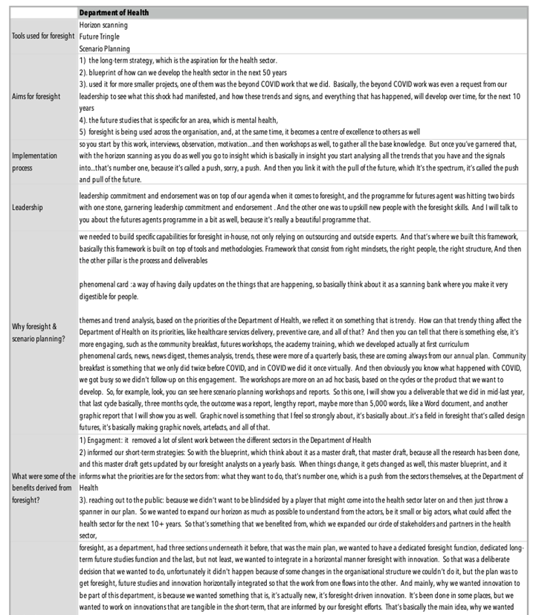
Figure 34: Part of the Summary of Foresight Practice for the Department of Health—Phase 3B
Note: This copy of the summary is truncated to fit the size of the page for legibility. A detailed copy of this summary is appended as Appendix 7A.
The summary presented in Figure 34 was used for mapping processes and/or procedures for foresight implementation. Maps were used to structure the data to make sense of foresight practice within each entity. A cognitive mapping convention is adopted when reading the maps. These six copies of the maps are appended as Appendix 7B; one of the six maps is presented here to explain the analysis process (see Figure 35).
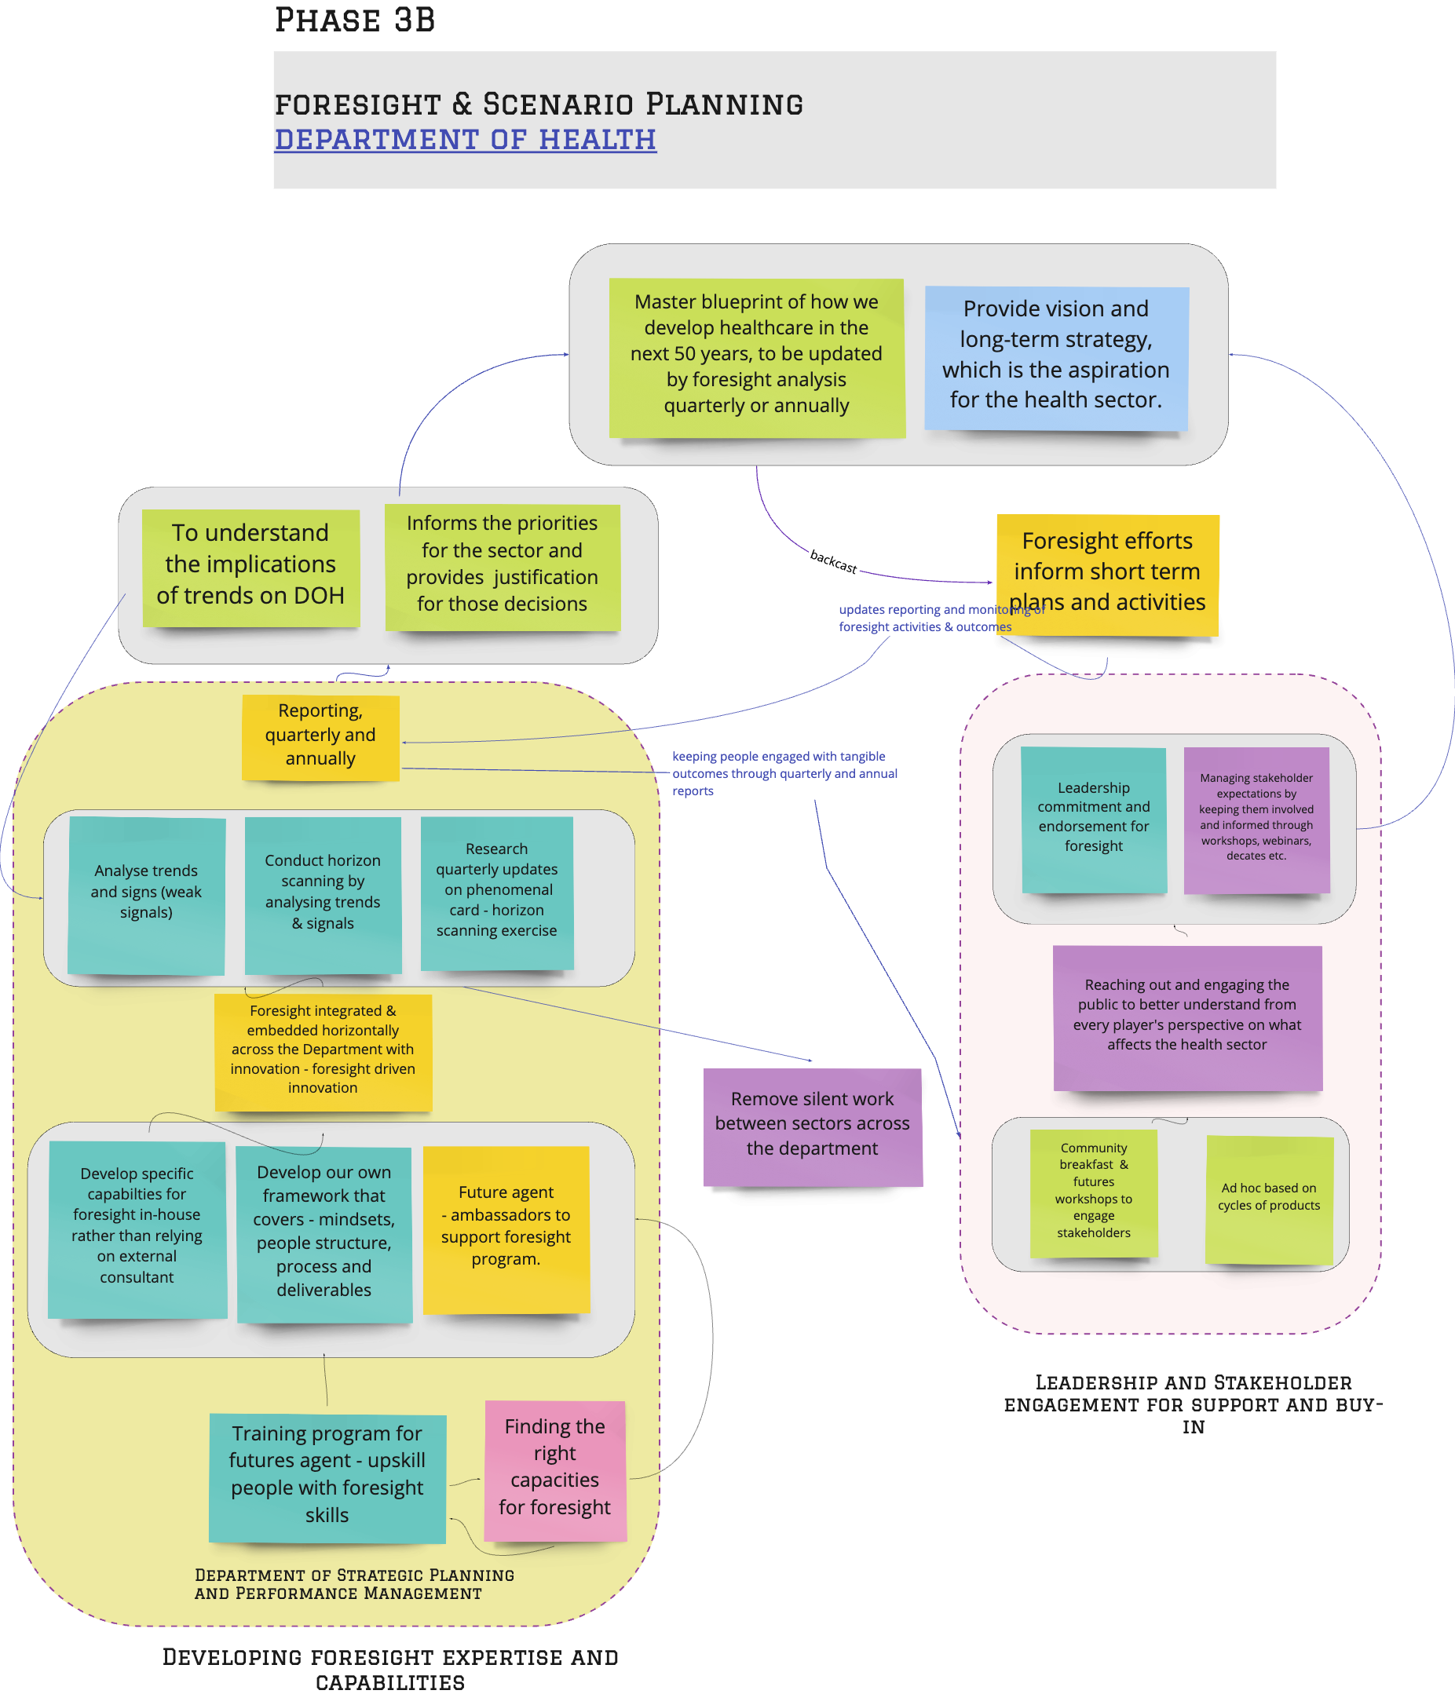
Figure 35: Visual representation of foresight and scenario planning practice at the Department of Health—Phase 3B

Findings - Phase 3B
The findings for Phase 3B are divided into 5 sections:
- Reasons for foresight
- Foresight practice
- Factors influencing foresight implementation
- Challenges facing foresight implementation
- Recommendations for foresight

Reasons for Foresight and Scenario Planning Practice
- Longer-term thinking and visualising possible futures
Better Informed Strategy Development:
Using scenarios, entities were able to develop specific strategies that could drive the Department toward a preferred plausible future. “It informed our short-term strategies, so think about it like we have something, more of a blueprint and our normal strategic planning cycle runs, there is the one-year refresh and also, we have the three-year cycle, strategy cycle. So, these are basic, usually at the end of a year, so people don’t know where to start after three years, and we were due in 2020 to update our strategy.” – (DOH). Scenarios have a particular benefit in that they can be used to organise the various possibilities into narratives that are easier for executives to grasp and use than large volumes of data.
“We want to ensure that we made the right decision, especially that these decisions will be shared with key stakeholders with minsters, farmers, food security decision-makers and policies will change based on this.” – (ADFSA)
Think of the unthinkable:
Aiming to encourage stakeholders to think broadly and creatively about key issues and/or changes that may affect the institution. Scenario planning can provide a mechanism for solving complex problems and developing new and creative solutions to challenging leaders in times of great uncertainty. For example, the management on DOH used the foresight tools to test the stakeholder appetite to establish the unit, as mentioned by the foresight manager.
“Establishment of the Foresight department in DOH was a well-planned and structured way. They aimed to understand more about what they wanted to do with foresight and inform and promote foresight within the health sector.” – (DOH)
As a basis for testing strategy
The scenarios were used to wind tunnel strategies or strategic options, as a mechanism for consideration of which strategies are likely to be most effective in which situations.
“It gives you somehow clarity on what kind of strategic actions or initiatives that you need to do and in which priority that you need to do them in order” – (ADEK)
"Dig down on each required subject so we have detailed analytics, and we know where we are heading, and the second thing when we go to the goal-setting, when we bring the consultants or the expert house, we can run the conversation and challenge him, instead of him just dumping his views on us.” – (ADFSA)
Managing uncertainties and developing resilience
While driven and motivated by the Abu Dhabi Excellence Award to be innovative with public sector management, most Abu Dhabi government entities' foresight and scenario planning initiatives were also triggered by the need for resilience and radical alternative views about the future. This need to be resilient became more pressing with the COVID-19 pandemic, which disrupted Phase 3 and continues to disrupt the way people live and the way businesses operate while this is being written. The government must react and adapt accordingly. The entities wanted tools to help them develop robust, resilient strategies in addition to the conventional SWOT and PESTLE analysis.
"Foresight started in the Department of Health as part of a vision from the Executive Director of Strategic Affairs. He noticed a gap in the planning and looking at risks and the resilience of the health sector and thought why not start a programme for foresight and futures studies?” – (DOH)
“When the future foresight came into the picture by the year 2014, I think, as part of the Excellence Award of the Abu Dhabi Excellence Award 2015, we started to look at the scenario plan from a different perspective, instead of just changing small variables we would have radically different views of the future.” – (TCD)
Embedding foresight into the planning process
There was a need to embed the foresight process across the Department to ensure the development of policies and initiatives derived from comprehensive analysis—foresight-driven innovation. The foresight process is to be embedded as part of a strategy development process, which allows for discussions, to begin with, of possible scenarios, and of what strategies might fit well for which scenario. Foresight also triggers departments to think about how their role might change based on possible scenarios.
Regular reporting for engagement and buy-in
Regular reporting was essential in reaching out to the public, bringing people to the same table, and encouraging continuous and broad dialogue with the organisation's internal and external stakeholders. One interesting benefit of this intervention is that some entities are using the tool to enhance dialogue with leadership, stakeholders, and the community.
“Reaching out to the public. we had a way of engaging the community and the businesses as well, and the investors, and all of that, but it was more on a transactional level. When we involve them in making decisions, and I wouldn't say making, but in the spectrum of engagement." – (DOH)

Foresight Practice
The foresight practice for the six entities was mapped and analysed. The map for each entity is appended as Appendix 7(c).
When the maps were collapsed into one main map, there were six components of foresight practices:
- Establishing a dedicated unit for foresight, whether as a specialised unit or within a unit with a foresight mandate.
- Using foresight methodology for horizon scanning, identifying critical uncertainties, assessments of impacts, and implications of change and emerging issues in order to better anticipate the future.
- When those analyses were completed, scenarios were created to visualise Abu Dhabi in 50, 60, or 70 years.
- With the scenarios, entities wind tunnel strategies for fitness check and back cast for shorter-term planning, using the scenarios to create a master plan or radar for planning.
- Findings from the analysis to justify proposed changes the departments make, e.g., how the role or organisational structure of the department must change to remain relevant.
- The reports from the analysis serve as strong justification for the projects and initiatives endorsements for budgets.
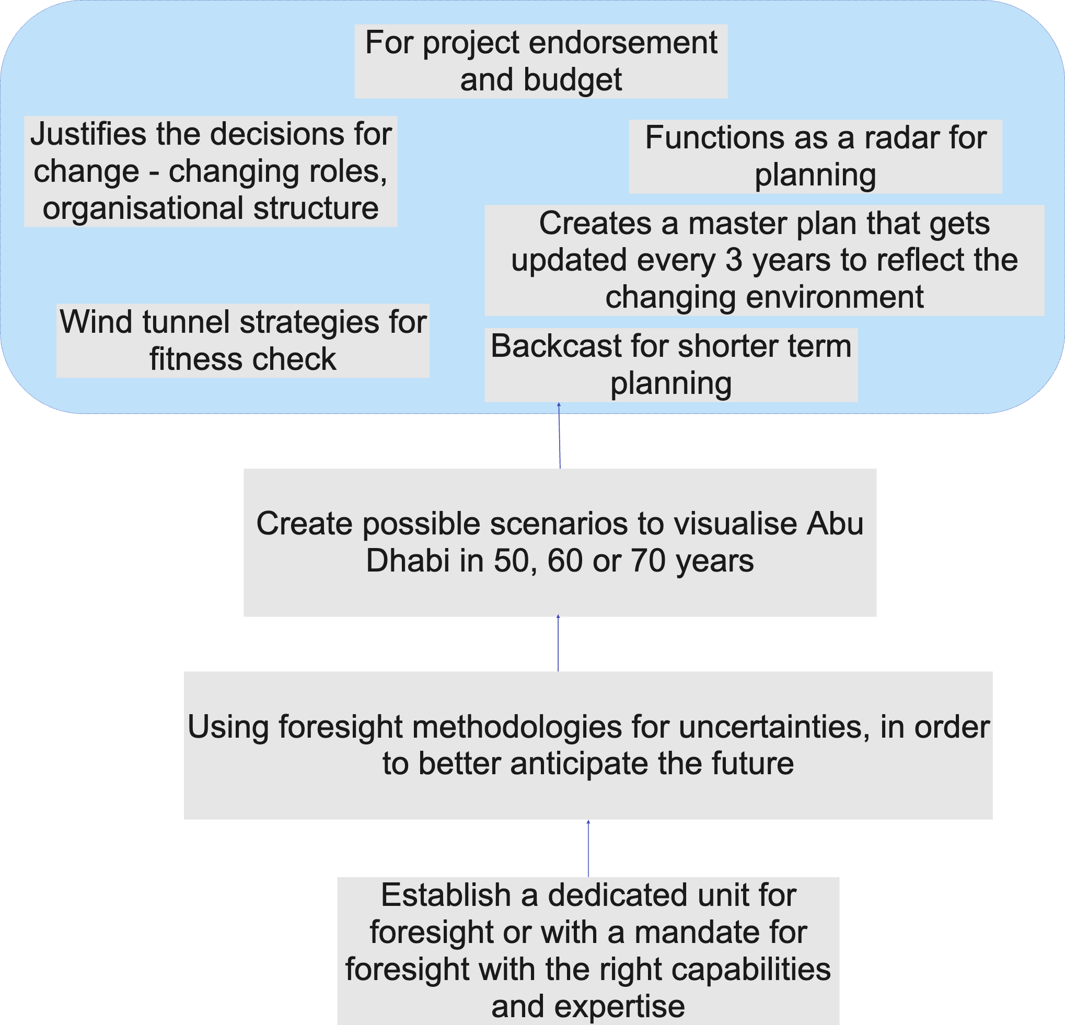
Figure 36: An overview of foresight practice—Phase 3
There were variations in the foresight or scenario implementation approaches adopted by different Abu Dhabi government entities, from the use of single tools to a combination of tools. Appendix 8 summarises the different approaches adopted by each of the six entities.
Foresight was adopted as an approach to help management better understand the rapidly changing environment so that they can better anticipate what’s coming. They were using foresight methodologies to analyse and identify drivers of change, assessing the impacts and implications of those changes and uncertainties. The findings from those analyses inform strategy development and prioritisation of initiatives and plans. The findings justify why the Department needs to change and create opportunities for implementing innovative ideas. Figure 37 below shows the foresight process for Abu Dhabi Statistics.
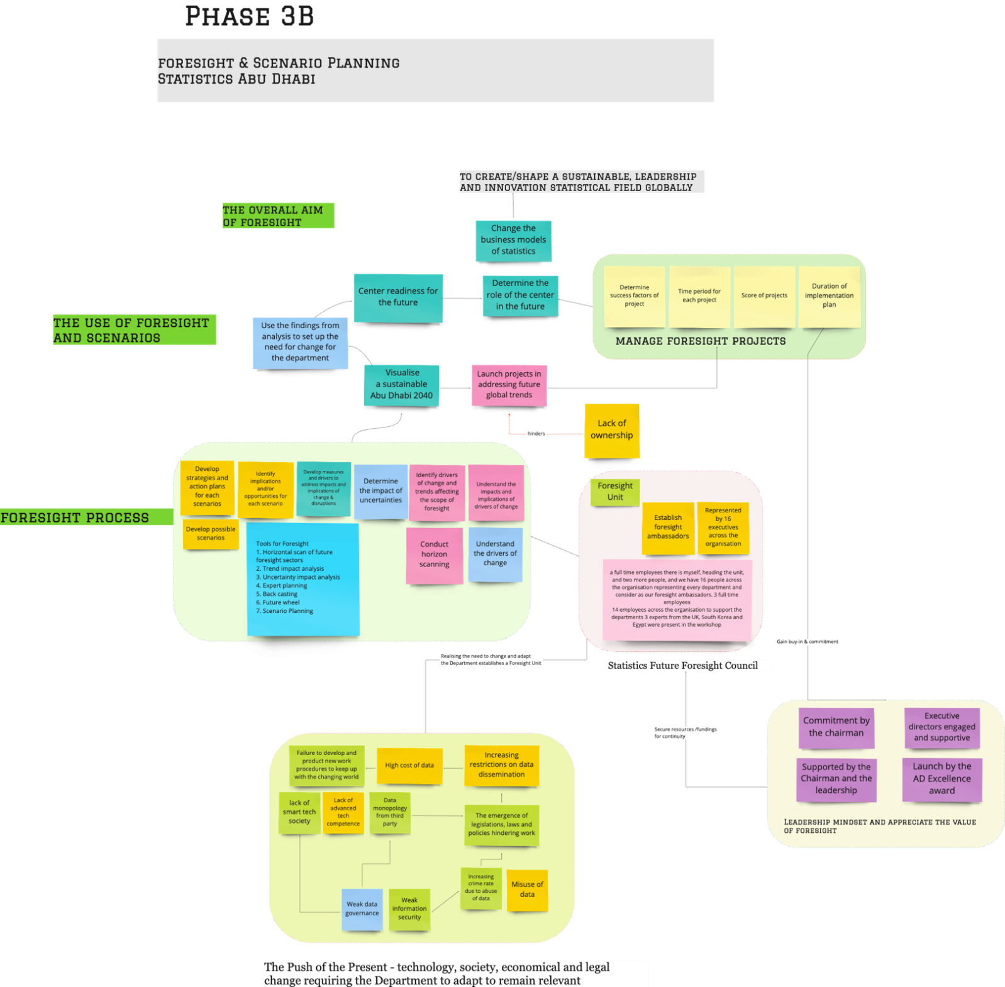

Figure 37: Foresight process for the Abu Dhabi Statistics Authority.

Factors Influencing Foresight Practice
The Establishment of a Dedicated Unit for Foresight
All six entities appreciate the extent of the work involved in research and analysis for foresight. Each has a dedicated unit; although some of these do not carry foresight as a name, foresight was mandated under each of those establishments. Two entities have foresight functions as part of the Business Development or Intelligence unit, while the remaining four have foresight as part of the planning and strategy unit.
Each of these entities knew they could not rely on external consultants but needed to develop in-house capabilities and competencies for in-house intelligence. Each entity has a team for foresight with members from diverse backgrounds and experiences. These entities plan to integrate and embed foresight horizontally across the department in their attempt to achieve foresight-driven innovation.
Figure 38 shows the organisational structure for the foresight unit of Abu Dhabi Education Council, Department of Health, Statistics Council Abu Dhabi, Tourism and Culture, as well as for the Abu Dhabi Food Control Authority (ADFCA) and the Khalifa Fund (KF), where the foresight function was embedded in a unit with other functions. In the ADFSA, the foresight function was mandated to the business development unit and assigned to in-house experts and five consultants. In the KF, the function was assigned to the Business Intelligence section.
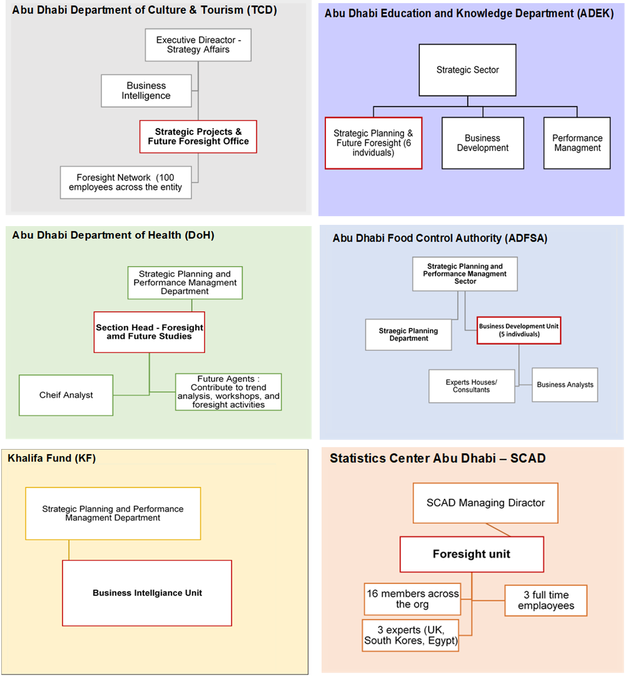
Figure 38: Establishment of Foresight Units—Phase 3B
Support for Foresight
Some entities had set up specific elements to support their execution of foresight efforts and to ensure proper knowledge transfer and stakeholder engagement, this includes:
- Change Management Team: to support the implantation of the outcomes and ensure the knowledge is spread across the entity, as emphasised by the strategy director:
- Foresight Network: members representing different entities to support the foresight function.
- Future Agents: employees recruited from various departments on a part-time basis, who receive futures training; the aim was to ensure that different people learn about foresight across the health department and to gain leadership commitment.
- Future Ambassadors: people across the organisation representing every department are considered foresight ambassadors.
- Consultant Support
At the outset, each entity had commissioned consultants to assist them in developing the foresight interventions/project in different stages of the process. In the later stage, the entities realised that they needed to build expertise internally, hire individuals with expertise on foresight, and empower them with training to learn and share knowledge internally.
“We did it in-house. I think this is a nice approach from our Excellency and trusting the people. At the same time, we brought the right people in the right team in place to be able to do this. For example, we had enough data analytics, basically individuals, we had some.” – (ADEK)
Capacity Development
Capacity for foresight was felt to be lacking, and there is an urgent need to develop in-house analysts and workshop facilitators to sustain the interest and efforts for foresight. There were concerns regarding the reliance on external experts or consultants as they were not fully immersed in the local context and what was felt to be important for each respective sector.
“We were heavily reliant on consultants, there are pros and cons to this. So, the pros are sometimes you might be indulged in heavy kinds of activities, your problems, your activities, so you want someone to do the dirty work for you. Like, they might go and investigate some, kind of, what stakeholders are doing, ... So, we, let's say, analysis on all of the university majors, what is the future majors that we need? So, they will go and meet with industry partners, the lot, which you might not have the time to do all of these workshops. So, they might do all of this dirty work for you. But maybe the cons of it are most of the time, yeah, and consultancy could end to have just a shallow study level that may not translate to a practical solution. And the reason why is there won’t be common background, you know what I mean? They don't know what are you facing. What are the ingredients of the sector itself and you are much more indulged in the situation…”– (DOH)
Leadership mindset and engagement
Having a sponsor or a champion who truly appreciates the value of foresight can encourage stakeholder and executive management engagement and support. The Abu Dhabi Excellence Award motivates the wider adoption and acceptance of foresight within the entities.
“There is the one who takes the lead to engage us to do the benchmark. We then come and present the findings and recommendations, and this was one of the recommendations that we directly got the endorsement for. They said go ahead we need it. This was followed immediately by the establishment of task forces, identifying members, etc. The commitment was the driver behind this.” – (ADFSA).
“The initiatives were started by the leadership themselves, especially after the announcement of the UAE strategy for the future and the inclusion of the foresight on the Abu Dhabi Excellence Award, so it was supported by them.” – (SCAD)
Leaders’ enthusiasm for the initial scenario and/or further development of the scenario was a further factor in implementing foresight planning.
“Is the leadership engaged from day one or only the later stage? No, not on day one in the definition of the question. For example, executive management is a part of defining, for example, museums where executive management decided to look at how a museum will evolve in 25 years and 50 years from now. Also, in the leadership role, they not only endorsed the direction of the study but also suggested and recommended the study. The future of artists in the era of technology, we have done a study for this, and we created the scenario because today one of the mandates is to support artists and different types of interlocking industries.” – (TCD)
Stakeholder Engagement: Regular presentations, engagements in workshops, participation in foresight networks
Stakeholders’ communication and engagement were also critical elements in all the interviews. Stakeholders can be both internal (employees and organisational leadership and management team) or external (public sectors, federal or private organisation), and one of the entities claimed their success is due to communication.
“I believe what we did well was two things, communication with management, frequent reporting on the plan.” – (ADFSA)
Where some entities limited their efforts on engagement during the workshops, others went the extra mile by establishing a full unit, hiring full-time employees as well as attracting experts to assist them in building the internal capabilities.
“We brought all the stakeholders from the health sector, the normal transactional ones, and the ones in our operating environment, like our technology companies. And even the public, when we wanted to understand more about what we wanted to do with foresight and inform and promote foresight in our sector. And it was one of the best decisions that we ever made. That we didn’t want to do foresight by ourselves in a vacuum; no, we opened it from the beginning to everybody, to promote it, number one, and to engage them early on.” – (DOH)
Monitoring and Governance
Project monitoring and proper governance for quarterly or annual review were felt necessary as the outcomes of each initiative approved were linked to the respective strategy plan.

“This is the whole deliverables, there is an arm that does performance management of every deliverable, from the qualitative and quantitative manner and try to assess the outcome of all of these deliverables. We have to make sure that we have the output measurement and outcome measurement for these deliverables as well.” – (C)
Master plan update and annual review:
“With the blueprint, which thinks about it as a master draft, that master draft, because all the research has been done, gets updated by our foresight analysts yearly. When things change, it gets changed as well, this master blueprint, and it informs what the priorities are for the sectors from what they want to do, that’s number one, which is a push from the sectors themselves, at the Department of Health. And then there is a pull from what happens in the health sector locally, nationally, regionally, and globally. This is from our team of analysts and now we have a few of them.” – (DOH)
“We do a review, for example. Every two years we do that review. Today with the CEO we're focusing on culture-specific with five domains, corporate, another five domains and tourism, five domains. In 2019 we have done the library, which is another five domains. So, when we finish this year’s cycle we will go back to the library and today there is a new entity that comes under us called the Arabic Centre, which will be included in this review. We look at and see how the signals are on everything.” – (TCD)

Challenges Facing Foresight Implementation
Leadership Change
Leadership changes often mean new directions or goals, resulting in reduced support or interest. Leaders’ mindset and appetite for exploring new ideas influence the level of reception or adoption of new approaches to planning or management in general.
“Unfortunately, something was out of our hands. The foresight unit in DOH started with eight people, but not all of the employees were direct here, as some of them were brought on an ad hoc basis due to their expertise, and to assist in building the basics. However, after the new directions from the DOH leadership the department shrunk into a smaller unit, The role of the section head is developing foresight and related roadmaps.” – (DOH)
“Change on leadership impact I think it's very high, it’s super high, if you could elaborate from one to ten, I can tell you it's going to be eight or nine. ADEK depends on the person's issue and three leadership styles, and each leader has his mindset, right? Does he have a disruptive/bold leader who would like to push innovation business development?” – (ADEK)
Availability of skilled foresight calibre in the region
“It was very hard to find specific skill sets in foresight and future studies, so we reached out to a lot of experts to see how we could start our programme and you know how we are in the government sector, we’re big on Emiratisation, right? So, it was very hard as well, because most of the work that we needed to do, the people that we needed to hire were Emiratis, and I do believe that there is a bit of a skills gap and workforce gap when it comes to foresight.” – (DOH)
Data Scarcity and Management
A shortage of data to document and evaluate intervention impact was a central limitation, with the issue also relating to weak data governance and lack of ownership. Abu Dhabi Statistics does not have a formal role in managing the future foresight initiative at the Emirate level, a problem compounded by a scarcity of technical cadres specialised in future technology, the high cost of data and misuse, increasing restrictions on data dissemination and data monopoly from third parties and weak information security. There are also difficulties in analysing and processing large data sets and weak technical competence leading to a failure to develop and produce new methodologies and work procedures to keep pace with foresight.
Data plays a big role in effective Foresight and scenario analysis. The quality and availability of data, high cost of data, the misuse of data and third-party monopolising of data repositories and dissemination are central to the impact assessment analysis and evaluation across the Emirate. These issues emerged due to weak data governance and information security. There was also a lack of technical competence in dealing with analysis and processing larger data sets.
Resistance to change
There was some resistance to adopting foresight as an innovative approach to enhancing the public sector. This was due to the experience of discontinuity and a lack of follow-through with past interventions and projects. Public administrators felt the pressure to get involved in new projects and put in the effort, and then the project got abandoned.
“Yes, we have managers we have people that might be resistant, and this is an issue, we tend to be biased. I am biased in my view. It's all about the exercise and the workshop because at the end of the day all of us want to have the best, as long as everybody is agreeing to that. And as soon as you unfold this and explain it, it is right there. And let's put it this way, sometimes in the workshop we have discussions, we have tense discussions plus we have the mindsets, and we have an equal distribution of the team within the workshop in the exercise itself. We didn't have a serious matter after that.” – (TCD)
“I think there was a lot of enthusiasm when we started the project until we presented it to the assessors. After that everything went quiet. Yes, we did share our experiences with other entities and understand lessons learned, but no further progress. Even the council that established the council as a body still exists, but there were no meetings, no inputs, or outcomes.” – (SCAD)

Recommendations for Foresight Practices
There is no one-size-fits-all approach to strategic foresight. Yet, governments must start engaging in conversations about the future to stay at the forefront of change and act in their citizens' best interests. The challenge, however, remains to develop sustainable capabilities and a forward-looking mindset that can accomplish high policy impact.
The need for a customised, agile approach for each entity
“There is no one-size-fits-all approach to strategic foresight, yet governments must start to engage in conversations about the future, for them to stay at the forefront of change and act in their citizens' best interests. The challenge however remains to develop sustainable capabilities and a forward-looking mindset that can accomplish high policy impact.” – (DOH)
- The need for a customised, agile approach for each entity
“Foresight is a science, it’s a science, an art, where we can also play with it. Because it’s something we can’t control, it’s a future and we know it’s uncertain. So, we can, I think, yes, we are working with futures, and they have their frameworks, but we can also create our own from our perspective from what we see, from what we learn. So, I am recommending that everyone sees the future from his perspective, creates their model, and creates a framework that fits their needs. Fit’s your perspective.” – (TCD)
“I recommend adopting an agile approach. Replace future foresight big events with multiple focused sessions. It is better to involve smaller teams and discuss niche issues than to organise a big event during the whole year. Also utilising internal resources for research, facilitation, final report writing, and implementation is essential to reduce cost.” – (KF)
- The right competency and skill set for improved data analytics are fundamental for decision-making and planning.
“A think-tank that produces in-depth reports on specific areas, as part of the capabilities that were needed. After so many interviews, I think it was for nine months we were interviewing and trying to find the right skill sets, and you know how we are in the government sector. I do believe that there is a bit of skills gap and workforce gap when it comes to foresight.” – (DOH)
“Good people who are doing a lot of good research, people who are good communicators and workshop’s facilitators. So, these are some of the competencies that we were looking at, as you can see here, it’s about the diversity of people who are in the section itself like I mentioned research and analytical capabilities.” – (ADFSA)

Phase 3 Findings Summary and Discussion
The feedback from and conversations with the participants demonstrate a level of familiarity with foresight and scenario planning as they spoke of how and why foresight or scenario planning was incorporated as part of the strategy development process and based on their explanations in highlighting what worked well for them and what they thought was necessary to make adoption and implementation more effective. The inclusion of foresight as a pillar of the Abu Dhabi Excellence Award seems to have successfully inspired nationwide adoption. However, there was no clear indication of the effects foresight and scenario planning have on the short- and longer-term decision-making capabilities and whether those capabilities translate into enhanced organisational performance, similar to the concern voiced by Chermack et al. (2001).
Foresight and scenario analysis were appreciated as government entities struggle to keep up with the rapid pace of change and keep ahead of the disruptions it causes, with questions such as “How must the role of the department change to remain relevant?” While foresight practice was found to be embedded across functions within some departments or entities, to instil foresight-based innovation in the public sector, the entities realised that foresight and scenario planning requires intense involvement of senior executives, extensive time, and financial resources, and they struggled with the lack of expertise and capabilities for the application methodologies. There were cases where a change of leadership in a department hampered the progress and/or the continuity of foresight practice.
A small team commonly championed foresight and scenario planning practice within a unit (formally or informally formed). In their efforts to reach out to a broader audience, internally and externally, through the appointment of futures agents and ambassadors, the creation of foresight networks in bringing people together for breakfast meetings and regular presentations and reporting was felt to be crucial in keeping interest alive as well as gaining buy-in and to instil foresight practice as part of management and strategy development culture. This team is usually sponsored by a leader who can “think of the unthinkable” (van der Heijden, 1997).
The feedback from each public manager informs and expands the construction of knowledge about foresight and scenario planning practice within the government. The six components of foresight practice that emerged from the findings inform the development of a framework for an Ecosystem for Foresight for the Abu Dhabi government presented in Chapter 9 of this dissertation.

Chapter 8 Discussion and Conclusion

Introduction
This chapter begins with a detailed summary of Chapters 5, 6, and 7, followed by a discussion of the findings of two comparative analyses on the findings from Phase 1 and Phase 3B. The next part of the chapter highlights the contributions of these empirical findings to the broader body of knowledge. It concludes by synthesising the findings and learning from the three phases. These insights form the building blocks of the framework for the foresight ecosystem for the Abu Dhabi government.

A Summary of Phase 1 of the Study: Intervention 1
Phase 1 of the study was a detailed examination into the introduction of scenario planning as an early intervention within the Abu Dhabi government as a nationwide initiative (Intervention 1). Phase 1 comprehensively documented the process of every stage of the intervention from the conception of the idea, commissioning of consultants, development of an operations manual for the public sector in Abu Dhabi, and the final stage of piloting scenario development for the Human Resource Sector in the UAE. This section of the chapter provides rich insights into the implementation of Intervention 1, which sets the context for the research project. This documentation was supplemented by a series of nine interviews with a select nine individuals who were directly involved in Intervention 1. The interviews were designed to gain a perspective from three groups of people, namely, the project champions (core team), end users (planning directors), and the trainers (consultants), on the factors influencing the implementation process, lessons learned from the experience, and to determine whether, based on that experience, the public administrators desire an operational manual or guide for scenario planning implementation.
The findings from Phase 1 demonstrate the level of leadership determination and commitment to searching for appropriate tools to support public managers as they navigate the rapidly changing operating environment in the management of the public sector. The executive committee of the Abu Dhabi government resolved for governance for accountability, for evidence-based decision making for strategy and policy development process, and for Intervention 1 as the initial effort to inculcate a culture of anticipation while widening and deepening the thinking on alternative, possible futures.
The series of interviews successfully compiled the knowledge, experience, and lessons learned from Intervention 1. The inputs from the interviews generated a list of factors influencing scenario planning implementation with four main themes: 1)leadership commitment and support, stakeholder engagement and buy-in, 2)instil scenario planning culture withing government. 3) Capacity and the development of capacities and competencies required for scenario planning and finally 4) scenario planning potential. The findings reveal that public administrators had a good grasp and understanding of the theories, frameworks, and the reasons why scenario planning was useful and had the opportunity to participate in workshops led and facilitated by consultants; from that experience, they now understood the skill sets and expertise required to do the actual work required for scenario planning implementation.
Overall, Intervention 1 has laid the foundation for introducing frameworks and approaches to improve the policy and strategy development process. Intervention 1 can be said to be successful if senior executives continue to push for evidence-based policies and governance for accountability at all levels; if there was buy-in for adopting different management and strategy development practices, such as scenario planning, in the planning process; if decision making were enhanced following the rigorous step-by-step process; and if public administrators would change their ways of thinking about the future to acknowledge that there are alternatives futures that might play out.

A Summary of Phase 2: An Elicitation of Expert Opinion
Phase 2 of the study elicited expert opinion on some of the key factors of good practice for scenario planning implementation as a reference point or guide for the Abu Dhabi government. A series of interviews were conducted with six experts over seven months between June 2018 and January 2019. The interviews intended to encourage a conversation about scenario planning on what they have learned from their years of practice, how the practice has evolved, their experience with things that did and did not work well. The questions were aimed at identifying the recommended methodologies, what to avoid, and their recommendations on how implementation can be improved or enhanced to provide a better experience for decision makers/users. The feedback and inputs from the experts were collated, clustered, and thematically analysed.
The experts defined scenarios as stories about the future and they went on to describe how the approach can be used and why it can help think about the future. Scenarios can be used to challenge pre-conceived ideas about how the future unfolds, and the dominant assumptions about the future. Scenarios can be used as change management tools, as a way to sensitise the process to indicators of change and to the unpredictability and volatility of the future, and as a way of challenging long- held ideas.
An overview of scenario planning methodology was mapped out based on the expert input. While each has preferences for the tools for different stages of the process, the underlying principles were similar to the widely accepted and practiced scenario planning process.
The experts agreed that getting engagement and buy-in to scenario planning is the most important factor influencing implementation, and that this factor facilitates and enables four other factors influencing scenario planning implementation, namely:
Leaders (i) have an acute sense of urgency and awareness of the impacts and implications of environmental factors, (ii) understand the context within which the government operates, and (iii) have an appreciation for the value of scenario planning for strategy development and decision making, which enables the development of the necessary mindset among leaders that was necessary to facilitate the (iv) understanding of the relevance of scenarios for decisions in specific contexts.
Experts agreed that adoption of scenario planning was favoured by mind-sets that were:
- Open to new ideas, open to listening and discussing different views and perspectives
- Aware of the time and resources required for implementation
Similarly, experts agreed it was important for leaders to be aware of the limitations of different planning tools, open to experimentation and trial and error, and understand the need for double loop learning rather than placing blame and taking punitive actions for failed attempts. They also spoke of the need to conduct regular review and refinement of scenarios and narratives with a wide audience and to use the review and report sessions to educate users and stakeholders, and the public about the use and usefulness of scenarios. The experts advised that it is crucial to pre-define success criteria for any scenario project as some outcomes were intangible such as a shift of mindset or thinking process. Intervention success can be assessed through:
A change in the way people think, such as:
- Did the team get it right? Did what was proposed to happen a few years later? Was a wrong decision avoided?
- Did decision-makers actively make use of the information gained/generated by the scenarios developed?
- Regular review and revision of scenarios as the real world unfolds and updating of scanning documents with changing trends and emerging issues.

A Summary of Phase 3: Foresight and Scenario Planning as an Innovative Approach
Phases 1 and 2 completed empirical documentation of the factors influencing scenario planning implementation. Phase 3 was designed to follow up on the developments in governmental management practice since Intervention 1, with two objectives: (i) Phase 3A, to examine the evolution of the Abu Dhabi government and their search for a more structured approach to planning and policy-making and to gauge their readiness for scenario planning; and (ii) Phase 3B, to gain an in-depth understanding of the role of foresight and scenario planning as an innovative tool to enhance operations in public sector organisations from the perspective of participants rather than through the views of scenario practitioners, in identifying the critical factors for scenario planning in the Abu Dhabi government. The over-arching questions for this phase include “is the Abu Dhabi government ready to implement foresight and scenario planning as an innovative approach to enhance strategy and policy development”; and “how do the public perceive the role of scenario planning as an innovative approach towards enhancing public sector operations?”
Two series of in-depth interviews were conducted. The first (Phase 3A) was with a select six individuals who were holding executive positions and had extensive working experience in the government and were thus in a good position to describe how the Abu Dhabi government has evolved. The second (Phase 3B) was with a different set of individuals who were the heads of various strategy units or departments and had experience with foresight work. These six individuals represent entities that have completed a full cycle of foresight implementation and were eligible for the Abu Dhabi Excellence Award.
Phase 3A findings document the evolution of the Abu Dhabi government, explained by six major components: (i) the push for change, (ii) leadership and power within the central government and leadership change, (iii) change management, (iv) talent and competence within the government, (v) accountability and performance, and (vi) nation building.
“Is the Abu Dhabi government ready to implement foresight and scenario planning as an innovative approach to strategy and policy development?”
There was a push for change in how decision-making for policy and strategy was undertaken, as the context within which the government was operating was shifting rapidly. The government is invested in working with new and different approaches to changing and enhancing government practices. Since the early 2010s, the Abu Dhabi government decentralised from being a stronghold of a federal government with top-down directives and close scrutiny to governing with local entities and ministries having more autonomy in sector-related decisions. The leadership culture of the Abu Dhabi government has its roots embedded in Bedouin society, where reputation, family, and religion play an immense role in the decision-making process (Sheldon, 2012). Following the drive for transformation, these values have evolved as the government strives for relevance, pushed by the forces of change.
There was a realisation of the need to manage change as the government evolves in embracing new approaches to management. Senior executives call for emotional intelligence and empathy in managing any change, such as the introduction of new approaches or reforms within the government, as people are fuelled by emotions, including fear and anxiety in anticipation of the unfamiliar. To calm those fears and anxieties, training and development for the required competencies and skill sets must be provided. There was a noticeable lack of the required knowledge, skills, and experience within the government to work with new management approaches such as foresight and scenario planning. Efforts were set in motion to recruit the right talent. Knowledge management and sharing are important to ensure that everyone gains from lessons learned, both successes and failures. The feedback from senior executives also indicates some level of appreciation for the softer skills required for change management.
The Abu Dhabi government has evolved over time and demonstrates the efforts made to reform the public sector to enhance delivery. The push for Intervention 1 and the inclusion of foresight and scenario planning as part of the Abu Dhabi Excellence Award are evidence that the government has begun its journey to modernise the public sector, responding to changing societal needs and maintaining competitiveness in an uncertain international environment. The reflection on what the government needs for transformation was a sign of readiness for change.

A Comparative Analysis between Phase 1 and Phase 3B Findings
There was a gap between the interviews conducted for Phase 1 and Phase 3.
- Phase 1 — June 2018 to January 2019
- Phase 3 — June 2021 to September 2021

In the time between Phase 1 and 3, public administrators applied the knowledge from Intervention 1. The analysis for this section revealed their progress over the three years. The following presents two comparative analyses on (i) the reasons for foresight and scenario planning; and (ii) the factors influencing foresight and scenario planning implementation.

Reasons for Foresight and Scenario Planning
The common sets of questions for Phases 1 and 3B were asking about the reasons for and the use and usefulness of scenario planning. Table 37 below presents a comparative analysis between the findings of Phase 1 and Phase 3B.
Reasons for foresight and scenario planning: a comparison between feedback from Phase 1 and Phase 3B
Phase 1 | Phase 3B
Scenario planning is a useful planning tool for a natural resource economy when the country is faced with uncertainties and external forces of change | Longer-term thinking and visualisation of possible futures
Scenario planning as an assessment framework for core strategies and their associated risk – for policy planning and development | Managing uncertainties and developing resilience
Scenario planning as a tool to identify local opportunities and become a center of excellence independent of foreign influence | The need for a more evidence-based planning process by embedding foresight into the planning process
 | Reporting the outcomes of scenario for buy-in and engagement
 | An opportunity to engagement with stakeholders for buys-in to plans and strategies – to consult the wider community about what’s changing. An opportunity to expand the engagement circle to a wider stakeholder
 | A need to educate people about the usefulness of scenario planning through reporting outputs of planning; advocate for the use of scenario planning

Table 37: Reasons for foresight and scenario planning: A comparison between Phase 1 and Phase 3B.
Comparison of the summaries from Phase 1 and Phase 3B shows a heightened competence in the use and usefulness of foresight and scenario planning. In Phase 1, the responses circled around textbook theories and concepts while in Phase 3B, the responses reveal a more perceptive appreciation for foresight and scenario planning in how the methodology, if embedded into planning process, enables different functions, from a broader visioning of the future and developing resilience, to the use of scenarios to engage with diverse stakeholders for discussion and consultation about the changing societal needs, and in educating the wider community about foresight and scenario planning.
Responses from Phase 3B show a greater depth of understanding derived from the experience of doing the actual work for implementation with minimum support from external consultants.
The data from Phase 3B provide sufficient information for the analysis of foresight and scenario practice for each of the six entities. A map was drawn as a visual representation of the practice for each organisation. An analysis of the six maps, when collapsed, produced six components for foresight practice. A unit or a department dedicated to planning with a foresight mandate was a common feature across all the six entities. This depicts the level of commitment to the use of foresight in management. Foresight methodologies were used for horizon scanning, identification of uncertainties, assessment of impacts and implications of change to better anticipate the future. Scenarios were used to visualise possible futures for Abu Dhabi 50, 60 or 70 years into the future. These possible scenarios were presented to a diverse group of stakeholders and with the approval of the senior executives, select scenarios were used for back casting, followed by wind-tunnelling strategies as part of the process for the development of a master plan. Scenarios were found to be useful as justifications for decisions for change, such as changing roles and/or organisational structures, and for project endorsement and budgetary considerations.

Foresight and Scenario Planning Practice

The interviews for both phases set out to examine the factors influencing foresight and scenario practice. The findings on the factors for both phases were put side by side for a comparative analysis. Table 38 presents the key themes emerging from the findings of both phases.
Foresight and scenario planning practice: a comparison between feedback from Phase 1 and Phase 3B
Phase 1 | Phase 3B
Leadership belief in, support and sponsorship, and Stakeholder engagement for scenario planning as a strategy development tool | The establishment of a dedicated unit for foresight
Instil scenario culture within the government and across all levels for continuity | Support for foresight implementation such as change management team, foresight network, Futures agent, Futures Ambassador, and consultant support.
A need for a unit responsible for scenario planning and strategy development with the right talent and expertise | Capacity and competency development
Value & Potentials of Scenario Planning  Emerging Theme: An awareness and appreciation of the value and potential of scenario planning – a realisation of the need for skills and expertise to use them | Leadership mindset and engagement
 | Stakeholder engagement: regular presentations, engagements in workshops and participation in foresight networks
 | Monitoring and governance for projects, assess projects for impacts, establishes accountability for outputs and outcomes of projects
Table 38: Foresight and scenario planning: A comparison between Phase 1 and Phase 3B.
The responses from Phase 3B showed some development in terms of how the heads of strategy/planning now realised the need for more dedicated support for foresight implementation, such as a change management team, creation of a foresight network to connect and share information and knowledge, appointment of Futures Agents and Ambassadors to champion foresight practice, and commissioning the help of external consultants for specific projects. Another marked difference in the Phase 3B findings was the realisation of the need to set up monitoring and governance for projects. The heads of strategy felt a strong need to establish governance and accountability of outputs and outcomes of projects.
Leadership support and stakeholder engagement and the need for a unit responsible for foresight and scenario planning were consistently a cause for concern across the two phases. The emphasis to instil scenario culture across all levels for continuity was notable only in Phase 1 as it was a whole new practice in the public sector. By the time Phase 3 was conducted, most entities were familiar with foresight and scenario planning, and it was apparent that the practice was well embedded.

The Contributions of These Empirical Findings to the Wider Body of Knowledge

The Abu Dhabi government launched Intervention 1 when they realised the urgent need to be able to think and act ahead in formulating strategies in anticipation of possible futures to remain viable and relevant today and in the future (Cummings and Worley, 2001; Lustig, 2017; Rohrbeck,et al., 2018).
The government introduces scenario planning in Intervention 1 and foresight as an innovative approach (Phase 3B) with an aim to open up the mindsets of public administrators for exploration in making sense of the uncertainties the Emirate must navigate to better anticipate the future, or purposeful scenario work as proposed by Bradfield et al. (2005). Phase 1 and 3B findings reveal that public administrators find scenarios are useful to help shift the mental models of public administrators away from being stuck with the status quo, which prevented them from sensing socio-economic changes (Wack, 1985b, van der Heijden, 1997, Wright et al., 2008).
The foresight and scenario planning practice was introduced and implemented by the government to encourage collaboration, participation, and coordination across departments and entities, and between the public and the foresight unit (Schmidthuber & Weiner, 2018) with a view to improve decision making, policy development, and planning as reported to be effectively practiced in the public sector by Rickards et al. (2014). With these initiatives, the Abu Dhabi government demonstrated that they are beginning to accept alternatives that may challenge the dominant assumptions underpinning government management.

Foresight and Scenario Planning Methodology

The foresight and scenario planning methodology uncovered from the three phases of the study was very much in line with the literature; see, among others, Voros (2003) Four-step generic foresight process framework or PepsiCo Foresight Model (Farrington et al. , 2012); and as summarised by Chermack et al. (2001). The process begins with (i) INPUTS: horizon/environmental scanning to collect data about the happenings within the context, as guided by PESTLE (political, economic, social, technology, legal and environment) and identifying a focal question that drives the vision (Schwartz, 1991); (ii) ANALYSIS: emerging issues, trends, weak signals, scenario development, back casting and wind-tunnel strategies; (iii) OUTPUTS: develop strategic options, produce reports and presentations for endorsement and approval; and (iv) STRATEGY AND POLICY DEVELOPMENT: finalise the scenarios and the set of strategies to launch initiatives and projects and budget approval.
Phase 1 findings highlight the importance of the research (i and ii above) required for scenario development (Code P2C3) as reported by Schwartz (1991), Ringland (1998), Van Der Heijden et al. (2002) and Godet (2001). This observation led to a proposal for the establishment of a unit dedicated to strategy /planning responsible for foresight and scenario planning to provide the required talent and expertise (Phases 1 and 3B).
Phase 3B findings point to how the analysis stages enrich the way managers think, learn, and feel about strategic situations (Georgantzas and Acar, 1995) as they investigate what they found most engaging (Schwartz, 1991).

Factors Influencing Foresight and Scenario Planning Implementation

Past research cited ‘leadership continued support and involvement’ plays a major role in ensuring scenario process be embedded in management practice for a lasting impact (Schwartz and Ogilvy, 1998; De Geus, 1997). Findings from all three phases persistently emphasised leadership support and engagement to ensure continuity. There was a sense of resistance amongst public administrators (Phase 1) as past experience taught them that most initiatives came to an end with a change of leadership.
Leadership support and commitment to see the implementation through with the appropriate level of support and resources (De Geus, 1997; Georgantzas and Acar, 1985; Mietzner and Reger, 2005) was deemed important. This was observed in Phases 1 and 3B, where public administrators realised the need to develop the required skill sets and expertise to work on foresight and scenario planning. They requested the establishment of a unit dedicated to foresight and planning in Phase 1, and such units were set up within entities, as seen in Phase 3B.
For stakeholders engagement and buy-in, it is crucial for scenarios to be aligned with the current and on-going concerns and anxieties of decision makers (Van der Heijden, 1996; Shoemaker, 1993). In the findings from Phases 1 and 3B, public administrators put an emphasis on regular engagement through presentations and workshops with diverse groups of stakeholders at every point throughout the stages of foresight analysis and scenario development “to get everyone at the table for discussion and feedback”.

A Shift from a Rationalist School to a Processual School for Decision Making

Intervention 1 successfully created a nation-wide level of awareness of the usefulness of scenario planning as part of strategy development. There was an understanding that there the future is plural and there are alternatives and possible futures. Scenarios are not predictions and are not about getting the future right but rather scenarios open up space for challenging current paradigms of thinking and to direct attention to aspects that would otherwise have been overlooked (Schoemaker, 1995). There is a general appreciation for scenario analysis and planning as an approach as “part pf strategic planning which relates to the tool and technologies for managing uncertainties of the future” (Ringland, 1998) and for “ordering one’s perceptions about alternative future environments in which one’s decisions might play out” (Schwartz, 1991). While public managers seemed to have a grasp of the concepts, theories, ideas, and usefulness of scenario planning, at that point (during and after Intervention 1), they were concerned with the lack of capability or competence to put scenario analysis and planning to work.
Nonetheless, Intervention 1 marks the beginning of public management reform for Abu Dhabi, as the strategy development and decision-making process has shifted from highly centralised, top-down directives to having an emphasis on the complex nature of the organisation and the context within which the organisation operates and where processes were created; in this case, foresight and scenario planning were embedded, making the government more adaptive and able to learn from its mistakes. Although it might be a little too early to claim that Intervention 1 has impacted the way public managers think and make decisions, or whether it has made significant tangible contributions, Intervention 1 has clearly communicated the government’s intention to make public management more effective in steering the Emirate forward, and that the government is open to new approaches to help make the public sector better managed along the way.
Intervention 1 and the inclusion of foresight and scenario planning as a pillar for the Abu Dhabi Excellence Award demonstrate that the leaders of the Emirate have enthusiasm for better public management in serving the society. Those initiatives demonstrate that the leaders are progressive and innovative in their search for tools to support public managers in developing greater acuity and ability in thinking wider, broader, deeper, further, and over longer terms.
In exploring the factors influencing foresight and scenario planning implementation, the study revealed that the Abu Dhabi government has evolved to embrace a more progressive leadership and that public managers’ function is rapidly changing and broadening as government entities are expected to collaborate with each other, with the third sector, and with citizens’ groups in managing and delivering services in a rapidly changing environment. The findings from the study reveal that public managers were working towards improving their ability to learn new approaches to address the challenges facing them.

A Shift of Mental Model from Making the Best Decision to an Exploration of Possible Outcomes

The adoption of foresight and scenario planning has educated public managers to broaden their mental model to think wider, broader and over a longer term before narrowing down to developing strategies. With foresight practice, there is now a more active and open discussion about uncertainties and unknowable, as the scenario building process brings together diverse stakeholders for “brainstorming, checking for plausibility, and playing the driving forces of change into different positions” (Chermack, et al., 2001). Scenario analysis brings attention to key patterns and trends, causal relationships between emerging issues, and the impacts and implications of those emerging issues. This process widens the typical strategic planning analysis of assessing the strengths and weaknesses of each respective entity, in strategizing to exploit existing opportunities to overcome threats (SWOT analysis) to embracing the unknowable that might play out in different scenarios and then back cast for strategy development. The scenarios act as “tools for research and study rather than for decision making” (Shoemaker, 1993). This research process provides the much-needed justification for each proposed strategy.
“Scenarios must challenge the microcosm of decision makers” (Chermack, et al., 2001; p24) and “scenarios as a means of seeing the world in different ways that focus on critical uncertainties” (Wack, 1985b, van der Heijden, 1997). Do public managers use scenarios when assessing their choices and in making judgements (Wack, 1985a)? Findings reveal that government entities were using scenario analysis and scenarios to justify decisions in developing their master plans, and that the analysis was used to review and update those master plans.
Scenario planning can be used as a tool for organisational learning, where scenarios and scenario analysis provide opportunities for organisational learning as it encourages the (i) causal mode of thinking, (ii) challenging mental models, and (iii) improving mental models (Senge, et al., 1991).
The introduction of foresight and scenario planning has changed the rules that public managers had always known. It has shown them that they need to integrate the fact that government is susceptible to disruptions and the external driving forces of change into the strategy development process. Scenario analysis was said to have brought the ‘silent part of the work of each entity’ on the table, where it could be shared and discussed with diverse stakeholders that were connected directly and indirectly in decision making and strategy/policy development.

A Framework for a Foresight Ecosystem For the Abu Dhabi Government

The findings reveal a set of factors that inform components of the framework for foresight ecosystem for the Abu Dhabi government. The key factors for foresight practice and the rich insights create the content for each component of the framework.
As the government progressively learns innovative approaches to public management, the development of this framework is timely. The development of this framework serves as the foundation for an evaluation process or a method for measuring the impact of foresight and scenario planning on the decision making and learning process of the government as advocated by Chermack et al. (2001). The development of the framework is presented in the next chapter.

FORESIGHT ECOSYSTEM FRAMEWORK FOR THE ABU DHABI GOVERNMENT

Introduction
One of the outputs of this research is the development of a foresight guide for public managers, as per research aim 1.4. The design and development of the tool were informed by findings from the three research phases and by the wider published literature. The tool was structured based on the framework conceptualised from the research findings. It was a compilation of fundamental challenges describing each of the key components of foresight practices. It differs from the many published frameworks as it does not offer step-by-step instructions but rather a description of key components and examples of good practices or approaches.
As shown in Chapter 5, the Abu Dhabi government launched Intervention 1 in late 2009 to support robust decision-making by infusing a culture of scenario thinking in strategy and policy planning across the public sector. Working with a consultancy, the government’s work on embedding scenario planning in the public sector was anchored in the articulation capabilities of personnel in leadership positions.
Subsequently, as a spill over from the federal government in 2015, the scenario planning framework was reintroduced in the government as part of the government excellence mechanism to encourage public sector entities to be innovative in their operations, as mentioned in Section 2.4.10.
These two interventions indicate that there is an appetite for a comprehensive approach to foresight in the Abu Dhabi government, to support robust decision-making by infusing a culture of scenario thinking in strategy and policy planning across the Abu Dhabi government. Achieving this will require a fully designed approach to do many things beyond discrete scenario projects.
This section presents details about the proposed foresight ecosystem framework based on the design and development, the tool review process, the feedback on tool usability, recommendations, and lessons learned. For this thesis, the development and testing of the tool conclude with a series of reviews and feedback. Further tool development, testing, and improvement are planned in future.

Why Foresight, not Scenario?
Many might perceive foresight and senior planning as a niche responsibility limited only to a small group of experts or to one-off projects with temporary and limited impact. However, the findings show that building a sustainable system of strategic foresight at the public sector or government level requires putting together the fundamentals that will enable a sustained and ongoing practice of strategic foresight and that promotes widespread usage in policymaking and strategic planning.
Foresight is the word that has been used across the federal government when launching the foresight strategy; it reflects employing the relevant tools to shape the future, which helps governments in forecasting opportunities, trends, challenges, and future implications, analysing their impact, developing innovative solutions, and providing alternatives. The term scenario planning is used to describe the process that the federal government is using to implement foresight.
Hence, the researcher observes an opportunity to develop a comprehensive ecosystem in order to help the government of Abu Dhabi create sustained, high-value foresight that enhances strategic planning practices and the policy-making process. This extends beyond the creation of scenarios themselves. Additionally, it is encouraged that the Abu Dhabi government lead the creation of a series of networking, skills development, and awareness-raising events around foresight, systems thinking, and integrated policy development. This reflects the more significant aspiration to develop a “foresight culture” within the government of Abu Dhabi to help achieve its broader policy objectives and to support the aspirations of the Abu Dhabi government.

Tool Design and Development
Based on the above, the ecosystem framework takes into consideration the following:
- Research Aim: The over-arching aim of this study is to conduct an in-depth study to explore the factors influencing scenario planning implementation and practice within the Abu Dhabi government to develop a guide for public managers.
- Literature Review: With other foresight institutions, as mentioned in Section 3.9 (Application of Scenario Planning in the Public Sector). This is aimed at understanding the main steps of the scenario planning process. This helps to develop the Public Sector Foresight Process.
- Research Findings (Chapters 5, 6, and 7): The tool was structured based on the findings in Chapters 5, 6, and 7. It was a compilation of factors that impact scenario planning intervention and implementation. For instance, the project sponsor in Intervention 1 indicated that the government needs an approach to help them to deal with uncertainties (Chapter 5, key theme 4). Also, Table 36: Clusters of Codes Phase 3A: Reasons for Scenario Planning, shows that there is a clear understanding of foresight and its importance, meaning that the appetite for accepting a framework is there. Also, participants from Intervention 2 emphasised the importance of having a comprehensive ecosystem to “right mindsets, the right people, the right structure, it needed some sort of standardisation because you needed to get people up to speed with the work that we were doing in foresight.” – (DOH)
Although it aimed to be comprehensive, it remains ‘live’ for review and improvement.

Main Objectives
The main objectives of this Framework include:
- To describe the key elements of the foresight ecosystem for the Abu Dhabi government and public sector entities.
- To inform the design and implementation of scenario planning as a coherent and integrated practice that emphasises engaging with key stakeholders’ perspectives, linking strategy planning and policy development, clarifying and embracing its role as a planning tool rather than just a single-use tool, and system flexibility to reflect internal and external demands.
- To provide an opportunity for other governments and public sectors to learn from the experiences of Abu Dhabi, which could reduce both the time required to climb the learning curve and the cost of the improvement.
- To be a generic and reference tool for public sector foresight efforts.

Target Users and Proposed Use
The purpose of this Framework is to document the key components and pillars of the establishment of foresight for the government of Abu Dhabi, public sector employees and analysts (hereafter referred to as the foresight unit in the Abu Dhabi Executive Office), and foresight departments or teams in public sector entities. It is also intended to provide a brief introduction to foresight and scenario planning for a variety of other stakeholders, including:
- Abu Dhabi government public sector Foresight Departments
- Strategy and Policy Analysts in other Abu Dhabi government entities
- Senior Abu Dhabi leaders wanting to understand more about foresight
- Individuals seeking to establish internal foresight planning capabilities within their own Abu Dhabi government entities
The Framework is tailored for Abu Dhabi government public sector organisations, with potential to extend its applicability to other contexts in future research. It aimed to serve as a guide for setting up a foresight ecosystem or improving an existing foresight ecosystem.
A brief oral assessment was designed to test the framework’s usability and comprehensiveness and to determine what may be helpful for both the Abu Dhabi government public sector in general and individual government entities in particular.

Structure of Foresight Framework
To build a total foresight capacity within the public sector, I propose a three-pillar framework, as shown in Figure 39, in which the three pillars are independent. One can take each element and develop it based on the maturity of the country, organisation, and the current foresight capacity and capabilities.
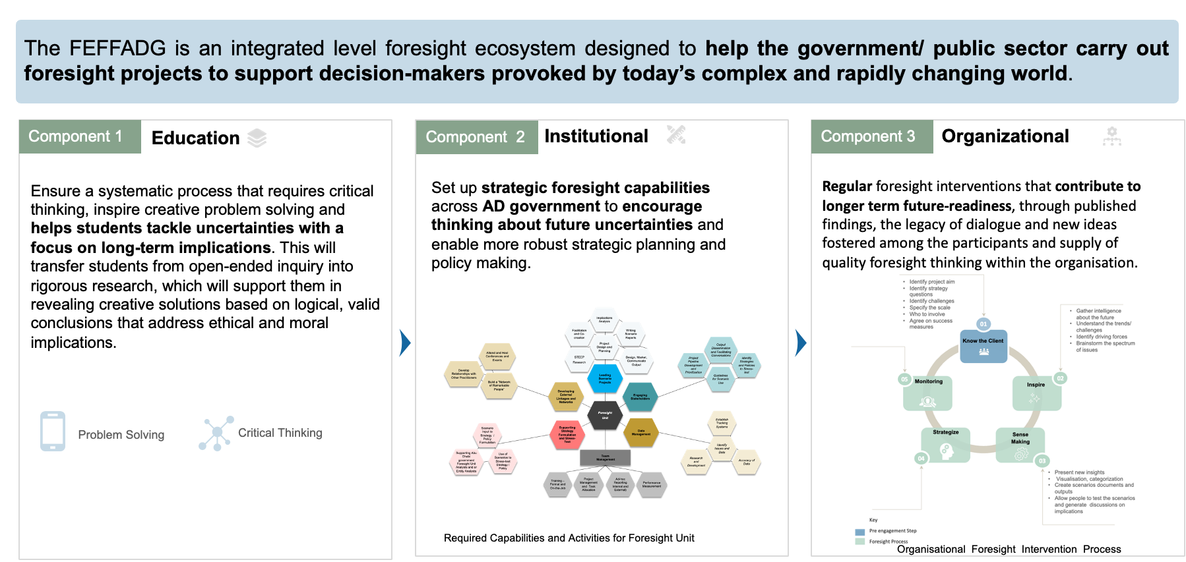
Figure 39: Foresight Ecosystem Framework for the Abu Dhabi Government (FEFFAG)
The ADGPSFE is an integrated level foresight ecosystem designed to help the government/ public sector carry out foresight projects to support decision-makers provoked by today’s complex and rapidly changing world. As shown in Figure 40, the ecosystem consists of three main pillars:
- Educational
- Institutional
- Organisational

Pillar 1: Education – Foresight Infused Educational System:
Building capabilities has always been a challenge and a mandate within the Abu Dhabi government, as mentioned by the Project sponsor in Intervention I.
“Capability is a challenge in almost all sectors and all fields. But it is manageable with training, awareness.” – (KM)
“It is noticeable that it is a challenge in different fields and especially when it comes to strategic planning, performance management and policy formulation.” – one of the social experts in the Abu Dhabi government
“…the capabilities in certain sectors are more mature in the strategic planning, like police and the security side, because they…saw the effect of developing, executing, and monitoring a strategy and how that helps them achieve their goals” – (AJ)
This was obvious in Intervention 1, where the first requirement for the consultant was to deliver three training programs for Abu Dhabi government employees on the introduction to and use of scenario planning for the policy development of the Emirate (Section 5.4.1: Intervention 1: Project Scope).
When the federal government introduced future foresight, the leaders emphasised the importance of building future capacities and instructed the establishment of a solid organisational infrastructure to build the future and invest in local cadres. Thus, the federal government worked towards building capabilities to ensure sustainability in the field of future foresight by introducing future foresight principles in simplified ways. These took different forms, such as school curricula and national capacity-building scholarships to overseas schools and institutions, as well as through launching tools explicitly designed for the UAE government and teaching future foresight specialisations in federal universities and public capacity-building programs, to fulfil the requirements of all sectors, e.g., the Dubai Future Experts Program that is offered by Dubai Future.
As stated in Sections 7.7.5 and 7.7.7, a skilled workforce is an important factor in running a successful public sector operation, and the first step to achieving it is education. This was required by the study participants, who felt the need for aggressive capability-building programs to ensure equitable access to opportunities in the public sector and to protect the interests of the locals.
“We are in an unfair situation of competition; people are coming from different cultures where education and development have been available for them since the beginning and…so you need to give an advantage in this competition to the local minority of Emiratis.” – (MO)
With this in mind, and with a clear indication from the findings of both the interventions in 2009 and 2019, capability development is one of the critical challenges facing the Abu Dhabi government today, and it takes time to develop, as mentioned by the Intervention 1 project sponsor.
“ … the capacity building was part of the whole SP project from the beginning, and it does not come overnight, it takes time” – (KM)
The researcher proposes introducing Foresight Education from the early stages (e.g., high school curriculum and university degrees as mentioned by one of the executives in the education field who stated:
“To ensure sustainability in the efforts and double loop learning where they learn and practice, such capacity must be embedded within the Abu Dhabi government from an early stage” – (MN)
The aim is to ensure a systematic process that requires critical thinking, inspires creative problem solving, and helps student tackle uncertainties with a focus on long-term implications. This will transfer students from open-ended inquiry into rigorous research, which will support them in revealing creative solutions based on logical, valid conclusions that address ethical and moral implications. The outcome of such a pillar is to enable students to develop, experience, and apply their capacity for wisdom in the face of uncertainties.
At the level of high schools, a good example is the International School of Prague, which has included Foresight in its 11th-grade Physics course; will offer individual foresight projects, and will host, with The Central & Eastern European Schools Association (CEESA), a teachers’ foresight program in March 2013. Similarly, the International School of Brussels will have several Foresight pilots’ programs. Foresight will be taught in Grade 10 Humanities. A middle school Foresight program is being designed for the 7th grade. Foresight will be added to upper school English. And Foresight will be included in the High School Art program. Overall, Brussels finds foresight is aligning especially well with new curriculum components.
Some universities showed clear evidence of understanding the need for such a program at the university degree level. For example, the University of Strathclyde, UK, has introduced an entire research program on Research Scenario thinking and scenario planning. Also, the Master of Science in Foresight prepares students to enter an emerging professional field, helping clients and employers anticipate significant changes that lie ahead and to influence those changes to achieve long-term goals. In summary, and as mentioned in Chapter 5, key theme 3, scenario planning requires knowledge and experience that is built over time, as well as proper government custodians that enable effective integration of foresight practices across all government agencies, and central decision-making processes; this will be expanded in the discussion of pillar 2.

Pillar 2: Institutional Design: Establishing Abu Dhabi Government’s Foresight Unit
Effective predictive governance also relies on forward-looking interventions that succeed and regularly contribute to long-term future readiness; through published results, a legacy of dialogue and new ideas are nurtured among active participants, increasing both the demand and supply of quality forward-looking thinking in related organisations.
As seen in Key Theme 2 (Instil Scenario Planning Culture within the government), Intervention 1 successfully sparked interest and created a significant level of awareness regarding scenario planning as part of the strategy development process. Establishing a dedicated unit was an important factor in institutionalising scenario planning and successfully embedding it within Abu Dhabi government entities, as one of the main deliverables of Intervention 1 was a proposal to set up a dedicated scenario planning department.

On the federal level, and to encourage the practice of foresight, it was mandated by Federal Authorities to change the strategy department of all federal entities to the Strategy and Future Department, as shown in Figure 40.
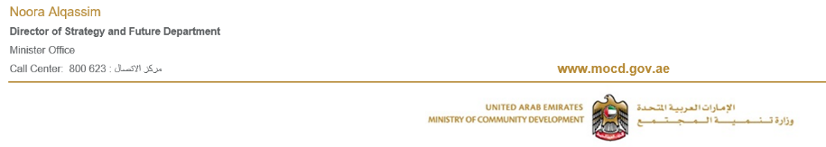
Figure 40: Sample of adoption of foresight practices in the federal government. – Source – Email Account
Moreover, the second intervention also showed that most of the entities have formed Future Studies and Foresight Function, a clear indication of the importance of such a unit (Appendix 6 and 7).

Along with the introduction of foresight in the school curriculum, it is recommended that the government have a dedicated foresight function and dedicated long-term future studies function for horizontal integration of foresight with innovation. The institutional arrangements needed to ensure foresight can take many forms, but the key ingredient is having at least one central foresight unit to advocate, lead, and coordinate visionary work throughout the government as shown in Figure 41.

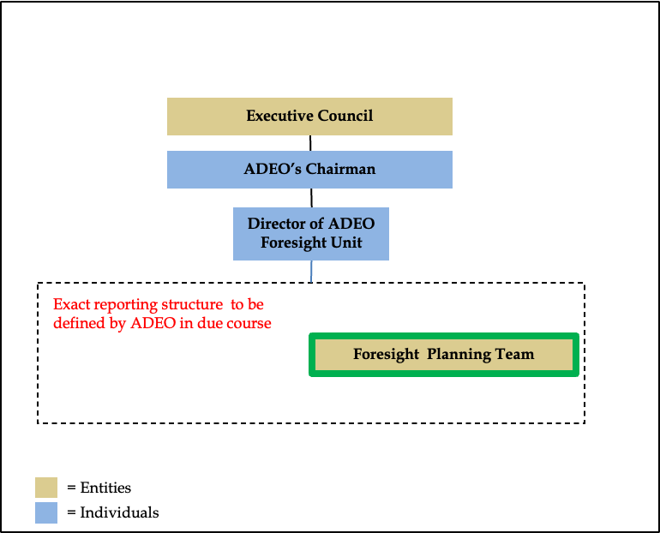
Figure 41: Foresight Unit proposal for Abu Dhabi Executive Office (ADEO)
To ensure agility for the public sector, the goal is not to centralise foresight but to provide a large body of work that will enable effective integration of foresight practices across all government agencies and central decision-making processes. Similarly, most departments and agencies that see it as challenging to develop future-ready policies will generally set their foresight task forces to support the adoption of foresight in their respective mission areas.
- The Foresight Unit should be set up as a standalone team within ADEO.
- It will report either directly or indirectly to the Director of the ADEO Foresight Unit.
- The priorities of the ADEO Foresight Unit will, in the first instance, be determined by the Director of the foresight unit and endorsed by the ADEO chairman.
- The Director of the ADEO Foresight Unit will seek input or decisions from the ADEO chairman and the Executive Council as required.
- The Foresight Director should be empowered with day-to-day responsibility for managing the foresight team, its budget, and its activities.

Within this unit, certain aspects need to be taken into consideration as per the findings:
- Availability and accuracy of data: One of the main elements of this pillar is the data lab, or proper research units, as stated by the project sponsor in Intervention 1
“We wanted the unit or the think tank to be centralised, and include different tools that any individual organisation can tab in and use it” – (KM)
and as agreed by the public sector financial experts, who mentioned
“Investing the right talent across the UAE, and in education, I think that is very, very crucial, and it is very crucial what the government is doing, in terms of investing in R&D” – (MO)
As mentioned in Section 3.10.1 (The intensity of the research approach), there is a need to undertake appropriate research that can support decision makers to take the necessary actions at the right time to meet the challenge of the unpredictable. Decision-makers are unlikely to take scenarios seriously unless they can be convinced that the scenarios have been built upon a well-thought-out, credible research process. Therefore, the quality of the materials used and produced in the foresight process varies widely. Quality issues must be considered at all levels, both by those who implement and participate in the foresight process and by those who use the results. Stakeholder analysis and quality analysis of data, information, and knowledge should be performed early in the process, as well as that concerning results and implementation.
As noted by one of the government's executives when asked about the availability and accuracy of data in the government
“It is a big problem unfortunately and it does not help us take a better decision. It takes a lot of effort to collect the data and make a decision; we have good resources money-wise, human resources, higher education institutes etc., we have a very good infrastructure for economic activity. So, the transparency, lack of data and sometimes short-sightedness” – (MN)
Moreover, the researcher suggested the following competencies be taken into consideration.
Figure 42: Required capabilities and activities for scenario planning.
- Leading Scenario Projects: the researcher believes that the foresight unit should take into consideration running several high-profile, ‘whole of government’ scenario projects annually and at different levels, as stated by one of the participants, who encouraged:
“use of the scenario in the macro level, not micro level (organisation level), as I think in the micro level, they can use SP in different ways… At the macro level, the decision that is made affects almost 80% of the impact, so when we said SP, we wanted to be in the level of government, yet we introduced it to the individual organisation as we want them to be part of the decision-making process. Part of the dynamics. As they are the stakeholders and part of the contributors.” – (KM)
Along with this, it was obvious in Intervention 2 that the scenarios were applied for a different reason (Appendix 7), which shows that initiating and delivering macro-level scenario projects includes project definition, project design and planning, project execution (research, co-creation, implications analysis), scenario report production, and communication.
- Developing External Linkages and Networks: This encompasses building the government foresight unit, meaning they need to develop their own ‘network of remarkable people’ via ongoing cultivation of relationships to provide outside-in thinking and leads on trends and drivers of change, expert input to specific scenario projects, and lessons of best practice in scenario planning. As mentioned by one of the experts:
“You need to have that inside knowledge, in the organisation. At the same time, you need people coming from the outside, because the outside is like fresh blood, it refreshes your thinking so that you're not captured by the organisation and only think like the organisation, you can think more broadly” – (EXP3)
Yet, this should be very well integrated within the organisational structure, making the organisation more resilient to changes in leadership.
- Engaging Stakeholders: Engaging government and other stakeholders across Abu Dhabi in scenario thinking is critical because foresight is one of the fields that consistently needs to drive a lot of tangible outcomes and outputs; therefore, it needs to keep people engaged.
“dedicated stakeholder management or partnership management, and keeping people always involved, informed by different methodologies, such as workshops, such as webinars, such as debates, a lot of things.” – (DOH)
This engagement can take different forms, such as disseminating scenario reports, building awareness of specific scenario implications, communicating, and facilitating conversations about the future to establish a new culture and way of thinking about planning, and providing guidelines on where scenarios may be helpful (which strategies or policies), as stated in Section 7.7.7b.
- Supporting Strategy Formulation and Stress-Testing: Supporting the use of scenarios in strategy and policy formulation and stress-testing is important. This can be done by guiding analysts within GSEC SPP and across Abu Dhabi government entities on how to use systems, both in the formulation of new strategies and policies and for stress-testing existing procedures and policies, as well as actively supporting analysts where necessary.
- Measures of Success: Building capabilities in an organisation is most effectively achieved through a clear set of performance parameters and corresponding measurements that are uniquely developed for the organisation. As mentioned in Section 7.7.7, one of the needs of the Abu Dhabi government is to have proper performance monitoring practices that encourage having well-defined criteria, and proper accountability and governance systems in place.

Pillar 3: Public Sector Foresight Process
A key process that emerged from both the literature review and the research findings was identification of a key question or issue, understanding business factors that could affect the key issue (environmental scan), identifying external forces that will impact the issue, followed by the creation of critical uncertainties, narrowing of possible futures, and building of narratives.
The GBN approach was the most common approach, and it was used in Intervention 1 as well as by three of the experts consulted (EXP2, EXP5, and EXP 7). The approach is illustrated below:
Figure 43: Global Business Network (GBN) scenario planning process. Source: Developing & Using Scenarios - Scenario Training Seminar -Abu Dhabi Jan 9 -13, 2011.
The researcher deliberately aims for a process that is more open and not very process-oriented with a wish to leave some creativity for the organisation when it comes to which processes are used. This process aims to stretch awareness and develop plausible descriptions of future states useful for policy creation and testing. A typical scenario planning project accomplishes this in different ways, as described in Chapter 2 (application of scenario planning). Yet this proposed process, as shown in Figure 45, is designed to help foresight practitioners develop scenarios for senior management and to help managers plan for and monitor scenario project execution.
Customised approach that is designed to fit the needs of the organisation:
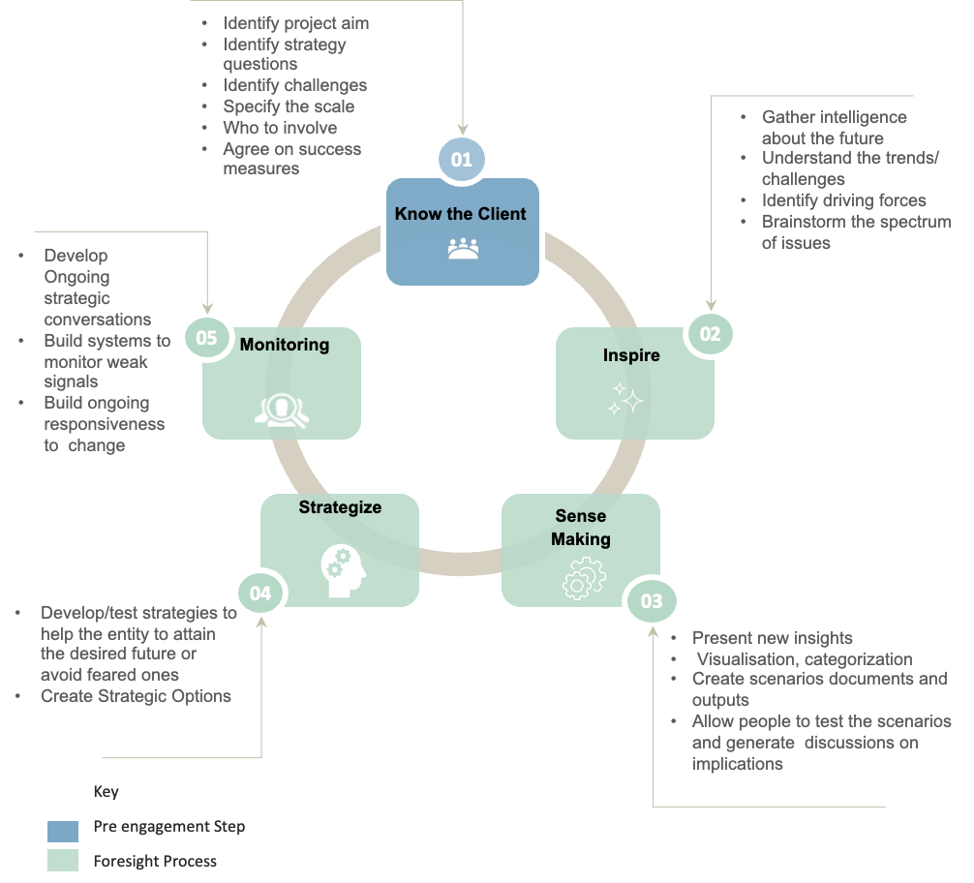
Figure 45: Public sector foresight process.
Step 1: Know your client: The initial stage of the proposed Public Sector Foresight framework is designed to set the tone for the entire project. Van der Heijden (2005) emphasised that both facilitator and client need to agree on the main points and define the framing of the project before initiation to avoid any future misunderstandings or reaching a point that might lead to project failure. This is a pre-step aim to understand the entity/organisation and the inspiration for conducting a foresight project. It starts by setting up the agenda that serves as a backbone for the entire project. That was referred to in Section 6.3.2 (by EXP6) as the diagnostic phase: “a kind of diagnostic exploration phase that happens in all projects really to help to, you know, frame and level set the starting point”.
In this stage, agreement would be reached on the time frame that the entity would like to cover (10, 15, 20, 30 years). In addition, the willingness to use scenarios as a single tool or to combine scenarios with other strategic planning or foresight tools should be determined. Along with this, before developing a scenario agenda, a few critical questions must be raised at the beginning of the scenario project. The activities, stakeholders, resources, and time allocation depend on (1) who sponsors the process; (2) what the primary purpose of the project is; (3) who will be using the scenarios; and (4) what the expected outcomes are (Van der Heijden, 1996).
The most important part of a foresight project is choosing a relevant focal question. Without a crisply defined focal question, scenarios run the risk of “talking about everything and saying nothing.” Therefore, managers must help determine the focus of scenarios before any work is developed. Moreover, an excellent focal question will be relevant to a broad group of stakeholders, critical to ongoing policy discussions, intrinsically uncertain as to the outcome, and helpful to pursue.
Agreeing on what is considered a successful foresight project, and how a project or intervention will be evaluated at the beginning of the process is important and is determined by the client's desired outcomes. This is a key element to determine the successfulness of the intervention, as mentioned in Section 6.6.5.
Step 2: Inspire: Understanding the current challenges that the entity is going through and gathering intelligence about it along with the driving forces involves forms the detailed research and data collection phase. This usually involves between 10 and 25 interviews with key stakeholders and experts (both internal and external to the organisation) on the subject in question. It also entails significant desktop research, ethnographic site visits, and/or drawing from existing statistical databases, research services, and studies. Scenario researchers will then brainstorm the spectrum of issues and analyse these interviews and data to produce key themes that will influence the future focal question.
Step 3: Sense Making: This step involves sorting the driving forces uncovered in Step 2 into those that are “relatively certain” and those that are “critically uncertain.” Relatively certain forces are those that will have a significant impact but are also reasonably certain to occur. Critical uncertainties are those that will have a significant impact but whose outcome is the most unclear.
It is suggested that the organisation should combine different tools of foresight to make it easier to grasp the goal of the project/intervention. The use of a range of methodologies, both quantitative and qualitative, over time is also essential. As the organisation becomes “future aware,” more complex and challenging methods can be used. Starting with scenario planning, for example, can be valuable if it is not the only methodology ever used. All methods have flaws and using various methods will help ensure outputs are well-founded.
The combination of these forces leads to developing “Scenario Frameworks” and “Scenario Stories.” Scenario frameworks are created in a workshop by combining different critical uncertainties to create a “scenario matrix.” This provides the guiding logic for scenario stories, in which participants and scenario planners create draft “scenario logics,” which are the beginnings of the final scenario stories. Scenario stories explore how the key driving forces influence important stakeholders and actors over time, leading to a rough outline for how the future might unfold. This usually results in three to five distinct scenario stories which describe how the critical uncertainties might unfold over time.
Step 4: Strategies: Incorporating scenario planning techniques into strategic thinking strategies allows decision-makers to prepare for uncertain future situations. Transparent processes are required to clarify individual thoughts about the future and allow these views to be seen together so that organisations and employees can think about the future in their daily plans. This step involves exploring how each of these scenarios would impact key stakeholders and issues. This is often begun in a workshop setting and then detailed and refined in a series of post-workshop meetings and mini-workshops. The output of this step helps link scenario stories to policy development by explicitly identifying important implications in each scenario and using these as a basis to generate or refine a set of policy options. Presentation of the scenarios in a way that engages and has a lasting impact on the executives and affected parties is one of the most critical steps in any scenario project. It has been proven from previous scenario interventions that written summaries and PowerPoint presentations of the vast amount of collected information were considered dull and uninspiring. The organisation should put as much effort into communicating the scenario as they do when communicating the organisation's strategy.
Steps 2, 3, and 4 are frequently done in draft form in a participatory workshop and then refined later in greater detail.
Step 5: Monitor: Project evaluation, monitoring, setting clear milestones, and regular evaluation are all key elements to ensure sustainability and continuous engagement from leadership and stakeholders. As explained in Intervention 1, Key theme 2, foresight projects are not a one-time job, and the outcomes need to be translated into strategies, policies or as per the need of the organisation. The failure to do so will lead to failure in accepting the foresight. Both Sections 6.5.5 and 7.7.7. emphasise the importance of this step. There should be clear indicators and metrics during scenario planning to determine the success of the intervention. When it is unclear how the scenarios will be used, then the process is bound to fail.
Building a foresight system requires feedback and consideration to improve and respond to new situations. Another essential reason to ensure a total review is to demonstrate the positive effects of foresight on better policies, on the invisible opportunities identified and realised, or on the invisible costs and the crises that have unfolded or been avoided. Such an assessment is inherently difficult because it involves assessing the value of counterfactual results and providing a source of new ideas in a complex decision-making process. Moreover, this brings implications from the previous step back to the present by laying out a “road map” of possible indicators and signposts that decision-makers can use to understand how the world may change. An extensive socialisation and stakeholder engagement process is then conducted once the seven-step process is completed. This can take many forms, including written publications, webinars, or videos. One popular and highly effective method is a travelling “road show,” in which scenario staff conducts presentations and mini-workshops with key entities and concerned parties. These exercises aim to help entities understand and explore each scenario and reflect on how they would impact their specific policy concerns and areas of responsibility.
Although there is no direct reference to the importance of follow-up in the literature, the expert comments gathered in Phase 2 (see Section 6.6.5) indicate that following up with an organisation that has embarked on scenario planning is important.
Post-scenario creation workshops are often the most important part of the scenario planning process. These efforts help broaden engagement with the ideas and issues uncovered in the scenarios themselves, thereby ensuring deeper understanding, better adoption, and more value for money.

Tool Testing and Feedback
For this thesis, the Framework was reviewed by five individuals who provided preliminary feedback on its usability and completeness. The feedback showed positive results on implementing scenario planning and foresight practices. Following review, the researcher registered the framework and gained intellectual property rights from the Ministry of Economics, as shown in Appendix 9.

Candidates for the Review
Four participants from Phase 3 indicated their interest in reviewing the framework, along with the head of ADEO’s foresight unit. The Phase 1 Project Manager also expressed interest in reviewing the tool since they witnessed the first introduction and wanted to see if it is applicable and could add value. Therefore, a total of five individuals participated in this review.

Preliminary Feedback
A virtual meeting was arranged with the selected participants, and the diagram was shared with them. For confidentiality and copyright reasons, the researcher decided not to share the diagram earlier.
Those meetings aimed to obtain feedback on (i) the overall completeness of the ecosystem, (ii) the ease of use of the public sector foresight framework, and (iii) the overall effectiveness of the ecosystem. The full framework was not shared with the participants, only the diagram. A face-to-face interview was arranged with each participant, with two objectives: (1) the researcher explained the tool to the participants, taking them through the pillars and the added value of each, 2) the researcher asked the participants to raise any issues they saw with the tool and to clarify those issues to make improvements.
Each interview was scheduled for approximately 60 minutes and was conducted on Teams. The feedback was audio-recorded for analysis and reference purposes.

Data Analysis
The analysis comprises two sections: (1) to record and review the ratings of the usability and completeness of the tool, and (2) to identify the main issues participants had with the usability and completeness of the device. No extensive coding exercise was conducted on the data collected from interviews for this Phase due to the number of interviews and the objective for conducting those interviews, which was mainly to clarify written feedback received.
The feedback on the ease of use and completeness was dealt with in two ways:
(a) a 5-point rating scale, namely: 1 (poor), 2 (adequate), 3 (good), 4 (very good), and 5 (excellent); and (b) narrative feedback on limitations encountered and recommendations, if any. The feedback was extracted from the feedback forms and the interviews and is presented below
Ease of Use
Organisation | ADFSA | TCD | DOH | ADEO | Part 1
Rating | 4 | 3 | 4 | 5 | 4

Completeness
Organisation | ADFSA | TCD | DOH | ADEO | Part 1
Rating | 5 | 5 | 5 | 5 | 5

Descriptions of Overall Utility
Expectations: All reviewers expressed that the tool met their expectations regarding its usefulness, completeness, and non-prescriptive nature. TCD rated the ease of use as 3 as they believe the introduction of foresight in the education system will be hard to achieve due to the current challenges with the education system, and this might take a long time, unless it there is clear direction from the Abu Dhabi leadership to do so. The ADEO foresight manager wished for more details on the development of the foresight unit; this can be further explored outside this study.
Conclusions: A review of previous work on guides and frameworks highlighted the feasibility of the development of a tool to support the development of a comprehensive ecosystem for the public sector in the emirate of Abu Dhabi.
Suggestions for improvements and enhancements included:
- Register as a trademark for the researcher and the Abu Dhabi government
- Detail the framework and develop full guidelines on its use, including a policy on foresight tools and how to use them
- Work with the Abu Dhabi Executive Office to check the possibility of integrating it with the proposed structure for the foresight unit
- Provide detailed information about what foresight is, along with detailed guidance on how to run a successful foresight project and use the scenarios and other tools developed in various productive ways.
The observations from the tool testing underlined the possibilities for future research to further enhance and improve the tool. The tool could serve two primary purposes: as a helpful model of practice and as an initiative for further research to help the organisation develop and improve foresight practices. There is also potential for future research on the applicability of the framework and the tool in contexts different from that of agencies, public bodies, or a foreign country.

REFLECTIONS, LIMITATIONS AND FUTURE RESEARCH

Introduction
The Abu Dhabi government has made significant progress in introducing and improving the strategic planning and policy formulation practices in public sector institutions. Now, public sector entities should work to align their efforts in order to overcome the biggest obstacles to foresight, such as lack of internal resources and user-friendly methods, funding, time, management support, structural issues, and cultural barriers. Therefore, to promote foresight, management should support the programme culturally and financially to establish user-friendly processes and methods. Moreover, foresight should be funded by the central government to enable continuity. However, it should not require continuous management approval at each step and should be managed in a decentralised way.
The appetite for scenario planning or a structured foresight approach/tool to assist in developing policy or strategic thinking in Abu Dhabi was there and welcomed by both the leadership, executive management, and the individuals in charge of decision-making. However, attention to data maturity, scope, organisational culture, and capability development needs to be considered.
Capability building is still a challenge in the Emirate of Abu Dhabi. However, compared to when strategic planning was introduced in 2007, Abu Dhabi now has the right resources and employees who are eager to learn and expand their horizons. There is an acute need for continuous development of the future ecosystem within the Abu Dhabi government. This can be accomplished in different was, such as implementing a school curriculum or running a special design suite of courses for government employees regularly to equip them with methods and approaches for future work.
This study aimed to conduct in-depth research to do two vital things: (i) Examine the factors influencing scenario planning implementation and practice within the Abu Dhabi government, and (ii) Develop a guide for public managers for scenario planning implementation and practice within the Abu Dhabi government. The research objectives and research questions were addressed in several phases (Chapters 5, 6, and 7), data were gathered from 27 participants and organisations, and the analysis and interpretation of data led to the main findings presented in Chapter 8.
This chapter is divided into nine sections that detail the theoretical and practical contributions and the managerial implications of the thesis, followed by reflections on the researcher's journey. The limitations of the thesis are set out, and finally, future research on this topic is suggested.

Retiring the Gap in the Literature
The review of the recent literature related to scenario planning implementation is described in Chapter 3. The review highlighted several challenges in implementing scenario planning in the public sector, and synthesised the following conclusion:
- There is a lack of empirical research and published materials relating to scenario planning within the Middle East region. Moreover, the existing literature skewed very much toward the western world. In other words, most of the research in scenario planning implementation has been conducted in Europe, Asia, the United States, and other countries. To the best of the researcher's knowledge, limited documentation is available for Arab countries. No study has yet been conducted on UAE-based data to explore scenario planning implementation. In addition, the research context is relatively new since the UAE came into being in the early 1970s. Scenario planning as a discipline was introduced in the UAE in 2006 (details are provided section 2.4. Therefore, this study is believed to be the first to focus on scenario planning in the UAE and Abu Dhabi governments. The researcher believes that this research in the UAE may open the doors for future studies to explore the current scenarios in other Middle Eastern countries and regions.
- Despite the body of previous literature about scenario planning in general, little attention has been paid to the factors influencing the success and failure of scenario planning–based interventions. For example, Hodgkinson and Wright (2002) argue that until further case analyses documenting the success and failure of scenario exercises in a range of organisations are systematically reviewed, the ability to predict the appropriateness of scenario techniques as an intervention in specific organisational contexts will remain limited.

Contribution of the Research
This thesis has led to several contributions for the Abu Dhabi government public sector in particular and (argued contributions) to the public sector scenario planning literature in general. This section discusses the contribution this research makes to the general body of literature on public sector scenario planning implementation.

Theoretical contributions
- Identification of Factors that impact scenario planning intervention
Hodgkinson and Wright (2002) argue that until further case analyses of the success and failure of scenario exercises in a range of organisations are systematically documented, the ability to predict the appropriateness of scenario techniques as an intervention in particular organisational contexts must remain limited. The thesis contributes a new and important understanding of scenario planning in four main areas. First, even though much has been written about scenario planning in general, there is a lack of discussion about the identification of success and failure factors that might occur with any scenario planning intervention. In short, further case analyses are necessary to deeply understand organisational contexts that are differentially receptive to scenario interventions. The researcher has identified factors (Sections 5.12.1, 6.6.4, and 7.10.4) that can impact the implementation of scenario planning and foresight in government, which is a new contribution to the existing literature.
- Identifications of measures to rate successful scenario planning interventions
The findings uncovered the main interconnected elements that were key to the practical evaluation of the scenario planning project. The resulting empirical framework serves as a starting point for future research and practice on public sector foresight and scenario planning practices.
- Middle Eastern public sector organisations’ Scenario Planning
The research empirically documents knowledge based on the experiences of public sector participants during their very first encounters with scenario planning exercises within the Abu Dhabi government. Most of the research in scenario planning implementation has been conducted in Europe, Asia, the United States, and other countries. Limited documentation of Arab countries is available and UAE-based data are absent. The research context is relatively new since the UAE only gained independence in the early 1970s, and strategic planning as a discipline was only introduced in 2006 (Chapter 2). The findings of this study help understand the nature, issues, and challenges of scenario planning in the context of public sector organisations in the Arab world and Middle Eastern regions. Therefore, this study is believed to be the first to focus on the UAE and Abu Dhabi and may open the door for future studies exploring the current scenarios in other Middle Eastern countries and regions

Practical Contribution
- Continued Changes in the Leadership (Discontinuity):
The research findings presented in Sections 5.12.1, 6.6.4, 7.7.2, and 1.10.4 revealed that leadership support is one of the main factors that can significantly impact the implementation of scenario planning in the public sectors in Abu Dhabi. As mentioned in Chapter 2.2.5, when an organisation discourages divergent opinions and strategies, such as brainstorming, it is likely to be restricted in its solutions to problems or challenges. Thus, its operations or projects are more likely to fail than those of organisations or cultures that promote sharing of ideas. Hence, as mentioned in Chapter 3.10.2, leadership support during the scenario planning process is one of the most important elements for a successful scenario planning intervention, as noted by Schwartz and Ogilvy (1979). Although some researchers have stated this, none of them highlighted the impact of changing leadership on scenario planning implantation.
- The Foresight Ecosystem Framework
The study informs the broader methodology literature as the research was shaped by social constructionist epistemology and employed a qualitative approach for data collection to inductively develop a framework/ecosystem that aims to implementing adequate foresight in the public sector. The novel framework developed for this research includes all pillars necessary for foresight and scenario planning implantation practices. The resulting foresight ecosystem aims to help not only the Abu Dhabi public sector but the public sector in general, as it provides a guide for foresight intervention taking into consideration challenges specific to the public sector and benchmark countries or companies who successfully implanted such a concept. The framework is described in Chapter 9.

Managerial Implications
- From a managerial perspective, the study has provided several important implications for the Abu Dhabi government leadership, public sector top management, strategy, and policymakers within public sector entities. Firstly, the top management of the public sector and of Foresight and Futures studies units within public sector entities must encourage using and utilising several foresight tools while analysing the internal and external environment.
- Second, concerning the Abu Dhabi government leadership, represented by the Abu Dhabi Executive Office, the Foresight Unit should enhance the communication of foresight practices and connect them both internally and with external stakeholders. Findings show weak communication of such practices. Furthermore, by enhancing communication, public sector entities will allow better coordination with prominent foresight experts, partners, and think tanks that should have transparent discussions over various political issues and receive support for strategic decisions from the main stakeholders.
- Third, an important managerial implication is the implementation of quality strategies and plans that arise from interviews with public sector executive officers. The Abu Dhabi Executive office can enhance the implementation of strategies and plans by formalising the planning process and establishing foresight as an input to strategic planning. However, it should be highlighted that the extent to which formal planning processes are practised implies neither better performance nor better-developed strategies. However, the ADEO can expect several non-financial benefits deriving from a formal planning process, such as: enhancing the understanding of corporate priorities; awareness of potential problems; recognising internal strengths and weaknesses; and better overall coordination, implementation, and control of the company strategy.
- Fourth, the leadership team and line managers should pay more attention to internal and external obstacles to the planning process. Research results show a strong influence of internal constraints on the formality of the planning process as well as the quality of the subsequent strategic planning results. In addition, internal barriers shorten the planning horizon. The company's management team and executives should therefore moderate the effects of internal obstacles, such as employee resistance to change and poor strategic thinking from employees, by educating them on the importance of strategic planning and aligning employee interests with organisational goals.
- The contributions obtained from senior officials during this research suggest a cautious defensive mindset, especially regarding sharing of strategic information. Policymakers in the government of Abu Dhabi and leaders of public sector organisations in Abu Dhabi have a responsibility to create a culture that enables knowledge sharing and affirms that decisions taken have given due regard to ethical principles. While that may be justified, knowledge sharing is encouraged by a good work ethic, which is a crucial way to grow and learn from the experiences of others. Furthermore, although Islamic culture strongly influences individuals' practices and perceptions, Islamic ethics in business are not effectively understood and integrated. However, some officials in Dubai are not interested in planning and feel that only God can know the future, so planning is unnecessary. Such perceptions can significantly affect the quality of the planning process. Therefore, the planning process should be managed effectively.

Reflections as a Researcher and Strategy Practitioner
This section aims to reflect upon and share the researcher's personal experiences concerning the validity of this research. In this reflection, the researcher mainly focuses on those intangibles that do not necessarily belong to the scope of scholarly conclusions. Nevertheless, they are important to discuss. The personal experiences and opinions of the researcher are formulated below in a subjective way.

Reflection 1: Cultural Understanding and Appreciation of the Scientific Research
As a first reflection, it is vital to highlight the lack of cultural understanding and appreciation of scientific research. This reflection is rooted in the challenges the researcher, the decision-makers, and the participants faced. At the start of the research journey, the first step was to reach out to the entity that sponsored this project (GSEC). The researcher requested access to documents. However, even though the researcher showed proof of being a student to the management team of GSEC and informed them that the information would be used for scientific work that would undoubtedly contribute to the Abu Dhabi government once completed, the request was rejected due to the confidentiality of the data.
This led the researcher to contact the internal offices of GSEC and determine who the project sponsor was. Yet, due to the unavailability of the project sponsor; the researcher reached out to the project manager who explained the whole intervention, as mentioned in Chapter 5; access to the data was granted. The next challenge was to get approval from the Chairman of the Abu Dhabi Executive Council; the researcher ultimately obtained verbal approval to use the data. The primary reason for verbal approval was that the data were outdated and could be used as reference points for research.
In Phase 2, due to the researcher’s level of expertise, booking and interviewing went smoothly. In Phase 3, the researcher initially tried to meet with the excellence award office to learn more about how scenario planning was chosen as a pillar, but the request was rejected because the researcher was no longer working with the government office. However, later on when the researcher shifted the employer and back to work in government, then the researcher was able to easily secure interviews with executives and entities who had shown success in implementing scenario planning.
Finally, the researcher found that researchers in the UAE are handicapped in seeking knowledge, especially qualitative data, that can be useful to policymakers and leadership. Therefore, the government should create policies that support researchers and grant access to existing knowledge, databases) and an open system that allows freedom to perform scientific work. Moreover, the government should appreciate that if it supports researchers, it stands to gain, at little cost, reliable data that leadership and decision makers can utilise in future decision-making processes.
One of the main limitations of this study was that the participants did not fully understand the concept of future foresight, which appeared in the survey sent to the participants in Intervention 2.

Reflection 2: Data Collection Tools
Although the primary data were obtained by the use of an in-depth interview, the researcher has analysed the advantages and disadvantages of alternative primary data collection methods, such as a survey (attempted in the early stages of Phase 3, without success). The experience led to in-depth knowledge about these data collection methods.

Reflection 3: Data Analysis Tool: Manual vs. Automated
The researcher first attempted to analyse the data using manual coding. It was interesting to work with the raw data and to start developing codes and themes. However, the researcher could not interpret the data in a sufficiently analytical way using this method, as the results were only organised under categories rather than in context and dimension. Hence, a lack of understanding of the available tools can impact the quality of the analysis. Although a week-long course on qualitative analysis was offered during year one and the tools (NVivo) were available through the university portal, the researcher had limited knowledge of how to use the tools to extract codes and themes. Access to someone who can provide support in understanding, guiding, and troubleshooting these types of analysis is invaluable.
Given this experience, the researcher believes that it is important to initially consider the available tool options, as well as alternatives or combinations thereof. The researcher acquired valuable analysis skills while conducting this study. This was the first time the researcher had engaged in collection and analysis of primary data at this scale.

Reflection 4: Multi-Research Phase
The researcher decided to split the research into three different phases to optimally address each research aim. This was due to the impression that having separate phases could allow each phase to be dealt with in detail and the single-phase findings developed separately. Thus, splitting the research into three phases proved to be vital to addressing these specific research questions.

Reflection 5: Improvement of Time Management Skills
As a full-time employee who experienced career change during the research phase, the researcher has benefited from the research experience by improving their time management skills. Each of the three phases required extensive preparation and planning and the timing needed to be coordinated for all parties involved.
Initially, the researcher faced challenges in ensuring the study's timely progress. These challenges mostly appeared during Phase 1, as the researcher could not gain access to original documents or key people, as mentioned in Chapter 5. Eventually, the issue was dealt with by reaching out personally to those individuals, re-adjusting the study's time plan, and increasing the level of personal discipline in terms of the plan.
Another challenge was with re-submission, in which Phase 3 needed to be redone. It was challenging to think of how to restrict the study, and who should be involved and how. Given the tight schedule, all unnecessary activities (social gatherings, family gatherings, work-related trips) were avoided during the research process, and a schedule was made for completing a specific portion of the study every month. Occasional days off were built into the plan to avoid burnout, which could negatively affect the study. In conclusion, the research experience has contributed to improving the researcher's time-management skills, which offers substantial personal and professional benefits.

Reflection 6: Increasing the Level of Self-Confidence
The researcher's self-confidence level has increased significantly while conducting this research. This was mainly achieved through overcoming insecurity and communicating with primary data sources (members of the sampling group) in a confident manner.
At the outset, the researcher was reluctant to choose a primary data collection method because it involved approaching unfamiliar people in the street and asking them to participate in the survey. It must be acknowledged that the researcher had been approached in the streets many times with offers to participate in various surveys, most of which they declined. As such, the prospect of being refused by the sample group's perspective members negatively affected the researcher's self-confidence prior to the primary data collection process.
However, as a result of tremendous effort, which included spending many hours on preparations for primary data collection, as well as thanks to the encouragement given by tutors, friends, and relatives, the researcher was able to overcome a sense of insecurity and conduct the survey confidently. Moreover, it would not be an exaggeration to say that researcher’s communication skills have been greatly enhanced as a result of conducting the research.
It is beyond any doubt that the researcher will greatly benefit from the increased self-confidence in the future as an individual, as a researcher, and as a business manager. Businesses cannot survive without robust and effective leadership in today's highly competitive marketplace. Moreover, business managers must possess a high level of self-confidence and communication skills to communicate their business vision to stakeholders. Thus, engaging in the study has indirectly contributed to the researcher’s leadership skills.

Study Limitations
This study has some limitations. The first limitation encountered was access restrictions. The corporate planning documentation available could only be viewed by the researcher and could not be shared in the study context. Some of the interviews supplemented the needed data and some documentation data were obtained from the Intervention 1 project manager. Whilst this thesis contributes to the body of scenario planning literature, it has several limitations that must be identified. The limitations are discussed in terms of the limitations of the methodology.
In all phases, most of the semi-structured interviews were carried out with senior staff (executives, project sponsors, advisors, etc.). This helped to get access and generate solid data. The challenge was that these individuals had been heavily involved in the scenario planning process, and consequently would feel a relatively strong sense of ownership of it. In these circumstances, one can assume that they would not be forthcoming about challenges and faults in how the process was conducted and implemented. The documentation and data that had been collected (secondary data and government publications) helped to overcome this problem, but it should be stated that a less biased view might have been obtained if the interviewees had included a sample of managers that were affected by the process but not closely involved in its development. Nonetheless, staff interviewed at some organisations were remarkably sincere about what they perceived to be some of the challenges of scenario planning implementation as they had applied or experienced it at their organisation.
The second limitation is the research population. this study was limited by the of the limited access to the participants in Intervention 1. Intervention 1 took place almost nine years ago, and people the participants of Intervention 1 had moved on in their work. Moreover, the intervention was a new concept, so participants did not recall some of the specifics related to the process. It could also be argued that the entities participating in Phase 3 might not represent the entirety of the Abu Dhabi public sector., The entities were selected based on criterion that they had clear records of the implementation of scenario planning and had representative case studies. They were already eager about the experiences of their entity; hence, they could provide documented evidence of a widespread practice and knowledge of scenario planning. The research output might have been different if entities who did not practice scenario planning were also interviewed. However, on reflection, how much would organisations that were not very involved in performance measurement contribute towards good practice?
The third limitation was the research scope, this study was limited to investigation of factors that impact the implementation of scenario planning in the public sector by focusing on the case of the Abu Dhabi government. The factors relevant to the Abu Dhabi government might not be applicable to all other situations, due to the specific governance and leadership structure in Abu Dhabi. It may add value to study two or three different government organisations or entities, evaluate the process (before, during, and after), and test how factors, such as governance, power, decision-making, and knowledge, might vary from one entity to another.
Also, concerning the research context, this study was conducted within Abu Dhabi. However, public sector organisations in different cultural contexts globally or even within the Middle East may yield different results. Therefore, caution should be taken when generalising the results of this thesis.
With regards to methodology, much of the data were gathered using interviews. Internal validity can be further enhanced with getting feedback on the summary of findings for each phase from the participants to ensure that the interpretations were accurately depicting their views, ideas or opinions. The source of information could also be triangulated to develop a more comprehensive understanding of the unfolding events. For example, Phase 2 - expert opinions could be supplemented by case studies as evidence to support each point put forth, and/or more extensive examination into the work done by each expert. Phase 3 - in addition to the data from the series of interviews, participants could offer documentations of process or workshops conducted, reports of Breakfast Clubs organised, or feedback from Foresight Ambassadors.
Finally, a workshop could have been organised with public administrators to obtain some feedback on the Foresight framework that was developed based on the findings of this research. Future research can possibly use the Foresight framework to guide implementation as action research to examine how the framework can further be enhanced, improved or amended.
The fifth limitation encountered was the formulation of research aim and objectives. the initial focus of the research is to gain in depth understanding of the first implementation of scenario planning in Abu Dhabi government, and then it expanded to identify some of the critical factors of good practice for implementation scenario planning. While working on Phase 1 of the study, the government launched Foresight as innovative approach as one of the pillars for Abu Dhabi Excellence Award. The research was again expanded to capture the reflections from public administrators on what worked well. Therefore, throughout the research journey until the viva-voce session, came to a realisation that the objectives of the research were evolving as new opportunities for collecting evidence and information relevant to the research objectives emerged. In the final revision to the dissertation, the study was divided into three sequential phases, each with clearer focus.

Suggestions for Future Research
Although this study attempted to contribute to the public sector scenario planning literature, it left several important areas outside its scope, which offer potential for further research. These can be summarised as follows:
Considering the growing awareness of foresight, especially after COVID-19, and the importance of acknowledging uncertainties, researchers and scholars are encouraged to research foresight interventions in other Middle Eastern public sectors. Although Middle Eastern countries may share similar cultural environments, they differ significantly in their political and economic environments and leadership and governance structure. Therefore, researchers are encouraged to explore strategic planning in general and foresight in particular in other Middle Eastern public sectors. Researching an assortment of Middle Eastern public sectors would assist in generalising the findings.
The implementation of foresight in general and scenario planning in particular in the Middle Eastern public sector is an important area that lacks the necessary attention from scholars. This study has focused on understanding factors that lead to successful intervention. Researching the implementation phase through a longitudinal study could allow for a better understanding of cause-effect relationships and yield interesting implications for management and practice.
Further studies should also explore the relationship between foresight in the public sector and its impact on strategic planning and organisational performance. The researcher attempted to close gaps and open doors into new areas in the public sector scenario planning literature, hoping to encourage further research. The results and findings of this thesis alone will not do justice to this broad research context. A simplified methodology and practical tools that allow decision-makers to better prepare for uncertain futures are needed. There is also a need for technological support for agile decision-making. The scenario planning framework tool kit developed by the federal government was adopted from best practices, although it could be further simplified to make it more practical for implementation.

Summary
Implementing foresight interventions in the Middle Eastern public sector is an important area that lacks the necessary attention from researchers and scholars. This study has focused on understanding the factors contributing to the failure of scenario planning in the public sector of Abu Dhabi by identifying the underlying factors influencing its implementation in public sector organisation. Researching the implementation phase through a longitudinal study should enable a better understanding of the cause-effect relationship and produce implications for management and practice. Finally, through this study, the researcher has identified gaps and opened some doors into new areas in the Middle Eastern public sector scenario planning literature, hoping to encourage further research.

REFERENCES
Aichouni, M., Touahmia, M., Kolsi, L., Alghamdi, A.S. and Al-Homaid, T. (2021) 'Foresight readiness assessment for Saudi organizations', Journal of Futures Studies, 25(3), pp. 49-63.
Al‐Marri, K., Ahmed, A.M.M.B. and Zairi, M. (2007) 'Excellence in service: An empirical study of the UAE banking sector', International Journal of Quality & Reliability Management, 24, pp. 164-176.
Al-Muhairi, B.S.B.A. (1996) 'The Islamisation of laws in the UAE: The case of the penal code', Arab Law Quarterly, 11(4), pp. 350-371.
Amer, M., Daim, T.U. and Jetter, A. (2013) 'A review of scenario planning', Futures, 46, pp. 23-40.
Atiyyah, H.S. (1993) 'Management development in Arab countries: The challenges of 1990s', Journal of Management Development, 2, pp. 3-12.
Beck, J. R., Kassirer, J. P., & Pauker, S. G. (1982). A convenient approximation of life expectancy (the “DEALE”): I. Validation of the method. The American journal of medicine, 73(6), 883-888.
Berger, P. and Luckman, T. (1996) The social construction of reality. London: Penguin.
Bergson, H., Blumer, H., Charmaz, K. and Hutchinson, S. (2003) 'Qualitative Interviewing and Grounded Theory Analysis', in Holstein, J. and Gubrium, J. (eds.) Inside interviewing - New lenses, new concerns. Thousand Oaks: Sage Publications, pp. 310-330.
Berry, F. S., & Wechsler, B. (1995). State agencies' experience with strategic planning: Findings from a national survey. Public administration review, 159-168.
Bianco, C. and Stansfield, G. (2018) 'The intra-GCC crises: Mapping GCC fragmentation after 2011', International Affairs, 94(3), pp. 613-635.
Blair, J. and Presser, S. (1992) 'An experimental comparison of alternative pretest techniques: A note on preliminary findings', Journal of Advertising Research, 32(2), pp. RC-2.
Bloom, C. (1986) 'Strategic planning in the public sector', Journal of Planning Literature, 1(2), pp. 253-259.
Bodin, R., Chermack, T.J. and Coons, L.M. (2016) 'The effects of scenario planning on participant decision-making style: A quasi-experimental study of four companies', Journal of Futures Studies, 20(4), pp. 21-40.
Boyatzis, R. E. (1998). Transforming qualitative information: Thematic analysis and code development. sage.
Bradfield, R., Derbyshire, J. and Wright, G. (2016) 'The critical role of history in scenario thinking: Augmenting causal analysis within the intuitive logics scenario development methodology', Futures, 77, pp. 56-66.
Bradfield, R., Wright, G., Burt, G., Cairns, G. and Van Der Heijden, K. (2005) 'The origins and evolution of scenario techniques in long range business planning', Futures, 37(8), pp. 795-812.
Bryson, J. M., & Roering, W. D. (1988). Initiation of strategic planning by governments. Public administration review, 995-1004.
Bryson, JM (2004) Strategic Planning For Public and Non Profit Organizations: A guide to
strengthening and sustaining organizational achievement, 3rd edition, Jossey-Bass, San Francisco.
Braun V, Clarke V (2014) What can “thematic analysis” offer health and wellbeing researchers? Int J Qual Stud Health Well Being 9:26152.
Cairns, G., Wright, G., Bradfield, R., Van Der Heijden, K. and Burt, G. (2004) 'Exploring e-government futures through the application of scenario planning', Technological Forecasting and Social Change, 71(3), pp. 217-238.
Carpenter, M.A., Geletkanycz, M.A. and Sanders, W.G. (2004) Upper Echelons Research Revisited: Antecedents, Elements, and Consequences of Top Management Team Composition. Journal of Management, 30, 749-778.
Chakraborty, A. (2010) 'Scenario planning for effective regional governance: Promises and limitations', State and Local Government Review, 42(2), pp. 156-167.
Chermack, T.J., Lynham, S.A. and Ruona, W.E. (2001) 'A review of scenario planning literature', Futures research quarterly, 17(2), pp. 7-32.
Chermack, T.J., van der Merwe, L. and Lynham, S.A. (2007) 'Exploring the relationship between scenario planning and perceptions of strategic conversation quality', Technological Forecasting and Social Change, 74(3), pp. 379-390.
Chris Argyris, (1977), Organizational learning and management information systems, Accounting, Organizations and Society.
Churchill Jr, G. A. (1979). A paradigm for developing better measures of marketing constructs. Journal of marketing research, 16(1), 64-73.
Cummings, T.G. and Worley, C.G. (2001) Organization development and change. (6 edn.). South-Western College Publishing.
Cunningham, E., Holmes-Smith, P. and Coote, L. (2006) Structural equation modelling: From the fundamentals to advanced topics. Melbourn: Streams Statsline.
Day, G. S., & Schoemaker, P. J. (2004). Driving through the fog: managing at the edge. Long range planning, 37(2), 127-142.
De Geus, A. (1988) Planning as Learning. Harvard Business Review.
De Geus, A. (1997) The living company. London: Nicholas Brealy.
De Vaus, D. (2002). Analyzing social science data: 50 key problems in data analysis. sage.
Decrop, A. (2004). Trustworthiness in qualitative tourism research. In Qualitative research in tourism (pp. 174-176). Routledge.
Easterby-Smith, M., Thorpe, R., & Lowe, A. (2002). Management research: An introduction. London: Sage Publications. 2, 342.
Eden, C., & Sims, D. (1979). On the nature of problems in consulting practice. Omega, 7(2), 119-127.
epistemologies and methodologies. London, Routledge.
Farrington, T., Henson, K. and Crews, C. (2012) ‘Research Foresights: The Use of Strategic Foresight Methods for Ideation and Portfolio Management Research’, Technology Management, 55:2, pp.26-3. Available at: https://www.tandfonline.com/doi/abs/10.5437/08956308X5502023
Flynn, N. (1995) 'The future of public sector management: Are there some lessons from Europe?', International Journal of Public Sector Management, 8(4), pp. 59-67.
Foley, S. (1999) 'The UAE: Political issues and security dilemmas', Middle East, 3(1), pp. 25-45.
Frazer, L., & Lawley, M. (2000). Questionnaire design & administration: a practical guide. Wiley.
Galer, G. and Van Der Heijden, K. (1992) 'The learning organization: How planners create organizational learning', Marketing Intelligence & Planning, 10(6), pp. 5-12.
Galt, M., Chicoine-Piper, G., Chicoine-Piper, N. and Hodgson, A. (1997) IDON scenario thinking: How to navigate the uncertainties of unknown futures. Scotland: IDON Thinking Resources, Pitlochry.
Georgantzas, N.C. and Acar, W. (1995) Scenario-driven planning: Learning to manage strategic uncertainty. Quorum.
Gidley, J. M. (2017). The future: A very short introduction. Oxford University Press.
Glaser, B.G. (1998). Doing grounded theory: Issues and discussions. Mill Valley, CA: Sociology Press.
Godet, M. (2001). Creating futures. Economical. Michel Godet, Fabrice Roubelat, Creating the future: The use and misuse of scenarios, Long Range Planning, Volume 29, Issue 2,1996,Pages 164-171.
Goodson, L. and Phillimore, J., (eds.) (2004) Qualitative research in tourism: Ontologies, epistemologies and methodologies. London: Routledge.
Grim, T. (2009) 'Foresight Maturity Model (FMM): Achieving best practices in the foresight field', Journal of Futures Studies, 13(4), pp. 69-80.
Haeffner, M., Leone, D., Coons, L. and Chermack, T. (2012) 'The effects of scenario planning on participant perceptions of learning organization characteristics', Human Resource Development Quarterly, 23(4), pp. 519-542.
Harries, C. (2003) 'Correspondence to what? Coherence to what? What is good scenario-based decision making?', Technological Forecasting and Social Change, 70(8), pp. 797-817.
Herb, M. (2009) 'A nation of bureaucrats: Political participation and economic diversification in Kuwait and the United Arab Emirates', International Journal of Middle East Studies, 41(3), pp. 375-395.
Hines, A., Gary, J., Daheim, C. and van Der Laan, L. (2017) 'Building foresight capacity: Toward a foresight competency model', World Futures Review, 9(3), pp. 123-141.
Hodgkinson, G.P. and Wright, G. (2002) 'Confronting strategic inertia in a top management team: Learning from failure', Organization studies, 23(6), pp. 949-977.
Hollinshead, K. (2004). A primer in ontological craft: The creative capture of people and places through qualitative research. In Qualitative research in tourism (pp. 81-84). Routledge.
Holstein, J.A. and Gubrium, J.F. (2002) 'Active interviewing', in Weinberg, D. (ed.) Qualitative Research Methods. Oxford: Blackwell Publications, pp. 112-125.
https://qcc.gov.ae/
https://u.ae/en/about-the-uae/strategies-initiatives-and-awards/federal-governments-strategies-and-plans/future-foresight
https://www.tamm.abudhabi/
Huber, R., & Bode, W. (1978). Structural basis of the activation and action of trypsin. Accounts of Chemical Research, 11(3), 114-122.
Hurst, S., Arulogun, O.S., Owolabi, M.O., Akinyemi, R., Uvere, E., Warth, S. and Ovbiagele, B. (2015) 'Pretesting qualitative data collection procedures to facilitate methodological adherence and team building in Nigeria', International Journal of Qualitative Methods, 14(1), pp. 53-64.
Jackson, W. (1995) Methods: Doing social research. Scarborough Ontario: Prentice-Hall Canada Inc.
Jones, J. P., & Seraphim, D. (2008). TQM implementation and change management in an unfavourable environment. Journal of Management Development.
Kahane, A. 1992. The Mont Fleur scenarios. Deeper News 7( 1 ):http://www.gbn.org.
Kahn, H. and Wiener, A.J. (1967) The year 2000: A framework for speculation on the next thirty-three year. New York: MacMillan.
Katz, J. (1983) 'A theory of qualitative methodology: The social system of analytic fieldwork', in Contemporary field research. Boston: Brown Little, pp.
Kaufman, R. (1992) Strategic planning plus: An organizational guide. Calif: Newbury Park.
Kim, D.Y., Kumar, V. and Murphy, S.A. (2010) 'European foundation for quality management business excellence model: An integrative review and research agenda', International Journal of Quality & Reliability Management, 27(6), pp. 684-701.
Klein, H.E. and Linneman, R.E. (1981) 'The use of scenarios in corporate planning—eight case histories', Long Range Planning, 14(5), pp. 69-77.
Kleiner, A. (1996). The age of heretics: Heroes, outlaws, and the forerunners of corporate change. New York: Currency Doubleday.
Kuah, A.W. (2013) 'Foresight and policy: Thinking about Singapore's future(s)', Social Space, pp. 104-109.
Kvale, S. (1996). The 1,000-page question. Qualitative inquiry, 2(3), 275-284.
Lincoln, Y.S. and Guba, E.G. (1985) Naturalist inquiry. Beverly Hills: Sage Publications.
Lount, M. and Hargie, O.D. (1997) 'The priest as counsellor: An investigation of critical incidents in the pastoral work of catholic priests', Counselling Psychology Quarterly, 10(3), pp. 247-259.
Lustig, P. (2017) Strategic Foresight. Learning from the Future. England: Triarchy Press
Malaska, P. (1985). Multiple scenario approach and strategic behaviour in European companies. Strategic Management Journal, 6(4), 339-355.
Malaska, P., Malmivirta, M., Meristö, T., & Hansen, S. O. (1984). Scenarios in Europe—who uses them and why?. Long Range Planning, 17(5), 45-49.
Marsh, M. (1998). Testing the second-order election model after four European elections. British journal of political science, 28(4), 591-607.
Marshall, C. and Rossman, G.B. (1999) Designing Qualitative Research. 3rd Edition, International Educational and Professional Publisher, California, 35.
Marshall, C. and Rossman, G. (2016) Designing Qualitative Research. 6th Edition, SAGE, Thousand Oaks.
Martelli, A. M., Zweyer, M., Ochs, R. L., Tazzari, P. L., Tabellini, G., Narducci, P., & Bortul, R. (2001). Nuclear apoptotic changes: an overview. Journal of cellular biochemistry, 82(4), 634-646.
Maxwell, J. A. (2005). Qualitative Research Design: An interactive Approach (2nd Ed.ed.). Thousand Oaks, CA: Sage.
Maxwell, J. A. (2006). Literature reviews of, and for, educational research: A commentary on Boote and Beile’s “Scholars before Researchers”. Educational researcher, 35(9), 28-31.
Meristö, T. (1989). Not forecasts but multiple scenarios when coping with uncertainties in the competitive environment. European Journal of Operational Research, 38(3), 350-357.
Mietzner, D. and Reger, D. (2005) ‘Advantages and Disadvantages of Scenario Approaches for Strategic Foresight’, Int J. Technology Intelligence and Planning, Vol 1(2) 2005, pp.220-239.
Miles, M.B. and Huberman, A.M. (1994) Qualitative data analysis: An expanded sourcebook. Thousand Oaks: Sage Publications.
Miller, W.L. and Crabtree, B.F. (2004) 'Depth interviewing', in Hesse-Biber, S.N. and Leavy, P. (eds.) Doing qualitative research: A reader on theory and practice. New York: Oxford University Press, pp. 185-202.
Millett, S. M. (2003). The future of scenarios: challenges and opportunities. Strategy & Leadership.
Morton, M.Q. (2016) Keepers of the golden shore: A history of the United Arab Emirates. London: Reaktion Books.
Naeem, H. and Azam, M.F. (2017) 'Leadership styles in the maintenance industry of UAE: A focus group analysis', European Scientific Journal, 13(7), pp. 53-67.
Najeh, R. I., & Kara-Zaitri, C. (2007). A comparative study of critical quality factors in Malaysia, Palestine, Saudi Arabia, Kuwait and Libya. Total Quality Management & Business Excellence, 18(1-2), 189-200.
Neuman, S. P. (1994). Generalized scaling of permeabilities: Validation and effect of support scale. Geophysical research letters, 21(5), 349-352.
O'Brien, F. A., & Meadows, M. (2013). Scenario orientation and use to support strategy development. Technological Forecasting and Social Change, 80(4), 643-656.
Ogilvy, J., & Schwartz, P. (1998). Plotting your scenarios. In L. Fahey & R. Randall,. (Eds.), Learning from the future (pp. 57-80).
Ogilvy, J. and Smith, E. (2004) 'Mapping public and private scenario planning: Lessons from regional projects', Development, 47(4), pp. 67-72.
Organisation for Economic Co-operation and Development. (2019). OECD skills outlook 2019: Thriving in a digital world. Paris, France: OECD.
Patton, M. (2015). Qualitative research and evaluation methods: Integrating theory and practice. 4 ed. Thousand Oaks: Sage.
Phelps, E. A. (2006). Emotion and cognition: insights from studies of the human amygdala. Annu. Rev. Psychol., 57, 27-53.
Porter, M.E. (1985) Competitive Advantage. Creating and Sustaining Superior Performance. Free Press, New York, 557 p.
Porter, M. (1996) 'What is Strategy, Harvard Business Review, November-December', in Wheelwright, strategic management of technology and innovation. New York: McGraw-Hill, pp. 61-78.
QSR International Pty Ltd. (2015) NVivo, https://www.qsrinternational.com/nvivo-qualitative-data-analysis-software/home.
Reuters (2021), J.M. (2004) Strategic planning for public and non-profit organizations: A guide to strengthening and sustaining organizational achievement. (3rd edn.). San Fransisco: Jossey-Bass.
Reuters. (2021). UAE economy to grow 2.1% this year and 4.2% next - central bank. Available: https://www.reuters.com/world/middle-east/uae-economy-grow-21-this-year-central-bank-says-2021-09-22/ (Accessed October 18, 2021).
Rickards, L., Wiseman, J., Edwards, T. and Biggs, C. (2014) 'The problem of fit: Scenario planning and climate change adaptation in the public sector', Environment and Planning C: Government and Policy, 32(4), pp. 641-662.
Ringland, G. (1998) Scenario planning: Managing for the future. Chichester: John Wiley & Sons.
Rohrbeck, R., Kum, M.E., Jissink, T. & Gordon, A. 2018. Corporate foresight benchmarking report 2018.
Rohrbeck R (2010) Corporate foresight: towards a maturity model for the future orientation of a firm. Physica-Verlag, Springer, Heidelberg and New York.
How leading firms build a superior position in markets of the future. Aarhus University, Aarhus, Denmark
Ryen, A. (2003) 'Cross-cultural interviewing', in Holstein, J. and Gubrium, J.F. (eds.) Inside interviewing - New lenses, new concerns. Thousand Oaks: Sage Publications, pp. 429-448.
Salaheldin, S.I. (2009) 'Critical success factors for TQM implementation and their impact on performance of SMEs', International Journal of Productivity and Performance Management, 58(3), pp. 215-237.
Samuelsson, P. and Nilsson, L.E. (2002) 'Self‐assessment practices in large organisations: Experiences from using the EFQM excellence model', International Journal of Quality & Reliability Management.
Sarantakos, S. (1998) Social research. South Yarra: MacMillan Education.
Schmidthuber, L. and Wiener, M. (2018) 'Aiming for a sustainable future: Conceptualizing public open foresight', Public Management Review, 20(1), pp. 82-107.
Schoemaker, P. J. H. (1998) Twenty common pitfalls in scenario planning. In Learning from the Future (pp. 422-31). New York: John Wiley
Schoemaker, P.J. (1991) 'When and how to use scenario planning: A heuristic approach with illustration', Journal of forecasting, 10(6), pp. 549-564.
Schoemaker, P.J. (1995) 'Scenario planning: A tool for strategic thinking', Sloan Management Review, 36(2), pp. 25-50.
Schwartz, P. (1991) The Art of the Long View: Planning for the Future in an Uncertain World Available at: https://read.amazon.com/?asin=B006YYUPN8
Schwartz, P. (1996) The art of the long view: Planning for the future in an uncertain world. New York: Doubleday.
Schwartz, P., & Ogilvy, J. A. (1979). The emergent paradigm: Changing patterns of thought and belief (p. 13). Menlo Park, CA: SRI International.
Scott-Jackson, W.B. (2008) The Gulf Arab management style as a source of strategic advantage: Building global strategic capabilities on the foundations of local culture. Society for Organizational Learning.
Sekaran, U. (2003) Research methods for business: A skill building approach. (2nd edn.). New York: John Wiley and Sons.
Senge, P.M. (1990), The Fifth Discipline: The Art and Practice of the Learning Organization, Doubleday/Currency, New York, NY.
Senge, P., A Kleiner, C. Roberts, R.B. Ross, G.Roth and B. Smith (1991) The Dance of Change: The Challenges to Sustaining Momentum in Learning Organisations. Doubleday.
Shahrour, K. (2020) The evolution of Emirati foreign policy (1971-2020): The unexpected rise of a small state with boundless ambitions. Sciences Po: Kuwait Program.
Schoemaker, Paul J.H., (1995) "Scenario planning: a tool for strategic thinking" from Sloan Management Review 36 (2) pp.25-40, Cambridge, Mass.: Massachusetts Institute of Technology ©
Greaves, Sheldon. "A Primer of Middle Eastern Leadership Culture." Journal of Strategic Security 5, no. 4 (2012) : 99-118.
Shoemaker, P.J.H (1993) Multiple Scenario Development: Its conceptual and behavioral Foundation. Strategic Management Journal, 14, 193-213.
Slaughter, E. S. (2000). Implementation of construction innovations. Building research & information, 28(1), 2-17.
Smith, S. (2021). Privatization in the UAE: A growing alliance between the public and the private sector. Available: https://www.egic.info/privatisation-in-the-uae (Accessed 17 October 2021).
Sowmya, D.V., Chandrasekaran, A. and Patterson, L. (2018) 'An empirical study of leadership styles in the UAE human resource strategy', Academy of Strategic Management Journal, 17(6), pp. 1-22.
Spaniol, M.J. (2017). Scenario planning in practice: empirical philosophy, social foundation, paradox, and definitions. PhD Thesis. Aarhus University.
Strauss, A., & Corbin, J. (1998). Basics of Qualitative Research: Techniques and Procedures for Developing Grounded Theory. Thousand Oaks, CA: Sage Publications, Inc.
Tahir, R. and Ertek, G. (2018) 'Cross-cultural training: A crucial approach to improve the success of expatriate assignment in the United Arab Emirates', Middle East Journal of Management, 5(1), pp. 50-74.
Van der Heijden, H. (2004). User acceptance of hedonic information systems. MIS quarterly, 695-704.
Van der Heijden, K. (1997) Scenarios–the art of strategic conversation. Chichester: John Wiley and Sons.
Van der Heijden, K. (1996) Scenarios–the art of strategic conversation. Chichester: John Wiley and Sons.
Van der Heijden, K., Bradfield, R., Burt, G., Cairns, G. and Wright, G. (2002) The sixth sense: Accelerating organizational learning with scenarios. Chichester: John Wiley & Sons.
Van der Merwe, L. (1994) 'Bringing diverse people to common purpose', in Sense, P., Kleiner, C., Ross, R. and Smith, B.J. (eds.) The fifth discipline field book: Strategies and tools for building a learning organization. Doubleday, pp. 193-195.
Vanston Jr, J. H., Frisbie, W. P., Lopreato, S. C., & Boston Jr, D. L. (1977). Alternate scenario planning. Technological Forecasting and Social Change, 10(2), 159-180.
Varum, C. A., & Melo, C. (2010). Directions in scenario planning literature–A review of the past decades. Futures, 42(4), 355-369.
Venable, R. M., Zhang, Y., Hardy, B. J., & Pastor, R. W. (1993). Molecular dynamics simulations of a lipid bilayer and of hexadecane: an investigation of membrane fluidity. Science, 262(5131), 223-226.
Volkery, A. and Ribeiro, T. (2009) 'Scenario planning in public policy: Understanding use, impacts and the role of institutional context factors', Technological Forecasting and Social Change, 76(9), pp. 1198-1207.
Von Reibnitz, U.H. (1988) Scenario Techniques, Hamburg, Germany.
Voros, J. (2003) ‘A Generic Foresight Process Framework’, Foresight, Vol 5 No 3, pp10-21. Available at: https://www.emerald.com/insight/content/doi/10.1108/14636680310698379/full/html
Wack, P. (1985a) 'Scenarios: shooting the rapids', Harvard Business Review, 63(6), pp. 139-150.
Wack, P. (1985b) 'Scenarios: uncharted waters ahead', Harvard Business Review, 63(5), pp. 72-89.
Wang, M.-Y. and Lan, W.-T. (2007) 'Combined forecast process: Combining scenario analysis with the technological substitution model', Technological Forecasting and Social Change, 74(3), pp. 357-378.
Weinstein, M. C., O'Brien, B., Hornberger, J., Jackson, J., Johannesson, M., McCabe, C., & Luce, B. R. (2003). Principles of good practice for decision analytic modeling in health-care evaluation: Report of the ISPOR task force on good research practices—Modeling studies. Value in health, 6(1), 9-17.
Wilkinson, A., & Kupers, R. (2013). Living in the futures. Harvard business review, 91(5), 118-127.
Wilkinson, A., & Ramirez, R. (2010). Canaries in the mind: exploring how the financial crisis impacts 21st century future-mindfulness. Journal of Futures Studies, 14(3), 45-60.
Williamson, P. E., & Wright, D. (2002). Priorities for future Australian petroleum research and development.
Wilson, I. (1998) 'The effective implementation of scenario planning: changing the corporate culture', in Fahey, L. and Randall, R. (eds.) Learning from the Future. New York: John Wiley and Sons, pp. 352-368.
Wright, G. and Goodwin, P. (2009) 'Decision making and planning under low levels of predictability: Enhancing the scenario method', International Journal of Forecasting, 25(4), pp. 813-825.
Wright, G., Van der Heijden, K., Burt, G., Bradfield, R. and Cairns, G. (2008) 'Scenario planning interventions in organizations: An analysis of the causes of success and failure', Futures, 40(3), pp. 218-236.
Zhongming, Z., Linong, L., Xiaona, Y., Wangqiang, Z. and Wei, L. (2009) Looking back on looking forward: A review of evaluative scenario literature. EEA Technical Report.
Zikmund, W. G., Babin, B. J., Carr, J. C., & Griffin, M. (2003). Research methods. Health economics research method, 2.

APPENDICES

Appendix 1: History of the General Secretariat of the Executive Council (GSEC)
(Source : GSEC, Orientation Document – PPT - 2013)
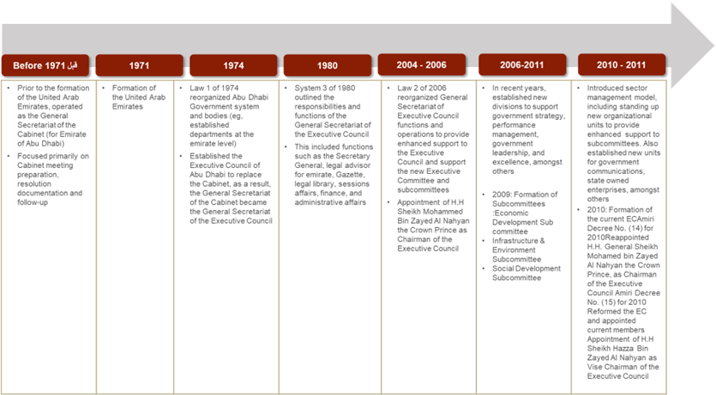

Appendix 2: Interview Guides and Protocol
Research Phase 1: Intervention I: Introduction of Scenario Planning in the Abu Dhabi Public Sector
Category: Government Employees / Consultant
Organisation | xxx | Date | 00/00/0000
Name | xxx | Role | xxx
Research Title | Implantation of Scenario Planning in Public Sector
Purpose | To understand the main challenges facing the implantation of SP  Identify factors that leads to the success/failure of SP

Identify factors that leads to the success/failure of SP
Personal Information
- Being one of the participants on the Scenario Planning Sessions that were run by GSEC in 2011, can you talk about your experience such as how you have been nominated to attend the sessions; did you find it useful tools that you might consider using in your organisation
- Tell me about your experience in the field of Scenario Planning?
Understanding factors that Impact SP intervention
- If you have participated in any type of Scenario Planning interventions, what considering all the SP projects that you have been involved with- what were the conditions that led to successful outcome?
- Considering all the SP projects that you have been involved with - what were the conditions that led to an unsuccessful outcome?
- To what degree do you think that the focal SP project has been a success?
- What were the reasons for the (degree of) success?
- To what degree do you think that the focal SP project has been a failure?
- What were the reasons for the (degree of) failure?
Private vs. Public Sector
- Are scenario interventions in the public sector different from those in the private sector?
- Do the conditions for success differ between the public and private sectors?
- To what extent do you think SP is a useful tool for strategic thinking by government?
Category: Core Team
Organisation | xxx | Date | 00/00/0000
Name | xxx | Role | xxx
Research Title | Implantation of Scenario Planning in Public Sector
Purpose | To understand the main challenges facing the implantation of SP  Identify factors that leads to the success/failure of SP

Personal Information
- How did you hear/ knew about scenario planning?
- What made you decide that Scenario Planning is the right fit for the Abu Dhabi government?
- What was your role?
Aims of the process:
- How did scenario planning improve the strategic planning in the Abu Dhabi government?
- How is scenario planning being used: is it more geared towards indirect forms of decision support or more geared towards direct forms of decision support?
- Level of executive involvement in the scenario planning process
- How decision makers and stakeholders support the delivery of the project
Monitor and Follow Up
- How do you measure the success of the full intervention?
- Factors impact implementation
- If you could re-do or re-introduce the concept; what would you do differently?
- Which impacts can be observed?
- In your opining, how variables such as organisation culture or management style in Abu Dhabi affect the success or failure of the scenario planning intervention?
- Being the sponsor of intervention; what lesson can be drawn from previous intervention?

Research Phase 2: Experts’ Interviews List of Questions
Organisation | xxx | Date | 00/00/0000
Name | xxx | Role | xxx
Research Title | Implantation of Scenario Planning in Public Sector
Purpose | To understand the main challenges facing the implantation of SP  Identify factors that leads to the success/failure of SP

Personal Information
- Please tell me about your background in Scenario Planning. When did you begin working in this field?
- At which kinds of organisations have you undertaken scenario planning?
- What kinds of projects have your undertaken? What was your role in these projects? Could you kindly offer me several examples of the kind of work you did?
Definition/Concept
- In your opinion, what is Scenario Planning?
- In your opinion are there any aspects routinely labelled as Scenario Planning that you believe are not? Which ones? Why do you think they should be excluded?
- How has the practice of SP evolved in the last 10 years?
- Application of SP
- In the projects you were engaged with, what was the main objective/s of scenario planning
- Does the objective vary from government, private and NGOs?
- Are there projects you know or have participated in where Scenario Planning was applied although it did not seem a suitable tool to you? What made SP unsuitable in these cases?
Methodology
- What steps, if any, do you generally follow when undertaking scenario planning? Please explain why you undertake each of these steps.
- Have you typically followed the same set of steps for all types of projects, in all countries?
- If not, what factors influence the design of the scenario planning process?
Enhancement of Scenario Planning
- Do you usually combine scenario planning with other foresight methods, or you do it as standalone method?
- (If yes above), which other foresight methods do you combine with scenario planning and what value do they add to the process or how do they augment scenario planning? Do you utilise these combination(s) in all cases or specific types of cases and if so, which ones and why?
Stakeholders and participants
- Who usually initiate the process; top management; or department management, and what difference does it make in your opinion?
- Which kinds of stakeholders have typically been involved in the Scenario Planning projects you have undertaken? Which kinds of stakeholders do you feel should have been involved but were typically not involved? Why have these kinds of stakeholders been typically left out?
- Typically, is your involvement in a Scenario Planning project collaborative with the client organisation or a consultation arrangement? Which arrangement works best in your opinion? Is it best for all kinds of projects of just some?
- How do you involve time-poor senior members and decision-makers?
- How does the sampling of participants affect the success of a Scenario Planning intervention?
SP in Public Sector
- How is scenario planning in the public sector different from private sector scenario planning?
- How do you meet the challenge politics and organisational complexity in public sector scenario planning projects?
- How do you go about ensuring scenario planning is linked policy making in the public sector?
- How do factors such as leadership, participant competencies, and organisational culture and structure impact the degree of adoption of the tool in the public sector? Which other factors are likely to affect the success of a scenario planning project?
Challenges
- Are there any limitations to using Scenario Planning techniques? If so, which ones?
- Which types of expertise and skills were necessary? (Types of capabilities, facilitators, participants qualifications)
Measurement
- How did you go about assessing the success or failure of scenario planning projects?
Research Phase 3: Understand the Use of Foresight as an innovation tool in Public Sector – Abu Dhabi Government
Phase 3A: understand the public sector in Abu Dhabi by identifying factors that can influence the efficiency of main operations in the public sectors such as leadership, culture, authorities
Organisation | xxx | Date | 00/00/0000
Name | xxx | Role | xxx
Research Title | Implantation of Scenario Planning in Public Sector – Understand the success and Failure Factors
Purpose | to understand the public sector operations in Abu Dhabi government, and how factors such as structuring, leadership, culture and other factors can impact the performance of the public sector in general

Background
Introduction to the individual and their experiences with Abu Dhabi government
You have been with Abu Dhabi government for more than 10 years, and you witness the development of several strategy documents, and lived on different leadership era,
- Can you tell me about yourself, years of experience in working with Abu Dhabi government public sectors?
- How do you describe the journey since you joined till today?
- In your opinion, what are the area that Abu Dhabi Public sector is or has been doing well, and where do then need to enhance
Strategy Planning in Abu Dhabi government
Explore views and attitudes on the importance of strategic planning, its obstacles, processes, and outcomes; assess the extent to which the tools of strategic planning are employed in the sampled organisations; and show the level of involvement in the strategic planning process by people at different organisational levels and the role of outsiders in this process
- A decade ago, Strategic planning was seen as important elements on running business in Abu Dhabi, however; Nowadays, the environmental conditions change so fast that engaging in strategic planning has become very difficult, what is your intake on this?
- Strategic planning obstacles. Two obstacles to strategic planning were addressed in this study, namely, environmental changes and the resources required for adopting a strategic planning approach.
The impact of culture on running business in Abu Dhabi government
- The UAE in general and Abu Dhabi in particular is constructed around a few families, Bedouin culture Nowadays, despite the UAE has an open economy, do you still believe that this is still an issue on leadership, and the way government operates?
Leadership Commitment
- From previous interviews with individuals and decision makers within the emirates, one of the critical factors that everyone agreed to is the change on the leadership. And how this cause delay on running initiatives or termination it. Can you help me to understand how change on government structure, change on leadership and change on priorities impact the public sectors operations?

Phase 3B: Understand the use of foresight as an innovation tool in the Abu Dhabi public sector
Organisation | xxx | Date | 00/00/0000
Name | xxx | Role | xxx
Research Title | Implantation of Scenario Planning in Public Sector – Understand the Success and Failure Factors

Introduction to the entity
A brief introduction to the entity, including an overview of why it exists and what it does. It also includes background context as to why the entity first became interested in scenario planning, particularly in relation to its ongoing strategic planning.
- Since the implementation of Abu Dhabi award, and the introduction of foresight/scenario planning as a pillar to improve the operation, in what ways has foresight/scenario planning been employed as a strategic management, innovation tool at your entity over the last few years?
- What has been your involvement in the process?
Aims of the process:
Wide variety of reasons for undertaking foresight/scenario planning were stated in the literature, and as a researcher I would like to know if the award is the main driver to adopt the process or not.
- In what ways has foresight/scenario planning been employed over the last year or two?
- What (in your understanding) were the aims of the process/es?
- What would you see to be some of the main benefits of foresight/scenario planning for your entity?
Development of the Scenarios
A brief description of how the foresight/scenario planning were developed up to the point at which they were presented to the leadership/management and staff on the entity.
- Can you describe the process of the selection, development of s foresight/scenario planning in your entity?
- Is any other foresight tool has been introduced along with this SP?
Presentation of the scenarios
The way and approach of how foresight/scenario planning were presented to the senior executive and/or staff of the entity had a significant impact on the willingness of the senior executive to provide ongoing support for the various follow-up activities.
- Describe the outcome(s) of foresight/scenario planning in your entity as per your experience. How would describe its outcomes?
- Once the scenarios were developed, what actions your entity have taken (did it trigger any change?). Elaborate the changes
- Extent to which the aims were achieved:
- Describe the process of foresight/scenario planning in your entity, as practiced. What short comings you have identified and, in your opinion, how it could have been improved?
- What would you see to be some of the main limitations and/or disadvantages of the process?
- Do you consider that there are any benefits/limitations for the use of scenario planning in public sector entities like yours?
Intensity of the research process:
Staff Resourcing - Duration and depth of the research before and after. - Process it takes to choose the right tool, is it only foresight/scenario planning or it has been grouped with other foresight tools - The extent of consultation carried out with internal and external stakeholders - Availability of Standalone section/think tank unit
- How your entity formed its team? Was it inclusive team having a mix of experiences and talent? Describe the team or people involved in the foresight/scenario planning project? How they worked with each other and on the project.
- Were any staff assigned to work on development of the scenarios on a full-time basis, and if so, how many, and for how long?
- How many internal staff were consulted, and to what depth (e.g., survey questionnaire, in depth interview) How many and how wide a range of external stakeholders were consulted, and in what way?
- Were any third party (such as consultants/individuals/entity) were involved in the project? How they worked/interacted with the SP team?
- Overall, what do you think so far, how this S-P project is managed in your entity? why you think so? How it is project management could have been improved?
Level of executive involvement in the scenario planning process
Proportion of executives interviewed during the development of the scenarios • Opportunity for executives to be involved in a variety of ways (such as workshops, meetings and/or online discussions) in the development of the scenarios • One or more executives having a role such as sponsor or champion of the scenario planning process
- How would you describe the role of leadership in the overall introduction, and implementation of foresight/scenario planning in your entity? (Did they provide any support or not? What support they provided or did not provide while the entity was expecting it?)
- how alternatively would you suggest that what precise role should be played by leadership for the successful implementation of foresight/scenario planning in your entity?
- Were the different stakeholders (including decision makers inside and outside entity able to understand the scenarios? Or scenarios were simple and understandable for them? How did they react to the scenario(s)?
Executive support for the follow-up
Criteria for rating: • Level of enthusiasm of executives for the initial scenarios and/or for further scenario work • Willingness of executives to encourage, resource and/or make use of follow-up or further scenario planning processes • Willingness of executives to make use of scenarios in subsequent strategic and/or business planning processes
- How the stakeholders of your entity acted in the foresight/scenario planning process in your entity? what role they played? Were they involved? How? Did they support SP or not? How? What was their level of support? And how do they look at this idea?
- Organisation Culture, Structure, and Internal Political influence
- The complexity of governance system (multiple levels of governance/decision making) role was facilitative or creating barriers in the project?
- How the employees in your entity reacted to the introduction of SP as a foresight/innovation tool? Did they readily accept it? Did they create any barriers/issues? What were their concerns that you came across? What were your concerns/apprehensions? And why? How these issues were address?
- Do you think that your existing entity structure is capable of SP, or it needs to be changed? What sort of changes would you suggest based on your experience with S-P? (Supplementary Question: Do you think an internal research unit for is needed to generate the required information or otherwise a centralised unit at the government level as a service provider can be better approach, share your understanding).
- Entity s in public sector have to face issues in the external environment too. What is your understanding that how political influences and leadership (changes etc.) affected the S-P project in your entity? and why you think so (Probe to ask for examples, stories).
- Conclusion: Would you like to ask any thing?

Appendix 3: Interview Consent Form
Name of department: Strategy and Organisation
Research Project Title: Implantation of Scenario Planning in Public Sector
Research Participant Name:
Research Name: Mariam Saif Al Mansoori
Thank you for agreeing to be interviewed as part of the above research project. I am looking at criteria that leads to success/failure of a scenario planning interventions from different perspectives.
You have been selected to take part of this research as one of the world’s leading experts on scenario planning.
The interview will take (45–60 minutes). We do not anticipate that there are any risks associated with your participation, but you have the right to stop the interview or withdraw from the research at any time.
The University of Strathclyde is registered with the Information Commissioner’s Office who implements the Data Protection Act 1998. All personal data on participants will be processed in accordance with the provisions of the Data Protection Act 1998. Therefore, it requires that interviewees explicitly agree to being interviewed and how the information contained in their interview will be used.
This consent form is necessary for us to ensure that you understand the purpose of your involvement and that you agree to the conditions of your participation. Would you therefore read the accompanying information sheet and then sign this form to certify that you approve the following?
- the interview will be recorded, and a transcript will be produced
- you will be sent the transcript and given the opportunity to correct any factual errors
- the transcript of the interview will be analysed by myself as research investigator
- access to the interview transcript will be limited to myself and academic colleagues and researchers with whom he might collaborate as part of the research process
- any summary interview content, or direct quotations from the interview, that are made available through academic publication or other academic outlets will be anonymised so that you cannot be identified, and care will be taken to ensure that other information in the interview that could identify yourself is not revealed
- the actual recording will be kept or destroyed after submitting the thesis
- any variation of the conditions above will only occur with your further explicit approval
I also understand that my words may be quoted directly. With regards to being quoted, please initial next to any of the statements that you agree with:
I wish to review the notes, transcripts, or other data collected during the research pertaining to my participation.
I wish to review the notes, transcripts, or other data collected during the research pertaining to my participation.
I agree to be quoted directly.
I agree to be quoted directly if my name is not published and a made-up name (pseudonym) is used.
I agree that the researchers may publish documents that contain quotations by me.

All or part of the content of your interview may be used
- In academic papers, policy papers or news articles
- On our website and in other media that we may produce such as spoken presentations
- On other feedback events
- In an archive of the project as noted above
By signing this form, I agree that:
I confirm that I have read and understood the information sheet for the above project and the researcher has answered any queries to my satisfaction.
- I understand that my participation is voluntary and that I am free to withdraw from the project at any time, up to the point of completion, without having to give a reason and without any consequences. If I exercise my right to withdraw and I do not want my data to be used, any data which have been collected from me will be destroyed.
- I understand that I can withdraw from the study any personal data (i.e., data which identify me personally) at any time.
- I understand that anonymised data (i.e., data which do not identify me personally) cannot be withdrawn once they have been included in the study.
- I understand that any information recorded in the investigation will remain confidential and no information that identifies me will be made publicly available.
- I consent to being a participant in the project
Thank you for reading this information – please ask any questions if you are unsure about what is written here.
David Wright, Director, Trilateral Research
Signature of Participant: | Date:
Researcher’s Signature  Mariam Al Mansoori | Date

Researcher’s contact details:
Researcher’s Name: Mariam Saif Al Mansoori
Registration Number: 201575712
Email: almansoori.marm-saif-alrada-saif@strath.ac.uk
Faculty: Strathclyde Business School
Programme of Study: DBA Strategy and Organisation
Chief Investigator details:
This should include the name of the Chief Investigator and the University of Strathclyde contact details (address, phone number and email address–do not include personal contact details).
This investigation was granted ethical approval by the University of Strathclyde Ethics Committee.
If you have any questions/concerns, during or after the investigation, or wish to contact an independent person to whom any questions may be directed or further information may be sought from, please contact:
Secretary to the University Ethics Committee
Research & Knowledge Exchange Services
University of Strathclyde
Graham Hills Building
50 George Street
Glasgow
G1 1QE
Telephone: 0141 548 3707
Email: ethics@strath.ac.uk

Appendix 4:

Research Phase 1: cohort detail – Intervention 1

Consultant/Facilitators
 | Role | Organisation | Code | Justification for Selection
1 | Facilitator | The Monitor Group / Global Business Network "GBN" | consult 1 | Scenario Planning facilitator
2 | Project Manager | The Monitor Group / Global Business Network "GBN" | consult 2 | GBN Project Senior manager & focal point between GBN team & GSEC team

Core Team participants
 | Role | Organisation | Code |  | Justification for Selection
1 | Core Team / Sponsor | General Secretariat of the Executive Council (GSEC) |  | Core 1 | Executive Director Policy and Strategy Formulation Division
2 | Core Team / Participant | General Secretariat of the Executive Council (GSEC) |  | Core 2 | Director Government Performance Management
3 | Member of the Core Team | General Secretariat of the Executive Council (GSEC) |  | Core 3 | Policy Formulation Advisor
4 | Core Team / Participant | General Secretariat of the Executive Council (GSEC) |  | Core 4 | Manager in Public Policy Department – Intervention Project Manager

Workshop Participants
Sr | Role | Organisation | Code | Justification for Selection
1 | Workshop Participants | Abu Dhabi System & Information Centre (ADSIC) | Part 1 | Strategic Planning Expert
2 | Workshop Participants | Department of Transportation | Part 2 | Strategy and Performance Management Director - Department of Transport
3 | Workshop Participants | Department of Finance | Part 3 | Head, Strategic Planning & Performance Management - Department of Finance, Abu Dhabi

Appendix 2: Expert’s Profile
Research Phase 2: The success or failure of scenario planning and influence of external and internal barriers

 | Organisation | Code | Description
1 | Centre of Strategic Foresight – Singapore | Exp1 | Deputy Head, Centre for Strategic Futures & Senior Assistant Director Strategic Planning & Futures) Strategy Group, Prime Minister’s Office
2 | Thinking Future (Australia) | Exp2 | Thinking Futures is a strategic foresight practice that helps people co-create shared futures to ensure organisations are future ready. Works primarily with people in organisations and professional associations who are ready to move beyond business-as-usual thinking to build robust and sustainable strategy for the future.
4 | Shell UK | Exp3 | Chief Political Analyst in the Global Business Environment team at Shell International in London. He is an active scenarios practitioner, focusing on using scenarios in futures thinking, with over 20 years of experience in leading and advising on country scenario projects. He advises on political trends and political risk for the Shell Group and leads the external environment assessments for Shell’s country reviews. He was actively involved in developing the 1995, 1998, 2001 and 2005 sets of Shell Global Scenarios, the 2008 Shell Energy Scenarios and the 2013 New Lens Scenarios. He has also worked on a range of scenario projects with international organisation, governments, universities, research institutes and business companies around the world.
5 | Trilateral Research (UK) | Exp4 | Written and edited four books on advanced technologies and their regulation, including Privacy Impact Assessment (Springer, 2012), Surveillance in Europe (Routledge, 2015), Enforcing Privacy (Springer, 2016) and Safeguards in a World of Ambient Intelligence (Springer, 2008). He has published more than 60 articles in peer-reviewed journals, such as Communications of the ACM, Computer Law and Security Review, Science and Engineering Ethics, International Data Privacy Law, Ethics and Information Technology, Technological Forecasting and Social Change, Futures, Foresight, International Review of Law, Computers & Technology, European Business Law Review, Science and Public Policy, Innovation: the European Journal of Social Science Research, The Information Society, The Journal of Contemporary European Research, IEEE Technology & Society, and IEEE Security & Privacy, among others. Has been a member of four ENISA expert groups and was a member of the DG Research Trust-at-Risk foresight group. He is also a member of the European Foresight Monitoring Network.
 | The Monitor Group / Global Business Network (GBN) (U.S.A.) | Exp5 | Over 20 years of experience in scenario planning, worked with the Monitor Group that eventually purchased GBN Early in his career. Worked with Peter Schwartz and consult with government, non-governmental organisations (NGOs), banks, the World Economic Forum and Finance Singapore
 | The Monitor Group / Global Business Network GBN (U.S.A.) | Exp6 | Works with GBN and Morgan Stanley focusing on internal support to Morgan Stanley while applying the same techniques to clients around the world (EXP6). Early in his career, he was in the software technology business and got involved with strategy planning for understanding the impact of the internet on financial services and markets.

Research Phase 3: Scenario Planning as innovation tool in public sector organisations
3-A Public Sector Participants
Those are individuals on executives position working on public sectors. Those has been selected due to the fact that they have witness the changes on leadership and have worked closely with the Abu Dhabi leadership

 | Code | Justification for Selection
1 | AJ | 15 years of experience in social aspects of the social sector in Abu Dhabi when it comes to education, health, social affairs and pension developing and managing projects from scratch to implementing stimulus package
2 | AS | 20 years of experience in government Strategic Planning and Organisational Development
3 | AK | 25 years of experience in Real Estate and Financial Institution Performance and Project Management
4 | MN | 18 years of experience leading the Education Affairs Office, sport council, Media, and Executive Affairs Investment on the government
5 | MO | Public Finance, Government Financial Affairs
 | SF | 15 years of experience in Economic public policy

Appendix 5: Comparison of Key Factors Across Scenarios
Abu Dhabi 2030 Scenarios on the future of Human Capital – April 2011- GBN
Factors | The Four Scenarios
Factors | “Made in Abu Dhabi” | “Runaway Train” | “Fighting Falcons” | “Crumbling Castle”
Overall Challenges | - Preserving culture.  - Conserving environment.  - Ensuring water & food security.  - Resisting complacency with so much wealth. | - Managing expatriate/Emirati relations.  - Revitalizing sense of cultural pride.  - Educating the young.  - Making trade-offs between economy and local development. | - Funding reforms.  - Creating jobs for local workforce.  - Managing government debt levels.  - Risks from integration with global economy. | - Creating jobs.  - Maintaining security.  - Managing development with a constrained budget.  - Easing youth dis- appointment.
Overall Opportunities | - Diversifying economy.  - Attracting companies & FDI.  - Creating long term growth & stability.  - Managing demographics. | - Raising overall quality of life.  - Ensuring knowledge transfer.  - Investing high revenues.  - Becoming innovation hub. | - Becoming self-sufficient.  - Taking advantage of crisis to:  - Reform economy.  - Reinforce culture.  - Become regional leader. | - Pushing through economic reform.  - Renewing culture.  - Engaging region to further integrate.  - Realigning educational and economic incentives.
Culture & Values | - Preserving culture is a challenge for an increasingly wealthy and globally integrated society. | - Worries are widespread as Abu Dhabi’s economy is increasingly dominated by foreigners. | - Economic hardship binds together community and produces a return of traditional values. | - Widespread erosion of values is part of the reason that the community is unable to respond to difficult times.
Economic Diversification | - Educated and dynamic new generation drives diversification. | - Economic reform and openness make Abu Dhabi a global business hub and  - Attracts entrepreneurs. | - Persevering local entrepreneurs persist in diversifying economy even as overall growth slows. | - Addiction to easy oil money is too strong and the economy remains vulnerable when the hard times come.
Quality of Healthcare & Education | - Quality is high as the economy develops and attracts world class doctors, nurses, and teachers. | - The Emirate has world class doctors, teachers and nurses who provide great care. | - Education and health care budgets are constrained but innovating leadership mitigates the challenge. | - Services suffer when the government budgets run tight and highly paid foreigners head elsewhere.
Competition for Talent | - Abu Dhabi can attract the talent it wants but manage the overall demographic mix. | - The Emirate attracts the best and brightest from around the world. | - The Emirate produces a lot of local talent but is struggling to bring in the best from around the world. | - The Emirate finds itself struggling to produce local talent and short on funds to bring in skilled foreigners.

Appendix 6: Foresight Practices
 | Department of Health
Tools used for foresight | Horizon scanning  Future Triangle  Scenario Planning
Aims for foresight | 1) long-term strategy, which is the aspiration for the health sector.  2) blueprint of how we can develop the health sector in the next 50 years  3) used it for more smaller projects, one of them was the beyond COVID work that we did. The beyond COVID work was a request from our leadership to see what this shock had manifested, and how these trends and signs, and everything that has happened, will develop over time, for the next 10 years  4) future studies specific for an area, which is mental health,  5) foresight is being used across the organisation, and, at the same time, the organisation is becoming a centre of excellence to others as well
Implementation process | you start by this work, interviews, observation, motivation...and then workshops as well, to gather all the base knowledge. But once you’ve garnered that, with the horizon scanning as you do as well you go to insight which is basically in insight you start analysing all the trends that you have and the signals into...that’s number one, because it’s called a push, sorry, a push. And then you link it with the pull of the future, it’s called the push and pull of the future.
Leadership | leadership commitment and endorsement were on top of our agenda when it comes to foresight, and the programme for futures agent was hitting two birds with one stone, garnering leadership commitment and endorsement. And the other one was to upskill new people with the foresight skills. And I will talk to you about the futures agents’ programme in a bit as well, because it’s really a beautiful programme that.
Why foresight & scenario planning? | we needed to build specific capabilities for foresight in-house, not only relying on outsourcing and outside experts. And that’s where we built this framework, basically this framework is built on top of tools and methodologies. Framework that consists from right mindsets, the right people, the right structure, And then the other pillar is the process and deliverables  phenomenal card: a way of having daily updates on the things that are happening, so basically think about it as a scanning bank where you make it very digestible for people.  themes and trend analysis, based on the priorities of the Department of Health, we reflect it on something that is trendy. How can that trendy thing affects the Department of Health on its priorities, like healthcare services delivery, preventive care, and all of that? And then you can tell that there is something else, it’s more engaging, such as the community breakfast, futures workshops, the academy training, which we developed actually at first curriculum  phenomenal cards, news, news digest, themes analysis, trends, these were more of a quarterly basis, these are coming always from our annual plan. Community breakfast is something that we only did twice before COVID, and in COVID we did it once virtually. And then obviously you know what happened with COVID, we got busy, so we didn’t follow-up on this engagement. The workshops are more on an ad hoc basis, based on the cycles or the product that we want to develop. So, for example, look, you can see here scenario planning workshops and reports. So, this one, I will show you a deliverable that we did in mid-last year, that last cycle basically, three months cycle, the outcome was a report, lengthy report, maybe more than 5,000 words, like a Word document, and another graphic report that I will show you as well. Graphic novel is something that I feel so strongly about, it is basically about. It’s a field in foresight that’s called design futures, its basically making graphic novels, artefacts, and all of that.
What were some of the benefits derived from foresight? | 1) Engagement: it removed a lot of silent work between the different sectors in the Department of Health  2) informed our short-term strategies: So with the blueprint, which think about it as a master draft, that master draft, because all the research has been done, and this master draft gets updated by our foresight analysts on a yearly basis. When things change, it gets changed as well, this master blueprint, and it informs what the priorities are for the sectors from: what they want to do, that’s number one, which is a push from the sectors themselves, at the Department of Health  3) reaching out to the public: because we didn’t want to be blindsided by a player that might come into the health sector later on and then just throw a spanner in our plan. So, we wanted to expand our horizon as much as possible to understand from the actors, be it small or big actors, what could affect the health sector for the next 10+ years. So that’s something that we benefited from, which we expanded our circle of stakeholders and partners in the health sector,  4) is dedicated stakeholder management or partnership management, and keeping people always involved, informed by different methodologies, such as workshops, such as webinars, such as debates, a lot of things.
Do they have a Foresight Unit? | foresight, as a department, had three sections underneath it before, that was the main plan, we wanted to have a dedicated foresight function, dedicated long-term future studies function and the last, but not least, we wanted to integrate in a horizontal manner foresight with innovation. So that was a deliberate decision that we wanted to do, unfortunately it didn’t happen because of some changes in the organisational structure we couldn’t do it, but the plan was to get foresight, future studies, and innovation horizontally integrated so that the work from one flow into the other. And mainly, why we wanted innovation to be part of this department, is because we wanted something that is, it’s actually new, it’s foresight-driven innovation. It’s been done in some places, but we wanted to work on innovations that are tangible in the short-term, that are informed by our foresight efforts. That’s basically the main idea, why we wanted that structure to happen. We shrunk it into a small unit.  We ended up in creating only a section under the Department of Strategic Planning and Performance Management. So under this section there’s a section head, who is the one who is a custodian for the management of this function, under that person there are others, who do normal foresight work, the one that I mentioned to you just now, the three pillars. And they do future studies, but future studies are something that is very...it depends on how sophisticated you want to get.
Challenges | Finding the right capabilities on foresight:  - when we started recruiting it was very hard to find specific skillsets in foresight and future studies, to the point that we started other programmes  - I was a one-man show basically, most of our work was I wouldn’t say outsourced, because we wanted to establish the unit first basically on a daily basis. I started learning by myself, self-taught, from courses and from books, and also, I started getting into professional certification courses.  - Structure change that led to the change on the foresight department mandate: changes in the organisational structure we couldn’t do it, but the plan was to get foresight, future studies, and innovation horizontally integrated so that the work from one flow into the other.
Does the Department have the capability for foresight? | Use of third party: Futures Platform, and Institute for the Future  External Resources to develop and produce in depth reports on specific areas  The future agent: a programme that contributes on a part-time basis, as ambassadors and as workforce that can come to you when you start a foresight programme, a team that is trained continuously. So, these futures agents...actually futures, it’s not future, we did it this way as well, if you can see it, it’s futures agents.  we needed, its experienced foresight experts, those who have done PhDs, who have done masters, and all of that. After so many interviews for, I think it was for nine months we were interviewing and trying to find the right skillsets  I do believe that there is a bit of skills gap and workforce gap when it comes to foresight. So, we had to go back to the drawing board and create more of a hybrid competency framework that had two main guiding principles – one was to bring somebody who has more expertise in foresight, but that would be just more of a mentor person. And the rest of the team, around 70% of the team, we assist them on their behavioural competencies and their skills that are close to foresight, so people are in innovation.
Reporting, Presentation | We wanted it to basically we categorised it into high level deliverables, quarterly deliverables, and annual reports as well. We needed to drive a lot of tangible outcomes, outputs, let’s say, for foresight because we needed to keep people engaged.
Monitoring | the continuous horizon scanning which is phase four of deliberation, and this happens by either automating the process or having the analysts updating it on a yearly basis, that’s what we do.

 | Abu Dhabi Food Control Authority
Tools used for foresight | Current Status assessment, future trends, specialised strategies  “we consider the specialised strategies as an input for the strategy, we revisited the whole thing as we brought a consultancy or expert house to validate our findings, current status, where are we going, and validation to our initiatives, and some common tasks that has been merged,”
Aims for foresight | 1. Deep dive on the area of the organisation focus,  2. To dig down on each required subject so we have detailed analytics  3. Know where we are heading, and the second thing when we go to the goal setting,  4. Enable us to challenge the outcomes and the deliverables in confidence  5. Collecting current data, facts, on each focus area, trying to have full picture of the current status. Followed by understand what the world is going in the next 20–30 years which helped us to identify the gaps…so now we have the benchmark  Establishment of specialised strategies. It is like you are taking on one focus areas, doing all the research, understanding it fully, carries the required benchmark, interviews, establishing trends, drawing scenarios, engagement with relatives’ audience, and stakeholder, agree on strategy and then develop the full strategy, and deliverables and of course this is internal document that help us to establish the current base. So, you may consider this as a base line.  Second stage is development of full comprehensive, cohesive strategy across the entity. So, we were depending on the specialised strategies as a base to setup the full strategy, and honestly, we did not do a lot of work, but when you go to the overall strategy, you end up with more than 50+ initiatives, which was a challenge
Implementation process | 1. Understand the Mandate/Request  2. Understand what the current status is, what is the future, what are the supporting programs  3. Develop Specialised strategy  4. Bring the consultants or the expert house, we can run the conversation and challenge him  5. Established a task force from all sectors by it private, local, and federal (Task Force) reporting to the top management that includes also representative from all sectors  6. Develop different scenarios, we had to develop different impact on the price, environment, imagine that you are ending with scenarios telling you that you have no future, and your future is black and dark, we reached this stage  7. Meet with the stakeholders, we presented every single scenario, one by one, so some has been rejected, other has been accepted, at the end we as government need to take decision  8. Endorse by the stakeholders, presented to the Executive Council, for final approval of the scenarios. Of course, each scenario if approved has it is own rollout plan, varies time frame, initiatives and programs, budget, etc. and they vary from each other’s
Leadership | There are the ones who took the lead, they engaged us do the benchmark, with KSA and when we came and presented the findings and recommendation, which was one of the recommendations that we got the endorsement directly on, they said go ahead we need it  This followed immediately with establishment of taskforces, identify members, etc.  Commitment was the driver behind this.
Why foresight & scenario planning? | Generated about 11 specialised strategies.
What were some of the benefits derived from foresight? | Gain common understanding and agreement on the current status and what needs to be done. And agree on the plan because we think if the sector fail, we fail as well. So, we need to corporate with each other
Do they have a Foresight Unit? | We don’t have a dedicated unit for foresight, before we had a plan to have dedicated unit, on the new structure, but we decided to have a unit called Business Development Unit in which we placed all our experts (expert house, and consultants) and we provide them with the foresight mandate.  Gives us more business focus on what we want to do. This thinking team or foresight unit, if you keep them within, we will end up using them for operations because you see them as extra resources. Therefore, initially we designed them separately, to be focus on trends, research to support on the taking decisions. After the new structure, we decided that they will be part of us in the same division. Yet, the leadership came and ask for his own analysis/data team to support him on the special requests outside operations, more focused. So, we decided to shift the foresight function and expand it is mandate and managed by us.
Challenges | Frequent Changes: Changes wasn’t easy frankly: Structure, Mandate, and leadership  "Changes wasn’t easy frankly, I believe what we did well was two things, communication with management, frequent reporting on the plan, and we tried our best to stick to our plans"  Changes on the scope: We noticed that we agree on 10 items, we notice departments increase this to 50 as a wish list. So, our frequent reporting and insisting to stick to the plan  The challenge management: Meaning that we have a methodology only to follow and report the changes that needs to take place for us to proceed on our plans. So we make sure that biweekly, every Thursday that we issue a report to the executives identifying the challenges that they need to take decisions because the internal teams cannot move forward, and we need their input to proceed  The whole directions changes: Simple example, lately the our appointment chairman is coming from private sector, so the whole way of managing business, operations changed, we have been working on one rhythm for the long time, when he joined, he brough different kind of mindset, he challenge the current status quo, the way of doing business is completely businesses.  Yet there a lot of clashes due to the different mindsets, some executives wanted to stick to the fact that we are not commercial arms, while the chairman insisted to think globally, out of the box, more into investment mindset. Yet it is a phase, at the end, you get mature, and accept the changes because you see the fruits of those decisions.
Does the Department have the capability for foresight? | Only want to make sure that you have the required tools, expertise. and methodologies. Today we don’t have the core team. We don’t have someone or internal individuals who are qualified and know the ABC to run foresight
Enhancement | Myself I enrolled in different sessions, online, attending course that are offered by different organisation, government accelerates, yet I don’t have the time to rollout it out or tested. Yet what we did is we looked internally, we pick the employees who we think that they have the capacity to learn, we requested them to join Corsa (Learning Platform) and attend course, and we played the role of coaching, facilities to test them on the tools, who we can use them, etc. For the special focus strategies, we take advantage of private sector or a third party where need and when we can afford
Reporting, Presentation | we are working on framework that we can apply it internally

 | Khalifa Fund
Tools used for foresight | LEGO SERIOUS PLAY. We used the LEGO cubes to imagine Khalifa Fund in the future  Scenario planning
Aims for foresight | Imagining what will happen in a specific area within a different timeframe
Implementation process | 1) Understand question or the request (either from the department (internal) or from the stakeholders (external))  2) Prepare required research, readings that can help to run the discussion using the internal research intelligence  3) Run the technical sessions with the concern parties including internal and external  4) Develop different scenarios and discuss them with the team  5) Develop reports
Leadership | Leadership presences: All directors, managing directors and senior people attended all the sessions  Invite consultant/expert depends on the time and requirements  Open Mindset: Khalifa Fund management is open, it’s really open for any enhancements for any methods, no objections
Why foresight & scenario planning? | Report. However this report is not linked to the strategy as mentioned " is incorporating the output into the strategic planning and put it on papers and sign it."
What were some of the benefits derived from foresight? | Exercises, bringing people on the table, the discussions, the idea of keeping out of the daily open issues and thinking of the future is very important. There is also... it might be non-negotiable or might be not approved by all, maybe a [unclear 0:21:52] exercise was, let’s say, useful for all of us, or a bit of a game. It was an engaging exercise, it was an exercise and opportunity to go out of the daily and routine work to think of the future, regardless of the output
Do they have a Foresight Unit? | not dedicated to future shaping or future fore sighting. Yet it comes to studies, it’s the Business Intelligence section

Challenges | Understanding the concept of foresight misunderstood the idea of future fore sighting, which is looking for plausible scenario or logical situations and forecasting and predictions.  Frequency of changes: we are in the middle of sudden organisational changes. I doubt frankly, that we will bring this to the table, establishing and specialising future fore sighting, because our old structure ... the new one submitted by the consultants a year ago and even until now, it is not finalised. It’s not in the regard of our management to add this frankly.  Foresight Expectations: from top management, the expectations of the future fore sighting, maybe this is one of the mistakes, it was not so clear for them. Some of them, they look at it at [unclear 0:24:09] the consultant study that we give answers or direct answers to some challenges or recommendations, it was not like that, it was negotiating or discussing the future different scenarios. I sense that there was a gap in the understanding from them.  Culture of following the leaders: frankly, and speaking with due respect, this is of course the culture itself. I call it with due respect of course, the shared approach. As you know, we all respect our leaders and we trust them, so this is all over the UAE, even in local, federal, and organisational, so yes, once Khalifa believes in something, people happily follow.  The same fact, much better than they would take it from us, the people in Khalifa. So, this is I believe, the culture, I believe yes, there is influence by leaders and they are trusted, and people are open to follow them and happily will.  The impact of leadership: We all believe in the influence of individuals. Usually individuals change things, I believe, so they are important. For example, Sheik Mohammed bin Rashid in Dubai, he on so many occasions insisted on the idea of the future changing and the future fore sighting in Dubai. Sheik Mohammed bin [unclear 0:31:37], he in different speeches opened the idea for excellence. So, as far as the effect of influence of the leaders is very substantial and I can’t deny it, but we can utilise this by institutionalising those directions, to take it, let’s say, long-lasting. If we have, for example, a supportive leader, who wants us to utilise future fore sighting, this is great, let’s try and put it either to create a function or to add this function to an existing unit, to make it institutionalised, not only personal. I think both can happen, because now there’s no contradiction between the general leaders and the organisation if you can incorporate the directions in a good manner.  Linkage to Strategic Planning: we need to educate, we need to push those reports, the output of the future foresight into the strategic planning. It’s not an automatic by the way, it needs advocacy. Other than that, people will start the cycle like they used to do in the previous years  is incorporating the output into the strategic planning and put it on papers and sign it.

 | Abu Dhabi Culture & Tourism
Tools used for foresight | Future Trends: We use the signals we the future tends to enrich the mental images of the future to release different perspectives of the future  six-pillar approach that is invented by Professor Suhail
Aims for foresight | Anticipate discontinuity and surprises.
Implementation process | Start with horizon scanning through the future radars and then we do we define the key historical points. And then we go to imagination issues analysis, then we create the future triangle to understand the pulls of the future and the pushes of the present that pushes our vision and to understand also the weights of the past where it's holding us back.  And then we go to do the CLA because of the analysis to deepen our understanding of our issue and to find solutions.  And this we move forward to scenario planning, where we see four scenarios, the no change scenario, the marginal change scenario and them the adaptive change scenario and we ended up with the radical change scenario. And from these scenarios we come up with the preferred future, our desired future.  And from based on the preferred future, we do the back casting. We vision how we put ourselves in the future and we go backward to identify the actions or the action that we need to take to create that vision that preferred future.  And from the back casting we come up with recommendations to embed in our strategy to build an action plan to create the future today.
Leadership | In the early stages of identifying the domain question, everyone is involved "leadership from under Secretary, executive directors, meet with their management team to identify the domain"  "support we don't have an issue in terms of that. Because today, foresight is part of the… it's part of the radar of the leadership that we do and there is appreciation  Stakeholders are engaged in the exercise."  the leadership role, they are the one not only endorsed the direction of the study but also suggested and recommended the study  "we have a young leadership here that they are forward they are talking with"
Why foresight & scenario planning? | After we finish the cycle, we embedded our strategy  Strategic alignment. So, when we come up with a recommendation, we identify a set of initiatives, and we align those recommendations with the strategic plan. So, you will be able to see what are TDC’s objective, what are their initiative that we have as part of the strategic plan and then we enter the metrics, we use the metrics, fitness metrics, strategic, foresight metrics and then we say where's those recommendations that we came out from the exercise would fit. And this matrix would tell us for a specific domain, for example, looking at what can be looking at, for example, the future of leadership, for example, the future of leadership.  So, we look at a recommendation that comes out of this scenario study, this exercise, and we add it to the existing strategic initiatives. And for example, if we found out one of those recommendations is not really…they want to have an initiative for it, in this case we create an initiative and we make sure we secure a budget for it. And this is created in the study we are planning on for studying.
What were some of the benefits derived from foresight? | build a more adaptive organisation.  foresee the unseen: to realise the unknown and to be able to convert the unknown to known where it will lead to us to get us to create the future today rather than waiting. We can't create the future today when we do the foresight or scenario planning.  To have agile strategies to cope with the changes and be more responsive the dynamic changes "at that time there was, sort of, agility as one of the principles to be implemented in TDC in order to agile and responsive e strategic planning team has initiated to have different scenarios. Also, at that time, tourism was really attached to economic factors. In 2009, there was the financial crisis of 2008 financial crisis and the strategic team found themselves that their strategy becomes obsolete overnight"
Do they have a Foresight Unit? | Yes "the team it was designated entity dedicated to overseeing the implementation of foresight practices at TDC". TDC is part of the strategic project outside the management office that reports directly to the Executive Director of Strategy affairs  That's really the business intelligence is basically collecting data, we have data scientist, we have people who produce insights, but they look at trends, data, they look at data but most of this data analytics and data insights and science is helpful to today's issues and we use this data to support or to support how or to understand the domain questions... But it is not the main driver.
Challenges | Biased: "we implement various tools to help people eliminate biases to being on past history."  We have managers we have people that might be resistant, and this is an issue, we tend to be biased. I myself biased to my view. It's all about the exercise and the workshop because at the end of the day all of us want to have the best, as long as everybody is agreeing to that. And as soon as you unfold this and explained it, it is right there.  And let's put it this way, sometimes in the workshop we have discussions, we have tension discussions plus we have the mind sets and we have equal distribution of the team within the workshop in the exercise itself. We didn't have really a serious matter after that.
Does the Department have the capability for foresight? | Use Consultancy: "We have been working with a number of futurities" TCD  Started by engagement with Carrie Graham in the first future foresight exercise  Three full employees  Foresight network : employees from all sectors and departments and from all levels here, because we have with us also executives’ directors, directors and section managers and also we have juniors as well.  "they are supporting us on the foresight work, as well as we have the foresight network, where we established last year with more than 100 members. So that's through that our unit maybe is still new but we have more than 100 members supporting foresight function in the TDC."  There’s a workforce team that works with Professor Suhail, Dr. Ray Palmer, to produce the scenarios, their implementation, that will fit.  Use of Business Intelligence: here we have a business intelligence to complete the path. Who…yes, another business intelligence team, a dedicated team, to collect data we have, it would be nice some time when things are back to normal to see our command room and normal…where full data gathering structure  I see results. I see implementation and I see structure. I see people hired today Khalid is the head of future foresight department and he has a team dedicated. Professor Suhail is a team member of him working with him. He has Dr. Ivan he has also other resources that allocate time and effort to build the future.
Enhancement | Include more participants and stakeholders: we need to include more, we still, there are more stakeholders that they have to be engaged  Customised approach: I am recommended that everyone sees the future from his own perspective, create your own model, create your own framework that fits your needs.  Use different tools: we use various tools and techniques when we plan for the future, scenario planning is an excellent tool to anticipate the future but only having scenario as the start and the end point is not sufficient. And we are required to have other techniques that challenges impartiality and biases and I will encourage that as much as possible to stakeholders to be included on the foresight interventions
Reporting, Presentation | Then this study is shared with the senior management in a presentation and all to get endorsed, because sometimes some of those actions requires a budget. So, it is presented to them and get that endorsement from them.  There is an internal report after that, that is being produced and it is with the management chair with the management and shared internally
Monitoring | Every two years we do that review. "We intend to do every two years, a review exercise."  look at our vision, how many innovations we had, how many of that project has been considered and implemented? And how much responsive of triggering one of those scenarios, which building efficiency.

 | Abu Dhabi Education Council
Tools used for foresight | Future Radar, Scenario Planning
Aims for foresight | To be able to have a rigid, robust strategy and clear  To use it as a guideline and a framework.
Implementation process | 1) Understand local current situation: What is happening, what is the current baseline. And we looked at what is the challenge that we are facing, basically, the demography, the community, what is the gap? What kind of majors do we have? What kind of schools do we have? Where are these schools?  2) Expand and looking at history globally: Then we expanded, we continued looking at truly arts history so we've seen how disruptive a new innovative, kind of, education models is changing some of the, I would say, sectors like our education sector. And how can we look at these basically as opportunities to help us create this, kind of, future foresight or strategy for ADEC?  3) Creating I will say uncertainty matrix for us: All the probabilities and risks and basically ambiguities or any uncertainties that's going to come in education, basically, you name it. From, let's say, technology perspective, political perspective, economy perspective and so on and so forth.  4) Work with the stakeholders: Come up with detailed analysis and they need to work very closely, by the way, with knowledge management (internally) and with also relevant stakeholders who are even outside the dialogue.  5) Build the Radar: how radar helped me vision based on the facts whereas basically the forecasts true and based on these forecasts delivered solely  6) Build scenarios: with projections that we will happen to us, whereas those probabilities that will happen to us if we take this action or this action or this action scenario and thus helping me and help leadership and management to say this is the most probable scenario, what is basically the initiatives or the actions that us as needs to take on a, let's say, 15 years level, five years level and basically one year or annual plan level.  7) Present the scenarios: based on the audience: we are presenting it internally within our strategy team we go into the boring details, we look at the detailed study and analysis and even basically the data, the raw data even if needs be, to understand everything that has been, I would call it, a control factor to come up with this kind of strategic thinking and these kind of decision scenarios level of the study to show it to our leadership. And to our leadership what we show is what is the direction? And if we take this direction, where are these scenarios? And if we take these scenarios, we choose the most recommended scenarios
Leadership | If leadership doesn't believe in it this is an imminent future and she brushed it away, for example, and institutions like a three kind of coding school that welcome everybody and wants to transform everybody, no matter what your background is, where are you coming from. If you have the will to change, students have become a reality,  it will hinder basically business development, it will hinder basically the project or the strategic initiatives from happening
What were some of the benefits derived from foresight? | think from my perspective, it gives you somehow clarity on what kind of strategic actions or initiatives that you need to do and in which priority that you need to do them in order for you to start, basically, changing the landscape, fixing challenges and at the same time bringing forth new innovative, kind of, concepts to reality within our ecosystem. So, this is how it helped me.
Do they have a Foresight Unit? | Strategy Sector> Strategy department > Planning & Future Foresight  5 people
Challenges | Driving force change radically or some change incrementally. So, they done make sense anymore. the driving forces to me is one of the things that our DNA, it's like input, you know what I mean? And so, for them, like input. You don't know if your input is fully right and you put them in a box, a black box, and it creates this kind of output at the end. But these inputs the decision of deciding if they are incremental or radical or how they are affecting their strength of affecting basically the probability of affecting methods, your sector and your initiative is very critical and very difficult to assess.  Change on leadership: I think it's very high, it’s super high, if you could elaborate from one to 10, I can tell you it's going to be eight or nine. Then…leadership styles and each leaders have his own mind sets, right? Does he have a disruptive/bold leader who would like to push innovation business development? Or you could have the other way around, conservative risk as I would say, yeah, basically kind of leadership where they will say “No, no, no, no, no, I don't want to do this. I’d rather basically maintain what I have, I want to do, I will, I will take the lower impact side because it's a safe side, you know” so definitely a change.  Speed of change in Abu Dhabi: they keep changing so quickly, very quickly. So, I think change is the name of the game as they say, so for anyone who is looking at future foresight they shouldn’t be shocked that if they put analysis today, they shouldn’t shy away from saying you know the analysis completely change from then left, right cause.
Does the Department have the capability for foresight? | Some of them work on strategic planning. Some of them work on stakeholders’ management and some of them work on to master planning, initiates the master planning.  We did it in house. To be honest or anything but I think this is a nice approach from our Excellency and trusting and people. And the same time we brought the right people in the right team in place to be able to do this. For example, we had enough data analytics, individuals, the right people in place that helped us to do this internally. And that analytics we had education experts, we had regulation and policy experts. And we had, let's say, economic economy, I would say experts. And finally, we had people with the strategy experience. So, when you put these people in one place, believe you me, magic happens. And the same, by the way because we’re replicated in other places, but really industry, you know what I mean.
Enhancement | I think all, any organisation needs to have this kind of hybrid thinking, where I think second section or divisions like future foresights needs to, I would say, have this kind of agile, fluid, flexible, kind of org structure and processes or mandates. Because the change for future foresight is innovative and in the way you deal with tools, the techniques, the models, as you said, it's new, everything is new, you might adapt something that changed by the minute. So, this is how I would look at it.  I think rather than having just people who are business/like strategy experts I would rather have a mix of different expertise in one place. For example, for our…as I told you in 2000, I call them the AI team. The AI team is the team who would have someone who is data scientist and someone who would be a, let’s say, field expert and someone who would be public policy experts, all in one basically place rather than them being scattered here and there.
Reporting, Presentation | I think, in my opinion, my honest opinion, if the most successful future foresight is the foresight that is a very simple straightforward story that leads to, I would say, practical on the ground solution that you can turn into reality, the more they are scientific, the more they are objective, the more you’d be able to be in control of your own future. The more they are, I would say, subjective the far away you are going to go away from your target.

 | Statistics Abu Dhabi
Tools used for foresight | 7 different tools were used:  1. Horizontal scan of future foresight sectors  2. Trend impact analysis  3. Uncertainty impact analysis  4. Expert plan  5. Back casting  6. Future wheel  7. Scenario planning
Aims for foresight | To draw a future picture of statistical work up to 2040, propose proactive measures and drivers to address the key repercussions of the possible economic, social, and environmental scenarios, in order lay the groundwork of a sustainable future for the Emirate of Abu Dhabi.  • To change the statistical business model.  • Determine the role of the center in the future.  • Dealing with potential situations and the extent of the center's readiness in this regard.  • Supporting and achieving sustainability, leadership, and innovation in the statistical field globally.
Leadership | The initiatives were started by the leadership themselves, especially after the announcement of the UAE Strategy for the Future and the inclusion of the foresight on the Abu Dhabi Excellence Award. So it was supported by them.  The chairman himself was attending the main meetings, including the workshop meeting. The executive directors were very clear that they need to be part of this, and they were supportive
Why foresight & scenario planning? | • Establishment of the Statistics Future Foresight Council (SFFC: that aims to: Foreseeing the future of statistical work and the key scenarios, drivers and implications lying ahead from the technical, technological, etc. perspectives  • Launch initiatives and projects based on joint analysis of expected future global trends
What were some of the benefits derived from foresight? | Main important benefits it helped us to understand our status quo and kick of the start to change the SCAD structure, because without it we were not able to make any mandate to the structure. So, you may say it was a reason behind changing the previous organisational structure
Do they have a Foresight Unit? | we established internally administrative resolution to establish the unit., this follow with transferring me to a full-time employee there is myself, heading the unit, and two more people,  • Determine the name and objective of the foresight project  • Identifying stakeholders and those affected by the project  • Determining the scope of the foresight project  • Determining the time period for the foresight  • Determine the duration of the foresight implementation plan  • Determine success factors for project foresight  • Identifying drivers of change and patterns affecting the scope of the foresight  • Preparing a matrix to determine the impact of ambiguity elements  • Preparing the expected scenarios  • Inventory of strategic implications/opportunities for each scenario  • Inventory of measures to confront or exploit each scenario  16 people across the organisation representing every department and consider as our foresight ambassadors.
Challenges | • Weak data governance and lack of ownership  • The Statistics Center - Abu Dhabi is not formal in managing the future foresight initiative at the emirate level  • Scarcity and scarcity of technical cadres specialised in future technology.  • High cost of data and misuse  • Increasing restrictions on data dissemination and data monopoly from third parties.  • Weak information security and increased crime rate  • The difficulty of analysing and processing large and huge data  • Weak technical competence and the difficulty of transforming into a smart technical society  • Failure to develop and produce new methodologies and work procedures to keep pace with the foresight.  • The emergence of legislation, laws and policies that may hinder work
Does the Department have the capability for foresight? | A full-time employee there is myself, heading the unit, and two more people, and we have 16 people across the organisation representing every department and consider as our foresight ambassadors. 3 full time employees  14 employees across the organisation to support the departments 3 experts from the UK, South Korea and Egypt were present in the workshop

Appendix 7: Cognitive mapping Explaining the Analysis Process
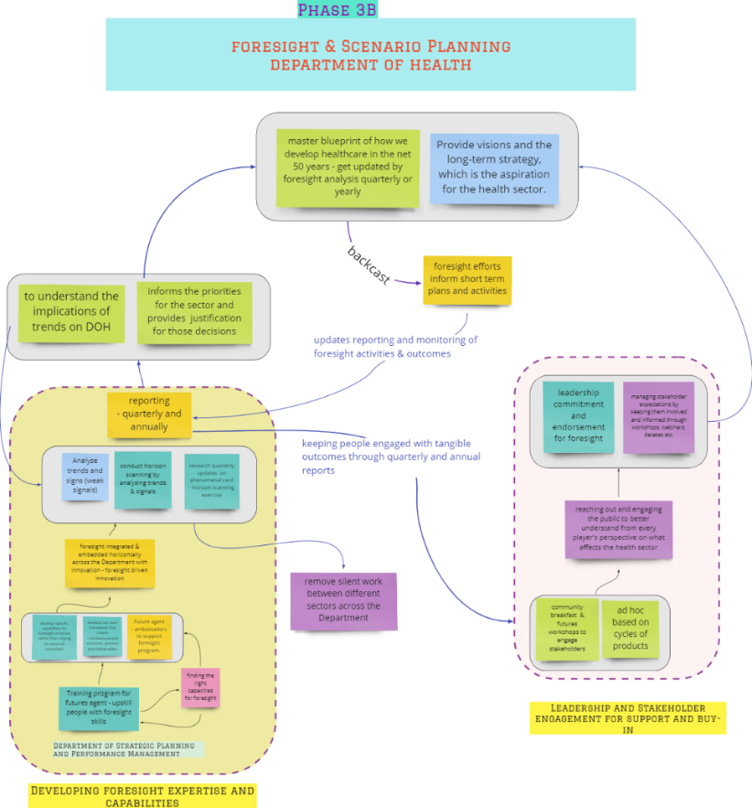
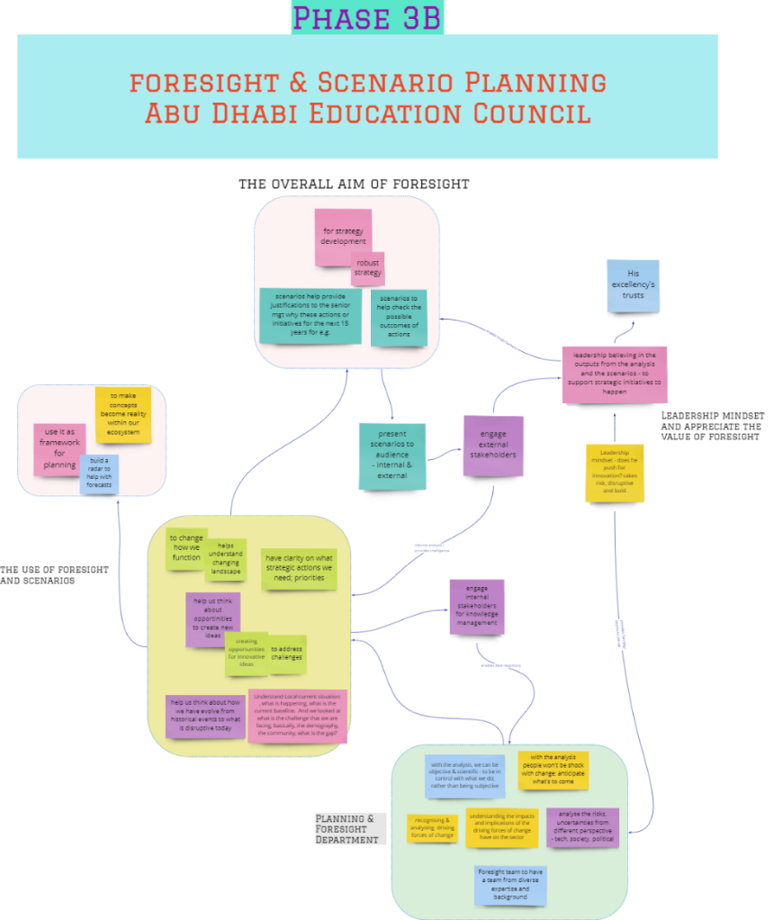
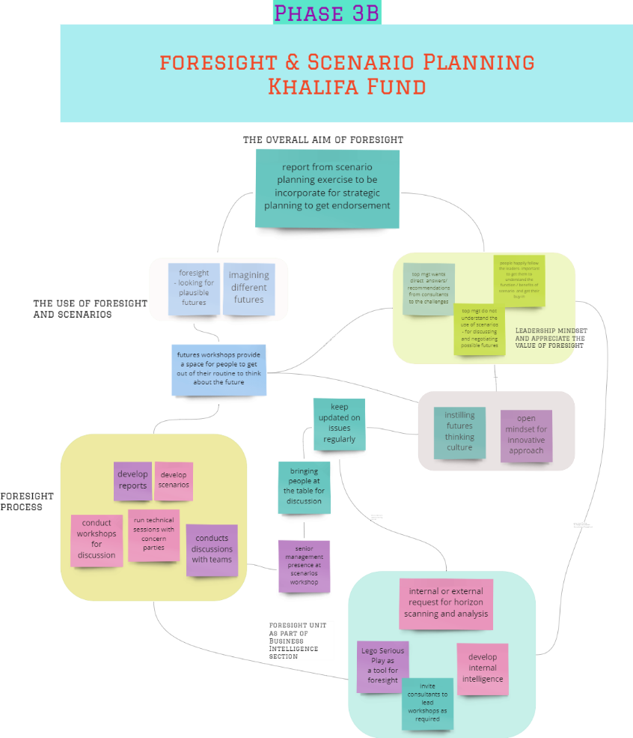
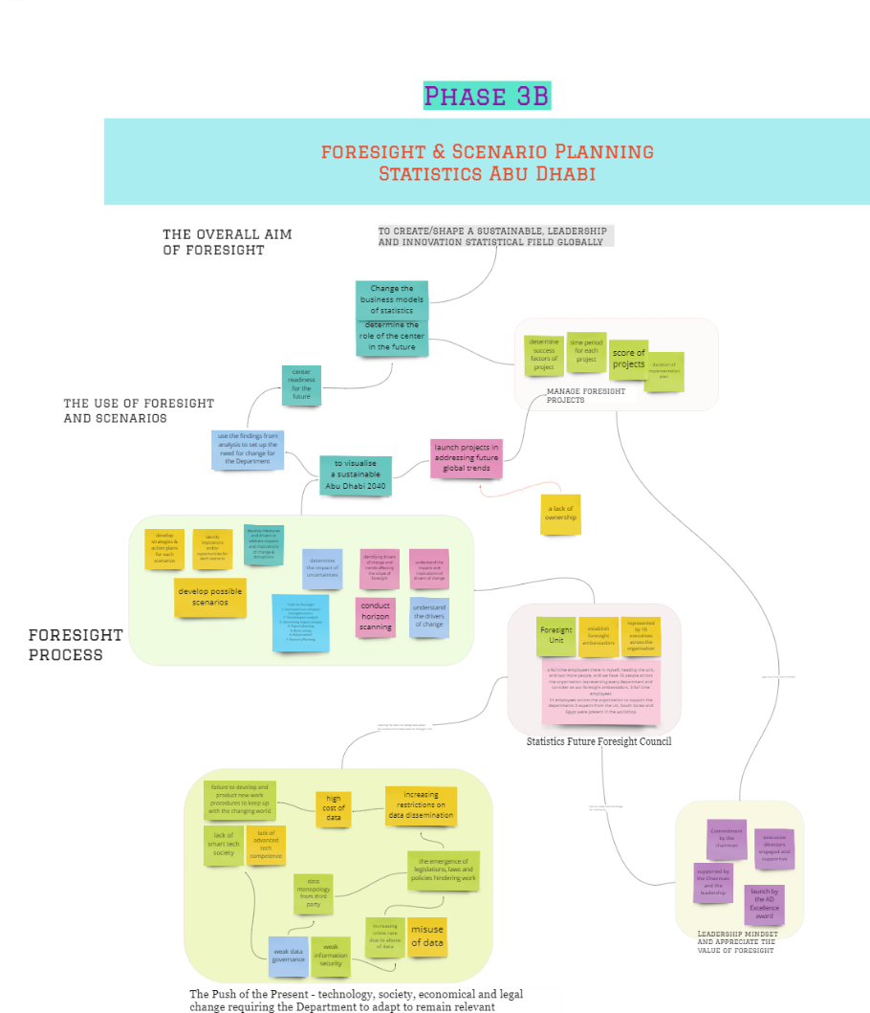
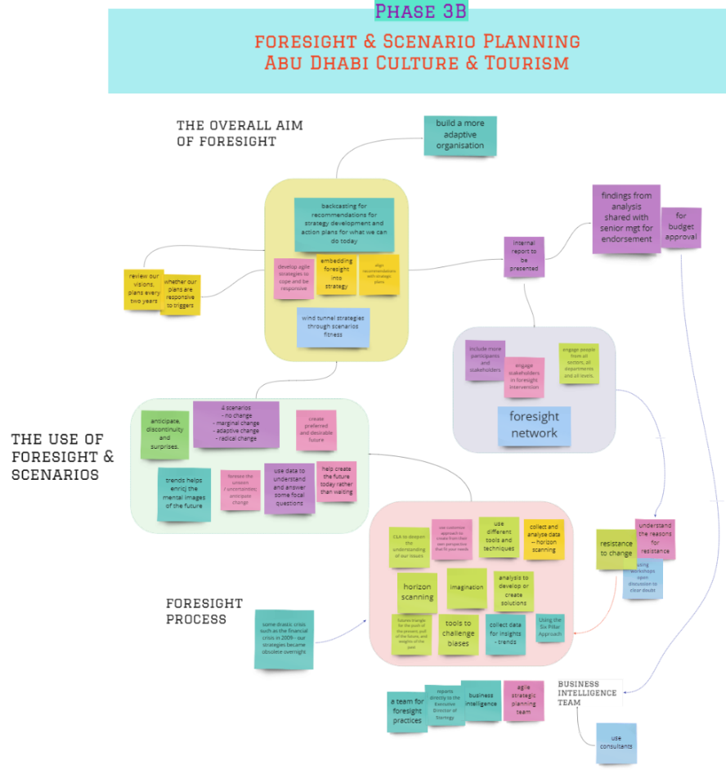
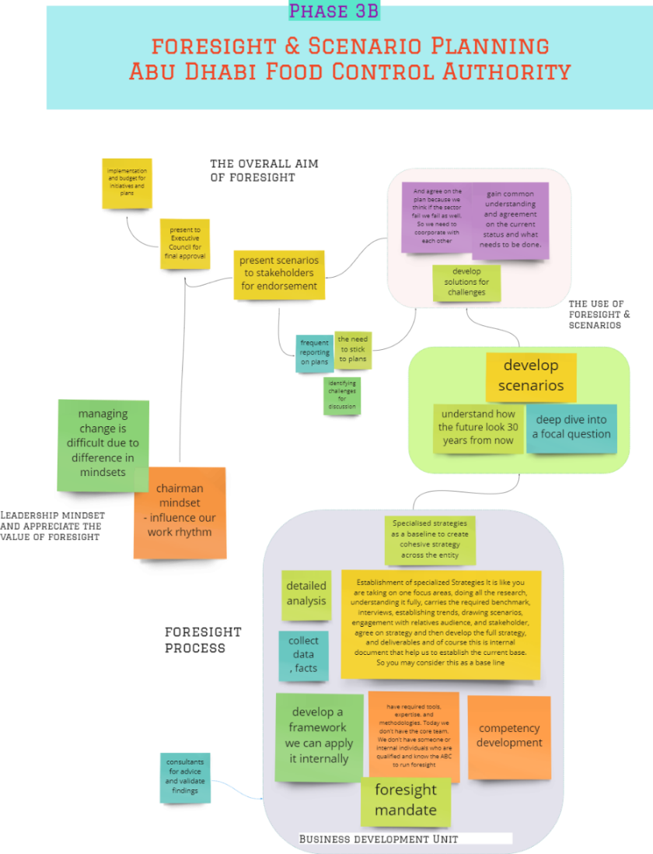

Appendix 8: Foresight Implementation Approaches
Public Entity | Tool | Time Cycle to produce one intervention | Presentation / Outcomes
ADFSA | - Specialised Strategies  - Scenario Planning | - 9–12 Months | - Organisation strategic plan, then followed by specialised topic  - The palm sector and the future of palm and date farming  - government support programs
ADEK | - Foresight Radar  - Scenario Planning | - 8–12 months | - Strategy Plan
DOH | - Foresight (Observations, Motivational and Trends analysis) Insights (Visioning, Building Scenarios)  - Action (Actions roadmap)  - Calibration  - (Continues Horizon Scanning) | - 9–12 months | - Futures Agents Program  - Phenomenon Cards  - Phenomena News  - Foresight News Digest  - Themes and Trends analysis Reports  - Foresight community Breakfast  - Future Workshops  - Foresight Academy  - Social Media outreach  - Deep Dive White Paper  - Scenario Planning workshop and Reports  - Graphic Novels  - Shorts Videos  - Future debates
KF | - Scenario Planning | - 12 months and updated after COVID | - Reports  - Discussions Panel
SCAD | - Horizontal scan of future foresight sectors  - Trend impact analysis  - Uncertainty impact analysis  - Expert plan  - Back casting  - Future wheel  - Scenario planning | - 6–8 months | - Establishment of the Statistics Future Foresight Council  - Launch initiatives and projects based on joint analysis of expected future global trends
TCD | - 6 Pillars Approach  - Horizon Scanning  - Future Radars  - Identifications of Key Historical Points  - Imagination Issues and Analysis  - (Create Future Triangle)  - Casual Layer Analysis (CLA)  - Scenario Planning  - Back casting  - Develop Strategy Plan | - each cycle 2–4 months | - Organisational strategy plan  - Detailed recommendations aligned with the strategic plan  - A set of initiatives  - Specify studies

Appendix 9: Foresight Ecosystem For Government and Public Sector, Copyright registration Certificate. Source: Ministry of Economy


Appendix 10: Foresight Benchmark Summary

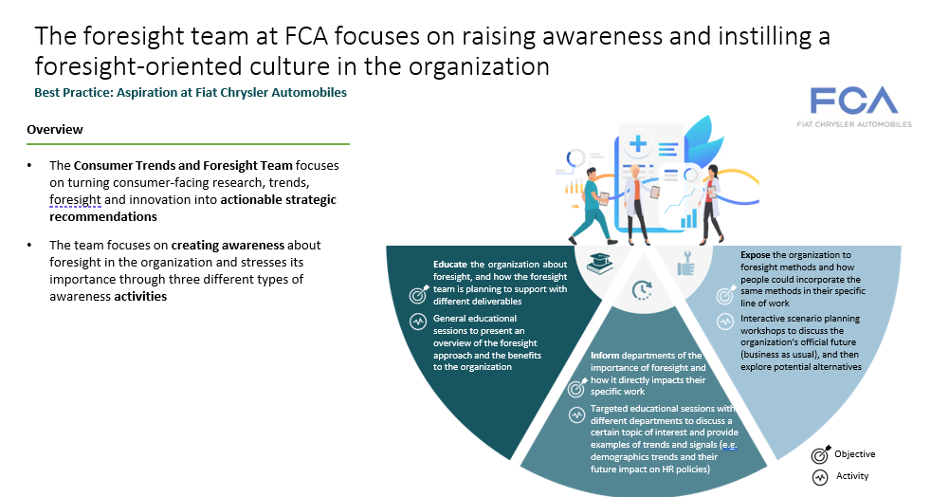

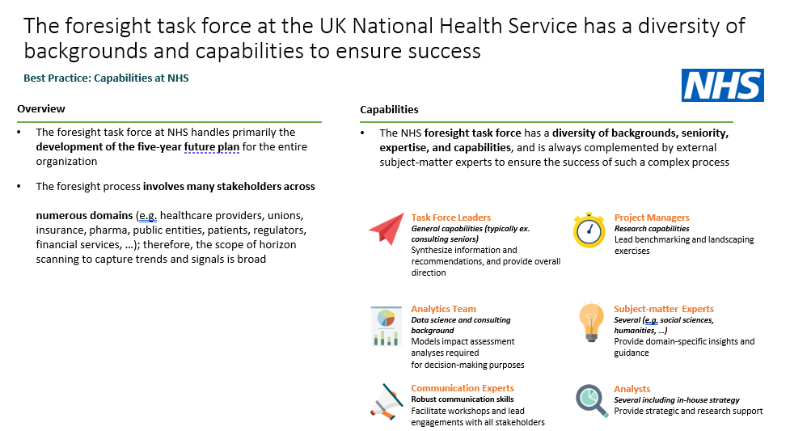
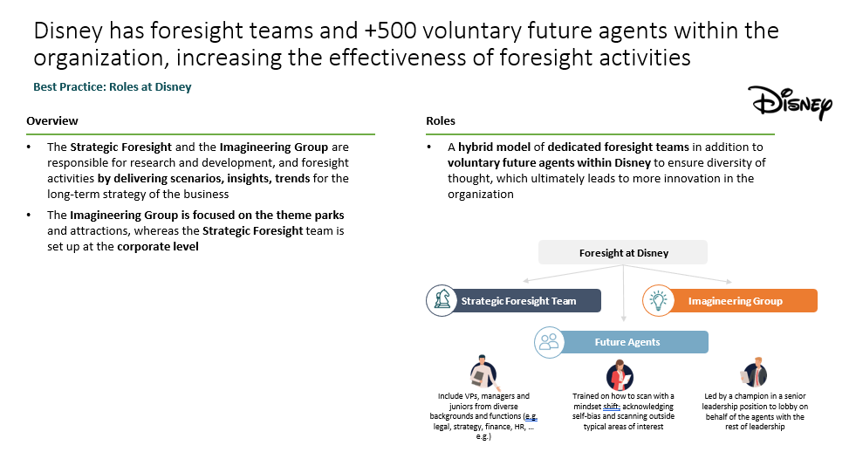

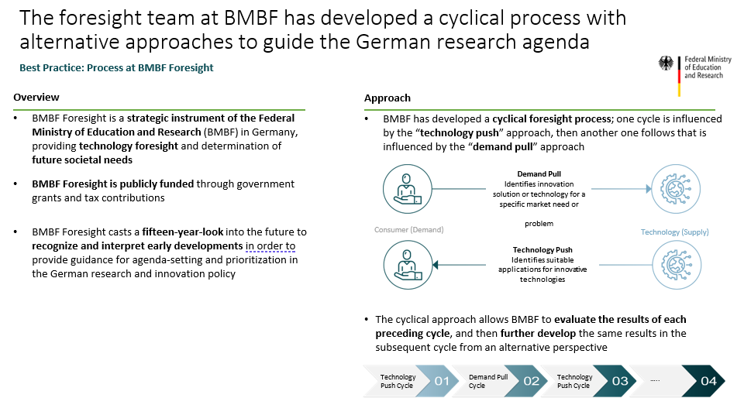
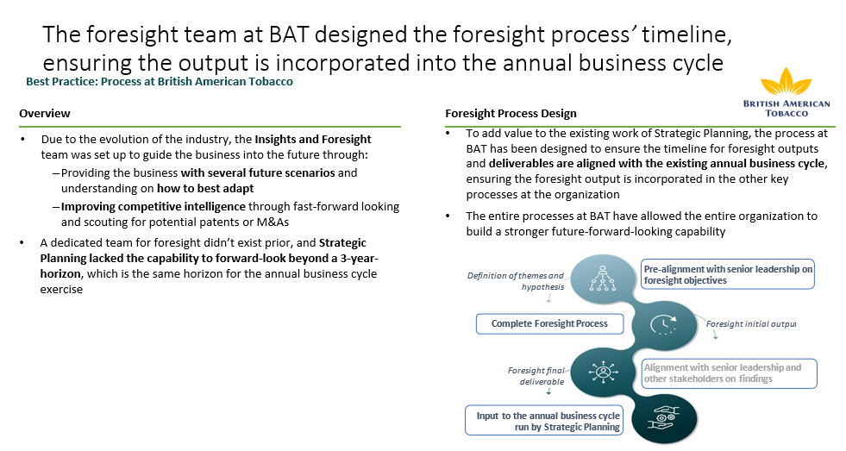

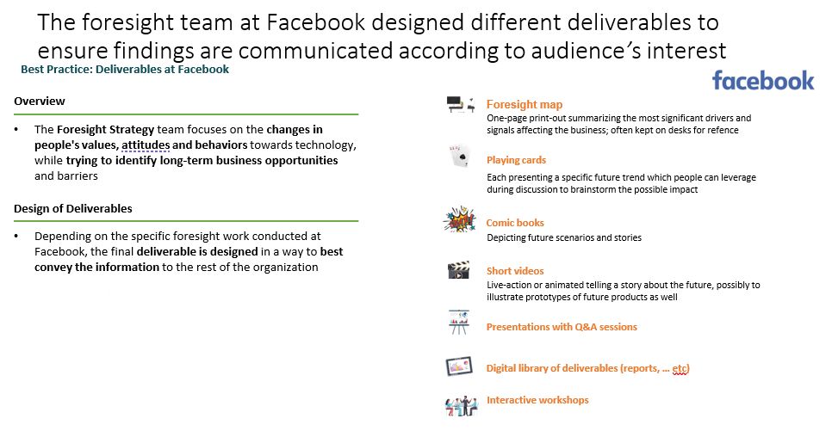

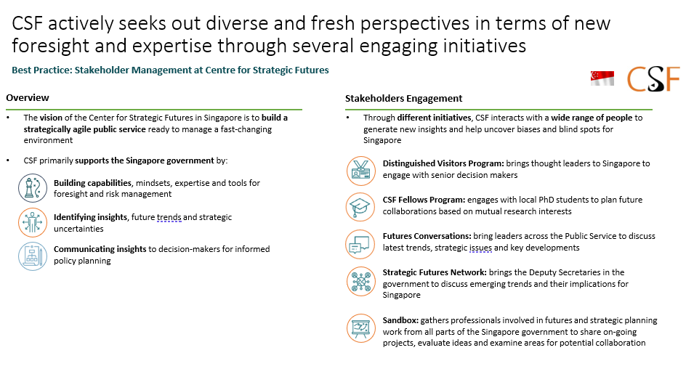

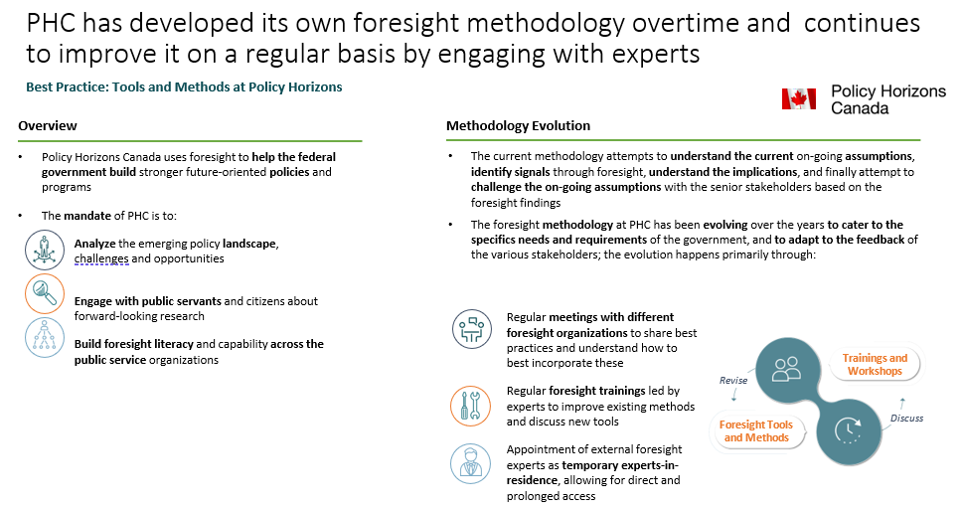

¹ The General Secretariat of the Executive Council: Assigned authority that proposes the general policies and strategies of the Emirate of Abu Dhabi and presents them to the Executive Council.
In 2019, the Abu Dhabi Executive Office became the authority in charge of supporting the Executive Council as well as its committees by virtue of the provisions of Law No. (18) of 2019; before 2019 this function was performed by the General Secretariat of the Executive Council (GSEC).
GBN ceased activities after Deloitte acquired Monitor Group in January 2013 (Turner and Fred, 2006).
Global Trends & the Implications for the UAE/ Abu Dhabi – GBN Global Business Network – Peter Schwartz 2009.
Majlis is a common word in UAE culture that refers to the ‘sitting places' where community members gather to discuss local events and issues, exchange news, receive guests, socialise, and be entertained.
https://programs.dubaifuture.ae/programs/625d0dbca9502d003dfd98d3

